**Bunsen Burner Lab**

Purpose: To understand and learn the parts & proper techniques using the Bunsen burner.

Materials:

|  |  |  |
| --- | --- | --- |
| * Bunsen burner * Safety goggles | * Matches * Crucible tongs | * Straight Pins |

Procedure:

1. **Make sure that long hair is tied back and baggy sleeves are secured**. **Make sure you wear your safety goggles throughout entire lab.**
2. Locate the following parts of the Bunsen burner: Barrel, air intake, and gas intake.
3. Attach the hose from the Bunsen burner to the gas jet located in the center of each lab station. Make sure that all hose connections are snug and secure to avoid gas leakage.
4. Light a match and THEN turn on the gas to the Bunsen burner. Practice lighting the burner by raising the match up the side of the barrel and slightly over the top. Each lab group member should practice lighting the burner.
5. 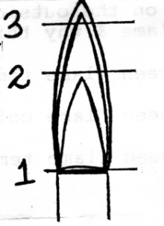Adjust the air flow to the Bunsen burner until you see a distinct inner blue cone in the flame. When properly adjusted, the inner blue cone should be clearly visible and about two inches high. Hold a straight pin with crucible tongs and place the sharp end of the pin in each of the three zones of the flames: the base (1), the tip of the inner blue cone (2), and the tip of the outer cone at the top of the flame (3); as shown in the diagram. What is the color of each portion of the flame? How long does the pin need in each part of the flame to go red (approximate in seconds)? What does this information tell you about the temperature of each zone? Record you observations in your data table.

**EVERYONE IN YOUR LAB GROUP IS RESPONSIBLE FOR KNOWING HOW TO USE THE BUNSEN BURNER CORRECTLY! ☺**

Name: _________________________________________ Class Period: ________ Date: _________________

**Bunsen Burner Lab**

Observations / Data tables:

**CHANGES IN FLAME**:

|  |  |
| --- | --- |
| ACTION | OBSERVATION: What do you see? |
| Change in gas flow | Changes the height of the flame |
| Change in air flow | Changes the color of the flame |

**STRAIGHT PIN IN FLAME**:

|  |  |  |
| --- | --- | --- |
| Section of flame | Approximate time to turn red (in secs) | Temperature of zone (hot, hotter, hottest) |
| 1 | 10 sec | HOT |
| 2 | 2 sec | HOTTEST |
| 3 | 5 sec | HOTTER |

Conclusion:

1. What is the hottest zone (section 1, 2, or 3) of the flame?

See above!

1. Which flame do you think is hotter, the blue or orange? Why?

Blue flame is the hottest! The safety flame (the yellow flame below) is not very hot in comparison to the blue flame. Note – the blue flame is best for lab work!

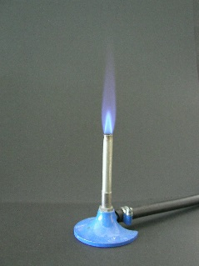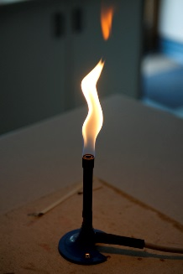We will not use the yellow flame in the lab

1. What part of the flame is most suited for lab work? Why?

Section 2

1. List two things you learned from this lab.