Pond Water Lab

Observation: According to Cell Theory; “CELLS COME FROM PREEXISTING CELLS, CELLS ARE THE BASIC UNIT OF LIFE, and ALL ORGANISMS ARE COMPOSED OF ONE OR MORE CELLS”

Question (Problem): Answer (1) bulleted question plus the (1) bold question below)
- Are single celled organisms actually real?
- What exactly do single celled organisms look like?
- How do microorganisms obtain energy? Do they eat each other or do they make their own energy?
- Are all microorganisms in the CMS pond only Prokaryotic (bacteria- no membrane bound nucleus) and Eukaryotic (plant/animal cells- has a membrane bound nucleus)?
What types of microorganisms are found in pond water in the CMS Nature Lab Pond?

Hypothesis: If the Cell Theory is true and all organisms are composed of one or more cells, and cells are actually the basic unit of life, then ______________________________________________________________________
______________________________________________________________________ because,
______________________________________________________________________
______________________________________________________________________

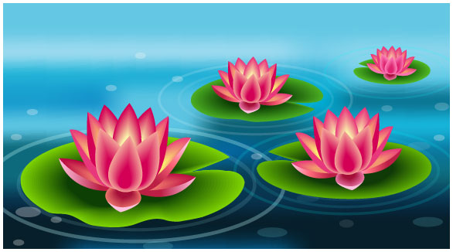
Materials:
- compound microscopes
- microscope slides
- cover slips
- eye droppers
- a source of pond microbes

Procedure:
1. Collect a water sample from the CMS Nature Lab Pond.
2. Using and eyedropper, place (1) drop of water on the center of the microscope slide.
3. Cover the slide with a cover slip by lowering the cover slip at an angle over the water drop in a manner that spreads out the water drop, but does not trap air bubbles.
4. Observe the prepared slide under the microscope.
5. Use the picture ID sheet to identify the organisms observed.
6. Draw a picture in a data table of each organism observed.
7. Write the name of the organism under the picture, if the organism can be identified.
8. Describe each organism using qualitative (adjectives) and quantitative (measurements and counts) terms.
9. Repeat steps 1 to 8 until 4 different organisms are recorded and described.
Name: ________________________________________ Period: _______ Date: _________________

Pond Water Lab: Enhanced

Results: (Describe what you observed)
List the different types of organisms found and how many of each type of organism was found. Use a data table with a title and headings in each column to summarize your results. The title should describe the data. Your data table should include the following columns: Organism Type, Number Found, Model (picture), and Description. (The description should include shape, size*, color*, number of legs etc.). Use an extra sheet of paper for your table.

Analysis: (Explain what the results mean)
How many different types of organisms were found?
Based on the types of organisms found, what do you think are the most important organisms found in your pond water? Were all the microorganisms found multi or single cellular? How many cells make up a paramecium and an amoeba? Look closely inside the rotifer cell. Are organelles present? What structures do you see inside the water flea that may be similar to human organs?

Conclusion: Answer the “Question”. Was your hypothesis correct? Explain why or why not.

Enhanced:
How can this lab experiment be improved? What would be a good experiment to do to follow up on this experiment? How does your results relate to you, and to all known life on Earth?

Draw 1 organism per circle and have it fill at least ¾ of the circle. Identify the organism and include your magnification

Name: ________________________________________ Period: _______ Date: _________________
Pond Water Lab

Analysis and Conclusions:

1. How many different microorganisms did you discover?

2. Which kind of microorganism had the highest population?(refer to your drawings)

3. What do you think microorganisms eat?

4. How many cells make up a paramecium and an amoeba?

5. Look closely inside the rotifer cell. Are organelles present?

6. What structures do you see inside the water flea that may be similar to human organs?
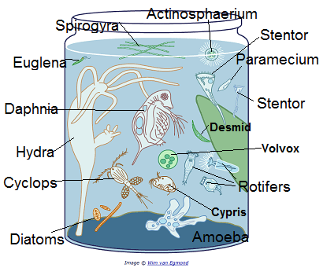

Draw any organism that you saw that is not in the above table.

