Prevention of Muscle Cramps
Prevention of Muscle Cramps

What are Muscle Cramps?

Prevention
Muscle cramps are defined as an involuntary contraction of a muscle. These can last anywhere from a few seconds, all the way up to several minutes. Most experts say that muscle cramping is associated with the hyper-excitability, or hyperactivity of the nerve endings within muscle tissue.

- Eat high sodium foods after practice or competition
- Acclimatize to heat in advance before sport season starts
- Add salt to foods
- Add salty foods to diet: pickles, soy sauce, Worcestershire sauce, soup, tomato juice, pretzels
- Salty Sweaters should drink sports drink instead of water during practice and competition

What causes Muscle Cramps?
The most common causes are dehydration, electrolyte imbalances, and mineral & nutrient deficiencies. Vigorous activity can also increase the likelihood of a muscle cramps when any of these factors are present, or if the body is not very well conditioned for the activity being performed. Dehydration occurs if fluid and electrolyte intake does not equal to their loss.

Sodium is the key electrolyte that helps to reduce the risk of whole body muscle and heat cramps during practice and competition (Bergeron, 2003).

Sodium is important to:
- Replace Sweat Loss
- Enhance Rehydration
- Speed Fluid Absorption
S- Sodium
A- Advances the
L- Level of
T- Training

Salty Sweaters
Salty Sweaters lose significant amounts of sodium during exercise and need extra replenishment.
Signs of a Salty Sweater:
frequent cramping
sweat stings eyes
sweat tastes salty
gritty skin
white streaks on skin or clothes
caked sweat on uniform

Websites
www.sportsmedicine.about.com
www.medicinenet.com
www.mayoclinic.com
http://www.livestrong.com/article/367733-foods-to-prevent-muscle-cramps

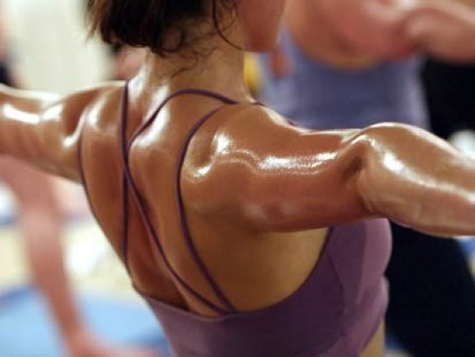
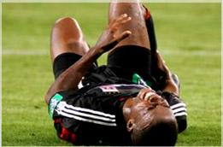

Proper Food Intake for a Female High School Runner

Protein food for muscle growth
Protein aids in muscle growth and a healthy immune system
For this athlete:
Minimum daily protein intake- 72 grams
Maximum daily protein intake- 108 grams
To calculate daily protein intake:
Minimum
.6 x body weight in pounds
Maximum
.9 x body weight in pounds
Protein= 15% - 20% of your daily diet
4.5 -8 portions per day
Good sources of protein portions:
Chicken
Beef
Pork
1 cup pinto beans
½ cup cottage cheese
2 oz canned tuna
Fat essential part of your diet
Limit fat intake before competition
Too much fat intake before competition can delay carbohydrates from reaching muscles
Fats= 20% - 30% of your daily diet
4-8 portions per day
Good Sources of fat portions:
1 tbsp peanut butter
¼ cup nuts
2 tsp mayonnaise
1 tbsp regular salad dressing

Good Fats
Monounsaturated fats
helps in lowering LDL levels, bad cholesterol, while improving the athlete’s HDL levels, good cholesterol. Popcorn, avocados, oatmeal, olive oil.
Polyunsaturated fats
helps in lowering LDL levels and also includes Omega 3 fatty acids. Seafood, corn, sunflower oil.
Bad Fats
Trans fats
extremely dangerous fats that, scientists created this type of fat to assist in extending the shelf life of products in grocery stores. Fried food, packaged products.


Protein

Fat
Carbohydrate

Female Track and Field Athlete
Age: 14
Height: 5’ 7”
Weight: 120 lb.
BMI: 18.8 (normal weight)

Carbohydrates food for energy
Carbohydrates are the primary food source
Fuels muscles and brain during activity
Carbs= 50% - 60% of your daily diet
9-14 portions per day
Good sources of carbohydrates portions:
½ large bagel
1 cup pasta
¾ cup rice
One English muffin
Two handfuls of pretzels
1 cup cheerios
Baked potato
Three fig bars
1 cup juice
1 packet oatmeal
¼ cup raisins

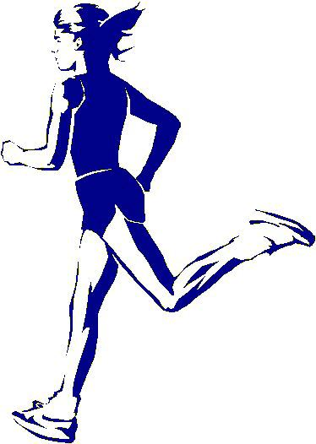

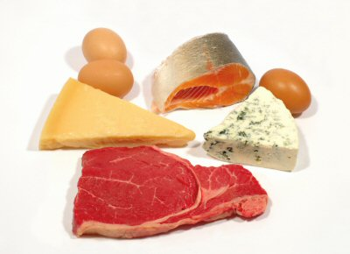

Proper Caloric Intake for a Female High School Runner

Daily Calorie Intake
Female High School Runner
1800 – 2400 Calories per day
Female athlete should eat 15 to 20 calories per pound
120 (weight in lbs) x 15 = 1800
120 (weight in lbs) x 20 = 2400
______________________________
One Hour Before Competition
20 oz of water or sports drink
Small amount of carbohydrates
During Competition
30 grams of carbohydrates per hour
After Competition
Drink enough to replenish sweat lost
Eat calories within 15 minutes after
Salty Sweaters need to replenish with saltier foods and drinks after competition

Eat small meals every four hours

Breakfast is the most important meal of the day
Eat within one hour of waking up
Skipping breakfast makes your body try to play catch up on the missing nutrients all day resulting in a weak body and mind for competition.

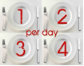

Female Track and Field Athlete
Age: 14
Height: 5’ 7”
Weight: 120 lb.
BMI: 18.8 (normal weight)

Nutrition for Female Runners
Female athletes need fewer calories per day. This means that they must meet the daily vitamin, protein, mineral, carbohydrate, and fiber requirements in fewer calories. This means that there is less room for eating nutritionally ‘empty’ foods that include candy and soda.
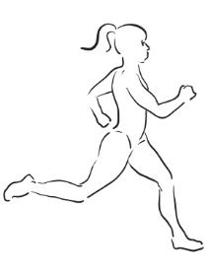

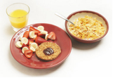



Supplementation for a Female High School Runner

Good Supplements
Pure Sport Drinks
Provide workout and recovery drinks and powders packed with lots of carbohydrates and protein.
www.puresport.com
G-Fit Gatorade Series
Provides a pre-work, during workout, and post workout drink. Each is packed with the best nutrients for optimal performance.
www.gatorade.com
Amino Vital
This product restores the athlete’s muscle fibers to their most advantageous state while boosting immunity, improve the fat and muscle ratio and amplify resistance to injury.
www.amino-vital.com

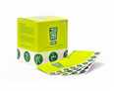
Food Supplements for Runners
Sports Drinks
Sports Bars
Carbohydrate Boosters
High Sodium Foods

Why Sports Drinks?
Electrolytes help the body retain fluid and prevent muscle cramps. When an athlte is exercising they are losing electrolytes through their sweat. Sports drinks contain electrolytes, such as sodium and potassium that an athlete needs.
Why Sports Bars?
Runners need sports bars that contain more carbohydrates than protein. While an athlete is exercising their muscles contract, this contraction occurs when running, jumping, kicking, swimming, etc. The muscle fuel is burned each time that the muscles contract. It is imperative for the athlete to keep the correct amount of muscle fuel to continue to function at an excellent level.
Why Carbohydrate Boosters?
It is imperative that endurance athletes get the majority of their calories from carbohydrates to ensure strong muscles and a strong mind. Sports gels, honey, honey sticks and cliff shots are all beneficial for runners.
Why High Sodium Foods?
Salty sweaters in particular should stick with a high sodium diet. High sodium food sand beverages are imperative to replenish the extra electrolytes that a salty sweater loses compared to the normal athlete. Salty sweaters experience muscle cramps and fatigue without the proper diet.


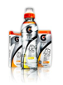

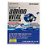

Female Track and Field Athlete
Age: 14
Height: 5’ 7”
Weight: 120 lb.
BMI: 18.8 (normal weight)

Hydration in Female Runners

Hydration in Female Runners



Female athletes should consume 90 ounces of fluids per day, 11 cups.
All fluids count: coffee, tea, milk, juice, water, soda and sports drink.
Drink throughout the day:
Within one hour of waking up 16 to 20 ounces of fluid
With every meal 20 ounces of fluid
With every snack 16 to 20 ounces of fluid
TIPS TO REMEMBER
Gulp, Don’t Sip
Swallow Fluids, Don’t Spit
Drink, Don’t Pour On Head
Do Not Over Drink
No Energy Drinks
Hydration During Exercise
Before Exercise
Drink 20 ounces of water or sports drink an hour before
During Exercise
Drink 14 to 40 ounces of water or sports drink per hour
light sweaters= 14 Oz per hour
heavy sweaters= 40 Oz per hour
It is important to calculate an hourly sweat rate to determine the type of sweater an athlete is during exercise. This is important to understand the amount of fluid the athlete needs to put back in their body after a workout.
How to Calculate Hourly Sweat Rate:
- Athlete will weigh before and after exercise.
- Subtract post-exercise weight from pre-exercise weight. Then convert the weight into ounces.
- Add number of ounces of fluid consumed during practice.
- Divide the sum of the amount of fluid lost plus amount of fluid consumed by the number of hours you exercised to get your hourly sweat rate.
Example:
Pre-exercise weight (148 lb) – Post-exercise weight (145 lb)= 3 lb
3 lbs = 48 oz
+
Amount of fluid consumed during practice (20 oz) /
number of hours in practice (2 hours)
=
48 + 20 = 68 / 2 = 34 ounces of fluid required per hour

Symptoms of Dehydration:
Noticeable Thirst
Muscle Cramps
Weakness
Impaired Performance
Headache
Nausea
Fatigue
Burning in Stomach
Dry Mouth
Dizziness or Lightheadedness

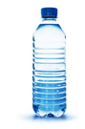

Post-Exercise Nutrition

Always eat or drink 50 grams of carbohydrates 15 minutes after completing exercise
Doing this will replete the muscle and liver glycogen stores
Not eating 15 minutes after exercise will result in a longer recovery period for the body

Excellent Foods to Eat Post-Exercise
Two handfuls of pretzels, crackers or cereal
Two handfuls of trail mix
A high carbohydrate sports bar
A piece of fruit and one handful of pretzels
Two granola bars

Salty Sweaters
Eat something salty after exercise such as crackers, pretzels, or chex mix with salted nuts. Choose sports drinks, tomato juice, or vegetable juice instead of water.

Always remember food and fluid before and after competition or practice

Practice
or
Competition
Food and Fluid
Food and Fluid

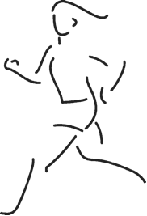

References
Bergeron, M. (2003). Heat Cramps: fluid and electrolyte challenges during tennis in the heat. Journal Science Medicine Sport. 6(1): 19-27
Bonci, L. (2009). Sport nutrition for coaches. Champaign, IL: Human Kinetics.
Consolo, K. (2008). Maximizing Peak Running on Race Day. Journal of Physical Education, Recreation & Dance, 79(3), 36-40.
Heart, M. (2011). Cramp!. Mountain Biking Australia, 60-64.
Thompson, S. H. (2007). Characteristics of the Female Athlete Triad in Collegiate Cross-Country Runners. Journal of American College Health,
56(2), 129-136.

