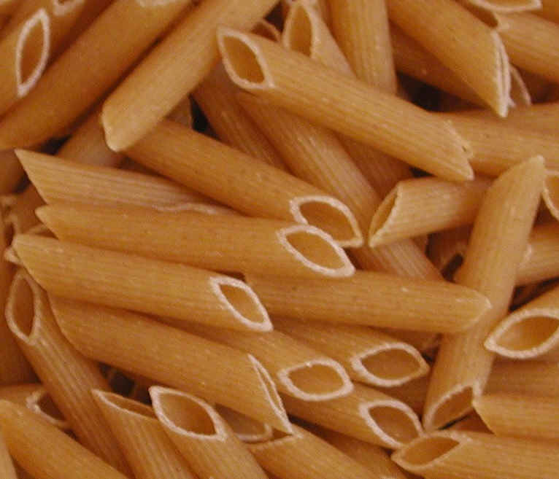

Post-Exercise Nutrition

After you exercise it is imperative that you replace any fluids lost during your workout. Having mixture of a protein plus carbohydrate intake has been shown to help replenish depleted glycogen after a tough workout (Poole, Wilborn, Taylor, & Kerksick, 2010).

**When to eat post-workout:**

* Make sure to eat within 15 minutes after you exercise
* Two important macronutrients that will help you in the recovery phase are
  + Protein
  + Carbohydrates (Poole, Wilborn, Taylor, & Kerksick, 2010)
* A ratio of 4:1 combination of carbohydrates and protein is the best way to refuel your body after a strenuous workout.

**What to eat post-workout:**

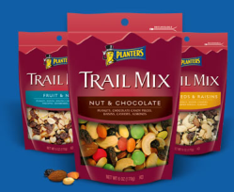 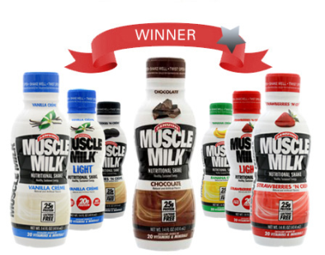 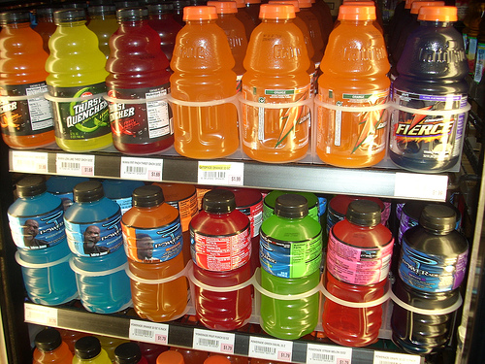

* Bag of trail mix and a sports drink
* Chocolate milk
* Fruit smoothie

**Post-workout Meal #1 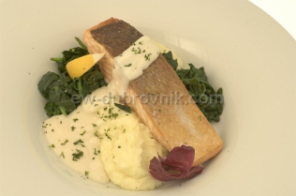 \***Grilled Salmon *Mashed potatoes *Salad **Post-workout Meal #2** 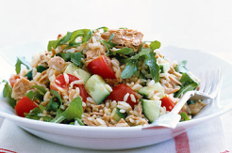

* Tuna
* Brown rice
* Vegetables

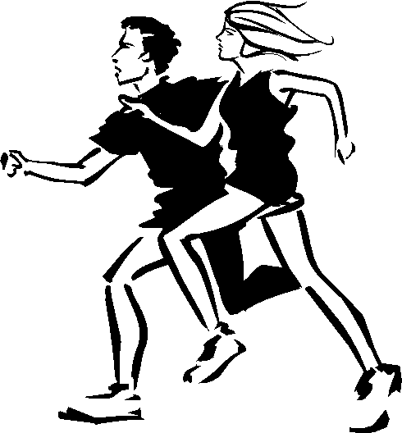

Refuel your body

|  |  |  |  |  |
| --- | --- | --- | --- | --- |
| **Morning Pre-workout meal 1-2 hours prior to exercise**     * Energy bar * 2-3 cups of water or sports drink   **Lunch Pre-workout meal 3-4 hours prior to exercise**     * Grilled chicken * Pasta * Green beans * Bread * Snack = bag of pretzels * Water or sports drink | |  |  |  |
|  |  |  |  |  |
|  |  |  |  |  |
|  |  |  |  |  |
|  |  |  |  |  |
|  |  |  |  |  |

# Pre-Exercise Nutrition

* Small meals eaten 2-3 hours prior to exercise
* Medium meals eaten 3-4 hours prior to exercise
* Light meals eaten 1-2 hours prior to exercise (Guest, 2005)

## Choices of Food to Eat

* Lean meat, chicken, fish, or alternative source of protein
* Bread or starch
* Fruit
* Dairy serving – yogurt with nuts
* Water

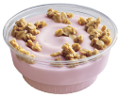

Guidelines for a pre-exercise meal or snack recommend that athletes consume meals and snacks that are **high in carbohydrates** (Cox, Snow, & Burke, 2010).

Some examples include bread, pasta, rice, potatoes, and fruits.

## When to Eat

Tandem bicycle

**Hydration Tips for Athletes**

Michael is a 160 pound High School track and field athlete who practiced for two hours. During his breaks he drinks a total of 24 ounces of fluids to recover. After practice, he weighs 158 pounds.

**What should athletes like Michael consume to stay hydrated for practice or competition?**

* **Water and sports drinks** are the top two choices for athletes to drink (Bonci, 2009).
* Sports drinks provide liquids as well as fuel and electrolytes, in particular sodium to your body (Bonci, 2009).
  + Sports drinks should be viewed as the sports supplement with the greatest potential to enhance performance in a wide variety of sporting situations (Cort, 2009).
* **Sports water** are lightly flavored and usually contains a much lower carbohydrate and electrolyte content than sports drinks.
* Fluids with sodium are vital when exercises lasts more than 60 minutes or if an individual has a sodium deficiency (Fitness handout, 2011).
* Avoid energy drinks like Red Bull and Rockstar. They only provide a short feeling of energy and are possibly too high in sugar.

**How much fluid should athletes drink throughout the day?**

* The following are some recommendations from the Gatorade Sports Science Institute (GSSI) based on the Northwest Texas Sports Medicine Clinic (NATA) Position Statement: Fluid Replacement for Athletes (GSSI, 2001).
  + **Before exercise:** Drink at least 17-20 oz. of water or a sports drink, such as Gatorade 2 - 3 hours before the activity starts.
  + **During Exercise:** Drink 28-40 oz. of water or a sports drink, such as Gatorade per hour of play (at least 7 - 10 oz. every 10-15 minutes or amount equal to sweat and urine loss).
* When drinking your fluids, gulps are preferred over sips, so encourage athletes to use a cup or loosen the top of their bottles and swallow up (Bonci, 2009).

Michael has a sweat rate of:

* 160 pounds (pre-weight) – 158 pounds (post-weight) = 2 pounds or 32 ounces
* 32 ounces (fluids lost) + 24 ounces (fluid consumed during practice) = 56 oz.
* 56 oz. / 2 (hours spent exercising) = 28 ounces per hour
* Our calculations show that Michael’s hourly sweat rate is 28 oz. per hour.

**How to hydrate after exercise:**

* **After Exercise:** Drink at least 20 oz. of a sports drink, such as Gatorade per pound of weight loss within 2 hours to help rehydration.
* Drink enough to replace sweat, but do not **over drink**.
* If you lost weight, it is all from sweat loss, so make sure that you gain the weight back before the next practice. You can accomplish this by drinking about 20 to 24 ounces of fluids for each pound lost.

Michael lost 2 pounds during the workout so in order to rehydrate his body he would need to consume 40 oz. of water or sports drink within in 2 hours after practice.

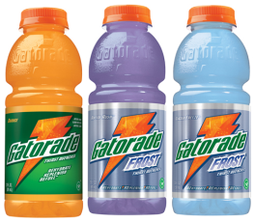

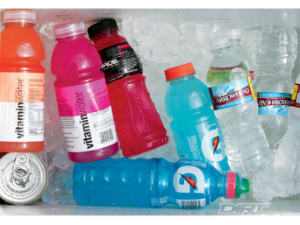

Dealing with Eating Disorders: Bulimia

**Signs to look for in a Person dealing with an Eating Disorder (**Kakaiya, 2008)

* Obsession with food and exercise
* Relentless pursuit of being thin
* Recurrent harmful behaviors to prevent weight gain. Examples include:
  + Self-induced vomiting
  + Excessive exercise
  + Fasting
* Low self-esteem

Irregular menstrual cycle

**Short-term and Long-term Effects of Bulimia**

* Your physical appearance begins to deteriorate
* Irregular heart beat
* Stomach ulcers
* Hormonal changes, menstrual cycle changes
* **Suicidal tendencies**
* Difficulty concentrating
* Substance abuse
* **Depression, anxiety**

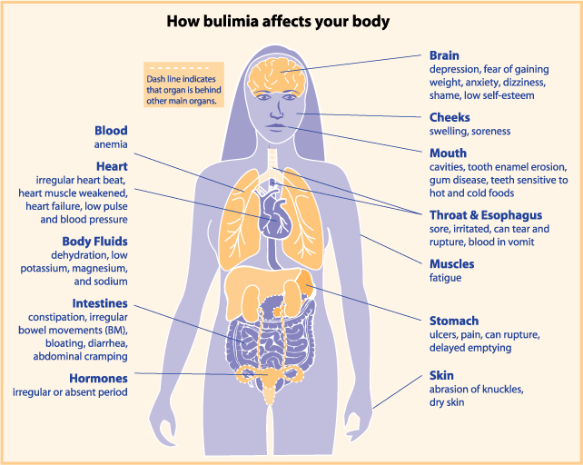**Recommendations for Prevention** (Clark, 2008)

* Fostering a positive eating environment
* Reminding the athlete of the many good inner qualities he or she has that makes them special.
* Administering a preseason nutrition screening
* **Referral to a registered dietitian**
* Avoid setting goals based on appearance, body composition, and overall weight.



**Valuable Resources/Websites**

<http://www.anorexia-reflections.com/>

<http://www.something-fishy.org/>

[](http://www.nationaleatingdisorders.org/index.php)



**Long term effects:**

* Depression
* Binge drinking – excessive amount of alcohol consumption.

**For Men:**

* you may HAVE DIMINISHED sexual performance.

**For Women:**

* You may have the risk of giving birth to deformed, retarded babies or low birth weight babies.

**Preventing alcohol abuse:**

* Avoid high risk areas
* know what triggers you to drink
* find a new outlet to expreess yourself

Long term effects

of

alcohol use

[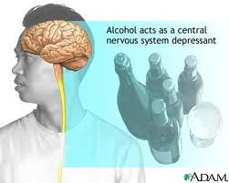](http://www.google.com/imgres?imgurl=http://trialx.com/curetalk/wp-content/blogs.dir/7/files/2011/05/diseases/Alcohol_Abuse-2.jpg&imgrefurl=http://trialx.com/curebyte/2011/05/25/pictures-for-alcohol-abuse/&usg=__Vo1yooCIUwgawfv_9ufobS-3ps0=&h=320&w=400&sz=16&hl=en&start=3&zoom=1&tbnid=n7ML9lLzxJcDIM:&tbnh=99&tbnw=124&ei=H-gMTunxI9C_gQf6gvDpDQ&prev=/search?q=alcohol+abuse&um=1&hl=en&sa=N&rls=com.microsoft:en-us:IE-Address&biw=1440&bih=727&tbm=isch&um=1&itbs=1)

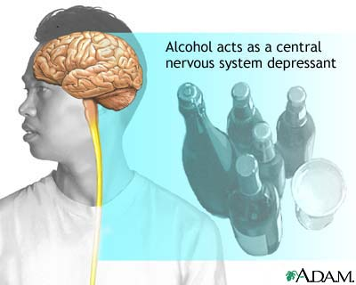

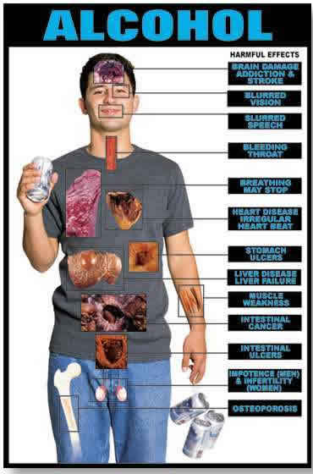

Delete text and place photo here.

Enter Contact Information Here | 1127 Lombard Blvd. San Francisco, CA 59802 | phone 555.555.5555 | fax 555.555.5555

**Informational websites**

[www.healthchecksystems.com/alcohol.htm](http://www.healthchecksystems.com/alcohol.htm)

[www.ncadd.org](http://www.ncadd.org)

[www.niaaa.nih.gov/Pages/default.aspx](http://www.niaaa.nih.gov/Pages/default.aspx)

[www.madd.org](http://www.madd.org)

**Effects of high alcohol use**

* Aggressive, irrational behavior, weakness of heart muscles.
* Liver damage, cancer of throat and mouth, severe inflammation of the stomach.
* Hangover or pass-outs
* It can decrease your lifespan and lead to accidents and fatality from drunken driving.

The abuse of alcohol use can affect an individual’s life in a negative way if they are not cautious of their alcohol intake level.

Who to communicate with in getting help in overcoming your addiction:

* parents
* school Counselors
* health care professionals
* hospitals, clinics

|  |  |  |  |  |  |  |  |  |  |  |
| --- | --- | --- | --- | --- | --- | --- | --- | --- | --- | --- |
| **SUBWAY** | | | | | | | | | | |
| **Meal** | **Item Chosen** | | **Carbohydrate (grams)** | | **Protein (grams)** | | **Fat (grams)** | | | **Calories (grams)** |
| **Breakfast** | Steak, Egg (White) & Cheese | | 25 | | 15 | | 4 | | | 180 |
|  | Milk, Strawberry Flavored Reduced Fat | | 44 | | 15 | | 7 | | | 300 |
|  | Apple Slices - 1 package | | 9 | | 0 | | 0 | | | 35 |
| **Lunch** | Foot long Turkey Breast & Black Forest Ham | | 92 | | 35 | | 8 | | | 570 |
|  | Ranch Dressing | | 1 | | 0 | | 11 | | | 110 |
|  | Water | | 0 | | 0 | | 0 | | | 0 |
| **Dinner** | 6" Oven Roasted Chicken | | 47 | | 23 | | 5 | | | 320 |
|  | Ranch Dressing | | 1 | | 0 | | 11 | | | 110 |
|  | Baked Lay's Sour Cream & Onion | | 24 | | 3 | | 3.5 | | | 140 |
|  | Water | | 0 | | 0 | | 0 | | | 0 |
| **Snack** | Chocolate Chip Cookie | | 30 | | 2 | | 10 | | | 210 |
| **TOTAL** |  | | 273  **(55%kcal)** | | 93  **(19% kcal)** | | 59.5 **(27%kcal)** | | | **1975** |
| **Denny's** | | | | | | | | | | |
| **Meal** | | **Item Chosen** | | **Carbohydrate (grams)** | | **Protein (grams)** | | **Fat (grams)** | **Calories (grams)** | |
| **Breakfast** | | Fit Slam (15 oz) | | 46 | | 27 | | 12 | 390 | |
|  | | Milk (10 oz) | | 12 | | 8 | | 5 | 130 | |
|  | | Water | | 0 | | 0 | | 0 | 0 | |
| **Lunch** | | Chicken Deluxe Salad-Grilled Chicken (17 oz) | | 13 | | 44 | | 13 | 340 | |
|  | | Vegetable Beef Soup (8 oz) | | 11 | | 0 | | 1 | 79 | |
|  | | Toast dry (1) | | 17 | | 0 | | 1 | 90 | |
|  | | Strawberry Lemonade (15 oz) | | 50 | | 1 | | 0 | 200 | |
| **Dinner** | | All-American Slam | | 5 | | 40 | | 68 | 8 | |
|  | | Water | | 0 | | 0 | | 0 | 0 | |
| **Snack** | | Smoothie: Strawberry Banana Bliss | | 65 | | 3 | | 0 | 250 | |
| **TOTAL** | |  | | 219 **(60%kcal)** | | 123  **(20%kcal)** | | 100  **(30%kcal)** | **2279** | |

Eating on the Road

* A 2,000 calorie a day diet is used for the basis of general nutrition advice; however individual needs may vary.

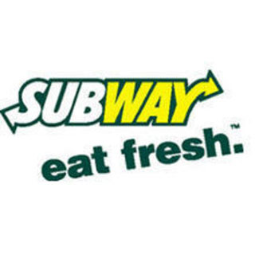





References

Bonci, L. (2009). Hydration for Top Performance. *Sport Nutrition for Coaches*. Champaign, IL: United States: Human Kinetics Publishers.

Burke, L., Loucks, A., Broad, N. (2006) Energy and carbohydrate for training and recovery. *Journal of Sports Sciences, 24(7)*. 675-685.

Clark, N. (2008). The Athlete's Kitchen. *ACHPER Active & Healthy Magazine*, 15(2/3), 11-12. Retrieved from EBSCO*host*.

Cort, M. (2009). Nutrition: Hydration Options: What are the Choices?. *Modern Athlete & Coach*, 47(4), 11-12. Retrieved from EBSCO*host*.

Cox, G. R., Snow, R. J., & Burke, L. M. (2010). Race-Day Carbohydrate Intakes of Elite Triathletes Contesting Olympic-Distance Triathlon Events. *International Journal of Sport Nutrition & Exercise Metabolism*, 20(4), 299-306. Retrieved from EBSCO*host*.

Denny’s Nutritional Menu. (2011, May 23). Retrieved July 1, 2011, from Denny’s Official Site http://www.dennys.com/files/nutrition_facts.pdf

Fitness handout. Hot-Weather Exercise. (2011). *IDEA Fitness Journal*, 8(6), 96. Retrieved from EBSCO*host*.

Fluid Guidelines for Athletes. (2001, August 27). Retrieved July 04, 2011, from Gatorade Sports Science Institute http://www.westfieldathletics.org/library/files/westfieldathletics/files/Fluid_Guidelines.pdf

Guest, N. S. (2005). Pre-exercise nutrition: help your clients make the right choices when fueling up to work out. *Fitness Business Canada*, 6(2), 48-49. Retrieved from EBSCO*host*.

Hornak, N., Hornak, J. E., & Cappaert, T. A. (2004). The Athletic Trainer and Eating Disorders: Part 1: Recognition and Prevention. *Athletic Therapy Today*, 9(3), 42-43. Retrieved from EBSCO*host*.

Hydration for Athletes. (2010). *Athletics*, 27. Retrieved from EBSCO*host*.

Kakaiya, D. (2008). Eating disorders among athletes. *IDEA Fitness Journal*, 5(3), 44-51. Retrieved from EBSCO*host*.

Keep Your Cool This Summer. (2011). *Practical Horseman*, 39(7), 67. Retrieved from EBSCO*host*.

Koutakis, N., Stattin, H., & Kerr, M. (2008). Reducing youth alcohol drinking through a parent-targeted intervention: the Orebro Prevention Program. Addiction, 103, 1629-1637. Doi:101111/j.1360-0443.2008.02326.x

Paljarvi, T., Koskenvuo, M., Poikolainen, K., Kauhanen, J., Sillanmaki, L. & Makela, P. (2009). Binge drinking and depressive symptoms: a 5- year population-based cohort study. Addiction, 104, 1168-1178. Doi: 10.1111/ j.1360-0443.2009.02577.x

Poole, C., Wilborn, C., Taylor, L., & Kerksick, C. (2010). The role of post-exercise nutrient administration on muscle protein synthesis and glycogen synthesis. *Journal of Sports Science & Medicine*, 9(3), 354-363. Retrieved from EBSCO*host*.

Subway United States Nutrition Information (2011, June). Retrieved July 1, 2011, from Subway Official Site <http://www.subway.com/applications/NutritionInfo/Files/Nutrition>