Virtual Meteorology 101

Name _______________________________ Period ______

Weather and climate are the two major abiotic (nonliving) factors responsible for determining the major geographic ecosystems called biomes.

Search the web and give a definition of weather:

Search the web and give a definition of climate:

Climate is closely associated with the seasons, but do you know what causes the seasons? Log on to the website below.

http://www.youtube.com/watch?v=DuiQvPLWziQ

After watching the video, describe what causes the earth’s seasons. Give examples of the earth’s position to the sun in December vs. June and compare the northern and southern hemispheres.

What do the red lines along the edge represent? What do the blue lines along the edge represent?
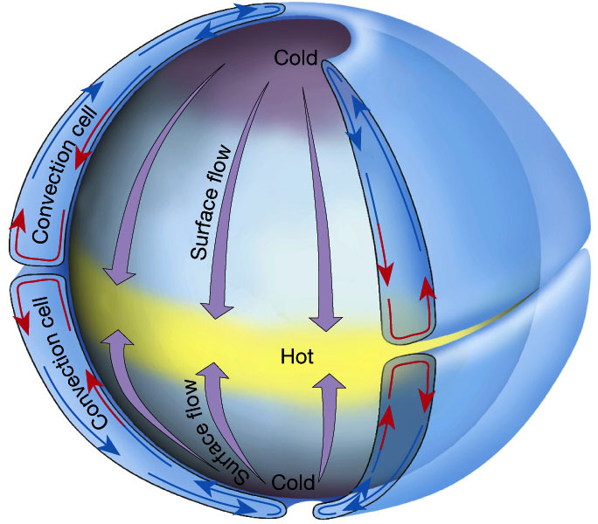

The diagram above shows a convection current if the earth is not spinning. Note that if the earth is not spinning, cold air from the poles would flow straight down to the equator where it would be warmed and would rise straight back up to the poles. However, the earth IS spinning, so we need to investigate what the rotation of the earth does to the winds.

For starters, which way does the earth spin? Do you know? Click on the link below to find out.
http://mmert.org/goltz/Universe/size5earth.gif

What is the Coriolus Effect? For general information, log on to the website below. Read the background information, watch the short video of the merry-go-round at the bottom and then answer the questions below.
Coriolus Part 1 http://ww2010.atmos.uiuc.edu/(Gh)/guides/mtr/fw/crls.rxml

What is the Coriolus Effect?

Which way does the Coriolus Effect bend the winds in the Northern Hemisphere?

Which way does the Coriolus Effect bend the winds in the Southern Hemisphere?

What factors determine how much the winds bend?

Click on the link below and watch the winds bend. Coriolus Part 2
http://www.classzone.com/books/earth_science/terc/content/visualizations/es1905/es1905page01.cfm?chapter_no=visualization

Which hemisphere is shown and which way are the winds bending?

Some people say that water goes down the toilet counterclockwise in the Northern Hemisphere, clockwise in the Southern Hemisphere, and straight down at the equator, due to the Coriolus Effect. Click on the link below to find out if this is true, and answer the questions below.
Coriolus – Snopes
http://www.snopes.com/science/coriolis.asp

Do winds blow faster or slower in Florida compared to the equator? Explain why.

Which way do hurricanes and tornadoes spin in the Northern Hemisphere?

If you shoot a cannon from the equator pointing toward the North Pole, which way would the cannon ball appear to be deflected?

Does the Coriolus Effect cause water in the toilet to spin in opposite directions in the Northern vs. the Southern Hemispheres? Explain.

The Rain Shadow Effect also plays a major role in climate formation. Clink on the link below to learn about the Rain Shadow Effect. Be sure to read the Introduction. Then, click on the Animation and choose “narrated” at the bottom. Then, read the conclusion and see how you do on the practice quiz. Once you have done that, answer the questions below.

http://bcs.whfreeman.com/thelifewire/content/chp56/5602001.html

Does North America receive most of its winds from the Northeast Trades, the Southeast Trades, or from the Westerlies?

Which way do these winds blow?
What is the definition of a rain shadow?

What happens to the temperature of rising air?

Does rising air expand or contract?

Which holds more water, warm air or cool air?

What happens to the water vapor in the air when it cools at high altitudes?

What happens to the temperature of falling air?

From the Animation, draw a sketch of the Rain Shadow Effect and label it. Be sure to include arrows showing what the air does and draw in clouds in the appropriate location.

From the conclusion section, what mountain range in the Great Basin Region of the U.S. causes the rain shadow effect that creates North America’s desert biome?

From this animation of the Rain Shadow Effect, you now know why clouds form. So, let’s familiarize ourselves with the basic types of clouds. Do an internet search and copy and paste an example of each of the following types of clouds in the chart below. Then, give a brief description of the type of cloud.

Cloud Type | Picture | Description
Cirrus

Stratus

Cumulus

Cumulonimbus

In the Northern Hemisphere, warm air moves up from the Gulf of Mexico while cold air moves down from the Arctic and Canada. Because the Coriolus Effect bends the winds from west to east, we, here in Texas, get most of our weather from the Gulf of Mexico or coming down from the North West through Colorado, down through New Mexico and then to Texas. Remember that the Rocky Mountains run through New Mexico all the way up to Canada.

When warm and cold air meet, fronts form. Click on the link below to learn about cold fronts and warm fronts. It will tell you about cold fronts 1st. Be sure to then click on warm fronts to learn about them. Answer the questions below.
http://ww2010.atmos.uiuc.edu/(Gh)/guides/mtr/af/frnts/cfrnt/def.rxml

What is a cold front?

Which way do cold fronts generally move?

How are cold fronts represented on a weather map?

What happens to the temperature when a cold front moves through?

Will it rain when a cold front moves through?

What is a warm front?

Which way does it move?

How are warm fronts represented on a weather map?

What happens to the weather when a warm front moves through?

Now, click on the animation below to watch cold and warm fronts moving through. Answer the following questions.
http://www.classzone.com/books/earth_science/terc/content/visualizations/es2002/es2002page01.cfm?chapter_no=visualization

When a cold front meets warm air, does the cold air move over or under the warm air that is already there?

What happens to the warm air?

What happens to air temperature when it rises?

Based on your answer to the question above, will clouds form? Might you get rain?

From the animation, what type of clouds usually form when a cold front moves through?

Will the temperature change be slow or quick when a cold front moves through?

When a warm front meets cold air, does the warm air go over the cooler air, or does it go under?

What happens to air temperature when it rises?

Based on your answer to the question above, will clouds form when a warm front moves through?

Based on the animation, what type of clouds form when a warm front moves through?

Which holds more water, warm air or cold air?

Do you think it usually rains more when a cold front moves through or when a warm front moves through?

The diagrams below do a good job of visually summarizing the difference between cold fronts and warm fronts.
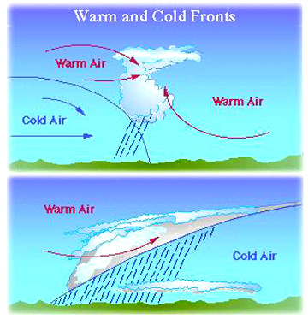

Cold air is more compressed than warm air and is therefore denser. Thus, cold air falls down toward the earth, pressing down on the earth to create zones of high pressure. High pressure zones are represented by H on the weather map. Since the air in a high pressure zone is falling down toward the earth, it generally warms up and dries out. Thus, high pressure zones are generally associated with DRY, but not necessarily hot weather. Cold fronts are considered to be High Pressure Zones.

Warm air expands and is less dense than cold air. Warm air also holds more water than cold air. When warm air rises, it moves away from the earth’s surface, so there is less pressure pushing on the earth. Low pressure zones are represented by L on the weather map. Low pressure zones are usually associated with rainy weather.

Click on the National Weather Map below to see today’s weather across North America.
http://www.weather.gov/outlook_tab.php

Describe your general observations from the weather map today.

What is the Jet Stream? There is a picture of it below.

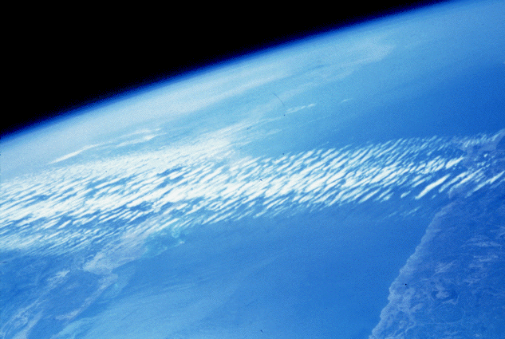

Click on the following link to learn about the jet stream and then answer the following questions.
http://www.wisegeek.com/what-is-the-jet-stream.htm

What is the jet stream?

Which way does it move in the Northern Hemisphere?

How high up is it in miles?

How long is it?

How wide is it?

What causes it?

Does it stay in the same place?

Click on the link below to find the current location of the jet stream in North America.
http://squall.sfsu.edu/crws/jetstream.html

Where is the jet stream currently located?

This map shows the general location of both the summer and winter North American Jet Streams.
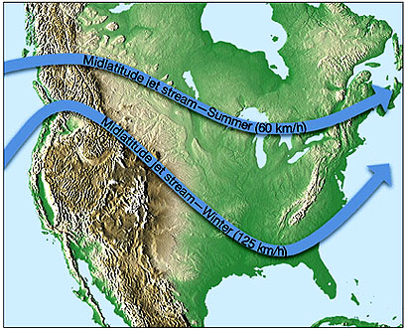
Why do you think airplane pilots check to find the location of the jet stream before every flight? (Could it help them? Hurt them?)

The Doppler Radar, also called the Nexrad, has greatly improved man’s ability to predict major weather events such as damaging thunderstorms, windshear and tornados. Click on the link below to learn about how the Doppler radar works.
http://www.srh.noaa.gov/radar/radinfo/radinfo.html

Click on the link below to see a Doppler image of an F4 tornado. The colors are the different echo intensities (reflectivity) measured in dBZ (decibels of Z) during each elevation scan. "Reflectivity" is the amount of transmitted power returned to the radar receiver. The colors move from blues, to greens, to yellows to reds to purples in order of increasing power. The hook on the lower left is a classic sign of a tornado.

http://images.google.com/imgres?imgurl=http://huzier.net/assets/tornado-doppler-radar.jpg&imgrefurl=http://huzier.net/forecasting.html&h=250&w=263&sz=29&hl=en&start=17&um=1&usg=__tAt78_ykzSzAEOYIs6hr9OW97iU=&tbnid=Iu8GW8HKbqWK2M:&tbnh=106&tbnw=112&prev=/images%3Fq%3Ddoppler%2Bradar%2Bof%2Ba%2Btornado%26um%3D1%26hl%3Den%26rlz%3D1T4ADBF_enUS226US227%26sa%3DN

