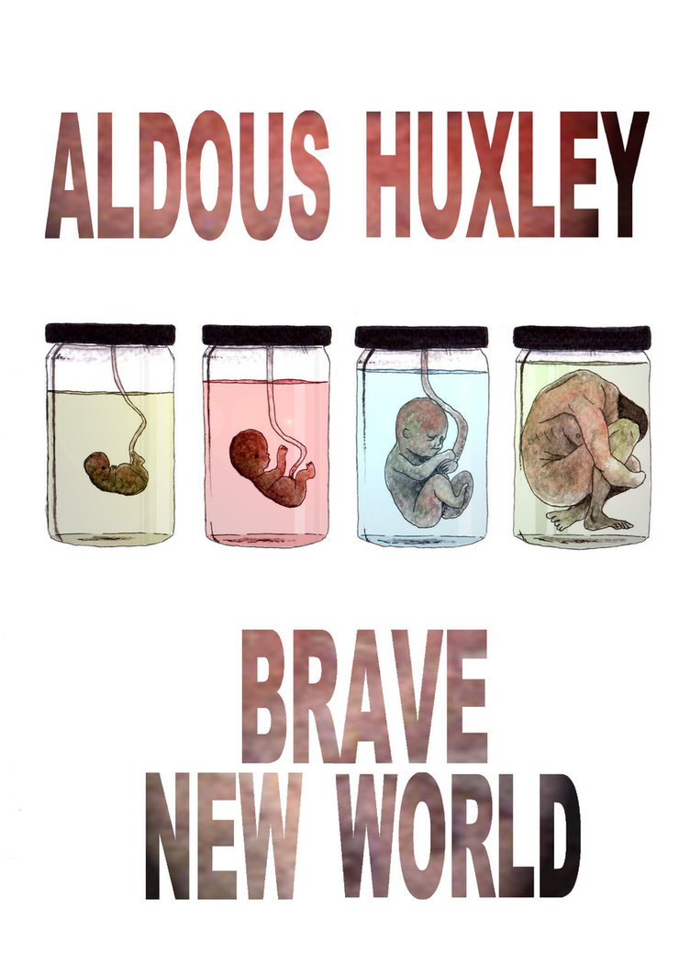

**Study Guide Questions**

You will turn in each page for a daily grade.   
  
These questions will also serve as your test review,   
so be sure to keep them as they are returned.

**Chapter 1**

1. What is the World State’s motto?

Name: ____________________________________

Class Period: _______________________________

1. Where does the story begin? In what year?
2. Explain what is happening at the Hatchery and Conditioning Center.
3. What is Bokanovsky’s Process? What is the result?
4. What are freemartins? What symbol are they given?
5. What are the five castes of the World State?

**Chapter 2**

1. What happens to the Delta babies after they were lured to the books and flowers?
2. Why were they conditioned to hate flowers?
3. Explain how hypnopaedia works.
4. What word or words are “Our Ford” and “his fordship” replacing in this society?

**Chapter 3**

1. What unusual behavior is encouraged in the childrens’ play?

1. What does Mond mean when he says “History is bunk”?

1. What are a few of the “smutty” or “vulgar” words in their language?

1. Why does Fanny chastise Lenina for going out with Henry again?
2. What is soma?
3. “Ending is better than mending.” “The more stitches, the less riches.” How do these sayings express the economic views of the State?

**Chapter 4**

Name: ____________________________________

Class Period: _______________________________

1. How is Bernard different from other Alphas? What is rumored to have caused his differences?
2. What is Helmholz Watson’s job?
3. Explain Helmholtz’s feeling toward the State.

**Chapter 5**

1. What is the crematorium and for what is it used? What is the point of this process?
2. What is unusual about the “Bottle of Mine” song?
3. Why is Lenina able to remember her birth control precautions despite the fact she took too much soma?
4. What is the Solidarity Service? What is the purpose of the Service?
5. What does Bernard do that makes him feel even more out of place at the Solidarity Service?

**Chapter 6**

1. What does Bernard want to do on his date with Lenina that she finds odd?
2. What did Bernard regret doing after his first date with Lenina?
3. What happened to the D.H.C and his Beta-Minus date when he visited the New Mexico Reservation 25 years ago?
4. To where does the D.H.C warn Bernard he will send him if he continues his current behavior?
5. Rather than the soap, hand lotion and shampoo that we are used to, what do Bernard and Lenina find waiting for them in their hotel room?
6. What did Bernard remember that he left running back at home?

**Chapter 7**

Name: ____________________________________

Class Period: _______________________________

1. How does Lenina react to the environment and people at the Reservation?
2. How does Lenina react to Linda? Why?
3. What about Linda is different from the other savages?
4. Who is John’s father?

**Chapter 8**

1. What substance satisfies Linda’s craving for soma?
2. Why do the other women hate and therefore, whip Linda?
3. What gift did Popé bring John when he was nearly twelve?
4. Describe what happened to John when we went with the Indian boys to the puberty ceremony.
5. What does Bernard say that he has in common with John?
6. What does Bernard propose to John? Why does he do this?
7. What is John’s reaction to this proposal?

**Chapter 9**

1. What does Lenina do immediately upon returning to the rest-house?
2. How does Bernard get permission to bring John and Linda back to the civilized world?
3. What does John do when he finds Lenina’s personal belongings and then finds Lenina sleeping?

**Chapter 10**

Name: ____________________________________

Class Period: _______________________________

1. Why does the D.H.C. dislike Bernard? What does the D.H.C. do to humiliate Bernard?
2. How does Bernard turn the tables to humiliate the D.H.C.?
3. What causes an uproar of laughter from the workers in the Fertilizing Room?
4. How does the D.H.C. react to this news?

**Chapter 11**

1. What happens to the D.H.C.?
2. Why do the people not want to see Linda? What is the plan for her?
3. How does Bernard become such an important and popular figure?
4. What word does Bernard omit in his letters to Mond? Why?
5. The libraries of the World State contain only reference books. Why is this so?
6. What is a feely? What does John think about it?.

**Chapter 12**

1. How do Bernard’s party guests react to John’s refusal to make an appearance?
2. What happens to Bernard as a result?
3. Why was Helmholtz in trouble with the authorities?
4. Why is Bernard jealous? What does he do out of vengeance?
5. Why does Helmholtz burst out in laughter? What is your reaction to Helmholtz’s laughter? Is it what you expected from him? Explain.

**Chapter 13**

Name: ____________________________________

Class Period: _______________________________

1. What does Henry suggest Lenina do for her bad mood?
2. What is Lenina thinking about when she makes a mistake at work? What is the result of her mistake years later?
3. What does John try to tell Lenina? What is her reaction?
4. How does John respond to Lenina’s reaction?
5. What “saves” Lenina from being trapped in the bathroom?

**Chapter 14**

1. To where has John been summoned by the phone call?
2. While John is by his mother’s bedside, who interrupts his visit? Why? What is John’s reaction?
3. Who does Linda think is actually there? What is John’s reaction to this?
4. What are the children given to reinforce their death conditioning?

**Chapter 15**

1. What does John see in the hospital vestibule? To what does he compare the khaki mob?
2. Why do you think John keeps repeating the phrase “O brave new world”? How is his tone different now from when he first arrived in the new world and quoted the phrase?
3. Who arrives at the hospital? What does Helmholtz do? What does Bernard do?
4. How do the police suppress the riot?

**Chapter 16**

Name: _______________________________________________ Class Period: _____________

1. How does Mond justify the banishment of Shakespeare and other beautiful things?
2. What does Mond say has taken the place of high art?
3. Why can’t everyone be Alpha-decanted and conditioned, according to Mond? What does he assert would be the result?
4. What was the Cyprus Experiment? What was the result? Why?
5. What does Mond say is a “menace to stability”?
6. What does Mond say is a “possible enemy”? Do you agree or disagree?
7. What is a “cookery book” according to Mond? What nearly happened to him as a result of his “cooking”?
8. What is Bernard’s reaction to the hint that they were to be sent to an island? What do you think about his reaction?
9. To where does Helmholtz prefer to be sent? Why?

**Chapter 17**

1. What two things does John say that the people have sacrificed for their happiness?
2. What does Mond call the old books about religion, including the Bible?

1. Explain what a VPS does. What does it attempt to replace?
2. What rights does John claim? What exactly does this mean for him?

**Chapter 18**

1. What does John say metaphorically made him ill? What literally made him ill?
2. To where does John go to be left alone?
3. What does John do to himself in order to purify and rid himself of his feelings of guilt and disgust?
4. What interrupts John’s independence?
5. Why does John kill himself? Besides the uproar and breach of his privacy, what factors do you think lead to this decision?

**Answer Key**

**Chapter 1**

1. Community, Identity, Stability

2. AF 632; Central London Hatchery and Conditioning Centre, London

3. One egg divided into 8-96 buds; making up to 96 identical twins

4. tropical heat and red light; they are like film

5. sterilized females with the tendency to grow beards; ?

6. make people like their “inescapable social destiny”

**Chapter 2**

1. They were given shocks, loud noises and flashing lights.

2. to dislike nature, so they would not want to leave their comfort area

3. Little Reuben experiment—a news program was playing while he was asleep, and he woke up repeating the words of the program; on the wrong track because they thought hypnopaedia would educate—in actuality they just repeat, but do not know intellectually what they are saying. The new world teaches moral education.

4. God; Lord; lordship

**Chapter 3**

1. sexual play; erotic games

2. History is absurd or nonsense; anything that was in the past is useless—the future is all that matters.

3. mother; father; family; baby; love; monogamy

4. She needs to be more promiscuous.

5. Beta

6. Bernard thinks Henry treats women as “meat” and gets jealous about Henry being with Lenina.

7. a “safe” hallucinogenic drug used for control

**Chapter 4**

1. Epsilon (semi-moron); he is so slow-witted that all he can say is “roof.” He gets confused and must be told what to do if something changes in his routine.

2. He is shorter, more of a loner, and a social outcast; attributed to too much alcohol in his blood-surrogate

3. They both act outside of the norm. Watson wants to write and be creative—he is very smart. Bernard is in love with Lenina, which is socially unacceptable; he also doesn’t know how to act in social situations, so he is almost ostracized.

4. He wants to write; he also wonders what else is out there in the world.

**Chapter 5**

1. to burn the bodies of the dead; the phosphorus is recovered and used for fertilizer

2. Rather than saying “love” or “honey” or “baby”, the song refers to a bottle, which is where the embryos are kept.

3. It has been drilled into her head so many times though hypnopaedia.

4. from the age of 12 to the age of 17

5. like a religious service; they praise Ford; they listen to synthetic music, sing hymns and take soma, and repeat over and over until the soma kicks in; in this particular case, people claimed to see Ford, and Bernard faked seeing him, just to fit in; as they become more intoxicated, a sexual frenzy ensues, “Orgy-Porgy.”

6. He fakes seeing Ford, then lies, saying he thought it was a good service; “had” Morgana Rothschild; this was supposed to be a good experience for Bernard, but it only reminds him again of his separateness and inability to conform.

**Chapter 6**

1. He wants to spend time together, alone, talking.

2. sleeping with her

3. They were caught in a storm; his date was missing and presumed dead, so the D.H.C. left.

4. Iceland

5. liquid air, television, vibro-vacuum massage, radio, boiling caffeine solution, hot contraceptives and 8 different kinds of scent

6. his Eau de Cologne tap

**Chapter 7**

1. She is shocked, appalled and sickened.

2. She is disgusted by her because she is old, fat and uncivilized.

3. She was decanted in the new world, not born naturally; she was a Beta

**Chapter 8**

1. Linda had been conditioned to be promiscuous; the women of the reservation do not behave that way; they wanted Linda to stay away from their husbands

2. mescal, which was alcohol

3. read

4. The Complete Works of Shakespeare

5. Popé; he hated him—possibly because John was jealous; or he was angry that Popé had his mother and brought mescal, which always made her sick

6. They are both uncomfortable and unwelcome in their worlds.

7. to bring him to civilization; he has realized who Linda and John are—he wants to show them to the D.H.C. and get out of being exiled to Iceland

8. He says, “O, brave new world” in anticipation and excitement.

**Chapter 9**

1. takes six half-gramme tablets of soma and goes to sleep

2. He says he wants to bring them to study them for an experiment.

3. He goes through her belongings, exploring like a child; he sees her and tries to touch her, then has pangs of guilt and stops.

**Chapter 10**

1. Because Bernard is an outcast and does not follow the “norm;” he finds the most populated room at the center to publicly humiliate and threaten to send him to Iceland.

2. Bernard brings in Linda and John.

3. John calls the D.H.C. “father”.

4. He runs out of the room, and is never seen again.

**Chapter 11**

1. He resigns and disappears, never to be seen again.

2. She is old, fat and ugly. To give her so much soma that she cannot function and goes on permanent “soma-holiday.”

3. He brings Linda and John to the civilized world.

4. “mother”; he does not want to offend Mond

5. He now has confidence and is popular; he says that he had six girls last week, and as they tour, he gets another date.

6. Very simple; basic. A black man and white Beta woman make love on a bearskin rug; the black man has a helicopter accident and becomes obsessed with the Beta blonde; he kidnaps her and keeps her in the helicopter for three weeks; three handsome Alphas rescue her; the black man is sent for re-conditioning, the blond becomes the mistress of all three Alphas. The feely starts with a scent organ; as they hold on to the knobs, they feel all the sensations of the movie—the bearskin rug, the kissing, the thump of the helicopter crash.

7. She wants to make love; he leaves; she takes soma—alone

**Chapter 12**

1. They are furious; they chastise and reject Bernard

2. He loses his popularity and returns to being an outcast.

3. He read a poem he wrote to his students; his students called the authorities.

4. He was jealous of John and Watson’s communication and friendship. He puts down Watson’s writing.

5. He didn’t understand Romeo and Juliet, and the idea of Juliet’s mother and father forcing Juliet to have someone she didn’t want. Also, the phrase “sweet mother” made him laugh. He thought it all smutty and absurd. *Individual responses will vary.*

**Chapter 13**

1. a VPS or a Pregnancy Substitute

2. John; an Alpha-minus administrator died of trypanosomiasis—the first case in over half a century

3. He tries to tell her that he loves her and wants to marry her; she doesn’t get it AT ALL; she proceeds to strip to make love

4. He gets very angry and slaps her.

5. John gets a phone call.

**Chapter 14**

1. the Park Lane Hospital for the Dying

2. a group of Delta Bokanovsky twins, who are receiving their death conditioning; he yells at them and the nurse, and slaps a child

3. Popé; he gets furious and shakes her.

4. chocolate éclairs

**Chapter 15**

1. a group of Delta Bokanovsky twins receiving their soma distribution; maggots

2. It once meant something wonderful to him; now this world is disgusting to him, and he cannot believe how everyone functions.

3. Helmholtz and Bernard; Helmholtz jumps into the fight and gets a bloody nose as a result; Bernard thinks about jumping in, then hesitates so long, the fight is broken up.

4. soma vapor and a voice from a synthetic box repeating peaceful sentiments

**Chapter 16**

1. No one would understand it; all beauty has been sacrificed for stability.

2. stability

3. Everyone would want to be in charge, no one would want to do the necessary menial jobs; total chaos would ensue.

4. an all Alpha Island in which this concept was tested; within 6 years they had a civil war, and 19 thousand out of the 22 thousand who started on the island were killed; the survivors begged for the Ten World Controllers to take control of the island.

5. change

6. science; *answers will vary*

7. all science; he was almost banished to an island

8. he sobs and begs not to be sent; he eventually had to be restrained; *answers will vary*

9. He wants to be sent somewhere where the climate is bad, to inspire his writing; he decides on the Falkland Islands.

**Chapter 17**

1. pornography

2. Violent Passion Surrogate floods the system with adrenalin and attempts to replace human emotions such as fear and rage, without all the “inconveniences.” They are given the surrogate so they do not think it is normal to feel these emotions on their own.

3. the right to experience human emotion, both good and bad; this means he will experience unhappiness, grief, pain, fear, etc. but also goodness, happiness, desire, and love

**Chapter 18**

1. civilization; mustard water

2. to purge himself of evil; a cleansing

3. a lighthouse

4. drinks mustard water and whips himself

5. spectators, camera crews

6. Had had no other choice in his mind: he would have been a freak to the rest of the world, and never able to have privacy, but didn’t even consider returning to the reservation. *Answers will vary.*