**Transformation, *from The TED Radio Hour on NPR***

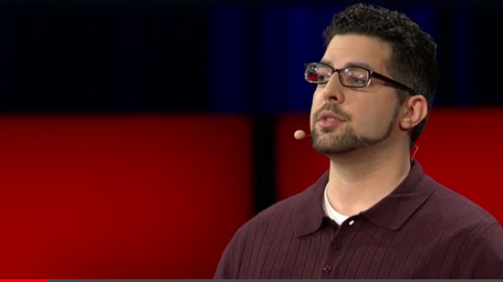

**Zak Ebrahim: How Did The Son Of A Terrorist Choose Peace?**

It's the TED Radio Hour from NPR. I'm Guy Raz. And our show today: transformation - stories and ideas about becoming a completely different person. Imagine rejecting everything you know, everything you were taught to believe, and starting over. When you think about all your life and the arc of your life, do you think of it as a transformation? That you gave yourself a second chance to have a completely different life?

ZAK EBRAHIM: That's a very difficult question.

RAZ: This is Zak Ebrahim.

EBRAHIM: I certainly - I guess I would use the term transformation. In some way, I'm very different in my beliefs than I was when I was, I mean, even 10 years ago.

RAZ: And really, you could say his transformation began more than 20 years ago. One November night in 1990, Zak Ebrahim told that story on the TED[1] stage.

EBRAHIM: On November 5th 1990, a man named El-Sayyid Nosair walked into a hotel in Manhattan and assassinated Rabbi Meir Kahane, the leader of the Jewish Defense League. Nosair was initially found not guilty of the murder but, while serving time on lesser charges, he and other men began planning attacks on a dozen New York City landmarks, including tunnels, synagogues and United Nations headquarters. Thankfully those plans were foiled by an FBI informant. Sadly, the 1993 bombing of the World Trade Center was not. Nosair would eventually be convicted for his involvement in the plot. El-Sayyid Nosair is my father.

RAZ: Zak Ebrahim was just seven years old at the time. He was too young to know that his dad was a member of a jihadist cell[2]. And eventually he'd get life in prison. And I know you were really young but do you remember asking, where's dad?

EBRAHIM: I did. I was told that he had been injured and that he was in the hospital recuperating. And the next thing I know, we are riding in our station wagon to Rikers Island to visit him for the first time, you know. My mother told me get in the car we're going to go see your father so I did, you know. The prison guards told me to open my mouth to check inside to see if I was hiding any, you know, razors or something. I just, you know, just kind of went with it.

RAZ: And Zak basically accepted what a lot of his dad's friends told him. That his father was a hero.

EBRAHIM: I had one man who, every time he saw me, he would give me a hundred dollar bill, apparently for what my father had done. I actually bought my first Game Boy with a hundred dollar bill that this guy had given me.

RAZ: Today, 25 years later, Zak Ebrahim is a peace activist. But to get there would require a kind of rebirth.

EBRAHIM: It was a very slow process, took a long time. But I had to kind of reevaluate the way I saw my father and his belief system. And so I had to basically realize that my father was an extremist, and that he was willing to take innocent people's lives for his cause.

RAZ: To realize that, to experience that kind of transformation, meant he had to make a choice. The choice to change.

EBRAHIM: I was born in Pittsburgh, Pennsylvania, in 1983 to him, an Egyptian engineer, and a loving American mother - and great schoolteacher - who, together, tried their best to create a happy childhood for me. It wasn't until I was seven years old that our family dynamic started to change.

My father exposed me to a side of Islam that few people, including the majority of Muslims, get to see.

A few months prior to his arrest, he sat me down and explained that for the past few weekends he and some friends have been going to a shooting range on Long Island for target practice. He told me I'd be going with him the next morning. We arrived at Calverton Shooting Range which, unbeknownst to our group, was being watched by the FBI. When it was my turn to shoot, my father helped me hold the rifle to my shoulder and explained how to aim at the target about 30 yards off. That day, the last bullet I shot hit a small orange light that sat on top of the target, and to everyone's surprise, especially mine, the entire target burst into flames.

My uncle turned to the other men and, in Arabic, said (speaking Arabic) like father like son. They thought they saw in me the same destruction my father was capable of. Those men would eventually be convicted of placing a van filled with 1,500 pounds of explosives into the sublevel parking lot of the World Trade Center's North Tower; causing an explosion that killed six people and injured over a thousand others. These were the men I looked up to. These were the men I called (speaking Arabic) which means “uncle.”

By the time I turned 19, I had already moved 20 times in my life. And that instability during my childhood didn't really provide an opportunity to make very many friends. Being the perpetual new face in class, I was frequently the target of bullies. So for the most part, I spent my time at home reading books and watching TV or playing video games. And growing up in a bigoted household, I wasn't prepared for the real world. I had been raised to judge people based on arbitrary measurements, like a person's race or religion.

He would just talk about Jews being evil. And I would hear similar things from, you know, from the men that were with him. You know, gay people being evil and them wanting to turn you gay so that you would go to hell too. And just them being all-around terrible people and a bad influence. And he used to say things like, “A bad Muslim is better than a good non-Muslim.”

RAZ: Do you ever remember, you know, sort of feeling that way too?

EBRAHIM: Yeah, I mean, that's pretty much what indoctrination is, you know. *You have authority figures around you telling you that the world is one way and you don't get to see another perspective.* You know, the people that I felt safe with taught me these things and so, you know, you just kind of accepted them as fact.

EBRAHIM: One of my first experiences that challenged this way of thinking, was during the 2000 presidential elections. Through a college prep program I was able to take part in the National Youth Convention in Philadelphia. My particular group's focus was on youth violence and, having been the victim of bullying for most of my life, this was a subject in which I felt particularly passionate. The members of our group came from many different walks of life. One day toward the end of the convention, I found out that one of the kids I had befriended was Jewish. Now it had taken several days for this detail to come to light and I realized that there was no natural animosity between the two of us. I had never had a Jewish friend before. And frankly, I felt a sense of pride in having been able to overcome a barrier that, for most of my life, I had been led to believe was insurmountable.

Another major turning point came when I found a summer job at Busch Gardens, an amusement park. As chance would have it, I had the opportunity to work with some of the gay performers at a show there, and soon found that many were the kindest, least judgmental people I had ever met. I don't know what it's like to be gay, but I'm well acquainted with being judged for something that's beyond my control. One day I had a conversation with my mother about how my worldview was starting to change. And she said something to me that I will hold dear to my heart for as long as I live. She looked at me with the weary eyes of someone who'd experienced enough dogmatism to last a lifetime, and said, “I'm tired of hating people.” In that instant, I realized how much negative energy it takes to hold that hatred inside of you.

RAZ: That must have been so powerful.

EBRAHIM: Yeah, you know, that was one of the most transformative times of my life. I kind of just wanted to let her know where my mind was starting to go. And when she told me, it felt like she gave me permission to go out into the world and just experience people for who they were instead of trying to fit them into some kind of, you know, category or box of some kind. Just to be free in a way.

RAZ: You describe what you've done as a choice. That you just - you made a choice. You decided that you were not going to be this person you were kind of raised to be.

EBRAHIM: *Well, I don't know that we're meant to be anything other than the sum of our experiences.* And I knew that from my experience that I had - you know, from being bullied - that I didn't want to be the bully. And at the same time I didn't want to be bullied. Because I knew what that felt like, the loneliness and the feelings of inadequacy and self-loathing. I knew that I didn't want to treat people like that. And if I could, I wanted to prevent others from treating people like that so that they didn't have to go through the same thing.

EBRAHIM: Zak Ebrahim is not my real name. I changed it when my family decided to end our connection with my father and start a new life. So why would I out myself and potentially put myself in danger? Well, that's simple. *I do it in the hopes that perhaps someone, someday, who is compelled to use violence may hear my story and realize that there is a better way.* That although I had been subjected to this violent, intolerant ideology, that I did not become fanaticized. Instead I choose to use my experience to fight back against terrorism, against bigotry. I do it for the victims of terrorism and their loved ones. For the terrible pain and loss that terrorism has forced upon their lives. For the victims of terrorism I will speak out against these senseless acts and condemn my father's actions. And with that simple fact, I stand here as proof that violence isn't inherent in one's religion or race. And the son does not have to follow the ways of his father. I am not my father. Thank you.

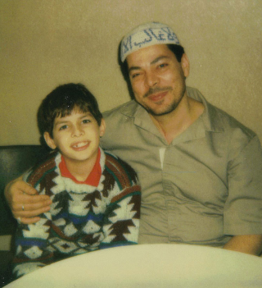

**Shaka Senghor: How Can Someone Move Beyond Murder?**

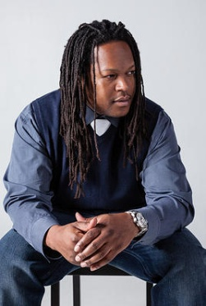

When we're talk about your life, right, in this life that you once had, does it feel, like, in some way that you and I are talking about a different person?

SHAKA SENGHOR: Yeah. Yeah because often times it feels like I'm flashing back and just, like, wondering what my face looked like back then, wondering, did I ever smile? Because I don't feel like I smiled back then. Just looking back, it's like wow. I can't even believe it sometimes. And I mean, I've had moments where I cried for that young man that I was.

RAZ: This is Shaka Senghor. He's a writer and a mentor to young people in Detroit, where he grew up. And here's how he began his story at TED.

SENGHOR: Twenty-three years ago, at the age of 19, I shot and killed a man. I was a young drug dealer with a quick temper and a semi-automatic pistol. But that wasn't the end of my story. In fact, it was the beginning. There's a story of acknowledgment, apology and atonement. But it didn't happen in the way that you might imagine or think.

You see, like many of you, growing up I was an honor roll student with dreams of becoming a doctor. But things went dramatically wrong when my parents separated and eventually divorced.

RAZ: Shaka explains that when his parents split up, his grades started to fall. His mom was abusive, both mentally and physically. And so a few years later, he started to sell drugs.

SENGHOR: At the age of 17, I got shot three times standing on the corner of my block in Detroit. My friend rushed me to the hospital, doctors pulled the bullets out, patched me up and sent me back to the same neighborhood I got shot. Throughout this ordeal, no one hugged me. No one told me I would be OK. No one told me that I would live in fear, that I would become paranoid. No one told me that one day, I would become the person behind the trigger. Fourteen months later, I fired the shots that caused a man's death. When I entered prison, I was angry, I was hurt. I didn't want to take responsibility. And I reacted with hostility to my confinement. I ran black-market stores. I loan-sharked[3] and I sold drugs that was illegally smuggled into the prison. I had, in fact, become what the warden of the Michigan Reformatory called the worst of the worst. And because of my activity, I landed in solitary confinement[4] for seven and a half years out of my incarceration.

RAZ: I mean, that is so hard to imagine, living like that. But, I mean, how did you start to go from that place to where you eventually got to, to where you are now?

SENGHOR: You know, it kind of grew in stages. I think the first time was - I had read Malcolm X's autobiography. Just his ability to redeem himself and turn himself around kind of pricked my consciousness in a way to make me think, like, this is possible. And so literature kept me strong, you know, whenever I felt myself growing vulnerable to feeling like I was going to go insane, or feeling like I couldn't cope one more day in this little 6-by-9 cell. I would just turn to literature. I would turn to books and I began - at some point I began to set my cell up like a classroom. And I would study a different subject each hour as if I were going to school. And kind of like the tipping point came after I received a letter from my oldest son.

SENGHOR: And anytime I would get this letter from my son it was like a ray of light in the darkest place you can imagine. And on this particular day I opened this letter, and in capital letters he wrote, “MY MAMA TOLD ME WHY YOU WAS IN PRISON - MURDER.” He said, “Dad, don't kill. Jesus watches what you do. Pray to him.”

Now I wasn't religious at that time nor am I religious now. But it was something so profound about my son's words. It was the first time in my life that I had actually thought about the fact that my son would see me as a murderer. I sat back on my bunk and I reflected on something I had read in Plato's "Republic," where Socrates stated an apology[5] that the *unexamined life isn't worth living.* At that point is when the transformation began.

When he wrote that letter, you know, it made me realize that, you know, whatever happened - whether I ever got out of prison or not - that I had a responsibility as a father to give my son an example of what a man should be and what he could be. *That's when I began to do the* *hard work, which was uncovering how did I land in prison in the first place*? I just saw it in the most basic, simple way that I would do whatever was necessary to reclaim the parts of me that I knew were good.

SENGHOR: When I got the letter from my son, I began to write a journal about things I had experienced in my childhood and in prison. And what it did was it opened up my mind to the idea of atonement[6]. Earlier in my incarceration, I had received the letter from one of the relatives of my victim. And in that letter she told me she forgave me because she realized I was a young child who had been abused and had been through some hardships and just made a series of poor decisions. It was the first time in my life that I ever felt open to forgiving myself.

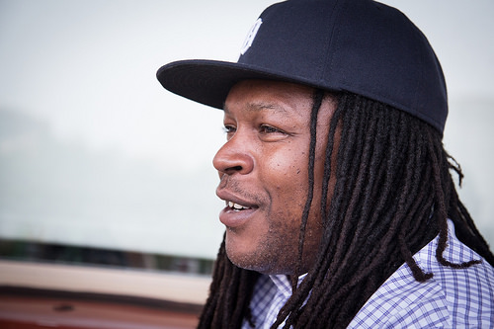

RAZ: Do you ever think about just the capacity that humans have to regenerate - like for self-regeneration and for, like, almost rebirth?

SENGHOR: Yeah.

RAZ: Do you think it's, like, an inherent human capability, or do you think that just *some* people have that ability?

SENGHOR: Yes, I do. I think that human beings are so resilient. And I think that we have failed to acknowledge that. We tend to make transformation a “freak show” so to speak, as something that's abnormal or, you know, not...

RAZ: Or like superhuman.

SENGHOR: Superhuman, right.

RAZ: Yeah.

SENGHOR: And I never thought of it like that. When it comes to my own personal journey, when you are in prison, it's all about authenticity in that environment. You know, if guys think you are trying to play the good guy to get a parole or to get favor from the officers or something like that, they'll prey on that, you know. But when they know that it's genuine and it's not based on fear, but it's based on you wanting to be who you were destined to be, they respect and they celebrate that. And what I've realized is that the majority of men I encountered had the desire for something different, something better. The thing that was lacking was the courage to step out on their own, or for somebody to give them permission to step out on their own. And I think what happened with me is that I learned how to give myself permission.

RAZ: You mention that line from Socrates about the unexamined life not being worth living. It sounds weird, but, like, had you not gone through the pain that you went through in your life, you may not have had an examined life.

SENGHOR: It's true. You know, had I not gone through this experience, and I see it - you know, I see it in most people's lives - you know, the typical trajectory[7] is you get up, you go to work, you pay the bills, you come home, take care of your family, repeat. But I found that life is so much deeper than that. We have to give ourselves permissions to expand and grow and evolve as human beings. That's our nature. And it wasn't easy. It wasn't - like I said - it didn't come without its challenges. Even when I was released from prison, there are constant challenges, constant battles. I didn't come home to a rosy neighborhood, you know, I came back home to Detroit. You know, the city I grew up in, the friends I grew up around who - some are still in the street culture and living, you know, half-butchered lives.

SENGHOR: Through my experience being locked up, one of the things I discovered is this - *the majority of men and women who are incarcerated are redeemable*. *Anybody can have a transformation if we create the space for that to happen.* So what I'm asking today is that you envision a world where men and women aren't *held hostage to their past*, where misdeeds and mistakes doesn't define you for the rest your life. I think collectively we can create that reality. And I hope you do too. Thank you.

RAZ: Shaka Senghor, his talk is at ted.com. After getting out of prison four years ago, he's become a mentor to young people in Detroit. He's also engaged to be married. And the son who wrote him that letter in prison? He's now 22 years old.

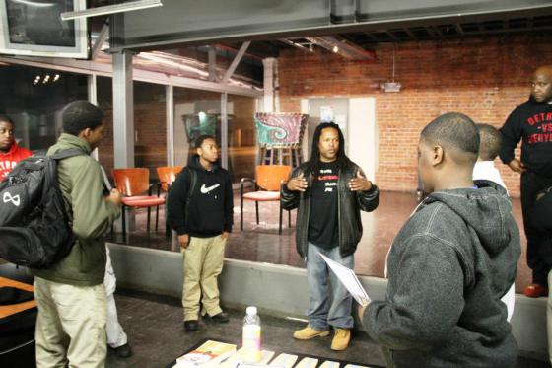

1. TED: Technology, Entertainment, and Design. Conferences featuring short, powerful talks.
2. Jihadist cell: a group of Muslim extremists dedicated to fighting a “holy war” against non-Muslims.
3. Loan-sharked: a moneylender who charges extremely high rates of interest, typically under illegal conditions.
4. Solitary confinement: the isolation of a prisoner in a separate cell as a punishment.
5. Apology: in this case it’s more of a statement
6. Atonement: making amends; making things right
7. Trajectory: flight path. In this case, the “way things usually seem to go.”