Name __________ ____________ Worksheet – Business Organizations
Period ____ Date _____________

57 1. Sole proprietorship-business owned and operated by _____ ____________________.
58. 2. (opinion) Of the six strengths of sole proprietorships, which one would be the most
important to you? ____________________________________________________________
58 3. Unlimited liability - _________________________________________________________
59 4. Limited life - _______________________________________________________________
60 5. General partnership - _______________________________________________________
60 6. Limited partnership - _______________________________________________________
62 7. Limited liability - ___________________________________________________________
62 8. Bankruptcy - _______________________________________________________________
63 9. Dividend - _________________________________________________________________
63 10. ____________ stockholders can vote but ___________ stockholders receive dividends
first and get first claim on assets when bankruptcy occurs.
64 11. Bond - ___________________________________________________________________
65 12. Double taxation - __________________________________________________________

Advantages/Disadvantages of Business Organizations [pages 58-65]

A – Advantage of a sole proprietorship or partnership
B – Disadvantage of sole proprietorship or partnership
C – Advantage of a corporation
D – Disadvantage of a corporation
___ 58 13. There is no need to file papers and few fees are necessary.
___ 64 14. Personal liability is limited to the amount of money invested in the business.
___ 64 15. The business can raise capital by selling shares of stock.
___ 62 16. Owners are personally liable for all debts & judgments against the business.
___ 58 17. Owners get to keep all the profits.
___ 64 18. These businesses have the better longevity(unlimited life).
___ 64 19. Because of the separation of ownership & management, specialist are assigned.
___ 59 20. The owner dies, the business stops.
___ 58 21. Unlimited liability means after bankruptcy, the owners can lose their house, car,
furniture and savings.
___ 62 22. Each partner is fully responsible for the acts of all partners.
___ 65 23. These businesses undergo double taxation-on its profits and on its dividends.

Matching(24-29)
___ 71 24. Merger of at least four unrelated business A. Horizontal Merger
___ 71 25. Merging of competitors B. Vertical Merger
___ 71 26. Merging with your suppliers C. Conglomerate Merger
___ 71 27. KFC buys Church’s Chicken
___ 71 28. Funeral home buys a cemetery and floral shop
___ 71 29. First National Bank buys Third National Bank

72 30. Multinationals - ___________________________________________________________
75 31. Nonprofit organization - ____________________________________________________
76 32. Cooperatives - ____________________________________________________________
76 33. What are the three types of cooperatives?
A. ____________________ B. ____________________ C. __________________________
77 34. Collective bargaining - _____________________________________________________

Business Organizations Crossword Puzzle

Down Across
71 1. A _______ is a merger between four or more 64 1. One advantage of a __________
companies producing or selling different products. is limited liability.
3. A company that retains its corporate identity 71 2. A _______ _______ is a merger of
after acquisition by another company. companies producing the same product.
60 4. A _______ is owned by two or more people. 57 3. A _______ _______ has only one owner.
71 6. A _______ combination is a merger of 68 5. A _______ occurs when one company
companies producing different phases of a product. absorbs another company.
76 8. A _______ is owned by the people who use it.. 63 7. A purchase of _______ represents
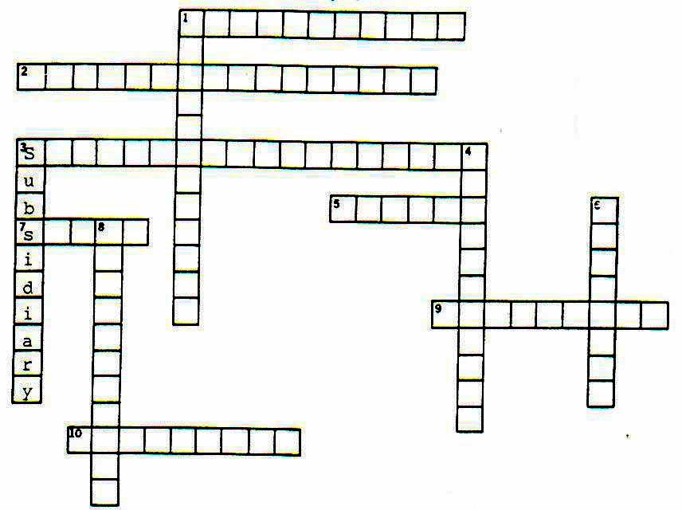
ownership in a corporation.
170 9. A _______ is a contract that allows
the use of a company’s name.
416 10. A _______ is a debt.

Match the characteristics of the 3 major types of business ownership under the appropriate heading. Three answers can be used twice.

Has limited life (2) Is complex to set up Has fewer skills to run business
Can sell stocks Can sell bonds Has unlimited liability (2)
Must share profits (2) Has unlimited life Keeps all the profits
Has elected directors Has limited liability Is viewed as a legal entity
Has profits taxed twice Has total control

Sole Proprietorship Partnership Corporation

1.___________________ 1.___________________ 1._____________________
2.___________________ 2.___________________ 2._____________________
3.___________________ 3.___________________ 3._____________________
4.___________________ 4._____________________
5.___________________ 5._____________________
6._____________________
7._____________________
8._____________________
9._____________________

