Name___________________________________Date_________________Block________________________Oil Prices: What’s Behind the Drop?

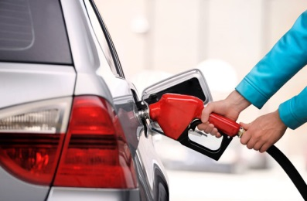**Part One: Gas Prices in Denton**

Using your phone, go to the website GasBuddy.com. Use it to answer the following questions. Make sure to explain your reasoning – that’s more important than getting the “correct” answer.

1. Click the icon that says “Tap to find gas near me.” (If your phone asks to use your location, say yes.) Find the price of gas at the three gas stations closest to Guyer.

|  |  |  |
| --- | --- | --- |
| Price | Name of Station | Location |
|  |  |  |
|  |  |  |
|  |  |  |

1. Using the “Search by city / state / zip” box, find the three cheapest places to buy gas in Denton.

|  |  |  |
| --- | --- | --- |
| Price | Name of Station | Location |
|  |  |  |
|  |  |  |
|  |  |  |

3. Are the gas prices by Guyer the cheapest places to buy gas in Denton? If not, why would the gas stations by Guyer sell at a higher price?

_______________________________________________________________________________________________________________________________________________________________________________________________________________________________________

4. How close are the prices of gas at all the stations by Guyer? Why do you think that is?

_______________________________________________________________________________________________________________________________________________________________________________________________________________________________________

5. When you shop at Kroger, you can earn fuel points that you can redeem to get a discount on gas. Why would Kroger do this?

_______________________________________________________________________________________________________________________________________________________________________________________________________________________________________

6. Why do gas stations always open up across the street from one another?

_______________________________________________________________________________________________________________________________________________________________________________________________________________________________________

**Part Two: Gas Prices Around The Globe**

Read the New York Times article, “Oil Prices: What’s Behind The Drop? Simple Economics.”

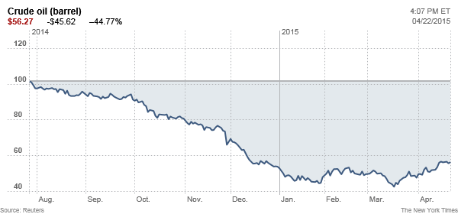

1. What has happened to the price of oil since June 2014? When was the last time oil was this price? _________________________________________________________________________________
2. Has the supply of oil increased or decreased? ____________________________________________  
   What happened to cause this? ________________________________________________________  
   _________________________________________________________________________________
3. Has the demand for oil increased or decreased? __________________________________________  
   What happened to cause this? ________________________________________________________  
   _________________________________________________________________________________
4. What are two ways the drop in oil prices has saved consumers money? __________________________________________________________________________________  
   __________________________________________________________________________________
5. What are two groups that are harmed by the drop in oil prices?

__________________________________________________________________________________  
__________________________________________________________________________________

1. OPEC (the Organization of Petroleum Exporting Countries) is a group of 12 countries who are major producers of oil. They partner together to agree on how much oil they’ll produce, which affects oil prices worldwide. Why is OPEC a factor in dropping oil prices?   
   _____________________________________________________________________________________  
   _____________________________________________________________________________________
2. Draw a supply and demand graph for oil to show how prices have dropped. (hint: use question 2 and 3)