### Understanding the Federal Budget [1]

"For in the end, a budget is more than simply numbers on a page. It is a measure of how well we are living up to our obligations to ourselves and one another."

--From *Remarks by the President on the Fiscal Year 2010 Budget*,

President Barack Obama, February 26, 2009

1. **Introduction**

One of the most important documents produced each year by the President and Congress is the federal budget. Through a lengthy process, government leaders determine how much money they expect the government to receive during each of the next several years, where it will come from, and how much to spend to reach their goals in areas such as national defense, foreign affairs, social insurance for the elderly, health insurance for the elderly and poor, law enforcement, education, transportation, science and technology.

You will be participating in a simulation in which you will be making decisions similar to those made every year by the government to determine next year’s federal budget.

The President and Congress decide how much spending they will finance through taxes, and debate how to use the budget to help the economy grow or to redistribute income. More recently, they have been debating how large a deficit the government needs to run in order to stimulate our distressed economy. In this overview, we will discuss these decisions in some detail--that is, how the government raises revenues and where it spends money.

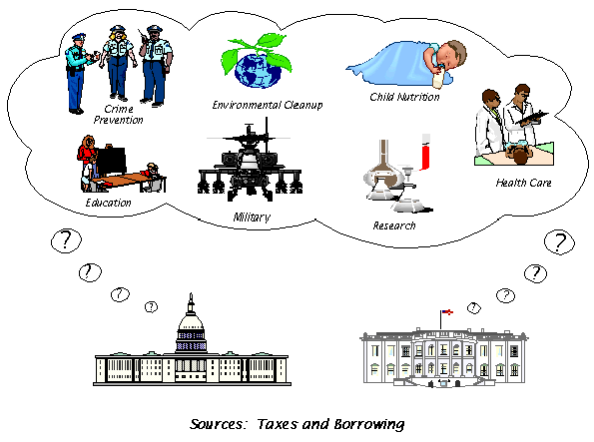

**2. What *Is* the Budget?**

The federal budget is:

* a plan for how the government spends taxpayers’ money.

*What activities are funded? How much should we spend for defense, national parks, the FBI, Medicare, and meat and fish inspection?*

* a plan for how the government pays for its activities.

*How much revenue does it raise through different kinds of taxes--income taxes, excise taxes (taxes applied to various products, including alcohol, tobacco, transportation fuels and telephone services), and social insurance payroll taxes?*

* a plan for government borrowing or the repayment of borrowed funds.

If revenues are greater than spending, the government runs a surplus. If expenses are greater than revenues (as is currently the case), the government runs a deficit.

* something that affects the nation's economy.

Some types of spending--such as improvements in education and support for science and technology—increase productivity and raise incomes in the future.

*Taxes, on the other hand, reduce incomes, leaving people with less money to spend.*

* something that is affected by the nation's economy.

When the economy is doing poorly, people are earning less and unemployment is high. In this atmosphere, revenues decrease and the deficit grows.

* an historical record.

The budget reports on how the government has spent money in the past, and how that spending was financed.

The 2011 budget document embodies the President's budget proposal to Congress for fiscal year 2011, which begins on October 1, 2010. It reflects the President's priorities and proposes his initiative to meet our national and international needs.

The federal budget, of course, is not the only budget that affects the economy or the American people. The budgets of state and local governments have an impact as well. State and local governments are independent of the federal government, and they have their own sources of revenue (taxes and borrowing).

**Where the Money Comes From**

The money that the federal government uses to pay its bills--its revenues or receipts--comes mostly from taxes. For the FY (fiscal year) 2010, the federal government had forecasted that it would receive $2.3 trillion in tax revenues.

These are the government’s sources of revenue:

**Table 1. FY 2010 Estimated Federal Taxes**

|  |  |  |
| --- | --- | --- |
| **Source** | **Amount (Billions)** | **Percentage** |
| Individual Income Taxes | 1,051 | 45.0% |
| Payroll Taxes (Social Security, Medicare, Unemployment insurance, and other retirement) | 940 | 40.3% |
| Corporate Taxes | 179 | 7.7% |
| Miscellaneous* | 143 | 6.1% |
| Estate and Gift Taxes | 20 | .9% |
| Total Collected | 2,333 | 100% |

From: http://www.whitehouse.gov/omb/budget/fy2010/assets/summary.pdf, Table S-4

* The government collects customs duties, excise taxes (taxes applied to various products, including alcohol, tobacco, transportation fuels and telephone services), and other miscellaneous revenues--e.g., Federal Reserve earnings, fines, penalties, and forfeitures.

# Spending

To better understand federal spending, let’s look briefly at the FY 2010 federal budget in which the government projected it would spend approximately $3.6 trillion. Federal spending is divided into *mandatory spending* which is required by law, and *discretionary spending* which is decided upon yearly by the President and Congress.

* The largest federal mandatory spending program is Social Security, which provides monthly benefits to over 45 million retired and disabled workers, their dependents, and survivors. The government projected it will spend approximately $696 billion on this program, which they calculated would account for approximately 20% of all federal spending.
* Medicare provides health care coverage for over 40 million elderly Americans and people with disabilities. The government projected it will spend $452 billion on this program, approximately 13% of all federal spending.
* Medicaid provides health care services to millions of Americans, including the poor, people with disabilities, and senior citizens in nursing homes. These programs account for $290 billion of the budget, approximately 8% of all federal spending.
* Other entitlements provide benefits to people and families with low incomes such as Food Stamps and veterans' pensions. The remaining mandatory spending mainly consists of federal retirement and insurance programs, unemployment insurance, and payments to farmers. All these remaining mandatory spending items account for $604 billion, approximately 17% of all federal spending.
* Discretionary defense spending for FY 2010 was budgeted at approximately $707 billion, comprising approximately 20% of all spending.
* Discretionary spending on programs not related to defense includes a wide array of initiatives such as education, training, science, technology, housing, transportation, and foreign aid, and represents approximately 19% of the budget.
* Interest payments are payments made to pay back the interest on the national debt. This accounts for $136 billion or approximately 4% of the federal budget. As the government increases the size of its debt, the amount of interest that must be paid increases.

**3. How Does the Government Create a Budget?**

The President and Congress both play major roles in developing the federal budget.

#### The President's Budget

The law requires that by the first Monday in February, the President submit to Congress his proposed federal budget for the next fiscal year, which begins October 1. For the fiscal year 2011 budget, President Obama submitted his budget to Congress on February 1, 2010. Occasionally, however, Presidents have sent it later for various reasons. For example, in a year with a transition between outgoing and incoming Administrations, the timing may change. In late February 2009, President Obama provided a broad outline of his budget request for FY 2010 to Congress. A more detailed budget was submitted in May 2009.

**The Budget Process**

Through the budget process, the President and Congress decide how much to spend and tax in any one fiscal year. The President's budget is his plan for the next year. But it's just a proposal. After receiving it, Congress has its own budget process to follow. Congress reviews the president’s budget and develops a budget of its own. Over the course of several months—usually from about March to September—Congress debates the budget and creates several bills.

Congress first passes a "budget resolution"--a bill where it makes its decisions about how much money the government will spend and how much money it will make. It includes targets for total spending, total revenues, the surplus or deficit, and says how much money the government should spend, in two types:

* *Discretionary spending* is what the President and Congress must decide to spend for the next year through annual appropriations bills. It includes money for such activities as the FBI, the Coast Guard, housing, education, space exploration, highway construction, defense, and foreign aid. Discretionary spending for FY 2010 was estimated to account for 39% of all federal spending.
* *Mandatory spending*, which accounts for approximately 61% of all spending in FY 2010, is authorized by permanent laws, not by the annual appropriations bills. It includes entitlements--such as Social Security, Medicare, and Food Stamps--through which individuals receive benefits because of their age, income, or other criteria. It also includes interest on the national debt. The only way the President and Congress can change how much is spent in these accounts is to change the laws which dictate the amount of spending on these mandatory programs.

In the simulation in which you will be participating, you will only be examining the discretionary programs that are part of the federal budget. It is these programs that the President and Congress must act upon each year.

After Congress passes its budget, it works on passing appropriations bills, which authorize specific departments in the government to spend money. *Only after Congress passes and the President signs his approval for these budget bills has the Government made its official yearly budget into the law.*

**4. Supplemental Spending**

Sometimes the President requests that Congress go outside the regular budgeting process to provide “emergency” funding for particular situations. From 1975-2002, supplemental spending averaged $14 billion a year. In the past seven years, however, supplemental spending has skyrocketed.

Under President Bush, military operations in Iraq and Afghanistan were mostly funded by supplemental spending that was not included in his proposed budgets. In 2008, Congress passed the Troubled Asset Relief Program (TARP), which allowed the U.S. government to use up to $700 billion to help failing banks.

Later, in 2009, Congress passed $787 billion in additional government spending and tax cuts to jump-start the economy and save jobs. The stimulus program provided aid to state governments, tax cuts for workers and businesses, expansion of health and unemployment benefits, and significant investments in areas such as infrastructure, renewable energy, and education.

**5. Surpluses and Deficits**

When the government spends more money than it makes in revenues, we call the difference between spending and revenues a deficit. When the government brings in more revenues than it spends, we call the leftover money a surplus. The government has to borrow money to make up the difference, which adds to the national debt. The current national debt, as of 2015, is over $18 trillion.

When President Bill Clinton was first elected in 1992, the federal budget was in a deficit. During the 1990’s, as a result a strong economy, the government brought in much higher revenues than expected and began, by the end of the decade, to run a budget surplus. In 2002, as a result of September 11, increased military spending and anti-terrorism spending, tax cuts, and the downturn in the economy, the federal budget went back into deficit. In October 2009, the Congressional Budget Office (CBO) estimated a deficit for FY 2009 of $1.4 trillion.

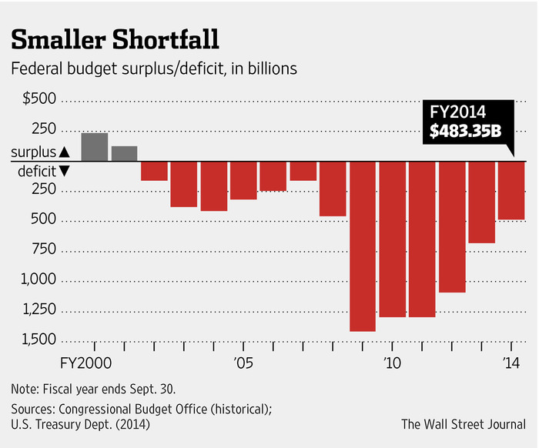

#### Glossary

#### Appropriation

An appropriation is an act of Congress that enables federal agencies to spend money for specific purposes.

#### Balanced Budget

A balanced budget occurs when total revenues equal total outlays for a fiscal year.

#### Budget Resolution

The budget resolution is the annual framework within which Congress makes its decisions about spending and taxes. This framework includes targets for total spending, total revenues, and the deficit, as well as allocations, within the spending target, for discretionary and mandatory spending.

#### Deficit

The deficit is the difference produced when spending exceeds revenues in a fiscal year.

***Deficit Spending***

Deficit spending occurs when the government’s revenues do not cover the cost of all its spending and it borrows money to finance its programs, using that borrowed money to pay for items in the budget.

#### Discretionary Spending

Discretionary spending is what the President and Congress must decide to spend for the next fiscal year through annual appropriations bills. Examples include money for such programs as the FBI, the Coast Guard, housing, education, space exploration, highway construction, defense, and foreign aid.

#### Entitlement

An entitlement is a program that legally obligates the federal government to make payments to any person who meets the legal criteria for eligibility. Examples include Social Security, Medicare, and Medicaid.

#### Excise Taxes

Excise taxes apply to various products, including alcohol, tobacco, transportation fuels, and telephone service.

#### Fiscal Year

The fiscal year is the government’s accounting period. It begins October 1 and ends on September 30. For example, fiscal year 2010 ends September 30, 2010.

***Gross Domestic Product (GDP)***

GDP is the standard measurement of the size of the economy. It is the total production of goods and services within the United States.

**Mandatory Spending (Non-discretionary Spending)**

Mandatory spending (also called non-discretionary spending) is authorized by permanent law. An example is Social Security. The President and Congress can change the law to change the level of spending on mandatory programs—but they don’t have to do so.

**National Debt**

When revenues do not cover the costs of government spending, the government borrows money to finance this deficit. The total it has borrowed over the years, but not repaid, is the national debt.

**OMB**

Part of the Executive Office, the Office of Management and Budget assists the President in the development and implementation of the federal budget.

#### Revenue

Revenues include the collections that result from government activity, such as taxes. They do not include collections that result from the government’s business-like activities, such as the entrance fees at national parks. Business-like collections are subtracted from total spending to calculate outlays for the year.

#### Social Insurance Payroll Taxes

This tax category includes Social Security taxes, Medicare taxes, unemployment insurance taxes, and federal employee retirement payments.

#### Surplus

A surplus is the amount by which revenues exceed outlays.

1. Adapted from the Office of Management and Budget online publications*, A Citizen’s Guide to the Federal Budget, FY 2001*and *FY 2002* (http://www.gpoaccess.gov/usbudget/fy01/pdf/guide.pdf and http://www.gpoaccess.gov/usbudget/fy02/pdf/guide.pdf). Note that most numbers and dates have been adapted to reflect the 2010 fiscal year.