Guyer High School
7501 Teasley Lane
Denton TX 76210

Dear Cadets

It is with great pleasure that I welcome you to Guyer High School’s Air Force Junior ROTC Program. Your commitment to the program will be exemplified throughout this school year as your instructors promote the goals of Guyer High School and the United States Air Force.

“Building Better Citizens for America” is the mission of our JROTC Program. To this end, through our aerospace curriculum and community service projects, your instructors will integrate such character traits as integrity, teamwork, responsibility, ethics, self-discipline, and respect.

These traits will serve you well as you move through your years as a Guyer Wildcat. Congratulations on having the courage to choose a program with such high standards…I will expect great things from you! I firmly believe that significant involvement in our AFJROTC program provides you with the tools to be a true citizen leader.

Best of luck this year!

Shaun Perry
Shaun Perry
Principal

Department of Aerospace and Leadership
AFJROTC TX-20056
Guyer High School
7501 Teasley Lane
Denton Texas 76210

FOREWORD

The Texas 20056 (TX-20056) Air Force Junior ROTC (AFJROTC) Unit was established at Guyer High School in the summer of 2005 by agreement between the Denton Independent School District and the United States Air Force.

The AFJROTC curriculum consists of aerospace related academic instruction and leadership training. The Senior Aerospace Science Instructor and the Aerospace Science Instructor are both retired Air Force personnel with over fifty years of combined Air Force experience. Additionally, we have extensive backgrounds in professional education and Air Force testing.

Your cadet unit is managed and operated by cadet commissioned and non-commissioned officers. By leading and managing the cadet organization, cadets learn leadership and management skills. A person cannot grow and develop leadership skills without making mistakes. We expect cadets to learn from their mistakes; other cadets learn through observation of their peers’ varying leadership styles and actions.

This Cadet Guide contains policy guidance, requirements, and rules of conduct for AFJROTC cadets at Guyer High School. Every cadet is required to study this guide and will be held responsible for its contents on examinations. Remember, it is only a guide and not a substitute for initiative, common sense, and good judgment.

Congratulations to each of you on your decision to enroll in the AFJROTC program. We wish you success and personal satisfaction as members of Guyer High School’s TX-20056 AFJROTC Cadet Unit.

J. Blake Fentress
J. BLAKE FENTRESS
Lt Col, USAF (Retired)
Senior Aerospace Science Instructor

INTRODUCTION

The purpose of this Cadet Guide is to inform you of your personal responsibilities and obligations as a member of TX-20056. You will be expected to know and comply with the policies and procedures as outlined in this guide. You should read, become thoroughly familiar with, and refer often to the information in this guide.

You are expected to keep yourself informed and to comply with all published unit orders and directions. Ignorance of directives is not an acceptable excuse for failure to comply with their provisions. When you encounter situations not specifically covered by this guide or supplemental directions/instructions, you will be expected to use good judgment and common sense. If you are in doubt about the meaning of the directive or order, you should request clarification from your AFJROTC cadet leaders. Further questions concerning AFJROTC academics or leadership training requirements may be referred to the appropriate Aerospace Science Instructor (ASI).

It will be your responsibility to keep this guide current and to make all changes that may be published. The overall success of the Guyer High School Cadet Corps this year will depend on how well each individual accepts personal responsibilities and performs their assigned duties. The Cadet Corps is dedicated to maintaining the high standards of excellence we have established at Guyer High. Your individual efforts, attitude, and dedication will determine how successful we are in achieving our goals.

CADET HAZING POLICY

Hazing, embarrassing or any activity that degrades JROTC cadets is NOT in accordance with AFJROTC POLICY. Hazing of a cadet in any manner will not be condoned at Guyer High School. In addition, a punitive demerit system requiring cadets to work off demerits will NOT be used to enforce cadet discipline. Cadets violating regulations, uniform wear policies, or any other directive, will not be publicly reprimanded by higher-ranking cadets, in front of other cadets, or any other students.

The AFJROTC instructors will be notified of violators of this policy and they will take appropriate action.

Cadet organizations will NOT require or allow initiation activities that include hazing or other activities that are degrading or embarrassing to the Cadet Corps. The AFJROTC instructors will strictly enforce the hazing policy.

CODE OF HONOR

“We will not lie, cheat, or steal, nor tolerate among us anyone who does.”

1. A Cadet Does Not Lie: Making partially true statements which omit information causing another to believe something other than the truth is the same as telling a lie.

2. A Cadet Does Not Cheat: Giving unauthorized assistance either outside or inside the classroom is the same as cheating.

3. A Cadet Does Not Steal: Unlawfully receiving another’s property is the same as stealing.

PREAMBLE

We the People of the United States, in Order to form a more perfect Union, establish Justice, insure domestic Tranquility, provide for the common defense, promote the general Welfare, and secure the Blessings of Liberty to ourselves and our Posterity, do ordain and establish this Constitution for the United States of America.

AFJROTC Cadet Creed

I am an Air Force Junior ROTC Cadet.

I am connected and faithful to every Corps of Cadets who served their community and nation with patriotism.

I earn respect when I uphold the Core Values of Integrity First, Service Before Self, and Excellence in All We Do.

I will always conduct myself to bring credit to my family, school, Corps of Cadets, community, and to myself.

My character defines me. I will not lie, cheat, or steal. I am accountable for my actions and deeds.

I will hold others accountable for their actions as well.

I will honor those I serve with, those who have gone before me, and those who will come after me.

I am a Patriot, a Leader, and a Wingman devoted to those I follow, serve, and lead

I am an Air Force Junior ROTC Cadet.
AIR FORCE SONG
Off we go into the wild blue yonder,
Climbing high into the sun;
Here they come zooming to meet our thunder,
At 'em boys, Give 'er the gun! (Give 'er the gun now!)
Down we dive, spouting our flame from under,
Off with one helluva roar!
We live in fame or go down in flame. Hey!
Nothing'll stop the U.S. Air Force!
Additional verses:
Minds of men fashioned a crate of thunder,
Sent it high into the blue;
Hands of men blasted the world asunder;
How they lived God only knew! (God only knew then!)
Souls of men dreaming of skies to conquer
Gave us Groups, ever to soar!
With scouts before And bombers galore. Hey!
Nothing'll stop the U.S. Air Force!
Bridge: "A Toast to the Host"
Here's a toast to the host
Of those who love the vastness of the sky,
To a friend we send a message of his brother men who fly.
We drink to those who gave their all of old,
Then down we roar to score the rainbow's pot of gold.
A toast to the host of men we boast, the U.S. Air Force!
Zoom!
Off we go into the wild sky yonder,
Keep the Groups level and true;
If you'd live to be a grey-haired wonder
Keep the nose out of the blue! (Out of the blue, boy!)
Flying men, guarding the nation's border,
We'll be there, followed by more!
In echelon we carry on. Hey!
Nothing'll stop the U.S. Air Force!

TABLE OF CONTENTS

CHAP | TITLE | PG
1 | Mission and Objectives of the AFROTC Program | 6
2 | Admission, Transfer, and Disenrollment of Students | 7
3 | General Information | 9
4 | Conduct and Military Courtesy | 12
5 | Personal Appearance and Wear of the Uniform | 14
6 | Uniform Requirements | 24
7 | Clothing and Equipment Accounts | 25
8 | Saluting Rules | 27
9 | Courtesies of the Flag | 28
10 | Co-Curricular Activities | 30
11 | Promotion of Cadets | 32
12 | Organization of the Texas-20056 Cadet Corps | 40
13 | Job Descriptions | 44
14 | Awards and Decorations | 55
15 | Letter Jacket& Exceptional Cadet Recognition Policy | 59
16 | Certificates of Training and Completion | 60
17 | Unit Staff Meeting Procedures | 61
18 | Flight Drill Sequence | 62
19 | Chain of Command | 72
20 | Organizational Goals | 73
Atch 1 | TX-20056 Organizational Chart | 74
Atch 2 | JROTC Badges | 75
Atch 3 | JROTC Insignia | 76
Atch 4 | Active Duty Insignia | 77
Atch 5 | Male Headgear | 78
Atch 6 | Female Headgear | 79
Atch 7 | Airman Battle Uniform (ABU) | 80
Atch 8 | Lightweight Blue Jacket | 81
Atch 9 | Male Service Dress | 82
Atch 10 | Female Service Dress | 83
Atch 11 | Male Blue Shirt | 84
Atch 12 | Female Blue Shirt | 85
Atch 13 | How to Tie-a-Tie | 86
Atch 14 | Sample – Memorandum for Record | 87

CHAPTER ONE
MISSION AND OBJECTIVES OF THE AFJROTC PROGRAM

1. The AFJROTC mission is to “Develop citizens of character dedicated to serving their nation and community.”

2. The Objectives of AFJROTC are to: educate and train high school cadets in citizenship, promote community service, instill responsibility, character, and self-discipline, and provide instruction in air and space fundamentals.

The AFJROTC program is grounded in the Air Force core values of integrity first, service before self, and excellence in all we do. The curriculum emphasizes the Air Force heritage and traditions, the development of flight, applied flight sciences, military aerospace policies, and space exploration.

Curriculum opportunities include:
- Academic studies
- Character education
- Life skills education
- Leadership opportunities
- Team-building experiences
- Intramural competition
- Field trips / training opportunities
3. Cadets who are actively involved in the JROTC program will develop confidence, self-discipline, self-reliance, and learn to work together as a team. In addition to the academic program that teaches leadership and life skills, aerospace history, and aerospace science, the cadets can also benefit from the following:
a. Leadership – The corps of cadets and the JROTC program is an active, on-going leadership laboratory. Cadets have numerous opportunities to develop and practice leadership skills as they plan, organize, manage, lead and participate in community service projects, field trips, drill competitions, and other corps activities.
b. Credits – JROTC is an elective credit. The first year of JROTC may count as a PE credit. Additional years of JROTC are state elective credits.
c. Certification of Training and Completion – A Certificate of Training or Completion is awarded for the successful completion of one to four years of AFJROTC. These certificates can enable a cadet to enlist in any branch of the armed services at an advanced rank with increased pay and benefits as well as compete for scholarships or service academy appointments.

CHAPTER TWO
ADMISSION, TRANSFER AND DISENROLLMENT OF STUDENTS

1. To be eligible for and to participate in the AFJROTC TX-20056 program, a student must be:

a. Enrolled in a course of instruction at Guyer High School.

b. A citizen or national of the United States or an alien lawfully admitted to the United States for permanent residence.

c. Of good moral character.

d. Physically fit to participate in AFJROTC training. A cadet is considered physically fit if he or she is qualified for the Physical Education (PE) Program.

2. TRANSFER: Students who transfer from Army, Navy, or other JROTC units may receive full credit for training already received, with appropriate documentation from their previous unit. It is the student’s responsibility to forward all documentation to the aerospace science instructors.

3. DISENROLLMENT: A cadet may be disenrolled for any of the following reasons:

a. Failure to maintain acceptable course standards, i.e., haircuts, grooming, proper uniform wear, etc.

b. Ineptitude, indifference to training, disciplinary reasons, or reasons involving undesirable traits of character.

c. Failure to remain enrolled in school.

- Failure to maintain a passing grade in AFJROTC course work.

e. Insubordination toward cadet leaders or Guyer High faculty or staff.

4. CADET RESPONSIBILITY: Each cadet will agree to abide by the rules and regulations of the Aerospace Science Department and to accept responsibility for the proper care and maintenance of their uniform, textbooks, and any other AFJROTC equipment. Each cadet is also responsible for his or her debts. Failure to promptly pay cadet obligations may result in an incomplete for the course or dismissal from the Corps.

5. OFFICER/NCO RESPONSIBILITIES: The cadet OFFICER/NCO has special leadership responsibilities by virtue of their achievement in becoming a cadet officer or NCO. They are expected to set a positive example at all times in all actions. Among other general responsibilities to maintain rank/position, cadet officers and NCOs are expected to:
a. Take the initiative when leadership action on their part is needed to insure the unit mission is successfully accomplished.

b. Meet their financial obligations to the unit and the AFJROTC program promptly and completely.

c. Complete AFJROTC class and program assignments conscientiously.

d. Ensuring that resources under your control are effectively used.

e. Remaining alert to detecting adverse morale trends and initiating corrective action within your control, providing appropriate feedback to superiors

f. ensuring that other cadets are treated fairly and reporting violations to the instructors and cadet staff.

g. Always wear the uniform properly and at all designated times. Officers and NCOs who fail to wear their uniform at designated times, may lose their position, and be reduced in grade.

CHAPTER THREE

GENERAL INFORMATION

1. CADET BULLETIN BOARD: All cadets are required to read the unit bulletin board at least once each week. If your name appears on the bulletin board, you should place your initials beside it to indicate that you have read and understand the information that pertains to you. Cadet Officers and NCOs are expected to check the bulletin board every day they are scheduled for class.

2. PHYSICAL TRAINING: Emphasis will be placed on physical fitness throughout the school year. Each cadet will be tested at least twice each year to determine physical fitness, normally at the end of the semester. The results of this test will be a part of semester grades.

3. ORGANIZATION: The unit will be organized as one operational Group consistent with guidance contained in AFI 38-101.

4. CHAIN OF COMMAND: Within the corps of cadets, the chain of command is as follows:

a. Cadet Airmen report to their Element Leader, who report to the Flight Sergeant, who in-turn report to the Flight Commander.

b. The Deputy Group Commander will act on behalf of the Group Commander during the Group Commander’s absence.

c. See the chart on page 74 for the remainder of the chain of command.

5. TEXTBOOKS: The textbooks used in the AFJROTC program are furnished to the cadets without charge. All textbooks, hard back and paper back, are controlled items and must be safeguarded and accounted for. Cadets who damage or lose their books will be required to pay for them.

7. FLAG DETAIL: A flag detail will be assigned by the Color Guard Commander to ensure that the flags are raised at the beginning of the school year and lowered at the end of the school year. The appropriate Flight Commander is responsible for the flag detail in their flight. If the weather is inclement (bad), check with the SASI or ASI prior to raising or lowering the flags. Do not go out into threatening weather to lower or raise the flags.

8. AFJROTC ACADEMIC PROGRAM: The Air Force Junior ROTC program is divided into three graded parts. The first part is called Aerospace Science, and consists of classroom instruction of subjects pertaining to the Aerospace Science. Aerospace Science counts for 40 percent of the program. The second part is called Leadership Studies and it consists of drill, inspections, life skills instruction, and other corps training activities. It counts for another 40 percent of each semester grade. The remaining 20 percent comes from participation in the PT program and a PT test given at the end of each semester. This is a change from the historical AFJROTC grading standards and reflects the new emphasis the Air Force has placed on physical fitness at the Air Force Academy, college ROTC, and throughout all basic training phases.

9. COURSE LEVELS: A brief summary of the curriculum of each course level is listed below.

a. AEROSPACE SCIENCE I (AS I) covers the history of flight, the development of air power, and military aerospace policies. The Leadership portion of the course stresses fellowship and leadership fundamentals, customs and courtesies of the armed forces, drill and ceremonies, discipline, responsibility, and citizenship.

b. AEROSPACE SCIENCE II (AS II) is a general study of aeronautics and the principles of flight. Specific areas include the aerospace environment, human requirements of flight, principles of flight, basic meteorology, and navigation. The leadership portion covers communication skills, leadership theory, and individual/group behavior.

c. AEROSPACE SCIENCE III (AS III) studies our present military and aerospace systems and the social aspects of aerospace. In the Exploration of Space, the subject matter includes aircraft propulsion systems, rocketry, and space vehicles. The Leadership area refines management and communication techniques, and hones the cadet’s fellowship and leadership skills.

d. AEROSPACE SCIENCE IV (AS IV) covers career opportunities in civilian and military aerospace. We will tailor a program for each cadet designed to prepare him or her for post-secondary or advanced vocational education. The Leadership area gives special attention to leadership of cadet operations, activities, and special projects. * Corps management is the primary activity for “AS IV” cadets.

10. LEADERSHIP TRAINING PROGRAM:

a. Leadership as defined by the Air Force is the “art of influencing and directing people in a way that will win their obedience, confidence, respect, and loyal cooperation in achieving a common objective.” The principles and techniques of this art can be taught academically, but of little value to a cadet without practical application. AFJROTC training provides each cadet the opportunity to develop their leadership potential through practice and experience in a military organization setting.

b. In the Leadership Program, cadets learn about the organization and functions of an Air Force unit by participating in certain activities that closely simulate a typical Air Force unit. The individual cadets, as they progress through the ranks, will obtain direct experience in dealing with people. They will learn to appreciate the need for planning, organizing, directing, controlling, and coordination. They will observe among their own classmates the difference between good and bad leadership techniques, thereby acquiring experience in evaluating the performance of others, and developing the ability to understand why one cadet succeeds and another fails.

11. CLASS SCHEDULE:

a. Aerospace Science academics will normally be taught by the SASI.

b. Leadership Studies will normally be taught by the ASI.

12. GRADING: AFJROTC academics are divided into three parts: Aerospace Science is 40 percent of the grade, Leadership Education makes up 40 percent, and wellness makes up the remaining 20 percent. Cadets are required to wear their uniform on “uniform day”; failure to wear your uniform on “uniform day” or do a uniform make-up prior to the next uniform day will result in a zero in uniform wear for that week (unless excused by ASI staff for mitigating circumstances). Failure to wear the uniform 3 or more times in any nine weeks period will result in removal from AFJROTC.

CHAPTER FOUR
CONDUCT AND MILITARY COURTESY

1. GENERAL: Cadets are expected to be courteous and to conduct themselves as proper young ladies and gentlemen at all times while observing correct military bearing. This will reflect credit upon themselves, their parents, TX-20056, Guyer High School, and the United States Air Force. Cadets will not use abusive, vulgar, obscene, or profane language. Cadets will not annoy or harass other cadets with insulting, inflammatory, insinuating, or defaming remarks or obscene gestures. Cadets will not indulge in horseplay such as hitting, slapping, sparring, or wrestling that frequently develops into undesirable behavior. Cadets will not indulge in other forms of physical contact such as “romantic” HUGGING, KISSING, HOLDING HANDS or EMBRACING (Public Display of Affection- “PDA”) within the confines of the AFJROTC area or ANYWHERE WHILE IN UNIFORM. Cadets will be expected to maintain high standards of conduct and behavior.

2. CLASSROOM PROCEDURES: Classroom instruction will begin with cadets sitting in their seats before the last bell. Tardiness will not be tolerated. The Flight Leader will step forward and face the class, call the flight to attention and lead the flight in the Pledge of Allegiance. The Flight Leader will then call for the Element Leaders to report. Element Leaders will report all absent cadets in their Element and the Flight Leader will report absentees to the SASI/ASI. “Room ATTENTION, Please join me in the pledges to the American and Texas flags. (Post called to face the flags) With the exception of element leaders seats at ease. First Element REPORT…” The SASI/ASI will take charge of the Flight after the Flight Leader’s report and direct “seats” or as required. At the end of the period the Flight Commander will call the Flight to attention and then dismiss the Flight. All cadets will remain attentive during class or may be directed to stand at attention at the rear of the classroom. Gum, candy, or drink (except water) will not be used/consumed during any AFJROTC classroom activity without specific permission of the SASI/ASI. No electronic devices such as cell phones, iPods, or MP3’s will be allowed to be used in the classroom during any activity without specific permission of the SASI/ASI.

3. MILITARY COURTESY DURING ALL FORMATIONS: The practice of saying “Yes Sir, Yes Ma’am or No Sir, No Ma’am” to the SASI/ASI will be observed at all times, and Cadet Officers of higher rank, during military formations. A cadet officer is addressed by cadets of lower rank by his/her last name (Example: Captain Smith) OR, a cadet officer may be addressed as “Sir” or “Ma’am”. NEVER address a cadet officer during formations by his/her first name. This is a long established military courtesy that will soon become a habit. All cadets will be addressed by their rank followed by their last name.

4. CALLING THE ROOM TO ATTENTION: When the United States Flag, School Staff Member, Civilian or Military Guest enters the classroom, the first cadet to see them will call the room to attention. Cadets will remain at attention until the command “At Ease”, “As you were”, etc. is given. The room does not need to be called to attention if a Guyer student enters the room to deliver a note, etc. but, it is better to err by calling the room to attention if you are not sure.

5. TELEPHONE PROCEDURES: TX-20056 cadets have access to a telephone in the corps area. The telephone will not be used by cadets for any activity without the specific permission of the SASI/ASI. Calls home to be picked up or to obtain JROTC related information is considered official use. Calls to a friend to talk about going to the mall or hanging out after school are not considered official use. The use of the corps phone is a privilege; don’t abuse the privilege. The office phone is the primary phone for SASI/ASI use. Answer the AFJROTC phone in the following manner:

“Guyer High School AFJROTC, Cadet (your last name), how may I help you?”

6. CLASSROOM LUNCH PROCEDURES: Cadets may eat lunch only in the Cadet Staff Room. Cadets are NOT permitted to eat lunch in the main classroom. Standard staff room policies still apply. Therefore, only Master Sergeants and above can eat lunch in the staff room. Horseplay and loud activity will not be tolerated. You may bring a non-JROTC friend into the classroom during lunch with permission from ASI.
- In the case that our unit begins losing money the snack bar will be shut down. Snack-Co holds power to ban cadets for inappropriate behavior.

Remember: Each cadet is being evaluated daily for leadership positions, promotions, awards, and other forms of special recognition. Cadets who fail to maintain the standards or support good conduct and behavior may be relieved from leadership positions, demoted to a lower grade, and/or removed from Aerospace Science JROTC and placed in another class.
CHAPTER FIVE
PERSONAL APPEARANCE AND WEAR OF THE UNIFORM

1. The AFJROTC uniform is, with certain minor exceptions, the same as the uniform worn by active duty Air Force members. In instances where uniform standards are not specifically addressed in AFJROTC guidance, AFI 36-2903 will be followed. Cadets must constantly be aware of their responsibility for maintaining their uniform in good order, and for wearing it correctly. Uniforms are issued clean and in good repair. It is each cadet’s responsibility to keep it that way.

2. Each cadet is required to pay a one-time activity fee of $20.00, prior to uniform issue at the beginning of the year. This deposit is non-refundable.

3. Each member of the Guyer Cadet Corps must maintain high standards of uniform dress and personal appearance. Cadets will comply with the following standards:

a. GENERAL GUIDELINES:

(1) Keep the uniform clean, neat, and pressed.

(2) Wear the cap when outdoors-remove it indoors.

(3) Keep hands out of pockets.

(4) Keep all buttons buttoned, zippers zipped.

(5) Do not put bulky items/jingling change in pockets.

(6) Keep shoes/boots shined and clean; this includes the heels and edges of the soles.

(7) Keep all metal devices such as belt buckles, badges, ribbons, or insignia clean.

(8) Cadets CANNOT wear headphones in service uniform.

4. All of the following standards will be maintained while in the corps room, the immediate hallway, outside activities/meetings, on corps activities, and in any AFJROTC uniform including all blues, travel, and PT uniforms at all times, before and after school.

MALE & FEMALE CADETS IN CIVILIAN CLOTHING

a. The following general standards apply:

(1) Hair, Overall: Must be clean, well groomed, and neat.

(2) Hair Styles: Hair must be a natural occurring color (no faddish hairstyles/colors), and hair must be all one color. Females may wear hair down while in civilian clothes.

(3) No facial piercings.

(4) Personal Hats: Personal hats are allowed for wear while in civilian clothes. The hat must be worn properly (straightforward, right side up, etc.) and must conform to all DISD standards. Unless serving on a color guard or other armed formation, cadets will not be permitted to wear covers in the school building. Any other headgear (bandanas, combs, etc.) is never allowed. Failure to follow these standards will result in confiscation of the hat/headgear.

(5) All pants, shorts, and skirts must be worn on or above the hip bone. (Belts if needed). Shirts that could be considered inappropriate should not be worn. All shorts and skirts must be longer than fingertips with arms straight down.

(6) All school dress codes will be enforced and can be found in the DISD School Handbook. All cadets, both upper and lower class men will enforce these standards at all times, regardless of one’s rank/position.

MALE CADETS IN UNIFORM

b. These specific standards apply:

(1) Facial Hair: Male AFJROTC cadets are permitted mustaches while in uniform; Facial hair must be in following the standard Air Force regulation AFI 36-2903. Any other exceptions must be individually approved by the SASI/ASI.

(2) Sideburns: Must not extend below the lowest part of the exterior ear opening and must be neatly trimmed and tapered in the same manner as the haircut.

(3) Hair Styles: Must have a tapered appearance on the sides and back, both with and without headgear. A tapered appearance is one that, when viewed from any angle, outlines the cadet’s hair so that it conforms to the shape of the head. A block cut is permitted as long as a tapered appearance is kept. It must not touch the ears or the collar. It must not exceed 1¼ inches of depth, regardless of length, on top of the head. It must not interfere with proper wear of the headgear. Hair may not protrude below the headband of properly worn headgear.

(4) Cosmetics: Cosmetic makeup is permitted to hide blemishes or other marks as long as the cadet is not noticeably wearing excess makeup. Therefore, all black or other non-natural colored lipstick, eye liner, etc. is prohibited.

(5) Jewelry: A conservative wristwatch may be worn and no more than 3 rings (maximum of two on one hand) altogether on both hands. No bracelets may be worn unless they serve a medical purpose. Once again males are not permitted to wear any earrings. One necklace may be worn, but it must be out of sight.

FEMALE CADETS IN UNIFORM

c. These specific standards apply:

(1) Cosmetics: Must be conservative. All non-natural colored lipstick, eyeliner, etc. is prohibited. Nail polish may be worn as long as it is the same conservative color on all nails. Designs, decorations, and/or decals are not allowed.

(2) Hair Styles: Must be styled to present a feminine appearance. Must not exceed 3 inches in bulk or prevent the proper wear of headgear. Must not include hair ornamentation such as ribbons or jeweled pins. However, plain pins, combs, and barrettes similar in color to the cadet’s hair color may be worn to keep hair in place. Hair must not pass/exceed the bottom edge of the collar in the back.

(3) Earrings: Women may wear small, conservative studs, that can be white pearl, gold, diamond, or silver spheres that fit tight against the ear and will not extend below the earlobe. You may not wear any rhinestones or hoops. ALL EARRINGS WILL BE WORN INTHE LOWEST FLESHY LOBE AREA OF THE EAR.EARRINGS ARE NOT ALLOWED IN THE EAR CARTILAGE.

WARNING: WE RECOMMEND NEW PIERCINGS WAITUNTIL SUMMER, SO THE NEW HOLES HAVE TIME TO HEAL BEFORE THE STUDS MUST BE REMOVED.

ALL CADETS

- Uniform of the Day

The ASI/SASI will announce which uniform is to be worn on the uniform day scheduled. The uniform is to be worn ALL DAY, unless authorized by the SASI/ASI.

a. Do not mix civilian clothing with the uniform.

b. Hats/caps will be worn outdoors. Always take hats off when indoors. When not being worn, it may be tucked under the belt to the left of the buckle, with the opening to the rear, and the top edge of the cap one-inch above the top of the belt. Once again all hat rules must comply with DISD handbook standards.

c. Keep hands out of pockets, all buttons buttoned, and do not carry bulky items in pockets or items that protrude outside the pocket.

d. Keep the shirt tucked in neatly with the gig line (shirt edge, belt buckle, and trouser fly) lined up in a straight line and trim off all loose threads.

e. Shoes should have a high shine with the edges of the soles and heels black. All shoes have a high degree of shine and a minimal amount of scuffs.

f. Carry books, etc., in the left hand when walking outdoors so that the right
Hand is free for saluting.

- Unauthorized Wear of the Uniform

a. Any person who wears a uniform without authority is subject to penalties prescribed by 18 USC 702: “UNIFORM OF ARMED FORCES AND PUBLICHEALTH SERVICE. Whoever, in any place within the jurisdiction of the United States, without authority, wears the uniform or a distinctive part thereof or anything similar to a distinctive part of the uniform of any of the Armed Forces of the United States, Public Health Services, or any auxiliary of such, shall be fined not more than $250 or imprisoned not more than six months, or both.”

b. The uniform must not be worn while hitchhiking.

c. Do not wear the uniform while participating in student demonstrations, or in any other inappropriate activity.

- Authorized Wear of the Uniform

a. The AFJROTC cadet uniform is, with certain exceptions, the same as that worn by active duty personnel. It is the distinctive dress of a proud and honorable profession. Cadets should always wear the uniform correctly and with pride. JROTC regulations require that cadets wear the uniform all day, one day each week. Uniform days are Wednesdays or Thursdays, depending on which day a cadet has JROTC class.

b. Each member of the Corps must maintain high standards of dress and personal appearance. The uniform must be kept clean, neat, and in good condition. If a uniform item becomes worn and unserviceable, or is outgrown, it should be returned to Logistics for a replacement. All returned items must be clean. Cadets will be required to pay for the replacement cost of any uniform item damaged or lost through carelessness or neglect of the cadet.

c. Uniform items and insignia for AFJROTC cadets, and proper wearing instructions, are prescribed in attachments to this handbook and on the Guyer AFJROTC website.

d. The semiformal uniform, which consists of the blue uniform with white shirt and herringbone blue tie for men, is authorized for the Military Ball or other special occasions designated by the SASI/ASI.

e. Cadets may wear their uniform for special occasions such as weddings, graduations, etc. Permission for this must be obtained first from the SASI/ASI.

f. With approval from the SASI/ASI, special teams may wear additional uniform items, insignia, and devices; or they may design and wear a separate, distinctive uniform of military style. These special uniforms or uniform items are only worn when performing duties as a member of a special team. Ascots are authorized for wear at the discretion of the SASI/ASI.

g. The TX-20056 hat may not be substituted for another form of cover, and you may wear local devices (cross rifles/flags/sabers) on it. Other pins may be worn at the discretion of the SASI/ASI. No hatpin insignia or rank of any kind shall be permitted on this hat at any time.

- Uniform Ribbons, Medals, and Badges

a. Ribbons are worn with the bottom row of ribbons immediately above the top of the pocket button and centered on the pocket for males. For females, the bottom row of ribbons must be even with the bottom of the nametag between 1½ inch above or 1½ inch below the first exposed button (3 inch variance). Medals may be worn simultaneously with the ribbons when authorized locally for formal, semiformal, and special occasions. The order of precedence will be the same as for ribbons.

b. Ribbons of other services: AFJROTC cadets are authorized to wear ribbons earned while enrolled in Army, Navy, or Marine JROTC. Group ribbons according to service in this order: Army, Navy, Marine Corps, Coast Guard, and Civil Air Patrol. Only four CAP ribbons (General Carl Spaatz Award, Amelia Earhart Award, General Billy Mitchell Award, and General J. F. Curry Achievement Award) are authorized on the AFJROTC uniform. Badges or insignia from any other non-AFJROTC groups are not authorized on the AFJROTC uniform.

c. Valor Awards: Wear valor awards ahead of other ribbons, regardless of which JROTC awarded them.

d. Order of Precedence: The medal or ribbon with the highest precedence is worn nearest the lapel on the top row. The ribbon or medal with the lowest precedence is worn on the bottom row furthest from the lapel. Consult Chapter 13 regarding specific order.

e. Oak Leaf Clusters:

(1) Bronze: Bronze oak leaf clusters are worn on the ribbon to designate the second or subsequent award of any ribbon.

(2) Silver: Silver oak leaf clusters are worn on the ribbon in lieu of five bronze oak leaf clusters.

f. Badges:

(1) Ground School Badge: Awarded for completion of the honors ground school curriculum option or completion of an aviation ground school program.

(2) Flight Solo Badge: Awarded to any cadet possessing a solo flight certificate signed by a FAA certified flight instructor for either powered or un-powered aircraft.

(3) Flight Certificate badge: Awarded to any cadet who possesses aFAA flight examiner pilot’s certificate for either powered or unpowered aircraft.

(4) Distinguished Cadet Badge: Awarded to the cadet who has high moral character and outstanding military potential.

(5) Awareness Presentation Team Badge: Awarded for participation in an Awareness Presentation Team.

(6) Kitty Hawk Air Society Badge: Awarded to cadets who are members of the Kitty Hawk Air Society.

(7) American Modeling Association (AMA) Groups: Awarded to cadets who have fulfilled AMA Program requirements.

(8) Distinguished AFJROTC Cadet Award: Awarded to an outstanding cadet selected by the SASI.

(9) Aerospace Education Foundation (AEF): Awarded to rising Junior and Senior cadets for academic excellence as signified by attaining an overall 3.3 grade point average with no grade below a "C" on their transcript. The individuals must be recommended by the SASI

(10) Model Rocketry Badge: Awarded to cadets who have fulfilled model rocketry program requirements.

- Name Tags: The standard Air Force blue name tag will be worn on all light blue shirts/blouses. Males wear the nametag grounded to the wearer’s right pocket top edge, (centered on the pocket) and parallel to the ground. Females wear the nametag 1½ inch above or 1½ inch below the first exposed button (3 inch variance) parallel to the ground on the wearer’s right side.

- AFJROTC Shoulder Patch: Wear of the AFJROTC official shoulder patch is mandatory on all outer garments except the raincoat, overcoat, and all weather coats. Cadets enrolled in Civil Air Patrol (CAP) and AFJROTC who use the same uniform for both activities may wear the CAP Group patch on the right shoulder and the AFJROTC patch on the left shoulder with the AFJROTCshoulder patch taking precedence.

- TX-20056 Unit Patch: Wear the AFJROTC patch on the left and the TX-20056
unit patch on the right sleeve 1 inch below the outer shoulder seam, centered.

- Shoulder Cords: Cadets are authorized to wear one shoulder cord on the left
hand side. Wear the shoulder cord only on the short sleeve, light blue shirt and
while wearing the service dress coat. Shoulder cords are to be worn with the narrow band at the top of designated criteria. Colors to denote different honors may be used. All cords (Drill Team, Color Guard, etc.) will be worn on the left shoulder, regardless of position within the Corps or special team. (See page 58)

13. Corfam Shoes: AS-II and above cadets are permitted to wear corfam shoes as long as they are in a presentable condition and purchased at the expense of the cadet.

14. Service Caps: AS III and IV Cadet Officers and NCOs are permitted to wear service caps. All caps must have the proper insignia and be purchased at the expense of the cadet.

GENERAL RULES FOR WEARING THE UNIFORM

a. Uniforms will be worn on the day designated A/B Scheduled “UNIFORM DAY”. The type of uniform to be worn or special uniform requirements for the coming week will be announced by the ASI/SASI.

b. When the military uniform is worn to school, only authorized uniform items will be worn. Do not mix uniform items with civilian clothing at any time.

c. The cap or hat is not worn indoors unless the cadet is participating as a member of a special team. When not worn, the cap will be tucked under the belt on the left side of buckle with the insignia on the outside and the opening to the rear. Females may carry their cap or tuck it into their waistband.

d. Trim loose strings and frayed seams on the uniform. Do not burn strings or frayed seams.

e. Keep shirt tucked in at all times.

f. Avoid carrying bulky items in the pockets which distort pocket flaps on the uniform.

g. Replace missing buttons promptly.

h. Cadet insignias are oxidized silver; do not attempt to shine these items.

i. Carry books/book bags in the left hand so the right hand is free for saluting.

j. A plain, white V-neck or sleeveless T-shirt will be worn with the AFJROTC Class A/B uniform. (T-Shirt sleeves should not extend below the shirt sleeve).

k. Keep shoes clean and shined. Shoes must be black, plain toed without decorative stitching or designs. Female cadets may wear plain black flats or heals not exceeding 2½ inches in height (as measured from the inside front of the heal) with the uniform, with approval of ASI.

l. The uniform will be worn the entire school day of uniform day to receive credit. It may be removed for sports or lab work as required, but must be put back on afterwards. Exceptions must be approved by the SASI or ASI.

m. A uniform wear make-up must be completed prior to the next “Uniform Day” or within two school days after returning from an absence. Make sure you inform the ASI when you are accomplishing a uniform make-up. Exceptions must be approved by the SASI or ASI.

n. The travel “T-shirt” is not an official AFJROTC uniform; however, it may be designated as the uniform-of-the-day for special occasions if authorized by the SASI/ASI. You will not receive normal credit or make-up credit by wearing the travel T-shirt for a regular uniform day unless approved by ASI.

UNIFORM CLEANING

a. Cadet coats, pants, skirts, hats, ties, and tie tabs WILL BE DRY-CLEANED ONLY. The cost of dry cleaning is the individual cadet’s responsibility.

b. The light blue shirt and blouse may be machine laundered, DO NOT BLEACH. Light starch will give them a neat appearance. All uniform items will be cleaned prior to turn in.

UNIFORM TURN IN

a. All uniform items will be accounted for, turned in clean, on hangers, inside plastic bags with cleaning tickets still attached, ready for reissue. LOST ITEMS MUST BE PAID FOR.

b. Fines for late turn in of uniform items may be $1.00 per school day up to the cost of the uniform deposit. Final report cards will not be released until all items, uniforms and books, are properly turned in or paid for.

15. Weekly Inspection:
a. All AFJROTC cadets are required to wear their uniforms and be inspected normally once each week. Uniforms are worn all day except for Physical Education classes. During a Shop, Lab, or Art class, you are allowed to wear something that will cover your uniform. Exceptions to these rules will be made by the SASI/ASI. Failure to wear the uniform all day will result in a zero for a grade.

b. On inspection day, each cadet will be graded on proper wear of the uniform, personal grooming, military bearing, and customs and courtesies. There are a maximum of 100 points available for each scheduled inspection. The following Group chart indicates point values for inspection violation.

UNIFORM DEMERITS
Discrepancy | Points Deducted
No uniform (max grade on make-up 60) | 100
Gross Uniform Violation | 90
Hair | 10
Overall Appearance | 10
Shave/Sideburns | 10
Make-up/Nail Polish | 10
Jewelry | 10
Moving in Ranks | 10
Improper Position of Attention | 10
Personal Grooming | 10
Uniform Dirty (10) Unpressed (10) | 10-20
Insignia Missing (10) Improper Display (5) | 5-15
Hat Missing (10) Improper Wear (5) | 5-15
Name Tag Missing (10) Improper Wear (5) | 5-15
Buttons Missing (10) Unbuttoned (5) | 5-15
Socks/Stockings Missing (10) Wrong Color (5) | 5-15
Improper Shoes (10) Unshined (5) | 5-15
School Identification Badge | 10-20
Ropes (5) | 5
Protruding items from pockets | 10
Gig Line | 5
Missing Patches | 5
Military Knowledge | 5-15
Military Bearing | 5-15
*Ribbons | 5
Missing T-Shirt (10) Improper (5) | 5-15
Mixed Uniform | 20

Note: *Ribbons should be grouped according to service with the order of precedence determined by the regulation of that service. Air Force JROTC ribbons will be worn ahead of other JROTC ribbons or awards. Badges or insignia from non-AFJROTC groups are not authorized on the AFROTC uniform except those specifically allowed in JROTC regulations.
CHAPTER SIX
UNIFORM REQUIREMENTS

1. Shirts will be worn with the shirt-tail pulled down tightly in the pants and tucked in at the sides. The only creases on the shirt will be down the sleeves. Items will not be carried in the shirt pockets. The male short sleeve shirt may be worn with the collar open or with a necktie.

2. Uniform buttons will be buttoned at all times. Particular attention needs to be paid to the rear pocket button on the men’s trousers. The bottom of the trouser legs will touch the shoes in such a manner as to cause a slight break in the crease. The back of the trouser leg will be hemmed so as to be 7/8 of an inch longer than the front. It is not necessary to get permission to hem the trouser legs. (Note: Do not cut off excess material when you hem the uniform.) Cadets who cut the uniform may be required to purchase damaged uniform items.

3. The outside pocket of the service coat is for decorative purposes only; nothing should be carried in it. The service coat may be removed in the classroom if it becomes too warm. The necktie will not be removed or loosened even though the coat is removed. The coat will be donned and buttoned prior to leaving the classroom. The sleeves of the long sleeve shirt may be rolled up to protect them during lab type activities.

4. The semi-formal uniform consists of a plain collar long sleeve white shirt, worn with the blue service dress uniform. Normal insignia will be worn on the service coat. Medals may be worn with this uniform. No headgear will be worn.

5. The male flight cap (garrison cap) will be worn slightly to the right with the vertical crease of the cap at the center of the forehead in a straight line with the nose and approximately one (1) inch above the eyebrows. The crown is not crushed.

6. The female flight cap is worn in the same manner as the male cap except it may be one (1) to one and a half (1-1/2) inches above the eyebrows. Hair may show in the front of the cap.

7. The male belt is threaded through the loops of the trousers to the left and the female belt to the right. When buckled, only the metal on the tip of the belt should show. The adjustable belt clamp on the belt buckle is used to change the length of the belt.

8. Shoes will be laced to the top, tied, and shined to a high gloss at all times. This includes the heel and sole.

.

CHAPTER SEVEN
CLOTHING AND EQUIPMENT ACCOUNTS

1. Protecting government and school property is each cadet’s responsibility. All AFJROTC uniform items and books are loaned to you by the United States Air Force. These items remain the property of the Air Force and must be accounted for at all times.

2. At the time you are issued your uniform and equipment items, you will be required to sign an Issue Log and place you initials on each line for individual items. Each item then becomes your personal responsibility. If you lose it, or willfully or negligently destroy it, you will be required to pay for it.

3. One complete uniform with all accessories and insignia will be issued to each cadet after paying the activity fee. It is important to understand that all items, except for socks and PT gear, must be properly turned in when a cadet leaves AFJROTC or at the end of the school year before the uniform deposit or the report card will be given to the cadet. REMEMBER: THE UNIFORM MUST BE PROFESSIONALLY CLEANED, ON HANGERS, UNDER PLASTIC, WITH CLEANER’S TAGS, AND TURNED IN ON TIME.

4. To preclude unnecessary expense or delay for the cadet and to provide efficient turn-in of uniforms and equipment, the following suggestions are offered:

a. DO NOT leave uniform items in unlocked lockers, or unattended in other places at school.

b. DO NOT lend uniform items or insignia to other cadets or persons.

c. DO NOT permit another cadet or person to turn in or exchange your uniform or equipment items.

d. DO NOT carry your flight cap with your books. If it’s not on your head, then tuck it under your belt or waistband.

e. DO NOT place your AFJROTC equipment in the care of others. IF YOUR ITEMS ARE LOST, YOU ARE RESPONSIBLE FOR PAYING FOR THEM.

f. DO be alert for items that are lost or misplaced by another cadet. Return those items to the SASI/ASI.

5. Clothing items that become worn or unserviceable should be turned in as soon as possible. If the unserviceable condition is due to fair wear and tear from normal use, then the item will be replaced at no cost. Items of clothing that do not fit properly should be exchanged.

6. When a uniform or equipment item is lost, a second item will be issued, but the cadet may be required to pay for all lost or stolen items. When turning in, exchanging, or purchasing uniform items or equipment, deal only with the designated supply personnel or ASI.

7. THE UNITED STATES AIR FORCE UNIFORM IS THE SYMBOL OF A PROUD AND HONORABLE SERVICE. WEAR IT WITH THE CARE AND PRIDE IT DESERVES.

CHAPTER EIGHT
SALUTING RULES
1. The salute is a courteous exchange of military greeting the world over. Military personnel consider the salute as a respectful greeting between members and it is one of the oldest traditions binding military professionals together. You will be taught the proper manner of saluting and the rules which govern its use among the military services.

2. Saluting between cadets, cadet officers, and commissioned officers is required at all times when in uniform outdoors. If the rain can fall on your head, not blow, not leak, and then you are outdoors. Under a porch or awning is considered indoors for saluting purposes.

3. The salute is rendered indoors only when cadets are reporting to cadet officers or the SASI/ASI. The proper sequence of “reporting in,” includes rendering the salute and the statement, “Sir/Ma’am, Cadet (last name) reports as ordered,” or other appropriate comment. The cadet holds the salute until it is returned or otherwise acknowledged by the officer. When the purpose of the report or meeting is completed, the cadet salutes again to report out. The officer will acknowledge the salute and the cadet will exit and leave.

4. The salute is never given or returned while running. The cadet will come to quick time (a walk), and render the salute when approximately six paces from the officer.

5. If a cadet observes the American Flag being raised or lowered while in uniform, they will come to attention and render the hand salute until the flag has reached the summit or base of the flagstaff. If the cadet is in civilian clothes, they will come to attention, remove headgear if worn, and place their right hand over their heart until the function is complete.

6. During the Pledge of Allegiance while in uniform, the cadet will stand at attention. When in civilian clothes, stand at attention and place the right hand over the heart.

7. When the cadet is outdoors in uniform and the National Anthem is played, the cadet will stand at attention, face the flag or music, and render the hand salute until the music stops.

8. If a cadet is late for a formation, they will approach the person in charge when the formation is at a halt, salute, and request permission to fall in.

9. Cadet Officers and NCOs should correct saluting violations in a courteous manner when such violations are made by cadets junior to them.

10. When in uniform and both arms are full, only a verbal greeting, “Good morning, sir or ma’am”, or “Good afternoon, sir or ma’am” is required. The officer will acknowledge the verbal greeting in the same manner. No salute is exchanged.

11. The Guyer High School yard is a saluting/hat area. Saluting and headgear wear is mandatory during extracurricular activities and field trips as directed by SASI/ASI.
CHAPTER NINE
COURTESIES OF THE FLAG
- The American Flag and National Anthem are symbols of all the people, their land, and their institutions. When we salute these symbols, we are saluting the nation. Air Force personnel follow specific procedures to show their respect to the flag and the National Anthem. We show the same respect to flags and national anthems of friendly foreign nations.

- WHEN IN UNIFORM AND IN FORMATION: When you are in uniform and in formation, but not part of a ceremony, the unit commander commands "present arms" during the National Anthem or "To the Colors." The unit should be facing the flag before being given "present arms."

- WHEN IN UNIFORM, BUT NOT IN FORMATION: At any outdoor ceremony that uses the American flag, come to attention, face the flag in the ceremony, and salute. At sporting events, if the flag is visible, face the flag and salute. If the flag is not visible, face the band and salute in its direction. If the music is recorded, face the front and salute. At all other outdoor occasions follow the same general principle: come to attention, face the flag (if it is visible), and salute. If the flag is not visible, face the music and do the same.

- WHEN INDOORS AND THE NATIONAL ANTHEM OR “TO THE COLORS” IS PLAYED: When you are indoors and the National Anthem or "To the Colors" is played, face the flag (if it is present) and assume the position of attention. If no flag is present, assume the position of attention while facing the music. Do not salute unless under arms.

- WHEN OUTDOORS IN UNIFORM: When you are in uniform and the National Anthem or "To the Colors" is played, stand at attention, face the flag, and render the military salute. If the flag is not visible, face the, music. Salute on the first note of music and hold the salute until the last note.

- WHEN OUTDOORS IN CIVILIAN CLOTHES: When in civilian clothes and the National Anthem or "To the Colors" is played, stand at attention, face the flag, and place your right hand over your heart. If the flag is not visible, face the music and do the same. A male cadet removes his headdress with the right hand and holds it at his left shoulder with his right hand over his heart. A female cadet salutes by standing at attention and placing her right hand over her heart. Male cadets without hats salute in the same way as female cadets.

- TO AN ESCORTED FLAG OUTDOORS: If you are at any outdoor event and an uncased flag is escorted past you, stand at attention, face the front, and render the appropriate salute. Render the salute approximately six paces before the flag is even with you, and hold the salute until the flag is approximately six paces past you.
- ON A STATIONARY FLAGSTAFF: Salute flags on stationary flagstaffs only at reveille, retreat, and special occasions. Do not salute small flags, flags at half-staff, or cased and folded flags.

- WHEN INDOORS IN CIVILIAN CLOTHING: When in civilian clothing indoors, render the civilian salute by standing at attention and placing the right hand over the heart.

- DURING INDOOR CEREMONIES: During indoor ceremonies, when the National Anthem or "To the Colors" is played, face the flag and come to attention. If the flag is not visible, come to attention and face the music or the front. Do not salute unless under arms. When you are indoors and the ceremony is outdoors, you do not need to face the flag or salute. The same rule applies during ceremonies that are broadcast over radio or on television.

- BY VEHICLE PASSENGERS: At the first sound of the music, all vehicles come to a complete stop. Occupants of a civilian or military vehicle, including the driver, should sit quietly until the music ends.

- AT HALF-STAFF: When the flag is at half-staff, it is to honor and pay respect to deceased people of national importance. The Chief of Staff of the Air Force sets the number of days or periods to keep the flag at half-staff. The flag is flown at half-staff on all bases that make up the command of the deceased commander. Deceased cadets may also be honored in the same way.

- MINIATURE FLAGS: Do not salute miniature flags, such as those displayed at downtown parades and sporting events.

- CONDUCT DURING HOISTING, LOWERING, OR PASSING OF THE AMERICAN FLAG: During the ceremony of hoisting or lowering the flag, or when the flag is passing in a parade or in review, everyone except those in uniform should face the flag and stand at attention with the right hand over the heart. Those in uniform should render the military salute. Cadets who are not in uniform should remove their headdress with their right hand and hold it at the left shoulder with the hand over the heart. When the flag in is in if moving column, salute at the moment the flag passes.

- CONDUCT DURING THE NATIONAL ANTHEM: When the flag is displayed during the National Anthem, all present except those in uniform should stand at attention facing the flag with the right hand over the heart. Cadets not in uniform should remove their headdress with their right hand and hold it at the left shoulder with the hand over the heart. People in uniform should render the military salute at the first note of the anthem and stay in this position until the last note. When the flag is not displayed, those present should face toward the music and act in the same way they would if the flag were displayed
CHAPTER TEN
CO-CURRICULAR ACTIVITIES

**Bolded Activities are available in TX-20056
1. Only the co-curricular activities listed below are authorized within TX-20056. Formation of, or membership in, organization not listed below will not be tolerated and can be grounds of disciplinary or administrative action.

A. COLOR GUARD: The unit Color Guards present the National, State, and Air Force flags at school and community events and color guard competition. Distinctive uniform items are worn by the Color Guard. The Color Guard teams are open on a competitive basis to all cadets. This is one of the most visible positions in the unit and only the most professional cadets will be chosen to participate as Color Guard members.

B. DRILL TEAM: The unit Drill Team represents TX-20056 Guyer High School at drill competitions and ceremonial functions. All cadets are eligible to compete for a position on the Drill Team. Drill Team practice is held several times each week, all year, so only the most dedicated should join. The drill team consists of armed, unarmed and saber teams.

C. PHYSICAL FITNESS TEAM: Unit Physical Fitness Team members practice to develop enhanced individual physical fitness toward earning a physical fitness ribbon and compete against other area school’s physical fitness teams.

D. AWARENESS PRESENTATION TEAM (APT): The APT is formed to give presentations to elementary and middle schools to help younger students develop into good citizens and avoid self-defeating behavior patterns and chemical dependency. All cadets are eligible for membership on this team. Members are responsible for developing their materials and participating regularly in recurring presentations. Primary team members are awarded the AFJROTC Awareness Presentation Team Badge.

E. MODEL ROCKETRY TEAM: Unit members with an interest in learning more about rocketry and space science may join the Model Rocketry team. They will complete training programs, build and launch model rockets, and compete in area model rocketry competition. Team members can earn the AFJROTC Model Rocketry Badge.

F. MODEL AIRCRAFT TEAM: Unit members with an interest in building models of all types, plastic, wood, display, flying, etc., may join the Model Aircraft Team. Models are not limited to aircraft. Cadets compete in unit competition and then show their models in “show and tell” setting. Participation can lead to the award of the American Model’s Association Groups.

G. ORIENTEERING TEAM: Orienteering is the skill of finding your way through a series of checkpoints on an unfamiliar course using a map and a compass. Typically a course is set in a wilderness area and the participants are timed as they complete it.

H. FIELD TRIPS: Field trips are available to all cadets who maintain good standing in AFJROTC. These include trips to military bases, space flight facilities, museums, college campuses, airports, etc. The trips are designed to expand your knowledge about the aerospace environment in which we live. Cadets must have written parental/guardian approval to participate.

I. FLIGHT ORIENTATION PROGRAM: TX-20056is working to create a flight orientation program to introduce cadets to flight in military and civilian aircraft.

J. SOCIAL ACTIVITIES: TX-20056 conducts various formal social events such as a Dining Out or Military Ball. In addition we have informal picnics and parties to help cadets become better acquainted with each other and have a good positive recreational experience. Dates are allowed at all unit social activities as specified by SASI/ASI. All official AFJROTC activities or meetings must be approved by the SASI/ASI.

K. FUND RAISING ACTIVITIES: TX-20056 sponsors fund raising activities to generate money to purchase special equipment and support field trips and social activities. Each cadet is expected to participate in fund raising if they take part in any activity that is supported by fund raising money.

L. KEEP DENTON BEAUTIFUL PROGRAM: Our unit is responsible for roadside clean-up of a one mile section of Teasley Lane between Ryan Road and Hickory Creek Road. All available students are expected to assist in this community service project.

M. FRENCHY’SCOMMUNITY SERVICE HONORS: Cadets that amass 20 documented community service hours in any semester will be awarded Frenchy’s Community Service Award. A cadet earning the Frenchy’s Community Service Honor shirt is authorized to wear the shirt for the duration of the school year in which it is awarded.

N. CYBER PATRIOT TEAM: For cadets who are interested in Cyber Defense education and an opportunity to participate in on-line competitions. There is a chance to compete in Washington D.C. in the finals against JROTC units around the nation. Cadets will learn valuable computer skills that can lead to an interest in career fields in Cyber Defense.

2. Cadets are expected to be in uniform for co-curricular projects unless instructed otherwise. Proper military customs and courtesies, such as saluting (when appropriate) will be practiced. All AFJROTC sponsored events require parental/guardian approval and supervision by the SASI/ASI. When school sponsored transportation is provided, cadets are expected to return on the school-sponsored transportation. Exceptions to this rule will require prior written approval by parents/guardians.

CHAPTER ELEVEN
PROMOTION OF CADETS
& SCHEDULED TESTING

Schedule for Officer Tests and Promotion Board-
There will be one scheduled each month however the Staff has the ability to change and add accordingly.

First Semester
- September- Week of the 15th
- October- Week of the 6th
- November- Week of the 10th
- December- Week of the 1st

Second Semester
- January- Week of the 26th
- February- Week of the 16th
- March- Week of the 9th
- April- Week of the 6th
- May- Week of the 4th

1. Promotion provides challenge and motivation to the members of AFJROTC. This attention and interest is proper since the insignia of promotion reflects visible evidence of progression and standing among fellow cadets. It should be noted that the insignia of rank is evidence of growing maturity, the ability and willingness to accept additional responsibility, and a demonstrated growth of leadership.

2. Promotions in TX-20056 are based on academic and leadership grades, testing, and on demonstrated leadership abilities. Each cadet should understand how selections for command and staff positions are made to permit equal opportunity for advancement. The ASI may waive any of the requirements in this chapter based on the needs of the Corps.

3. The TX-20056 promotion system is patterned after the active Air Force and conforms to guidance provided by Headquarters AFJROTC. Some JROTC units use permanent and temporary grade promotions to mirror the promotion system of the reserve Air Force or older active duty systems. We do not. At TX 20056, a cadet will wear only the rank he or she has earned and tested to and this may, or may not, correlate with the normal rank associated with the job position within the corps that the cadet has been assigned. This is the system currently used in the active duty Air Force. It is quite common in the active Air Force to find an SSgt fulfilling the work responsibilities of a MSgt or Major filling a position calling for a Captain, etc.

b. The Unit Manning Document and Organizational Chart reflect a limited number of authorized leadership positions. To give as many cadets as possible the opportunity to experience an active leadership role, we may employ a semester rotation system. Rotation may be lateral, up, or down. Every cadet must understand and cooperate with the rotation system to obtain maximum leadership training. Each cadet is asked to give their successor the same degree of loyalty and respect they would expect for themselves. During your tour in AFJROTC, you will experience both followership and leadership situations on an alternating basis, so stay flexible and responsive.

4. The following policies govern TX-20056 appointments and promotions:

a. The Unit Commander, SASI, and ASI will determine positions and appointments of cadets. These positions and appointments are adjusted continuously throughout the year. The following will be considered during selections:

(1) Individual desire/interest.

(2) Grade in school/years in JROTC.

(3) Present rank/position.

(4) Previous experience.

(5) Academic performance.

(6) Attitude/Conduct

(7) Professionalism/Maturity.

(8) Self-discipline.

(9) JROTC participation.

(10) Leadership ability.

b. To be eligible for appointment and to maintain a unit position, a cadet must possess at least a “C” GPA in all AFJROTC curriculum courses. They must also demonstrate an exceptional attitude, military bearing, and effective leadership potential to assume positions of higher responsibility.

c. All cadets will have a base grade according to the number of years of AFJROTC completed. The base grade is Cadet Airman for the first year of AFJROTC; Cadet Airmen First Class for the second year; Cadet Senior Airman for the third year and Cadet Staff Sergeant for the fourth year.

d. Cadet Officer and NCO positions normally will be filled by third and fourth year JROTC cadets with second priority given to second year cadets. First year cadets will not normally be considered for cadet officer or cadet NCO positions. Consideration is given for previous military studies experience, such as Civil Air Patrol and/or prior Junior ROTC rating.

e. The criteria used to select individuals to attend Leadership Laboratory Experience include, but are not limited to the following: desire to attend, academic grades, inspection grades, promotion testing scores, fitness examination scores, participation in community service activities, fund raisers, and a commitment to participate as a cadet in the JROTC program the following school year.

5. CADET OFFICER QUALIFICATION TEST (COQT). Only a select number of cadets will be promoted to Officer grade. The Officer corps will be comprised of those cadets with a demonstrated interest in AFJROTC as indicated by grades, demonstrated leadership abilities, and successful completion of the following criteria.

- Be a Cadet Master Sergeant and pass the Officer Qualification Test (COQT) with a score equivalent to the positions needed to be filled in the organization. For example, if we have four positions for fill, the top four cadets that have also passed the COQT will be promoted. The Cadet must not be currently failing a subject nor have failed a semester grade in the semester prior to the test. The test may be taken only twice in a career with at least a semester interval between tests. (This last provision may be waived at the discretion of the SASI.)

- Must have obtained the position of Flight Sergeant or above.

c. To become an AFJROTC officer, a vacancy must exist in the area the cadet has some skill or expertise. Before promotion, the cadet must be recommended by his/her Flight Leader and the Corps Commander. The final decision is made by the SASI.

d. The new cadet officer must take the Cadet Appointment and Oath of Office.

“I ______ hereby accept appointment as a cadet officer in the Junior Reserve Officer Training Corps, with full knowledge of the responsibilities attached to this position. I will live by and uphold the Cadet Honor Code. I will always seek integrity first, service before self, and excellence in all I do. I will perform the duties of my office, accept responsibility and conduct myself as an officer at all times. I further understand that I must continue throughout the school year to demonstrate my ability to hold the office to which I have been appointed.”

6. Again, we stress that the number of advanced positions of leadership are limited. There is only one Chief of Staff of the Air Force; likewise, there can be only one Group Commander at Guyer High School. All of the other roles and duties within the unit, however, are just as important in accomplishing our mission.

7. As in the active Air Force, evaluation and promotion is based upon a number of factors. The Air Force calls this the “WHOLE PERSON” concept. Consideration is given to each of the following qualities:

a. Academic Leadership: How well does the cadet perform on homework, quizzes, examinations, class projects, and class presentations? Are assignments completed on time and in a thorough manner?

b. Organizational Leadership: How well does the cadet function in positions of leadership in the organization? Has the cadet earned the respect of subordinates? Does the cadet give proper consideration for subordinates?

c. Co-curricular Activity Leadership: To what degree does the cadet carry interest and enthusiasm beyond the classroom? Does the cadet demonstrate excellence in a number of outside team activities?

d. Responsibility: There are many ways in which a cadet can reflect responsibility. The most evident measures of responsibility for AFJROTC evaluation purposes are the following:

(1) Promptness in arriving for classes or formations.

(2) Degree to which the cadet is prepared to respond to assignments/problems related to the development of leadership.

(3) Manner in which the cadet takes responsibility for their actions.

e. Service: How active is the Cadet concerning service to the community, school, church, and the cadet organization?

f. Organizational Support: To what degree does the cadet perform duties above and beyond those required in normal unit operations?

8. Demotion of Cadet Officers and NCOs: Cadet Officers and NCOs may be reduced in rank prior to completion of their TOUR OF DUTY for CAUSE. Reasons for demotion include but are not limited to:

a. Failure to maintain a passing grade in AFJROTC.

b. Failure to satisfactorily perform duties as outlined in the cadet guide job descriptions.

c. Failure to satisfactorily perform additional duties as assigned by the SASI, ASI, or Unit Commander.

d. Failure to maintain the additional standards of professionalism as expected for a cadet officer or NCO.

9. Promotion Requirements:

a. A system for each cadet to progress through the enlisted cadet ranks from Cadet Airman Basic to Cadet Chief Master Sergeant is outlined below. A listing of the requirements for each grade is posted here. We will conduct one standard promotion board every nine weeks in addition to Group and Feathers and Field Promotions

b. Standard Promotion:

- Every cadet applying for promotion must be prepared to demonstrate all criteria outlined in the standard promotion system guide.

- Every cadet applying for promotion to a rank of Cadet Master Sergeant and above must attend the cadet evaluation board for an interview.

3. Cadets applying for promotion to a rank below Cadet Master Sergeant do not have to meet a promotion board and will direct their efforts toward their flight leader.

4. Cadets must submit a TX-20056 Form 2 to their flight commander for promotion consideration. If the cadet is the current flight commander, and wishes to attend a promotion board, have an officer sign the Form 2.
c. Instructor/Cadet issued promotions:

- Wing and Feathers: To be eligible for a Wing and Feathers promotion a cadet must be recommended to/by the GP/CC, GP/CD, and the GP/CCC and approved by the SASI/ASI. Groups and Feathers promotions recognize outstanding performance beyond the call of duty.

- Field Promotion: Field Promotions are issued directly by the SASI or ASI for outstanding performance by a cadet going beyond the call of duty.

a. The SASI may promote from any grade to any grade.

b. The ASI may promote cadet airmen (C/E-1 thru C/E-3) to any cadet airmen grade (C/E-2 thru C/E-4).

10. Cadet Promotion Board: A cadet promotion board will be convened by the WG/CC when necessary. The promotion board will consist of at least two members in the grade of C/MSgt or any Officer grade:

a. Officer: This cadet will be the presiding officer over the board and is responsible for the discipline/conduct of board members and the board’s overall standardization. This cadet will ask all knowledge questions and review all requirements for cadets testing for any NCO rank above Cadet Technical Sergeant.

b. Inspection NCO: This cadet will inspect the testing cadet’s uniform and ask any questions necessary regarding the current uniform wear. When inspecting, the NCO should take into consideration the worst uniform of the board members (i.e.: If the Chairperson has scuffed shoes, then the cadet testing will not be marked down for scuffed shoes.) This cadet will evaluate all drill evaluation maneuvers required for promotion. This cadet is responsible to have a small cadre of cadets available for drill command evaluation.

- When attending a promotion board, the cadet who wishes to be promoted must be prepared to meet the board with the following items:

      - Signed and completed Form 2
      - Designated uniform
      - Paper copy of presentation (if required to obtain rank)
      - Knowledge on the Promotion Board procedures (entering, reporting in, etc.)

c. Standard promotion System Guide

This chart outlines the mandatory requirements that must be met before the cadets are eligible for a standard promotion. The cadet must submit a completed Request for Promotion (Form 2) to the promotion board (or Flight Commander for all promotions up to and including Cadet Senior Airmen) once all requirements have been completed if they desire consideration.

Cadets who are very involved in JROTC co-curricular activities can receive a waiver on the time restrictions if approved by the SASI/ASI.

RANK |  | TIG | REQUIREMENTS
CADET BASIC  AIRMAN |  |  | Initial entry rank.
CADET AIRMAN |  | 6 Weeks | Identify (1) Birthday of the Air Force. Demonstrate a proper salute. Pass one uniform inspection. Memorize the Honor Code, Preamble, and the Pledge of Allegiance.
CADET AIRMAN FIRST CLASS |  | 6 Weeks | Demonstrate knowledge of all cadet and Air Force insignias. Perform all stationary drill movements. Obtain a “C” or better in AFJROTC. Recite: (1) 1st and present Secretary of the Air Force (2) 1st and present Air Force Chief of Staff (3) 1st and present Chief Master Sergeant of the Air Force. Must have at least earned two hours of community service annually.
CADET SENIOR AIRMAN |  | 6 Weeks | Demonstrate knowledge of Courtesies to the Flag of the United States. Instruct a cadet on performing a proper salute and when they are required. Present a speech on leadership with visual aids (2 minutes min). Obtain a “C” or better in AFJROTC. Sing the Air Force Song (1st V). Must have at least earned four hours of community service annually.
CADET STAFF SERGEANT |  | 9 Weeks | Demonstrate knowledge of all AF Major Commands and their locations. Command another Cadet on all stationary drill movements. Have participated in at least one co-curricular, fundraiser, or JROTC community service activity. Obtain a “C” or better in AFJROTC. Must have at least earned six hours of community service annually.
CADET TECHNICAL SERGEANT |  | 9 Weeks | Command a flight through the 30 basic movement commands. Give a presentation on admission requirements for college ROTC scholarships and the advantages of completing 3 years in AFJROTC. Obtain a “C” or better in AFJROTC. Identify all current cadet goals. Must have at least earned eight hours of community service annually.
CADET MASTER SERGEANT |  | 9 Weeks | Lead a group of cadets in raising the flag, lowering and folding the flag. Give a presentation on acquiring an appointment to all service academies. Obtain a “B” or better in AFJROTC and a passing grade in all other courses. Must have at least earned twenty hours of community service accumulatively.
CADET SENIOR MASTER SERGEANT |  | 9 Weeks | Demonstrate knowledge of all job descriptions corps positions. Plan and lead a group of cadets through a fundraiser, community service or a co-curricular event. (This can include activities like being the designated “captain” for a competition or organizing a KDB clean-up) Obtain a “B” or better in AFJROTC and a passing grade in all other courses. Must have at least earned twenty five hours of community service accumulatively.
CADET CHIEF MASTER SERGEANT |  | 9 Weeks | Demonstrate knowledge of the entire chain of command from the Air Force to TX-20056. Submit a typed paper of not less than 250 words on leadership. Spelling and grammar will be graded. Must be in your own words, not copied. Obtain a “B” or better in AFJROTC and have passed all courses in the last 9-week period. Must have at least earned thirty hours of community service accumulatively.
 | REQUEST FOR PROMOTION
 | Purpose: This form is used to apply for promotion to higher rank. Applicant will complete blocks 1-6 and forward to flight commander. It is the Flight Commander’s responsibility to have all blocks completed and provide the promotion board (if required) with detailed information on all requirements the cadet has completed prior to the board.
 | 1. LASTNAME: |  |  | 2. FIRSTNAME
 | 3. FLIGHT |  |  | 4. DATE OF REQUEST:
 | 5. CURRENT RANK: |  |  | 6. DATE OF CURRENT RANK:
7. VERIFICATION OF COMPLETION OF REQUIREMENTS
a. Cadet meets Time in Grade Requirements Y N
b. Cadet has completed the promotion requirements (Attach supporting documents):

8. I verify that the above information is correct, and I RECOMMEND / DO NOT RECOMMEND this cadet for this promotion.

_____________________ ________________________________
FLIGHT LEADER REQUESTING CADET

TX-20056 FORM 2

**Form 2 is required for all promotions

CHAPTER TWELVE

ORGANIZATION OF THE TEXAS-20056 AFJROTC CADET CORPS

1. The organizational chart shown in attachment 1indicates how the cadet corps is organized. The basic structure is modeled on an Air Base Group with limited wing functions as described in AFI 38-101. Organizational charts break the functions of the unit down into specialized tasks. The responsibilities associated with each task are found in the corresponding job descriptions in Chapter 13. Each cadet should study all job descriptions to gain a more complete understanding of jobs as they relate to the total mission.

2. The organizational chart reflects a “Chain-of-Command” by a solid line connecting the functions or positions. Information, guidance, and decisions flow down the chain of command in oral and written instructions. Information and recommendations also flow up the chain of command. Information flow and coordination between lateral functions is also necessary for efficient staff functioning. Unless there is a free communication flow throughout the organization, the unit will quickly become ineffective. The Corps Commander, the Senior ASI and the ASI have an “open door” policy, meaning, if a cadet has a sensitive issue, or feels it is inappropriate to use their chain of command, a cadet may address a concern directly with them without using their normal chain-of-command.

3. Authorized leadership positions are shown in the Unit Manning Document found in this chapter. Not all positions are filled at all times. The UMD serves as “pool” from which to draw slots when needed. Those slots not listed on the organizational chart will be placed under the appropriate A-staff function. Cadets must learn the duties and responsibilities of assigned positions. Promotion up the chain of command will be based on job performance and potential for more responsibility.

UNIT MANNING DOCUMENT
AFJROTC/TX-20056
POS | POSITION TITLE |  | NO. | OFFICE
NO. |  | AUTH | AUTH. | SYMBOL
 |  | GRADE
1 | AIDE TO SASI/ASI | SrA | 2 | SASI
2 | GROUP COMMANDER | COL | 1 | GP/CC
3 | DEPUTY COMMANDER | LT COL | 1 | GP/CD
4 | GROUP SUPERINTENDENT | CMSGT | 1 | GP/CCC
5 | EXECUTIVE OFFICER | CAPT | 2 | GP/CCE
6 | PERSONNEL | MAJ | 1 | GP/A1
7 | OPERATIONS AND PLANS | MAJ | 1 | GP/A3-A5
8 | LOGISTICS AND INSTALLATION | MAJ | 1 | GP/A4-A7
9 | SUPPLY | TSGT | 1 | A4/LGR
10 | HIGHWAY ADOPTIONS | TSGT | 1 | A7/CE
11 | DISTRIBUTION (SNACKO) | TSGT | 1 | A4/LGRM
12 | COMMUNICATIONS AND TECHNOLOGY | MAJ | 1 | GP/A6
13 | CYBER PATRIOT | 2LT | 1 | A6/SCB
14 | TECH INTEGRATION | 2LT | 1 | A6/SCM
15 | TRAINING AND LESSONS LEARNED | MAJ | 1 | GP/A9
16 | HISTORIAN | TSGT | 1 | GP/HO
17 | FORCE SUPPORT SQ COMMANDER | MAJ | 1 | FSS/CC
18 | FSS FIRST SGT | MSGT | 1 | FSS/CCF
19 | PUBLIC AFFAIRS | 2LT | 1 | FSS/PA
20 | CHAPLIN | 2LT | 1 | FSS/HC
21 | RECRUITING | 2LT | 1 | FSS/RQ
22 | PERSONNEL AND ADMIN | 2LT | 1 | FSS/DPM
23 | OPS SQ COMMANDER | MAJ | 1 | OS/CC
24 | OPS SQ FIRST SGT | MSGT | 1 | OS/CCF
25 | COLOR GUARD CC | 2LT | 1 | OS/CG
26 | DRILL TEAM CC | 2LT | 1 | OS/DT
27 | APT CC | 2LT | 1 | OS/AT
28 | ORIENTEERING CC | 2LT | 1 | OS/OR
29 | PT TEAM CC | 2LT | 1 | OS/SO
30 | MODEL AIRCRAFT CC | 2LT | 1 | OS/MA

POS | POSITION TITLE |  | NO. | OFFICE
NO. |  | AUTH | AUTH. | SYMBOL
 |  | GRADE
31 | FUNDRAISING | 2LT | 1 | OS/FM
32 | COMMUNITY SERVICE | 2LT | 1 | OS/CS
33 | TNGSQ COMMANDER | MAJ | 1 | TRS/CC
34 | TNGSQ FIRST SERGEANT | MSGT | 1 | TRS/CCF
35A | A FLIGHT CC | CAPT | 1 | TRS/AFT
36A | FLIGHT SGT | TSGT | 1 | TRS/AFTA
37A | 1ST ELEMENT LEADER | SRA | 1 | TRS/AFT1
38A | 2ND ELEMENT LEADER | SRA | 1 | TRS/AFT2
39A | 3RD ELEMENT LEADER | SRA | 1 | TRS/AFT3
40A | 4TH ELEMENT LEADER | SRA | 1 | TRS/AFT4
35B | B FLIGHT CC | CAPT | 1 | TRS/BFT
36B | FLIGHT SGT | TSGT | 1 | TRS/BFTA
37B | 1ST ELEMENT LEADER | SRA | 1 | TRS/BFT1
38B | 2ND ELEMENT LEADER | SRA | 1 | TRS/BFT2
39B | 3RD ELEMENT LEADER | SRA | 1 | TRS/BFT3
40B | 4TH ELEMENT LEADER | SRA | 1 | TRS/BFT4
35C | C FLIGHT CC | CAPT | 1 | TRS/CFT
36C | FLIGHT SGT | TSGT | 1 | TRS/CFTA
37C | 1ST ELEMENT LEADER | SRA | 1 | TRS/CFT1
38C | 2ND ELEMENT LEADER | SRA | 1 | TRS/CFT2
39C | 3RD ELEMENT LEADER | SRA | 1 | TRS/CFT3
40C | 4TH ELEMENT LEADER | SRA | 1 | TRS/CFT4
35D | D FLIGHT CC | CAPT | 1 | TRS/DFT
36D | FLIGHT SGT | TSGT | 1 | TRS/DFTA
37D | 1ST ELEMENT LEADER | SRA | 1 | TRS/DFT1
38D | 2ND ELEMENT LEADER | SRA | 1 | TRS/DFT2
39D | 3RD ELEMENT LEADER | SRA | 1 | TRS/DFT3
40D | 4TH ELEMENT LEADER | SRA | 1 | TRS/DFT4

POS | POSITION TITLE |  | NO. | OFFICE
NO. |  | AUTH | AUTH. | SYMBOL
 |  | GRADE
35E | E FLIGHT CC | CAPT | 1 | TRS/EFT
36E | FLIGHT SGT | TSGT | 1 | TRS/EFTA
37E | 1ST ELEMENT LEADER | SRA | 1 | TRS/EFT1
38E | 2ND ELEMENT LEADER | SRA
39E | 3RD ELEMENT LEADER | SRA | 1 | TRS/EFT3
40E | 4TH ELEMENT LEADER | SRA | 1 | TRS/EFT4
35F | F FLIGHT CC | CAPT | 1 | TRS/FFT
36F | FLIGHT SGT | TSGT | 1 | TRS/FFTA
37F | 1ST ELEMENT LEADER | SRA | 1 | TRS/FFT1
38F | 2ND ELEMENT LEADER | SRA | 1 | TRS/FFT2
39F | 3RD ELEMENT LEADER | SRA | 1 | TRS/FFT3
40F | 4TH ELEMENT LEADER | SRA | 1 | TRS/FFT4

CHAPTER THIRTEEN
JOB DESCRIPTIONS

As with the active Air Force, responsibilities and duties increase with grade and rank. Each cadet is expected to prepare for assuming additional responsibilities in order to accept higher positions. The following job descriptions outline the major duties of each leadership position contained in the Unit Manning Document. Not all positions are filled at all times and are selected based on the SASI’s intent, cadet corps commander’s mission and available personnel.

1. CADET AIDE-TO-THE-SASI/ASI (AASI). Authorized Grade: c/Saran A member of the Group Staff. This is an important position, the honor and privilege, is given only to select individuals by the SASI/ASI. They will attend unit staff meetings as an advisor and will assist the unit commander when so requested. The Aide-to-the-SASI/ASI is responsible for:

a. Advising and assisting the SASI and ASI on cadet activities, organization, and personnel.

b. Assisting any cadet who voices a concern regarding regulations, procedures, or other unit functions.

c. Performing other duties as assigned by the SASI/ASI.

2. CADET CORPS (GROUP) COMMANDER (GP/CC). Authorized Grade: c/Colonel. Supervises the Deputy Group Commander, Group Executive Officer, all Squadron Commanders, staff officers and the Superintendent. Responsible for:

a. Command and control of the corps.

b. The appearance, discipline, efficiency, training, and conduct of the corps.

c. The accomplishment of the Academic and Leadership Training Programs and any mission objectives as outlined by the SASI and ASI.

d. Ensuring that all members of the cadet corps have the opportunity to develop leadership commensurate with their individual abilities.

e. Administering cadet corps activities according to Guyer High School and Air Force principles and procedures.

f. Directing the cadet promotion system, publishing cadet policy, and directing training as necessary to insure fair, equitable, and timely promotion consideration for each member of the cadet corps.

g. Conducting staff meetings for the improvement of the cadet corps activities.

h. Performing other duties as assigned by the SASI/ASI.

3. CADET DEPUTY COMMANDER (GP/CD). Auth. Grade: c/Lt Col. Is a member of the Group Staff. Responsible for:

a. Assuming command of the unit in the absence of the Corps Commander as directed by the SASI/ASI.

b. Assisting the Cadet Corps Commander as requested by the Commander and directed by the
SASI/ASI.

c. Coordinating the unit staff meeting agenda with the Group Executive Officer.

d. Assisting the SASI/ASI as required.

e. Establishing special committees and monitoring their progress.

f. Keeping the Corp Commander informed of all Cadet activities.

g. Assisting all staff officers on matters pertaining to their work.

h. Performing other duties as assigned by the Group Commander or SASI/ASI.

- Handling AFJROTC finances and informing the Group Commander about the balance in which the Cadet Staff is allowed to spend.

4. CADET GROUP SUPERINTENDENT) Auth. Grade: c/MSgt. Is the only enlisted member of the Group Staff. Although not involved in direct supervision, this position requires extensive management of the enlisted corps. This is a highly prestigious and selective position. Responsible for:

a. Providing recommendations to the Group Commander based on inputs from all the cadets and acts as liaison between the corps and the Group Staff.

b. Advising the SASI/ASI/Group Commander of possible problems with the corps and suggesting possible solutions.

c. Advising the SASI/ASI/Group Commander on policies concerning awards, morale, merits, and demerits program.

d. Coordinates all Parades.

e. Make monthly contacts with all first sergeants, flight sergeants and element leaders.

f. Performing other duties as assigned by the Group Commander or SASI/ASI.

5. GROUP EXECUTIVE OFFICER (GP/CCE). Auth Grade: c/Lt Col. Is a member of the GroupStaff.Supervises Accounting and Finance Officer, Public Affairs Officer, Historian, Chaplain, and Safety Officer. Responsible for:

a. Assuming command of the Group in the absence of the Group Commander and the Deputy Group Commander

b. Planning and coordinating AFJROTC co-curricular activities.

c. Short and long range planning of all scheduled activities

d. Ensuring appropriate school policies are complied with during scheduled cadet activities.

e. Coordinating the weekly publication and posting of the Unit Operations Orders to include all known scheduled activities and uniform requirements. Ops orders will normally be posted on the Unit bulletin board.

f. Performing other duties as assigned by the SASI/ASI.

6. PERSONNEL OFFICER (A1). Auth Grade: c/Maj. Is a member of the Group Staff. Supervises the A1 staff functions and serves concurrently as the Force Support Squadron Commander. Responsible for:

a. Ensuring all functions with the cadet corps is carried out consistent with AFJROTC instructions and policy, USAF instructions when not previously addressed by AFJROTC guidance and wholly consistent with Denton ISD and Guyer High School policy.

b. Supervises all functions placed under the A1 directorate or the Force Support Squadron.
c. establishes training standards for group staff and operational activities.

d. Oversees all administrative tasks and requirements.

e. Performs other duties as assigned by the SASI/ASI or Group Commander

7. OPERATIONS AND PLANS OFFICER (A3-A5). Auth Grade: c/MAJ. Is a member of the Group Staff. Supervises the A3-A5 functions and serves concurrently as the Operations Squadron Commander. Responsible for:

a. Planning and conducting all current operations for the cadet corps including fundraisings, community service, civic participation and academic/co-curricular and extra-curricular activities.

b. Orchestrates all activities consistent with higher headquarters, district, school and corps guidance and intent.

c. Monitors performance and skill levels of demonstration and performance teams.

d. Drafts operational orders to implement assigned tasks.

e. Key staff position for development and reporting of unit goals

f. Performs other duties as assigned by the SASI/ASI or Group Commander

8. LOGISTICS AND INSTALLATION OFFICER (A4-A7). Auth Grade: c/Maj. Is a member of the Group Staff. Supervises all A4-A7 functions assigned. Responsible for:

a. Managing all equipment and supply accounts.

b. Maintaining accurate inventories of all government, district and school equipment and supplies assigned to the corps.

c. Advise the SASI/ASI on shortfalls and projected materiel needs.

d. Perform other duties as assigned by the SASI/ASI or Group Commander.

9. SUPPLY (A4/LGS). Auth. Grade: c/TSgt. . Responsible for:

a. Assisting the A4 and ASI in maintaining supply records in accordance with all AFROTC Regulations.

b. Assisting the A4 and ASI in the issue, receipt, and accounting of all items of uniform, textbooks, equipment, and supplies related to the operation of the unit.

c. Organizing and supervising the maintenance, repair, and cleaning of AFJROTC facilities, uniforms, equipment, and supplies.

d. Assisting the SASI/ASI in inventories as required.

e. Providing guidance on proper supply discipline.

f. Performing other duties as assigned by the A4-A7 or the SASI/ASI.
10. Distributions (SNACK-O). Auth Grade: c/TSgt. Responsible for:

a. Maintaining a ready stock of items for sale in the staff room.

b. Depositing all monies collected with the appropriate cadet officer of instructor.

c. Organizing shopping trips when required and responding to specific item requests from staff.

d. Monitoring staff room usage ensuring only authorized personnel have access

e. Ensuring that the Staff Room is well kept and clean, including taking out the trash.

f. Has ability to ban any cadet from the staff room for inappropriate behavior or unauthorized use. The time allotted is up to Distributions Officer (it cannot be excessive). Multiple bans will take away privileges of using the Staff Room (3).

11. Communications and technology Officer (A6). Auth Grade: c/Maj. Is a member of the Group Staff. Supervises all A6 functions assigned. Responsible for:

a. Providing technical expertise when required to support academic, corps, extra or co-curricular activities.

b. Managing all ADPE equipment assigned to the corps.

c. Supervising web usage to facilitate advertising and documenting corps activities.

d. Assist SASI/ASI with technology utilization.

e. Perform other duties as directed by the SASI/ASI or Group Commander

12. CYBERPATRIOT TEAM COMMANDER Auth. Grade: c/2Lt. Is responsible for:

a. All aspects of the Cyber Patriot Team including membership, training, attendance, participation, equipment, competitions, and team member credit toward ribbons and other awards.

b. Train and educate team members as to the team's objectives, procedures, and requirements.

c. Lead the lead in preparation for competition as required.

d. Care and up keep of all team equipment to include a written inventory and cleaning required to meet the team's activity schedule.

e. enforces guidelines specified in each team operation instructions stressing attendance and participation.

13. TECHNOLOGY INTEGRATION. Auth Grade: C/2Lt. Is responsible for:

a. Leveraging IT systems to assist with corps management.

b. Operate, maintain and manage all cyber/tech functions outside the scope of the Cyber Patriot functional area.

c. Assist with managing the corps IT inventory accounts.

d. Assist with technical programs or projects facilitating academic, corps, extra or co-curricular activities.

14. TRAINING AND LESSONS LEARNED OFFICER (A9). Auth Grade: c/Maj. Is a member of the Group Staff and serves concurrently as the Training Squadron Commander. Is responsible for:

a. Developing standardized training programs for cadet activities at and below the flight level.

b. Assessing flight progress and recommending corrective actions to SASI/ASI.

c. Providing all training to flight commanders and flight sergeants.

d. Organizing and supplying manpower to other group functions.

e. Performing other duties as directed by the SASI/ASI and Group Commander.

15. HISTORIAN (GP/HO). Auth. Grade: c/Capt. Is responsible for:

a. Recording and recovery of historical information and data pertaining to corps activities.

b. Documentation of historical information and data pertaining to corps activities on computer and photographic medium.

16. FORCE SUPPORT SQUADRON COMMANDER (FSS/CC). Auth Grade: c/Maj. Same as GP/A1

17. FSS FIRST SERGEANT (FSS/CCF). Auth Grade: c/MSgt. Responsible for:

a. Keeping the Force Support Squadron informed on matters of drill, uniform wear, and conduct of cadets.

b. Updating information to the corps on AFJROTC regulations concerning uniform wear and care and standards of conduct, customs, and courtesies.

c. Maintaining a high degree of personal military bearing and appearance. Serves as an example for the Cadet Corps.

d. Monitoring compliance of AFJROTC regulations on uniform wear and care and standards of conduct, customs, and courtesies.

e. Performing other duties as assigned by the SASI/ASI or TRS/CC.

18. PUBLIC AFFAIRS (FSS/PA). Auth Grade: c/2Lt. Responsible for:

a. Coordinating all matters of AFJROTC publicity with the Group Commander, FSS/CC and the SASI/ASI.

b. Coordinating with the school newspaper staff and the yearbook staff regarding AFJROTC publicity.

c. Preparing appropriate publicity as follows:

(1) Publishes the Unit Newsletter.

(2) Prepares news releases for school and community publications.

(3) Coordinating a photographic/video record of unit activities; maintaining a unit photo album/scrapbook.

(4) Preparing a briefing with graphic/slide support to tell the AFJROTC
TX-20056 story.

(5) Maintaining an attractive and current display in the Unit display case.

d. Build communication between other JROTC units.

e. Write Thank You letters on behalf of the corps.

19. CHAPLIN (FSS/HC). Auth Grade: c/2Lt. Responsible for:

a. Morale and welfare of members of the cadet corps and recommending solutions to problems concerning morale and welfare issues to the Group Commander.

b. Delivering inspirational service as required for Dining-Outs and other corps activities.

c. Posting an inspirational/motivational phrase in the classroom each week.

d. Performing other duties as assigned by the FSS Commander or SASI/ASI.

20. RECRUITING (FSS/RQ). Auth Grade: c/2Lt. Responsible for:

a. Planning, organizing, and implementing a recruiting program for qualified/motivated Guyer High School students and the surrounding middle and elementary schools.

b. Working with the Public Affairs officer to maintain the unit display case in an attractive state.

c. Tracking and coordinating the award of the AFJROTC recruiting ribbon to qualified cadets.

d. Coordinating efforts with the unit Awareness Presentation Team.

e. Performing other duties as assigned by the FSS Commander or SASI/ASI.

21. PERSONNEL AND ADMINISTRATION (FSS/DPM). Auth Grade: c/2Lt. Responsible for:

a. Ensuring proper maintenance of administrative and personnel file.
Responsible for:

b. Authenticating, publishing, distributing, posting, and filing all unit publications, special orders, regulations, etc.

c. Publishing, and distributing agendas and meeting minutes.

d. Maintaining the unit roster, administration files, special orders, and the Unit Commander’s Policies Letters.
e. Maintaining the Cadet Reference Library and magazine collection.

f. Publishing promotion orders, special orders, and operating instructions (OI's) (Orders requests will be received from Personnel Officer.

g. Performing other duties as assigned by the Unit Commander or the SASI/ASI.

h. Filing and maintenance of Cadet Personnel Records.

i. Maintaining the Unit Organizational Chart and the Unit Manning Document (UMD).

j. Monitoring cadet participation in co-curricular activities for award credit.

k. Supervising the update of cadet personnel records in JUMS/CIMS.

l. Maintaining and keeping current the Unit’s Cadet Academic Records.

m. Publishing a Cadet Directory.

n. Requesting the publishing of special orders pertaining to promotion and assignment of cadets from the Information Management Officer.

o. Performing other duties as assigned by the Squadron Commander or the SASI/ASI.

p. Maintaining a record of cadet and unit awards earned and available.

q. Soliciting and coordinating awards from national, state, local, and community/school organizations.

r. Publishing and monitoring award suspense log.

s. Coordinating award ceremonies and presentations. Preparing plaques and or certificates for award winners.

t. Performing other duties as assigned by the Squadron Commander or the SASI/ASI.

22. OPERATIONS SQUADRON COMMANDER (OPS/CC) Auth Grade: c/Maj. Same as GP/A3-A5

23. OPS SQUADRON FIRST SERGEANT (OPS/CCF) Auth Grade: c/MSgt Responsible for:

a. Keeping the Operations Squadron informed on matters of drill, uniform wear, and conduct of cadets.

b. Updating information to the corps on AFJROTC regulations concerning uniform wear and care and standards of conduct, customs, and courtesies.

c. Maintaining a high degree of personal military bearing and appearance. Serves as an example for the Cadet Corps.

d. Monitoring compliance of AFJROTC regulations on uniform wear and care and standards of conduct, customs, and courtesies.

e. Performing other duties as assigned by the SASI/ASI or OPS/CC.

24. COLOR GUARD COMMANDER (OPS/CG). Auth. Grade: c/2Lt. Supervises the Color Guard.

a. Coordinating closely with the Operations Squadron Commander on all team activities to include membership, training, attendance, participation, equipment, competitions, and team member credit toward ribbons and other awards.

b. Recruiting eligible cadets for team membership who meet Unit academic and leadership requirements.

c. Training and educating team members as to the team’s objectives, procedures, and requirements.

d. Leading the team drill, ceremonial functions, and competition as required.

e. Care and upkeep of all team equipment to include a written inventory and cleaning required meeting the team’s activity schedule.

f. Enforcing guidelines specified in each team operating instructions stressing attendance and participation.

g. Performing other duties as assigned by the Squadron Commander and the SASI/ASI.

25. DRILL TEAM COMMANDER (OPS/DT). Auth. Grade: c/2Lt. Supervises the Drill Team.

a. Coordinating closely with the Operations Squadron Commander on all team activities to include membership, training, attendance, participation, equipment, competitions, and team member credit toward ribbons and other awards.

b. Recruiting eligible cadets for team membership who meet Unit academic and leadership requirements.

c. Training and educating team members as to the team’s objectives, procedures, and requirements.

d. Leading the team drill, ceremonial functions, and competition as required.

e. Care and upkeep of all team equipment to include a written inventory and cleaning required meeting the team’s activity schedule.

f. Enforcing guidelines specified in each team operating instructions stressing attendance and participation.

g. Performing other duties as assigned by the Group Commander and the SASI/ASI.

26. AWARENESS PRESENTATION TEAM (APT) COMMANDER (OPS/AT). Auth. Grade: c/2Lt. Supervises the APT.

a. Coordinating closely with the Operations Group Commander on all team activities to include membership, training, attendance, participation, and team member credit toward ribbons and other awards.

b. Recruiting eligible cadets for team membership who meet Unit academic and leadership requirements.

c. Training and educating team members as to the team’s objectives, procedures, and requirements.

d. Scheduling Team for all presentations. Keep SASI/ASI informed of awareness presentation opportunities in the area.

e. Informing the Recruiting Officer of all presentations.

f. Enforcing guidelines specified in each team operating instructions stressing attendance and participation.

g. Performing other duties as assigned by the Group Commander and the SASI/ASI.

27. ORIENTEERING TEAM COMMANDER (OPS/OT). Auth. Grade: c/2Lt. Supervises the Orienteering Team.

a. Coordinating closely with the Operations Group Commander on all team activities to include membership, training, attendance, participation, equipment, competitions, and team member credit toward ribbons and other awards.

b. Recruiting eligible cadets for team membership who meet Unit academic and leadership requirements.

c. Training and educating team members as to the team’s objectives, procedures, and requirements.

d. Leading the team in competition as required.

e. Care and upkeep of all team equipment to include a written inventory and cleaning required meeting the team’s activity schedule.

f. Enforcing guidelines specified in each team operating instructions stressing attendance and participation.

g. Performing other duties as assigned by the Group Commander and the SASI/ASI.

28. PHYSICAL FITNESS TEAM COMMANDER (OPS/SO). Auth. Grade: c/2Lt. Supervises the Physical Fitness Team.

a. Coordinating closely with the Operations Group Commander on all team activities to include membership, training, attendance, participation, equipment, competitions, and team member credit toward ribbons and other awards.

b. Recruiting eligible cadets for team membership who meet Unit academic and leadership requirements.

c. Training and educating team members as to the team’s objectives, procedures, and requirements.

d. Leading the team in competition as required.

e. Care and upkeep of all team equipment to include a written inventory and cleaning required meeting the team’s activity schedule.

f. Enforcing guidelines specified in each team operating instructions stressing attendance and participation.

29. MODEL AIRCRAFT TEAM COMMANDER (OPS/MA). Auth. Grade: c/2Lt. Supervises the Model Aircraft Team.

a. Coordinating closely with the Operations Group Commander on all team activities to include membership, training, attendance, participation, equipment, competitions, and team member credit toward ribbons and other awards.

b. Recruiting eligible cadets for team membership who meet Unit academic and leadership requirements.

c. Training and educating team members as to the team’s objectives, procedures, and requirements.

d. Leading the team in preparation for competition as required.

e. Care and upkeep of all team equipment to include a written inventory and cleaning required meeting the team’s activity schedule.

f. Enforcing guidelines specified in each team operating instructions stressing attendance and participation.

g. Performing other duties as assigned by the Group Commander and the SASI/ASI.

30. FUNDRAISING OFFICER (OPS/FM). Auth Grade: c/2Lt. Responsible for:

a. Planning and conducting all fundraising activities within the corps.

b. Forecasting funds requirements for planned activities.

c. Coordinating manpower requirements with corps staff positions to support activities.

31. COMMUNITY SERVICE OFFICER (CSO). Auth. Grade: c/2Lt. Is responsible for:

a. Maintaining complete record of all community service hours cadets have turned in.

b. Achieving goals determined by cadet staff by the end of the school year.

c. Creating new community service projects.

32. TRAINING SQUADRON COMMANDER (TRS/CC). Auth Grade: c/Maj. Same as Gp/A9

33. TRAINING SQUADRON FIRST SERGEANT (TRS/CCF). Auth. Grade c/MSgt.

a. Keeping the Training Squadron informed on matters of drill, uniform wear, and conduct of cadets.

b. Updating information to the corps on AFJROTC regulations concerning uniform wear and care and standards of conduct, customs, and courtesies.

c. Maintaining a high degree of personal military bearing and appearance. Serves as an example for the Cadet Corps.

d. Monitoring compliance of AFJROTC regulations on uniform wear and care and standards of conduct, customs, and courtesies.

e. Performing other duties as assigned by the SASI/ASI or OPS/CC.

34. FLIGHT COMMANDERS. (TRS/A-FFT).Auth. Grade c/Capt. Supervises the Flight Sergeant. Responsible for:

a. The appearance, discipline, and training of their flight members.

b. Acting as Liaison/Advisor to the SASI/ASI on matters pertaining to the flight.

c. Leading and directing the flight at all unit functions.

d. Forming up the daily class for Aerospace Science/Leadership education.

e. Providing documentation to the Squadron Commander, and SASI/ASI of identified problems in discipline, attitude, and grades that detract from the overall completion of flight responsibilities.

f. Administering the flight portion of the cadet promotion and awards system.

g. Keeping the Flight informed of all unit activities which will affect flight members.

h. Performing other duties as assigned by the Squadron Commander or the SASI/ASI.

35. FLIGHT SERGEANTS. (TRS/A-FFTA).Auth. Grade c/MSgt. Supervises the Flight Guide and Element Leaders. Responsible for:

a. Preparing the Flight for inspection.

b. Assisting the Flight Commander as required, assuming their position in their absence.
c. Maintaining current flight rosters.

d. Maintaining order and discipline at all times.

e. Assisting in the training of the flight members.
f. Performing other duties as assigned by the Flight Commander or the SASI/ASI.

36. ELEMENT LEADERS. (__FLT/_EL).Auth. Grade c/SSgt. Responsible for:

a. Keeping the Flight Commander informed on matters of drill, uniform wear, and conduct of cadets.
b. Leading the element in classroom and during Aerospace Science/Leadership education.

c. Assists the Flight Commander and Flight Sergeant during roll call and keeping track of individual cadets.

d. Assists cadets in their element with classroom and uniform supply items.

e. Performing other duties as assigned by the Group Commander or the SASI/ASI.

CHAPTER FOURTEEN
AWARDS AND DECORATIONS

A number of distinctive awards are authorized for the AFJROTC cadets to recognize outstanding performance in academics and leadership, of the specific display of valor. Medals, ribbons, badges, and certificates are awarded in accordance with AFROTC publications in the following categories:

1. NATIONAL AWARDS: Presented to cadets selected by a representative of the national organization giving the award or the SASI/ASI and approved by the principal. Normal award criteria are listed below.

a. Air Force ROTC Valor Award (Gold) -awarded to cadets for voluntary acts of self-sacrifice and personal bravery involving conspicuous risk of life above and beyond the call of duty.

b. Air Force ROTC Valor Award (Silver) - awarded to cadets for a voluntary act of heroism which does not meet the risk-of-life requirement of the Gold Valor Award.

c. Cadet Humanitarian Award - awarded to cadets for humanitarian acts involving actions above and beyond the call of duty.

d. Air Force Association Award - awarded annually to an AS III cadet who is in the top 5% of the class, top 10% in the academic class, and who demonstrates a positive attitude, exemplary personal appearance, and attributes of initiative, judgment, courtesy, and self-confidence.

e. Daedalian Award - awarded annually to an AS III cadet who is in the top 10% of the ROTC class, the top 20% of the academic class, and demonstrates an understanding of appreciation for patriotism, love of country, service to nation, and shows potential and desire to pursue a military career.

f. American Legion AFROTC Scholastic Award - awarded annually to an AS III cadet who is in the top 10% of the academic class, top 25% of the ROTC class, and who demonstrates outstanding leadership qualities and participates actively in ROTC.

g. American Legion AFJROTC Military Excellence Award - awarded annually to an AS III cadet who is in the top 25% of the ROTC class and demonstrates outstanding military leadership, discipline, character, and citizenship.

h. Daughters of the American Revolution Award - awarded to an AS IV cadet who is in the top 25% of the school class, the top 25% of JROTC class, and who demonstrates qualities of dependability, good character, self-discipline, and leadership ability and appreciates the importance of ROTC training.

i. American Veterans Award - awarded annually to cadet who has made an “A” in JROTC, is in good standing in all other classes, and demonstrates a strong, positive attitude toward JROTC and service in the Air Force, and exemplary personal appearance, strong initiative, dependability, judgment, self-confidence, and strong officer potential.

j. Reserve Officer’s Association Award - awarded annually to an AS IV cadet who is in the top 10% of the ROTC class, and has demonstrated a positive attitude, exemplary personal appearance, and personal attributes of courtesy, judgment, high ethical standards, and shows growth potential on positions of leadership responsibilities.

k. The Military Order of World Wars Award - awarded annually to a cadet who demonstrates excellence in military and scholastic performance, actively participates in JROTC, and endeavors to serve the nation and is committed to continuing in JROTC.

l. The Military Officers Association of America Award - awarded annually to an AS III cadet who is in good academic standing, and demonstrates high moral character, loyalty to the unit, school, community, and country, and shows exceptional potential for military leadership.

m. Veterans of Foreign Wars Award – awarded annually to an AS IV cadet who has at least a “C” average in all class work, and demonstrates a strongly positive attitude toward ROTC, outstanding bearing and conduct, strong personal attributes of courtesy, self-discipline, and leadership ability and appreciates the importance of ROTC training.

n. National Sojourner’s Award - awarded annually to an AS II or III cadet who is in the top 25% of the school class and demonstrates ideals of Americanism in ROTC and in the community, and shows outstanding leadership.

o. Sons of the American Revolution Award - awarded annually to an AS I cadet who has demonstrated a high degree of leadership, excellent military bearing, and is a top Aerospace Science performer.

p. Scottish Rite Award – 2nd or 3rd cadet who encourages Americanism, excel academically by being in the top 25 % of the class. Demonstrate qualities of dependability, good character, self-discipline, citizenship and patriotism.

q. Military Order of the Purple Heart Award - awarded annually to an AS III or IV cadet who has demonstrated a positive attitude toward AFJROTC and country, and has proved to be a leader in the Corps, active in school and community affairs, and has maintained a “B” average in all class work.

r. Air Force Sergeants Association Award- awarded annually to an outstanding third- or fourth- year cadet that demonstrates outstanding qualities in military leadership, discipline, character, and citizenship. The cadet must be in the top 25% of the AFROTC class and demonstrate outstanding qualities in military leadership, discipline, character, and citizenship.

s. Sons of Union Veterans of the Civil War Award – awarded annually to a recipient that displays a high degree of patriotism and has demonstrated a high degree of academic excellence and leadership ability.

t. Tuskegee Airman Award – 1st, 2nd or 3rd year cadet who maintains a “B” or better in the AS class, be in good standing and actively participates in Corps activities and 50% of all unit activities.

u. Retired Enlisted Association Award- awarded annually for exceptional leadership to the most outstanding cadet while service in an enlisted rank. The selected cadet must have demonstrated leadership throughout the year.

v. Embry Riddle University sponsored “Celebrate Freedom” Award- awarded annually to the most outstanding first or second year cadet in the unit for the past academic year. The award must be to the cadet that most displays the attributes of initiative, judgment, and self-confidence. The selected cadet must possess the highest personal and ethical standards and strong positive convictions and be the top 15% of their class academically.

w. Non Commissioned Officer Association (NCOA) Award- Awarded annually to the most outstanding enlisted (E1- E9) cadet in the unit for the past academic year. The cadet must have consistently exhibited the best military bearing, personal appearance, deportment, and leadership ability.

x. Air Commando Association (ACA) Award – Awarded annually to one cadet based on a one-page essay highlighting a historical Air Force Special Operations Mission. The cadet must also possess the 13 Critical Attributes of Success that distinguish an elite AFSOC Air Commando. These critical attributes include: integrity, self-motivation, intelligence, self-discipline, perseverance, adaptability, judgment, selflessness, leadership, physical fitness and family strength.

2. AFJROTC AWARDS: Authorized by AFROTC publications and presented to cadets selected by the SASI and approved by the principal. Normal award criteria are listed below.

- Outstanding Cadet Ribbon- awarded annually to the outstanding cadet in AS I, AS II, AS III, and AS IV. The cadet must demonstrate high moral character, positive personal attributes, display outstanding military potential, and attain academic and military excellence.

b. Leadership Ribbon - awarded annually to cadets in the top 10% of the cadet corps who have demonstrated sustained leadership performance in a position of leadership in corps training activities and display outstanding leadership ability above and beyond expected performance. (Limited to 5% of the cadet corps.)

c. Achievement Ribbon - awarded annually to cadets in the top 15% of the cadet corps who have demonstrated sustained leadership performance in a unit position and display superior leadership ability. (Limited to 5% of the cadet corps.)

d. Superior Performance Ribbon - Awarded annually to cadets in the top 25% of the cadet corps who have demonstrated outstanding achievement or meritorious service rendered specifically on behalf of AFJROTC. Achievement must be clearly outstanding and exceptional. (Limited to 10% of the cadet corps.)

e. Distinguished Unit Award- awarded to cadet’s enrolled during the inspection when a unit’s “outstanding” rating is earned. (Determined by annual inspection.)

f. Aerospace & Technology Honors Camp Ribbon- awarded for attendance at Honors Camp. This award consists of a Leadership School Ribbon with an “H” device.

g. Top Performer Award- The Headquarters AFJROTC award is presented to a maximum of 2% of the current unit cadet population. The award will recognize performance, self-improvement, and community involvement.

h. Academic Ribbon- awarded for academic excellence by attaining an overall grade point average of at least “B” for an academic term, in addition to an “An” average in AFJROTC.

i. Outstanding Flight Ribbon - awarded to each cadet in a flight designated as an Outstanding Flight by the Unit or Summer Leadership School

j. Leadership School Ribbon- awarded for completion of an approved leadership school program of at least 5 days duration. Add a silver star for outstanding performance or leadership ability at a leadership school. This ribbon may only be earned once. (Limit 10% of the class)

k. Drill Competition Ribbon - awarded to drill team members for placing, first second, or third in an Air Force or Joint Service drill meet.

l. Orienteering Competition Ribbon- awarded to orienteering team members for placing first, second, or third in an Air Force or Joint Service drill meet.

m. Curricular Activities Leadership Ribbon- awarded for leadership in AFJROTC curricular activities.

n. Drill Team Ribbon - awarded once to cadets who participate in at least 75% of the scheduled drill team practices, performances, and competitions and is recommended by the Drill Team Commander.

o. Color Guard Ribbon - awarded once to cadets who participate in at least 75% of the scheduled color guard practices, performances, and competitions and is recommended by the Color Guard Commander.

p. Saber Team Ribbon- awarded once to cadets who participate in at least 75% of the scheduled saber practices, performances, and competitions and is recommended by the Saber Team Commander.

q. Service Ribbon - awarded not more than once each semester to cadets for distinctive performance in school, community, or AFJROTC service projects outside of normal classroom time. Cadets must complete 20 hours of service for each Service Ribbon.

r. Health & Wellness Ribbon- awarded by the SASI for a score of 75 or better on the President’s Physical Fitness Test and sustained participation in the Guyer High AFJROTC physical fitness program as a whole.

s. Recruiting Ribbon - awarded each semester to cadets who have participated in at least 75% of the scheduled recruiting activities or have personally recruited two new members for the unit, and have the recommendation of the Unit Recruiting Officer.

t. Activity Ribbon - awarded no more than once each semester to cadets who have participated in a formally scheduled co-curricular activity such as a parade or activity in uniform representing the unit in front of the public.

u. Attendance Ribbon- awarded to cadets with no more than 4 excused absences and no unexcused absences in an academic term.

v. Good Conduct Ribbon- awarded to cadets with no suspensions of any kind, no adverse reports from other staff or faculty in an academic term.

w. Dress & Appearance Ribbon- awarded for wearing uniform on all designated uniform days and conforming to all AFJROTC dress and appearance standards.

x. Longevity Ribbon - awarded annually at the beginning of the fall term to cadets who have completed one, two, or three years of successful AFJROTC performance.

3. Shoulder Cords- Shoulder cords or aiguillettes will be issued to members of special teams. Cords will be turned in as an issued item once membership is terminated. Current GHS AFJROTC uniform is:

BLACK & SILVER Command Staff
RED Flight Commanders
GREEN Special Teams Commanders
WHITE Color Guard Qualified Cadets
YELLOW Cadet of the Quarter

4. Awards will be presented at appropriate ceremonies. Proper advance publicity will be arranged by the Public Affairs Officer. Family and friends will be invited to attend these ceremonies.

5. Ribbons and Badges: Precedence of awards is indicated by AFJROTC Visual Aid 36-4 which is displayed on the unit bulletin board.

6. AFJROTC cadets are authorized to wear ribbons earned while enrolled in Army, Navy, or Marine Corps JROTC.

7. Medals may be worn only on the service dress jacket. The top of the medals ribbon portion should stay flush against the bottom of row of ribbons. The order of precedence is the same as for the ribbons.

8. Every effort will be made to recognize top performers on a monthly, quarterly and annual basis.
CHAPTER FIFTEEN

LETTER JACKET and EXCEPTIONAL CADET RECOGNITION POLICY

LETTER JACKET

1. A Guyer High School letter jacket with an AFJROTC letter may be earned for outstanding sustained performance in AFJROTC activities.

2. To earn a letter jacket, a cadet must meet the following requirements:

a. Be classified academically as a Junior or Senior.

b. Have earned at least NCO status and served in a unit position.

c. Have an “A” average in AFJROTC, at least a “C” average in all other school courses.
d. Letter may be worn on school jacket.

e. Have secured the recommendation of the Group Commander and the approval of the SASI/ASI.

- Cadets may also purchase a jacket at their expense if all requirements have been met,
but they were not chosen by the instructors. The basic package of $50 will not be funded.

- Only sponsored 2 candidates can be selected per semester. Those cadets will be
selected by the instructors based on the requirements listed above and the total involvement in the corps.

CHAPTER SIXTEEN
CERTIFICATES OF TRAINING AND COMPLETION

1. There are two types of certificates that may be awarded to AFJROTC cadets; the “CERTIFICATE OF COMPLETION” and the “CERTIFICATE OF TRAINING”. Information concerning each certificate is provided below to enable cadets who qualify for minimum enrollment to assess the value of each certificate.

a. CERTIFICATE OF COMPLETION: Presented to cadets of good standing who have completed at least three years of the AFJROTC program. Cadets who have this certificate in their possession when they enroll in a senior ROTC program or upon enlistment in the Armed Forces of the United States may gain benefits offered by successful completion of the AFJROTC program.

(1) With the Certificate of Completion, the cadet may be excused from one year of the General Military Course (GMC) in the Senior ROTC Program. This privilege must be arranged with the Professor of Aerospace Studies (PAS) at the time of enrollment in a college or university.

(2) If the graduating cadet elects to enlist in the Armed Forces of the United States, the Certificate of Completion will provide for promotion to pay grade E-2 to E-3, depending on individual service. Enlistment in the United States Air Force will result in E-3 rank, equivalent to the grade of Airman First Class. This promotion at the time of enlistment provides for an immediate monetary benefit and will place the cadet ahead of all other enlistees who enter at the same time.

(3) Those cadets earning the Certificate of Completion who also take the Guyer High School sponsored ASVAB exam are eligible to apply for the Congressman Hebert Advanced Placement Award. This award provides guaranteed job placement in the career field of the cadet’s choice within the USAF. Specific requirements must be requested directly from the ASI.

b. CERTIFICATE OF TRAINING: Presented to cadets of good standing who have completed two years of the JROTC Program and who graduate from high school or transfer to another school.

2. These certificates are not awarded automatically based upon academic grades. Consideration is given to the total performance and achievement as a member of the unit. It is possible to complete the AFJROTC course for academic credit and not be considered to have met the “Whole Person Concept” requirements for the award of a certificate. The ASI will make the final determination.

CHAPTER SEVENTEEN
STAFF MEETING PROCEDURES

1. The Corps Group Commander will hold staff meetings at least once a month throughout the school year. Meetings may be held weekly as required.

2. Staff meetings are held to provide the opportunity for face-to-face communication between the Commander and the staff. It is a vehicle for Group problem solving and allows the cadet staff to participate in the unit planning and remain informed about issues and activities of importance to the unit mission. It is the responsibility of designated Group Staff members (as designated in chapter 12) to be present at staff meetings. Failure to attend staff meetings could result in loss of position/rank. All Corps members are invited to attend.

3. The following staff meeting procedures apply:

a. The Group Commander will normally conduct the meeting. The ranking officer will chair in the commander’s absence.

b. The Executive Officer or Deputy Commander (as directed by the Group Commander) will prepare the meeting agenda. The agenda will be approved by the Group Commander and include as a minimum a status report of each Group Commander (OPS, MS, LG, TNG) in the corps. Final agenda approval is by SASI/ASI. (Agenda will be finalized one full day prior to staff meeting).

c. The Information Management Officer (or NCOIC), will serve as recorder and prepare minutes of each meeting detailing decisions reached, actions taken, and assignments made with detail concerning the action officer/specialist and project suspense dates to be met. The staff meeting report will be submitted to the Group Commander within three school days of the meeting. After approved, a copy of the minutes will be posted on the unit bulletin board, with additional copies given to the SASI and ASI.

4. The Group Commander will follow-up on all pending actions directed during unit staff meeting to ensure that the responsible staff member accomplishes their required actions.

5. The meeting will begin with a status report from all Group Commanders. The Group Commander will brief Group staff on special interest items and unit policy. Subsequently, briefings will be given by other staff members on the status of upcoming activities, suspense, problem areas, and recommended solutions. When possible, issues brought before the staff should be put forth in the “completed Staff Work” format, i.e., problems, options, and recommended solution.

6. Each member of the Group Staff (function) will be represented by the officer (or their designated representative) at every staff meeting unless excused by the Commander or SASI/ASI.

CHAPTER EIGHTEEN

FLIGHT DRILL SEQUENCE

1. Fall In 16. To the Rear, March

2. Open Ranks, March 17. To the Rear, March

3. Ready Front 18. Column Right, March

4. Close Ranks, March 19. Forward, March

5. Present Arms 20. Eyes Right

6. Order Arms 21. Ready Front

7. Parade Rest 22. Column Right, March

8. Attention 23. Forward, March

9. Left Face 24. Change Step, March

10. About Face 25. Column Right, March

11. Forward March 26. Forward, March

12. Right Flank, March 27. Flight Halt

13. Left Flank, March 28. Left Face

14. Column Right, March 29. Right Step, March

15. Forward March 30. Flight Halt

The Flight Commander will salute to signify completion.

Flight Drill Movements

1. "Fall In"- Individuals form a formation at the position of attention.

2. "Fall Out" - Individuals drop out of formation. Officers usually take a single step backward with their left foot. Non-commissioned personnel take a step back with the left foot, then with their right, and then perform an about face.

3. "Present Arms" - Individuals execute a hand salute and hold it until given the command "Order Arms" where individuals bring their hand back down to their side.

4. "Open Ranks, March" - On the command "march", the fourth rank (row) stands fast and automatically executes dress right dress at normal interval. The third rank takes one pace forward, the second rank takes two paces forward, and the first rank takes three paces forward. The flight commander proceeds and aligns the flight. Once the flight is aligned, the flight commander commands "Ready, front".

5. "Close Ranks, March" - On the command "march", the first rank (row) stands fast. The second rank takes one pace forward with coordinated arm swing and halts at the position of attention. The third and fourth ranks take two and three paces forward, respectively, and halt at attention.

6. "Dress Right, Dress" - Movement in which individuals except those on the extreme right side raise their left arms parallel to the ground and lock their heads to the far right in order to get the proper distance from each other. This is maintained until the command: "ready, front." At which point, the individuals return to the position of attention.

7. "Parade, Rest" - On the command "rest”, the airman will raise the left foot from the hip just enough to clear the ground and move it 12 inches to the left. Keep the legs straight, and the heels on line. As the left foot moves, bring the arms, fully extended, to the back of the body. Face the palms of your hands outwards with the right the left. Keep head and eyes straight ahead, and remain silent and immobile. (Figure 1)

8. "At Ease"-On the command "at ease" airmen may relax in a standing position, but they must keep the right foot in place. Silence will be maintained.

9. "Rest"-On the command “rest", the same requirements for at ease apply, but moderate speech is permitted.
Figure 1 11

10. "Right (Left), Face" - On the command "face”, raise the right (left) toe and left (right) heel slightly and pivot 90 degrees to the right (left) on the ball of the left (right) foot and the heel of the right (left) foot, assisted by slight pressure on the ball of the left (right) foot. Next, bring the left (right) foot forward, ensuring heels are together. (Figure 2)

11. "About, Face"- On the command "face", lift the right foot from the hip just enough to clear the ground. Place the ball of the right foot behind and slightly to the left of the heel. Distribute the weight of the body on the ball of the right foot and the heel of the left foot. Pivot 180 degrees to the right on the ball of the right foot and heel of the left foot, with a twisting motion from the hips. Suspend arm swing during the movement. On completion of the pivot, heels should be together and on line and feet should form a 45-degree angle. (Figure 3)
Figure 2
12. "Forward, March" - Individuals begin marching, from the left foot and a 24 inch step at 120 steps per minute.

13. " Squadron/Flight/Detail, Halt"- Used to stop a unit from marching by calling it either on the right or left foot.

14. "Right (Left) Step, March" - On the command "march", the airman raises the right (left) leg from the hip just high enough to clear the ground. The individual places the right (left) foot 12 inches away from the left (right) foot. Transfer the weight of the body to the right (left) foot, and then bring the left (right) foot (without scraping the ground) alongside the right (left) foot as in the position of attention.

16. "Eyes, Right and Ready Front"- Called on the right foot, if marching. On the command" right", all persons, except those on the right, turn their heads and eyes 45 degrees to the right. The command "ready, front" is called on the left foot. On the command "front", heads and eyes are turned to the front. (Figure 4)
Figure 3re 3
17. "Half Step"- Called on either foot. On the command "march", the airman takes one more 24-inch steps followed by a 12-inch step. Do NOT speed up cadence.

18. "Change Step, March"- Called on the right foot. On the command "march" the airman takes one more 24-inch step with the left foot. Then place the ball of the right foot alongside the heel of the left foot, and shift the weight of the body to the right foot. Step off with the left foot in a 24-inch step.
Figure 4

19. "To the Rear, March"-Called on the right foot. On the command "march", the airman takes a 12-inch step with the left foot, placing it in front of and in line with the right foot and distributes the weight of the body on the balls of both feet then pivots on the balls of both feet, turning 180 degrees to the right, and take a 12-inch step with the left foot in the new direction, before taking a full 24-inch step with the right foot.

20. "Right (Left) Flank, March"- Called on the right (left) foot. On the command "march", all cadets take one more 24-inch step, pivots 90 degrees to the right (left) on the ball of the left (right) foot. Then step off with the right (left) foot with a full 24-inch step.

21. "Column Right (Left), March"- Called on the right (left) foot. On the command "column right (left), march" the fourth (first) element leader takes one more 24-inch step, pivots 90 degrees to the right (left) on the ball of the left (right) foot. Following the pivot, step off in a 24-inch step and begin taking half steps. Each succeeding member of the fourth (first) element marches to the approximate pivot point established by the person in front of him or her and performs the same procedures as the element leader.
The third (second) element leader takes one 24-inch step, pivots 45 degrees to the right (left) on the ball of the left (right) foot, and takes two 24-inch steps prior to pivoting 45 degrees to the right (left) on the ball of the left (right) foot. Continue marching in 24-inch steps until even with the person who marches on the right (left). Then begin half stepping and establish interval and dress. Each succeeding member of the third (second) element marches to the approximate pivot point established by the person in front of him or her and performs the same procedures as the element leader.
The second (third) element leader takes one more 24-inch step, pivots 45 degrees to the right (left) on the ball of the left (right) foot, and takes four 24-inch steps prior to pivoting 45 degrees to the right (left) on the ball of the left (right) foot. Continue marching in 24-inch steps until even with the person who marches on the right (left). Then begin half stepping, and establish interval and dress. Each succeeding member of the second (third) element marches to the approximate pivot point established by the person in front of him or her and
performs the same procedures as the element leader.
The first (fourth) element leader takes one more 24-inch step, pivots 45 degrees to the right (left) on the ball of the left (right) foot, and takes six 24-inch steps prior to pivoting 45 degrees to the right (left) on the ball of the left (right) foot. Continue marching in 24-inch steps until even with the person who marches on the right (left). Then begin half stepping, and establish interval and dress. Each succeeding member of the first (fourth) element marches to the approximate point established by the person in front of him or her and performs the same procedures as the element leader. (Figure 5)

Figure 5

Guidon Bearer

The significance of the guidon is that it represents the unit and its commanding officer. He or she stands in front of the unit alongside of the commander (or the commander's representative), and is the rallying point for troops to fall into formation when the order is given.

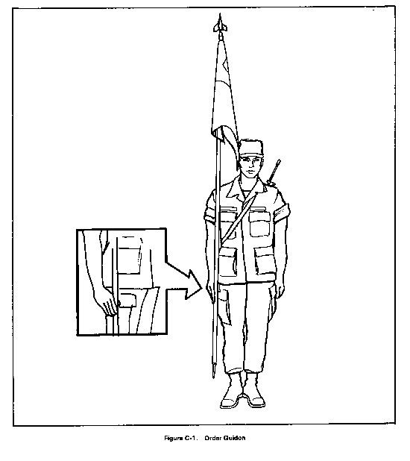
When the unit is formed, the guidon bearer is one step in front of and two left steps.

At order guidon (position of attention), keep the ferrule on the marching surface and touching the outside of the toe of the right foot. Hold the staff in the right hand in the "U" formed by the fingers and thumb. Keep the right hand and arm behind the staff. Rest the staff against the hollow of the shoulder (Figure C-1).

Parade

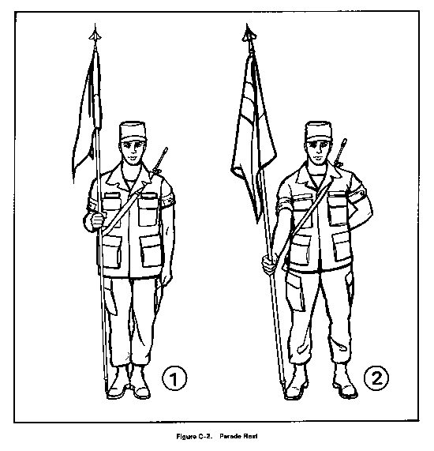
On the preparatory command Parade, move the right hand up the staff until the forearm is horizontal and grasp the staff (1, Figure C-2). On the command of execution REST, thrust the staff straight forward keeping the ferrule on the marching surface until the arm is fully extended (2, Figure C-2).
Figure C-1
At Ease
Stand at ease is the same as parade rest, except that the eyes and head are turned toward the commander.
Marching “carry guidon”
On the preparatory command for marching movements, execute from order guidon by grasping the staff with the right hand and raising it vertically six inches off the marching surface. At the same time, reach across the body (forearm horizontal) and grasp the staff with the left hand (1, Figure C-3). Hold the staff in position with the left hand while sliding
Figure C-2
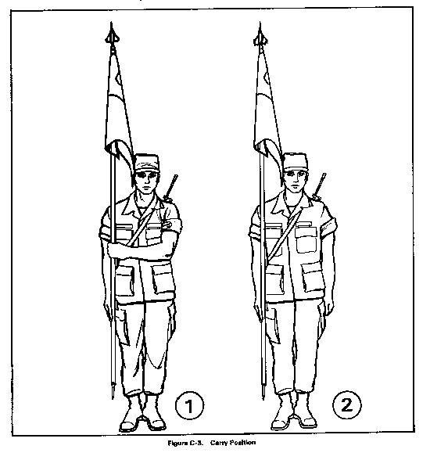
the right hand down six inches, regrasping the staff. On the command of execution MARCH, return the left hand smartly to the left side and simultaneously step off (2, Figure C-3).

To resume order guidon from carry guidon, let the staff slide through the right hand until the ferrule touches the marching surface
Figure C-3

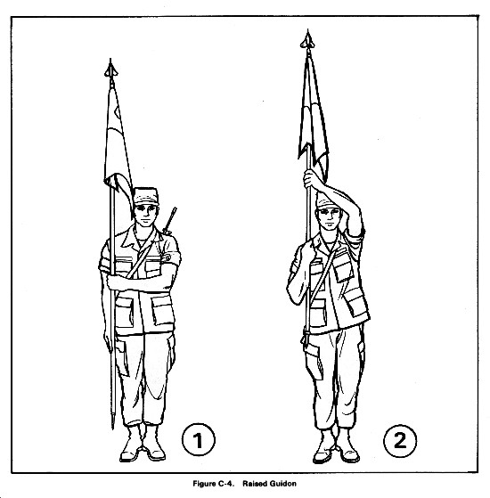
Raised Guidon
Figure C-3
On the preparatory command Present of Present, ARMS and Eyes of Eyes, RIGHT, raise the guidon vertically by grasping the staff with the right hand. Raise the guidon with the right hand while simultaneously moving the left hand across the body to guide the guidon (with palm to the rear, 1, Figure C-4). Keep raising the guidon until the right hand is on line with the right shoulder. Keep the right elbow into the side. Hold the guidon in this position until the command of execution is given (2, Figure C-4).

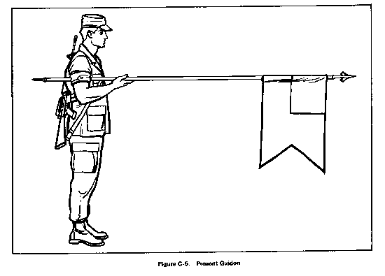
Present Guidon
On the preparatory commands for Present ARMS and Eyes RIGHT, execute raised guidon. On the command of execution, lower the guidon to the front using the right hand, keeping the left hand in the same position as raised guidon until the guidon is in the horizontal position resting under the arm pit. As soon as the staff is horizontal, return the left hand sharply to the left side (Figure C-5).
Figure C-4
During a review, execute eyes right as the guidon is presented on the command of execution RIGHT. Move the head and eyes to the front as the guidon is raised on the command Ready of Ready, FRONT.
Figure C-5
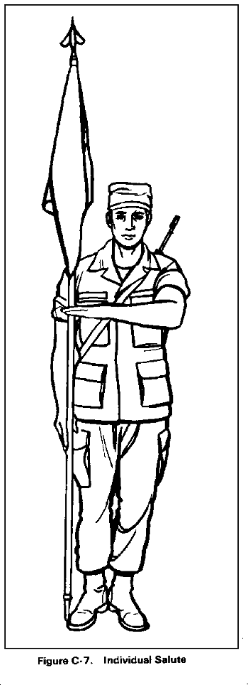
On the command Order of Order, ARMS or Ready of Ready, FRONT, regress the staff with the left hand at its original position and execute raised guidon. On the command of execution ARMS or FRONT, lower the guidon back to the carry or order position.
Guidon Bearer's Salute
When the guidon bearer (not in formation) has to salute from the order or carry position, the salute is given with the left hand. Move the left hand sharply to a position so that the first joint of the forefinger is touching the staff. The fingers and thumb is extended and joined, palm down, wrist straight, and forearm horizontal (Figure C-6).
After the salute is acknowledged, return the left hand sharply to the side

Replica Arms Procedures
- All replica firearms used in conjunction with drill and ceremonial activities will be treated as actual firearms with regard to safety considerations. Cadets must memorize the 10 principal safety rules, pass a practical examination of the 16- count manual of arms including inspection arms and have all applicable tasks certified completed in their training records before they will be issued a check-out card.
- Check-out cards are valid for the school year in which they were issued. Certifications must be completed each academic year to ensure training currency.
Issue Procedures
- An instructor or designated member (special teams commander/flight commander/flight sergeant) must be present during any issue or turn-in.
- When issuing replica firearms or sabers, a cadet must present a valid check-out card to the instructor/armorer. The card must be properly endorsed for the item requested. Cards not endorsed are eligible for issue of wooden riffles only. The card will be placed in the holder corresponding to the item issued and held until return.
- After the issued item is placed back in the armory, the check-out card will be returned to the student.
- At the conclusion of an activity, an inventory check will be conducted. The cadet associated with any check-out card still in place in the armory will be located and the status of the missing item investigated.
- Any cadet whose check-out card still in possession of the armory at the conclusion of an activity will forfeit his check-out card for a duration determined by the instructors.
- Requests for the replacement of lost or damaged check-out cards must be verified against training records prior to issue.
- Duplicate check-out cards or issuing more than one item to a cadet at a time is prohibited.
Saber Procedures
- Cadets must be previously certified for replica arms issue prior to adding a saber endorsement to their check-out cars.
- To add a saber endorsement, a cadet must demonstrate the manual of arms contained in FM 3-21.5 (FM 22-5) and memorize the saber safety rules. Certification is accomplished through practical examination and recorded in cadet training records.
- Saber issue procedures are identical to replica arms procedures above.

Color Guard
- Members of the color guard team must be certified for replica arms and saber issue as provided above. Additionally, they must be proficient in all four basic positions per USAFHGMAN, 1 January 2012:
American Rifle Texas Flag
American Flag Texas Rifle
and be proficient in raising, lowering and folding static flags.
- Color guard candidates must pass a practical examination of each position listed above before formal team acceptance. Examinations will be offered at least twice per month during scheduled practice sessions. A cadet must have a color guard endorsement to take possession of flags, belts, ascots, helmets, gloves or harnesses.
- Cadet can earn provisional status for a maximum of two color guard events based on proficiency and manpower requirements.
Replica Arms Safety Rules
- I will always treat replica firearms like real firearms.
- I will always carry a replica firearm at PORT ARMS when traveling.
- I will always ensure my checkout card is placed in the correct slot.
- I will always monitor those around me for violations or corrections.
- I will always exercise muzzle discipline.
- I will never lend my replica firearm to any individual.
- I will never leave my replica firearm unattended.
- I will never entry the armory with express permission from an instructor.
- I will never cycle the bolt unless the movement requires it.
- I will never engage in horseplay.
Saber Safety Rules
- I will always carry my saber at PORT ARMS when traveling.
- I will always guard the toe of my saber.
- I will never leave my saber unattended.
- I will never let the toe or blade contact anything.
- I will never engage in horseplay.

16 Count Manual of Arms
From order arms to right shoulder ARMS (1,2,3,4)
Right shoulder ARMS to left shoulder ARMS (1,2,3,4)
Left shoulder ARMS to Port ARMS (9,10)
Port ARMS TO Present ARMS (11)
Present ARMS to Order ARMS (12,13,14,)
Order ARMS to Parade REST (15)
Parade REST to Order ARMS (16)
FALL IN
RIGHT SHOULDER ARMS
LEFT SHOULDER ARMS
PORT ARMS
PRESENT ARMS
ORDER ARMS
PARADE REST
ORDER ARMS

CHAPTER NINETEEN

CHAIN OF COMMAND
POSITION | RANK/NAME
Commander-in-Chief
Secretary of Defense
Chairman, Joint Chief of Staff
Secretary of the Air Force (SAF)
Air Force Chief of Staff (AFCOS)
Commander, Air Education and Training Command (AETC)
Commander, Air University (AU)
Commander, Holm Center
Commander, AFJROTC
Principal, Guyer High School
Senior Aerospace Science Instructor TX-20056
Aerospace Science Instructor
TX-20056

CADET CHAIN OF COMMAND
POSITION | RANK/NAME
Group Commander
Deputy Commander
Training Squadron Commander
_______Flight Commander
_______Flight Sergeant
_______Flight Guide
_______Element Leader

CHAPTER TWENTY
ORGANIZATIONAL GOALS

The Group staff will establish organizational goals at the beginning of the school year. The following are the Corps organizational goals for the 2014-2015 school year. Status of these goals will be addressed during group staff meetings.

- .At least 80% of first year cadets will satisfy all promotion requirements to reach Airman First Class by the end of the first semester.

- Establish a weekly training regimen covering the 30-basic drill commands to boost interest in co-curricular activities and improve drill performance.

- Assist the local Civil Air Patrol and Boy Scouts of America troop to establish a color/honor guard to participate in community events. This will help establish AFJROTC visibility within the local junior high schools.

- Establish a peer tutoring service to help cadets struggling in all academic areas.

- Deliver at least two AFJROTC awareness briefings to district or community leaders and organizations to raise awareness and support for our cadet corps

- Partner with the local American Legion and Veterans of Foreign Wars to properly retire American flags collected throughout the Denton community

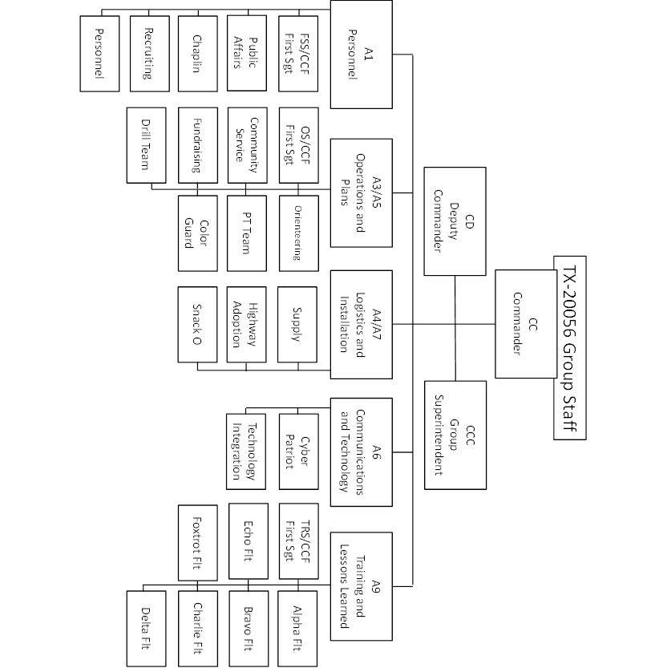
Attachment 1

Attachment 2
Attachment 3
Attachment 4

Active Duty Rank Insignias

Enlisted Ranks
Airman Basic  No insignia | Airman (Amn)  E-2 |   Airman First Class  (A1C) - E-3  (2 stripes)
  Senior Airman (SrA)  E-4 - (3 stripes) |   Staff Sgt. (SSgt)  E-5 - (4 stripes) |   Technical Sgt. (TSgt)  E-6 - (5 stripes)
  Master Sgt.  (MSgt) - E-7  (5 stripes down,  1 stripe up) |   Master Sgt.  First Sgt. - E-7  (5 stripes down,  1 stripe up)  w/ diamond in the upper blue field) |   Senior Master Sgt.  (SMSgt) - E-8  (5 stripes down,  2 stripes up)
  Senior Master Sgt. First Sgt. - E-8  (5 stripes down, 2 stripes up, w/ diamond in the upper blue field) |   Chief Master Sgt. (CMSgt) - E-9  (5 stripes down,  3 stripes up) |   Chief Master Sgt.  First Sgt. - E-9  (5 stripes down, 3 stripes up, w/ diamond in the upper blue field)

Officer Ranks
Second Lieutenant | First Lieutenant | 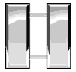Captain | Major
Lieutenant Colonel | Colonel | Brigadier General | Major General
 Lieutenant General |  General

Attachment 5
Attachment 6

Attachment 7
Airman Battle Uniform (ABU), Men’s and Women’s
7.1 The ABU replaces both the temperate and hot weather BDU and the desert camouflage uniform. Only cadets who have successfully completed SLS/LLA or current variant are authorized ABUs. ABUs may only be worn during the last scheduled uniform wear of the month or at the direction of the SASI. Do not starch or hot press the ABUs. The top button of the ABU coat will not be fastened; however, all other buttons will be secured at all times. Cadets are authorized to roll sleeves however, the cuffs will remain visible and the sleeve will rest at, or within 1 inch of, the forearm when the arm is bent at a 90-degree angle.
7.2 Cadet officer and NCO rank insignia will be worn on both collars in the active duty officer fashion. Nametapes will be worn immediately above the upper ABU coat pockets. Cut off or fold tapes to match pocket width. The “AFJROTC” tape will be worn above the upper ABU pocket on the wearer’s left. The last name nametape will be worn above the upper ABU pocket on the wearer’s right.
7.4 Badges. The total number of badges worn will not exceed four. Only cadet aeronautical badges are authorized on the ABU. Cords or other distinctive devices will not be worn on the ABU.

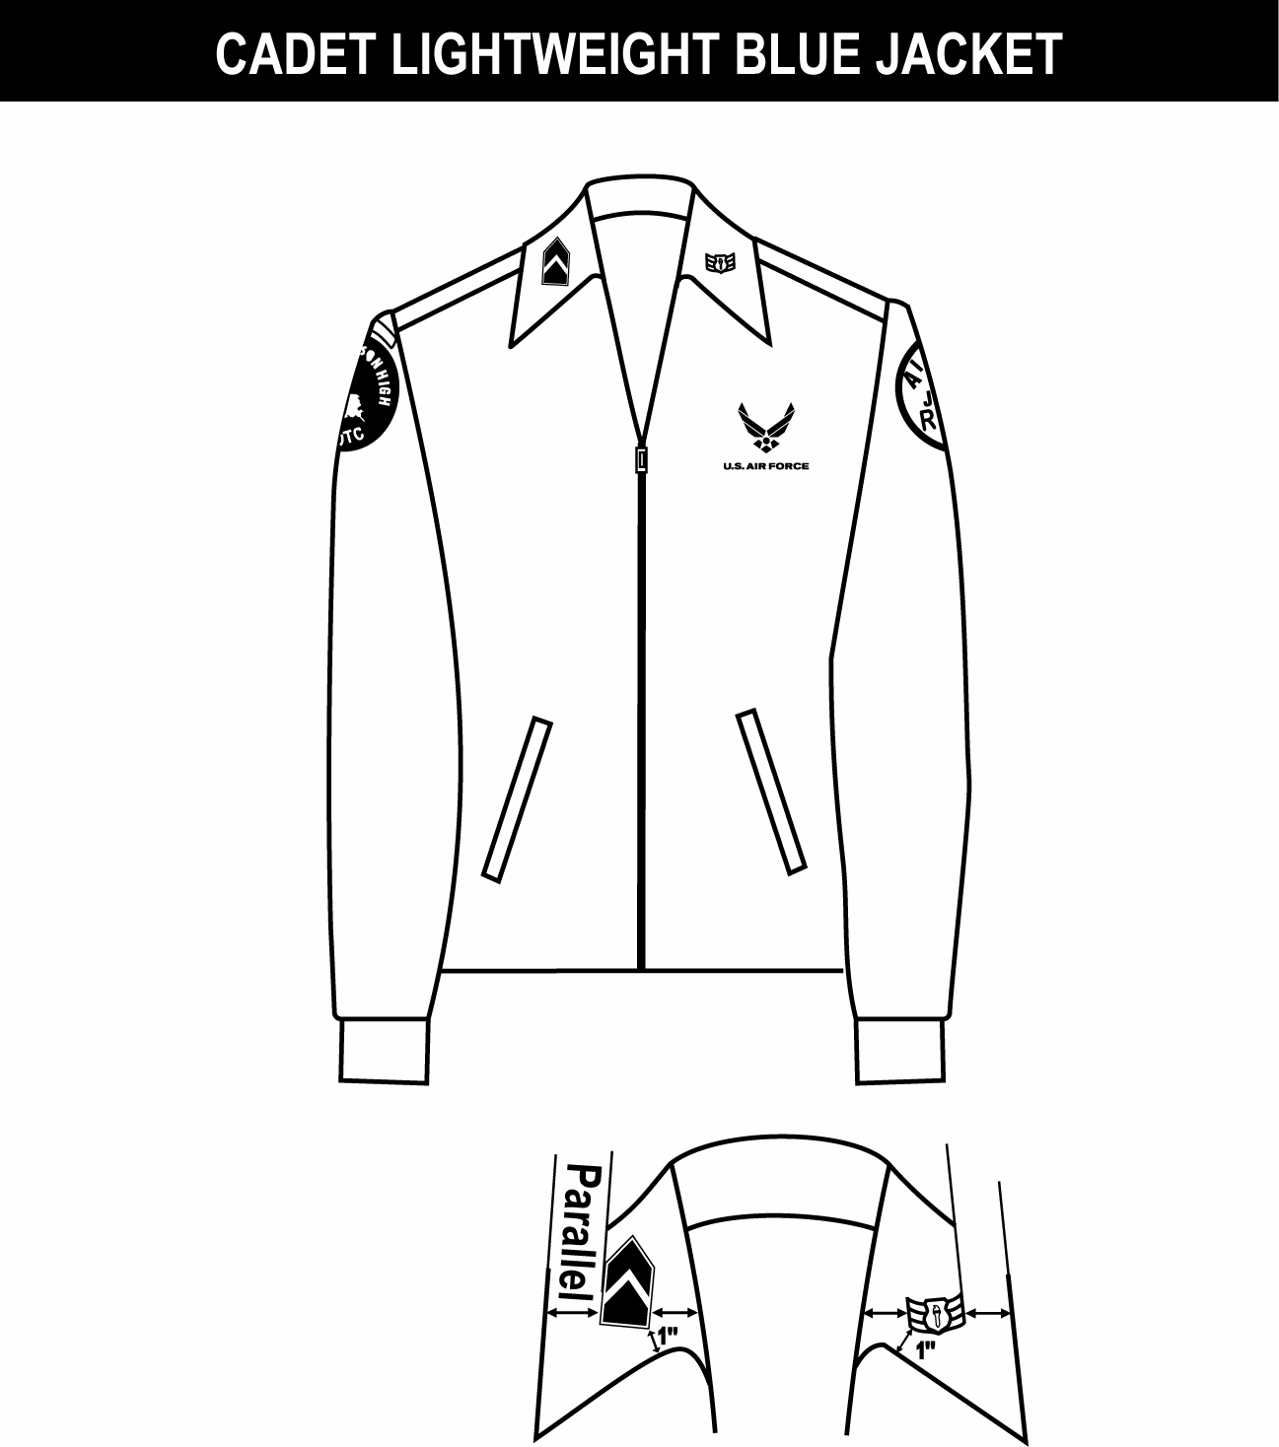
1. (Officers only) When placing rank on epaulet instead of collar, use standard size metal rank, center on epaulet 5/8 in from shoulder seam.
2. Shoulder tabs are centered between unit patch and shoulder seam. If no patch, then 1” below shoulder seam.
3. Unit patch on right sleeve ½ to 1 inch below shoulder seam and centered.
4. Grade insignia (officer and enlisted) is worn on both left and right collar. Airman Basics have no collar insignia.
5. Optional item: center vertically between the shoulder seam and where the underarm side seam joins the armhole sleeve and center horizontally between the center zipper and the sleeve armhole seam.
6. AFJROTC patch on left sleeve ½ to 1 inch below shoulder seam and centered.
7. Jacket will be closed to at least the halfway point.
8. Center insignia horizontally on collar. Place 1 inch from bottom of collar and parallel to the outer edge of the collar.
Note 1
Note 2
Note 3
Note 6
Note 7
Note 8
Note 5
Attachment 8
LIGHTWEIGHT BLUE JACKET
COLLAR INSIGNIA
Outer edge
Outer edge
Inner edge
Inner edge
Note 4

1. Awareness Presentation Team (APT) badge: Center on welt pocket 3 inches below the top.
2. Silver Name tag: Center between arm seam and lapel with bottom edge parallel to top of welt pocket. (Senior Only)
3. Kitty Hawk Badge: see note 15.
4. Unit patch: Placed ½ to 1 inch below shoulder seam and centered.
5. Shoulder tabs: Center between unit patch and shoulder seam. If no patch, then 1 inch below shoulder seam.
6. Aerospace Education Foundation (AEF) Badge: see note 15.
7. Distinguished Cadet Badge: see note 15.
8. Grade insignia (officer or enlisted) worn on both lapels. Airman Basic wear lapel insignia on both lapels. Place insignia halfway up the seam, resting on but not over it. Bottom of insignia is horizontal with the ground.
9. AFJROTC Patch: Placed ½ to 1 inch below shoulder seam, and centered.
10. Flight Solo or Flight Certificate Badge: see note 15.
11. Ground School Badge: see note 15.
12. Ribbons: Center, on but not over edge of pocket. Wear 3 or 4 in a row. Wear all or some.
13. Academy of Model Aeronautic Groups: worn 1 inch below pocket.
14. Model Rocketry Badge: worn 2 inches below AMA Groups or 3 inches below pocket if no AMA Groups are worn.
15. First badge placed ½ inch above name tag or ribbons and is centered horizontally. Additional badges placed ½ inch above previous badge.
16. Medals may be worn only on the service dress jacket. The top of the medal’s ribbon portion should stay flush against the bottom row of ribbons. The order of precedence is the same for the ribbons.
17. Cords are to be placed on the left shoulder.
Note 1
Note 2
Note 3
Note 8
Note 9
Note 10
Note 11
Note 12
Note 13
Note 14
Note: Cadets may wear the rank on both coat and shirt at the same time or only on the coat. The cadets must be in proper uniform at all times. If they have the coat on, the rank insignia must be on the coat. If they remove the coat, the rank must be on the shirt.

Service Dress may only be worn on designated uniform wear days by Cadets who hold a grade of “B” or above in the JROTC course with an exception for special events.

Note 4
Note 16
Note 17
Note 5
Note 6
Note 7

Attachment 9

1. Silver Name tag: authorized for wear and is to be centered on right side, even with to 1 1/2 inches higher or lower than the first exposed button. (Senior Only)
2. Awareness Presentation Team Badge: see note 15.
3. Unit patch: center ½ to 1 inch below shoulder seam.
4. Shoulder tab: centered between unit patch and shoulder seam. If no patch, then 1 inch below shoulder seam.
5. Kitty Hawk Badge: see note 15.
6. Aerospace Education Foundation (AEF) Badge: see note 15.
7. Distinguished Cadet Badge: see note 15.
8. Grade insignia (officer or enlisted) worn on both lapels. Airman Basic wear lapel insignia on both lapels. Place insignia halfway up the seam, resting on but not over it. Bottom of insignia is horizontal with the ground.
9. Flight Solo or Flight Certificate Badge: see note 15.
10. Ground School Badge: see note 15.
11. AFJROTC Patch: center ½ to 1 inch below shoulder seam.
12. Academy of Model Aeronautic (AMA) Groups: see note 15.
13. Model Rocketry Badge: see note 15.
14. Ribbons: center ribbons resting on but not over edge of welt pocket. Wear 3 or 4 in a row. Wear all or some.
15. First badge placed ½ inch above name tag or ribbons (whichever is appropriate) and is centered horizontally. Additional badges placed ½ inch above previous badge.
16. Medals may be worn only on the service dress jacket. The top of the medal’s ribbon portion should stay flush against the bottom row of ribbons. The order of precedence is the same for the ribbons.
17. Cords are to be placed on the left shoulder.

Note 16
Note 17

Note 1
Note 2
Note 3
Note 4
Note 5
Note 6
Note 7
Note 8
Note 9
Note 10
Note 11
Note 12
Note 13
Note 14
Note: Cadets may wear the rank on both coat and shirt at the same time or only on the coat. The cadets must be in proper uniform at all times. If they have the coat on, the rank insignia must be on the coat. If they remove the coat, the rank must be on the shirt.

Attachment 10

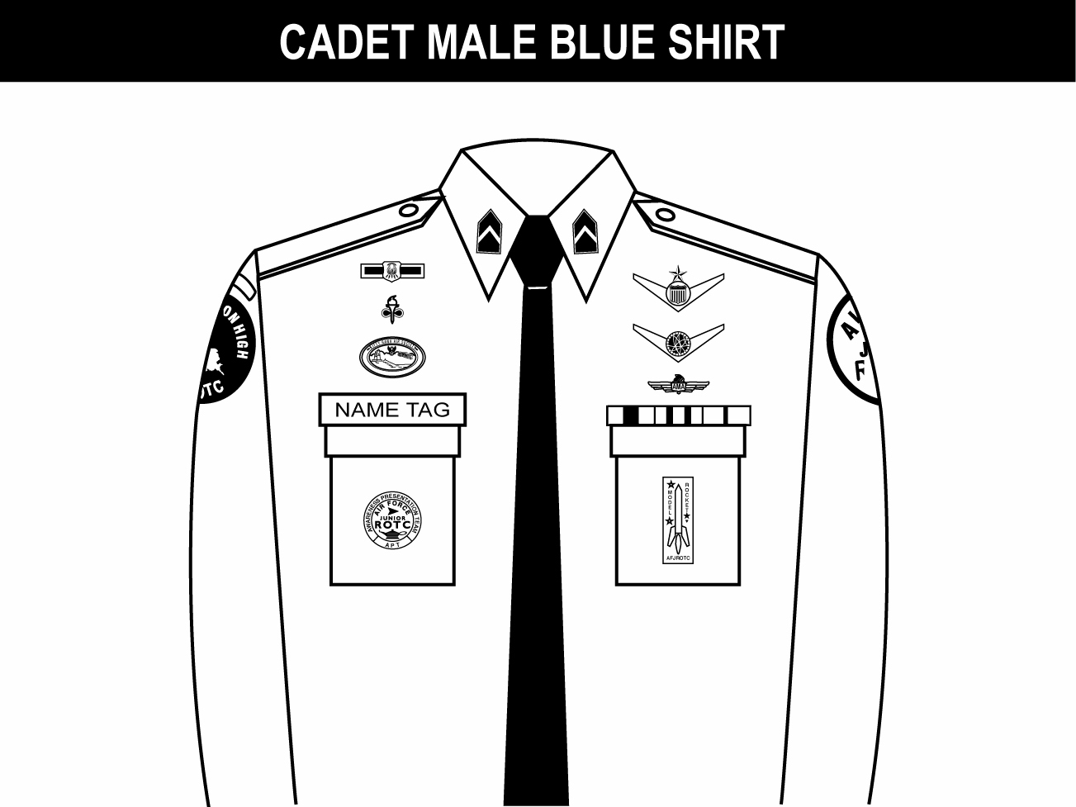
1. Awareness Presentation Team (APT) and Model Rocketry Badge are centered on the pockets on the appropriate sides as displayed above.
2. Name tag: authorized for wear and is to be grounded and centered over wearer’s right pocket.
3. Unit patch: center ½ to 1 inch below shoulder seam.
4. Shoulder tab: center between unit patch and shoulder seam. If no patch, then place 1 inch below shoulder seam.
5. Kitty Hawk Badge: see note 15.
6. Aerospace Education Foundation (AEF) Badge: see note 15.
7. Distinguished Cadet Badge: see note 15.
8. Grade insignia (officer or enlisted) worn on both left and right collar, centered side to side and top to bottom. Enlisted rank’s bottom point of the torch points toward the point of the collar. Officer top point of rank aligned with point of collar. Airman Basic have no insignia of any kind on the collar.
9. (Officers only) When using officer cloth rank on epaulets versus miniature metal rank on collar, place as close as possible to shoulder seam.
10. Flight Solo or Flight Certificate Badge: see note 15.
11. Ground School Badge: see note 15.
12. Academy of Model Aeronautic (AMA) Groups: see note 15.
13. AFJROTC Patch: center ½ to 1 inch below shoulder seam.
14. Ribbons: ground and center on pocket.
15. First badge placed ½ inch above name tag or ribbons and is centered horizontally. Additional badges placed ½ inch above previous badge.
16. Cords are to be placed on the left shoulder.

Note 1
Note 2
Note 3
Note 4
Note 5
Note 6
Note 7
Note 8
Note 9
Note 10
Note 11
Note 12
Note 13
Note 14
Attachment 11
Note 16

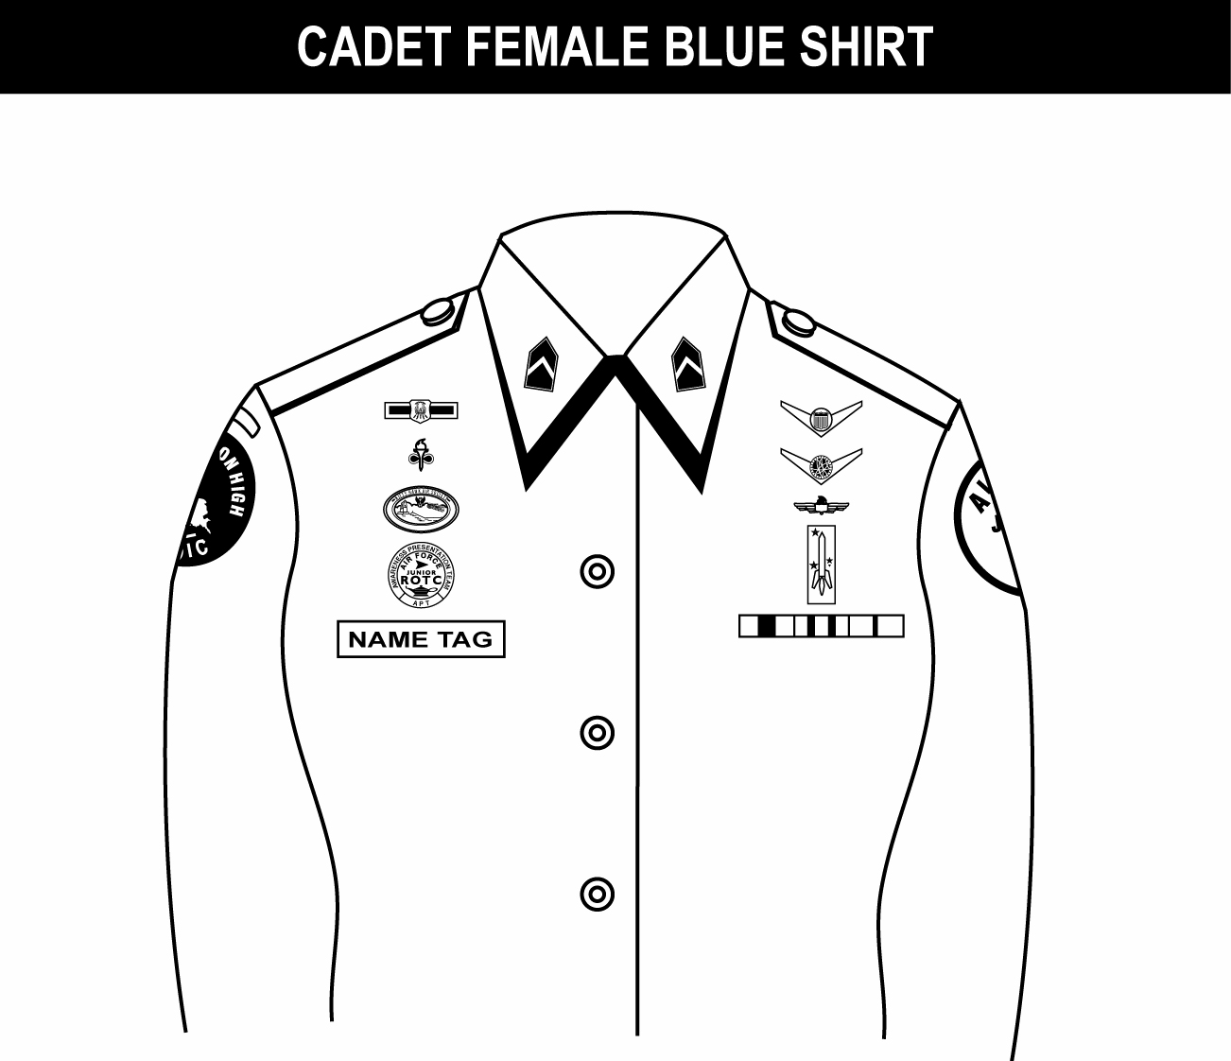
1. Name tag: authorized for wear and is to be centered on right side, even with to 1 1/2 inches higher or lower than the first exposed button.
2. Awareness Presentation Team Badge: see note 16.
3. Unit patch: center ½ to 1 inch below shoulder seam.
4. Shoulder tab: centered between unit patch and shoulder seam. If no patch, then 1 inch below shoulder seam.
5. Kitty Hawk Badge: see note 16.
6. Aerospace Education Foundation (AEF) Badge: see note 16.
7. Distinguished Cadet Badge: see note 16.
8. Grade insignia (officer or enlisted) worn on both left and right collar, centered side to side and top to bottom. Enlisted rank’s bottom point of torch points toward the point of the collar. Officer top point of rank aligned with point of collar. Airman Basic have no insignia of any kind on the collar.
9. (Officers only) When using officer cloth rank on epaulets versus miniature metal rank on collar, place as close as possible to shoulder seam.
10. Flight Solo or Flight Certificate Badge: see note 16.
11. Ground School Badge: see note 16.
12. Academy of Model Aeronautic (AMA) Groups: see note 16.
13. AFJROTC Patch: center ½ to 1 inch below shoulder seam.
14. Model Rocketry Badge: see note 16.
15. Ribbons: Center, parallel with ground. Align with bottom of name tag. Or, if no name tag, align bottom of ribbons even with to 1 ½ inches higher or lower than the first exposed button.
16. First badge placed ½ inch above name tag or ribbons (whichever is appropriate) and is centered horizontally. Additional badges placed ½ inch above previous badge.
17. Cords are to be placed on the left shoulder.
Note 1
Note 2
Note 3
Note 4
Note 5
Note 6
Note 7
Note 8
Note 9
Note 10
Note 11
Note 12
Note 14
Note 13
Note 15
Attachment 12
Note 17

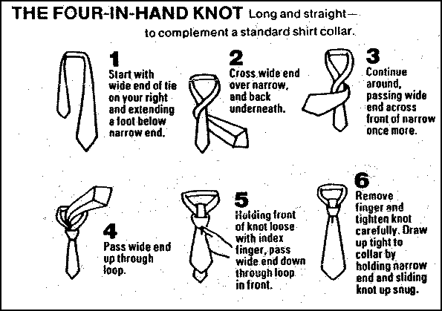
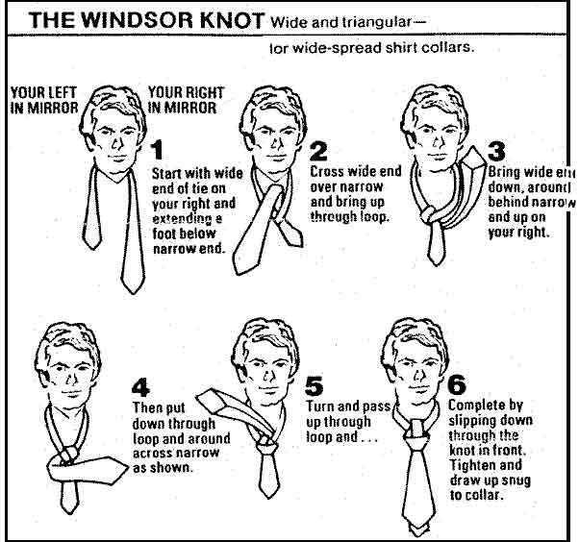
Attachment 13

ATTACHMENT 14

SAMPLE MEMORANDUM FOR RECORD

29 JUN 12
MEMORANDUM FOR GP/CC

FROM: FSS/DPM

SUBJECT: Format for the TX-20056 AFJROTC Official Memorandum (Letter)

1. This is the format for the TX-20056 AFJROTC official memorandum, and will be used when written correspondence is needed WITHIN the corps. The SASI or ASI must approve all of the following correspondence:

a. Letters addressed to individuals/organizations outside the Corps.

b. Correspondence going to “all cadets”.

2. Enter the office symbol the letter is going to after “Memorandum For”. Enter the office symbol of the person signing the memorandum (as identified in the Manning Document). The subject line should give a brief description of the content of the memorandum.

3. The style of writing is yours. When writing for someone else’s signature, try to write as though that person were speaking. Be succinct, use active voice, and keep it short (one page, if possible). Include extensive background as an attachment rather than within the memo itself.
4. If you want a response to a project officer rather than the signer, include that person’s name, office symbol, and telephone number in the body of the memo.

5. Even though most signers want their signatures on a perfect product, minor errors may be neatly corrected in ink.

IMA JOKER, c/Capt,
Information Management Officer

Attachment:
Staff Meeting Minutes, 28 Dec 11

