Amicus Brief

Central Asia

United Nations World Court of Historical Affairs

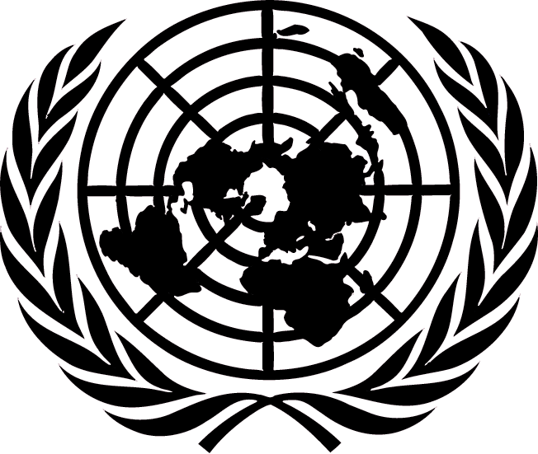

Post-Classical Situation Report

The United Nations is charged with the maintenance and order of world affairs. Keeping in line with this mission to provide stability and justice in the world the UN Council on Historical Affairs has compiled the following brief to serve as an overview of cultural affairs on the planet from 600 C.E. to 1450 C.E.

The UNWCHA will be charged with hearing evidence from the seven regions of the planet outlining their behaviors in creating frameworks of socio-cultural behaviors to provide for their people.

In the interest of full disclosure this amicus brief will provide litigation teams with all information already gathered by the court on each of the seven cultures. The following is that evidence.

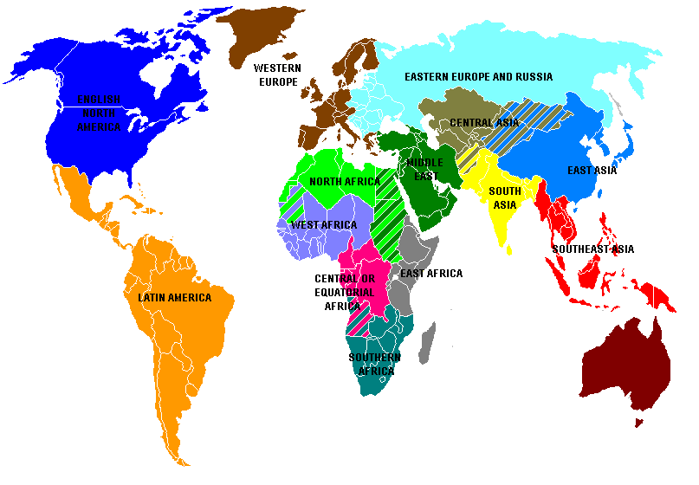

Pre-Mongol Eastern Europe

**Russian Politics**

A. KIEVAN RUSSIA

Slavic Peoples moved into the Russian area during Roman Times

-These people began to interact with natives

-Maintained an Animist religion

-Rich tradition of Folk music oral legends

B. 5th and 6th century Viking Traders began to work their way through Slavic lands then reached Byzantine Empire

-Scandinavian gradually set up governments in the area

-Founded the city of Kiev established a monarchy

C. EMERGENCE OF RUSSIA

A monarchy of Rurik emerged in Kiev

-From Denmark

-This flourish until 1100’s

Prince Vladimir I converted to Christianity

**Russian Religion**

Slavic peoples of Southeast Europe and Russia had been converted to Christianity in the 9thcentury when an Orthodox Christians, Saints Cyril and Methodius, used the Greek alphabet to create a Slavic alphabet, known as Cyrillic

A. Vladimir, a prince from Kiev, converted to Christianity

-Russian Orthodox Church was aligned with the Byzantines not Roman tradition

-So, when the Roman church reformed later, the Russian and Greek churches did not

-Russia became culturally different from the other European powers

B. RUSSIA BECOMES CHRISTIAN

-Not only did Vlad convert but he also converted his people

-Organized mass baptisms using military

-Imported leaders from Byzantium

-Controlled major appointments to the church

-Yaroslav (last great prince) ordered building of churched and translation of the bible from Greek to Slavic

**INSTITUTION AND CULTURE IN KIEVAN RUSSIA**

Borrowed much culture from Byzantium

-Did not replicate the great bureaucracies

-Leaders attached to rich ceremonies

Eastern Church leaders helped organize worship

-Built elaborate churches

-Adopted practice of monogamy and almsgiving

-Disasters seen as a wrath of God

-Success in war as praise from God

**SOCIAL ECONOMIC PATTERNS**

Developed independently from Europe

-Peasant were free farmers

-Aristocrats were land owners called Boyars held little political power

Russia mostly unaware of western Europe

**Decline of Kievan Russia**

Began to fade in 1100’s

-Princes set up rival regional governments

-Squabbled about succession

-Invaders from Asia

As the Byzantine went so did Kievan

-Mongols contributed to the decline “Tartars”

Trade was slowed under Mongol control

Christianity did still continue as long as tribute was paid Russian allowed to practice faith

Eastern Europe and Russia

* **Elbe River Boundary, Eastern/Southern Europe**
  + Lands east and south of line Elbe River to Port of Trieste on Adriatic
  + Created a historical region dominated by nobles, landlords, serfs, conflict, tensions
  + Tended to escape most of the Renaissance, Reformation, Enlightenment
* **Change over Time**
  + 1450: Poland-Lithuania was the largest state; Hungary was second; many states
* **Deep Ethnic and Religious Divisions**
  + Catholics: Czechs, Slovaks, Croats, Slovenes, Hungarians, Poles, Lithuanians, Ruthenians
  + Orthodox: Russians, Belarus, Ukrainians, Bulgars, Rumanians, Greeks, Serbs
  + Protestants: Finns, Estonians, Latvians, Germans, some Hungarians
  + Muslims: Turks, Bosnians, Albanians, Tatars, Mongols
  + Many ethnic groups, religious minorities include Jews, Gypsies
* **Multinational States, Autocratic Governments**
  + One dominant ethnic group (Russians, Germans, Poles, Hungarians) dominates state
  + Many lesser ethnic groups subject to assimilation, exploitation by largest ruling group
  + Russia, Austria, Ottoman Empire, Poland were multinational
  + Most states had autocratic rulers who could ignore assembles, nobles in decisions
  + Constant drive to increase state power at expense of all opponents including nobles, faith
* **Social and Economic Themes**
  + Elites: Land nobility (Russian = Boyars) controlled vast estates
  + Serfdom, forced peasant labor wide spread, serfs often exploited, mistreated
  + Few cities, small to no merchant or urban class
  + Agricultural economies with little industry; exports limited to grain, primary products

1. SUMMARY
2. The Mongol Empire of Chinggis Khan

*The Mongols intervened periodically in Chinese history. But tribal divisions and rivalries with neighboring ethnic groups, particularly Turkic peoples, had long blunted the expansive potential of Mongol warrior culture. Within the first decades of the 13th century, because of the political strategies and military accomplishments of Chinggis Khan, the Mongols and allies nomadic groups built an empire that stretched from the Middle East to the East China Sea*.

1. The Mongol Drive to the West

*While pursuing a fleeing Persian ruler, the Mongols made their first contacts with the kingdoms to the west of Chinggis Khan’s Empire. Subjugating these regions became the projects of the armies of the Golden Horde, the Mongol khanate, which ruled the western lands. After the death of Chinggis Khan, the empire was divided into four khanates. The khanate to the south, called the Ilkhan Empire, attempted to conquer the Muslim world. Although neither Europe nor the Islamic lands were subdued, Mongol successes affected the regions’ history.*

1. The Mongol Interlude in Chinese History

*Of all the areas the Mongols conquered, perhaps none was more closely administered than China. The Mongol interlude in Chinese history lasted only about a century. Although the Chinese attempted to assimilate the Mongols from the start, the Mongols managed to retain a distinct culture and social separateness until they were driven back beyond the Great Wall in the late 1360s. They also opened China to influences from Arab and Persian lands, and even to contacts with Europe, which came to full fruition in the centuries of indigenous Chinese revival that followed under the Ming Dynasty*.

1. Conclusion: The Mongol Legacy

*The Mongol impact on the many areas where they raided and conquered varied greatly. The sedentary peoples on the farms and in the cities, who suffered the fury of their assaults and the burden of their demands, understandably emphasized the destructive side of the Mongol legacy. But the Mongol campaigns also influenced the course of human history, especially through disrupting the political map. The Mongol empire promoted trade and other important exchanges between civilizations. Mongol rule also brought stable, often effective government and religious toleration to peoples over much of Asia*.

**The Mongols in Detail**

* Nomadic peoples
  + Pastoral nomads
  + Organized into clans with related languages
* Central Asia's steppes
  + Good for grazing, little rain, few rivers
  + Nomads and their animals; few settlements
    - Nomads drove their herds in migratory cycles
    - Lived mostly on animal products
    - Also produced millet, pottery, leather goods, iron
* Nomads and settled peoples
  + A love, hate relationship of war and trade
  + Sought trade, exchange
  + Nomads maintained caravan routes
* Fluidity of classes in nomadic society
  + Two social classes: nobles and commoners
  + Autonomous clans and tribes
* Religions:
  + Originally: mostly shamanistic
  + Later: Buddhism, Nestorian Christianity
  + By tenth century, Turks became Muslim
* Military organization
  + Khan organized confederation of individual tribes for expansion
  + Outstanding cavalry forces, formidable military power

**Turkish Empires**

* Turks in Central Asia
  + Long history of interaction with Chinese
  + Khitans, Oighurs and others were Turks
  + Much intermixing with Mongols
  + Oguz migrated from Mongolia to Central Asia
    - Turks created a state, society long before Islam arrived
    - Co-existed with Muslims, later converted
  + Some tribes Migrated into S. W. Asia
* Saljuq (or Seljuk) Turks and the Abbasid empire
  + Lived in Central Asia, borders of Abbasid, 8-10th century
  + Converted to Islam in 10th century CE
  + Invaded S.W. Asia, defeat Byzantines, Abbasids
  + Served in Abbasid armies as mameluks
  + Overshadowed Abbasid caliphs by the mid-11th century
  + Extended Turkish rule to Syria, Palestine, other parts
* Saljuq Turks and the Byzantine empire
  + Migrated to Anatolia, early 11th century
  + Defeated Byzantine army at Manzikert in 1071
  + Transformed Anatolia into an Islamic society
  + Crusades launched to stop Seljuk advance
* Ghaznavid Turks
  + Dominated northern India
  + Created Turkish Sultanate of Delhi

Seljuk Turkish Conquest

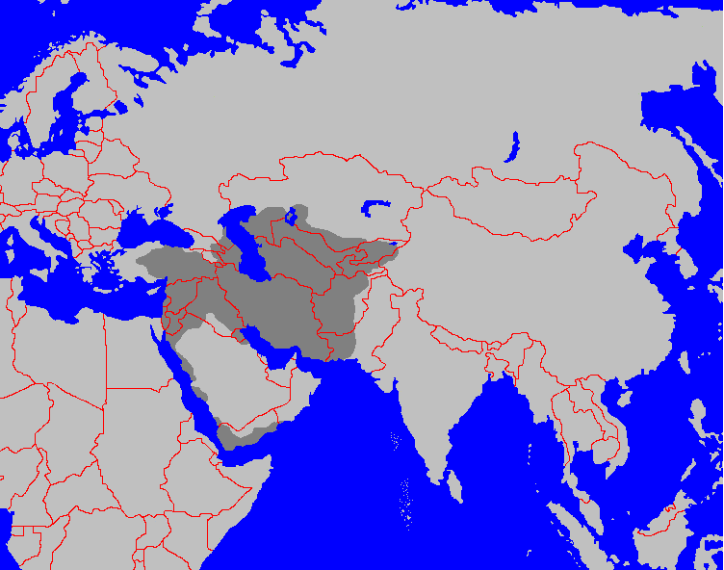

**Mongols in Detail**

* Chinggis Khan ("universal ruler")
  + Unified Mongol tribes by alliance, conquests
  + Merged into empire
* Mongol political organization
  + Organized new military units
  + Broke up tribal affiliations
  + Chose officials based on talent, loyalty
  + Capital at Karakorum
* Mongol conquest of northern China
  + Overran Xi-Xia
  + Jurchen (Qin, Khaitan) in north China in 1211
  + Controlled North China to Yangzte by 1220
  + South China was still ruled by the Song dynasty
  + Towns which resisted were used as examples
  + Later towns simply surrendered
* Mongol conquest of Persia
  + Wanted trade and diplomatic relations with Persia
  + Khwarazim ruler murdered envoys
  + Mongol force invaded Khwarazim empire
  + Mongol forces destroyed Persian cities and *qanat (underground irrigation systems)*
  + Chinggis died in 1227, laid foundation for a mighty empire
* Mongol rule was generally tolerant.
  + Capital of his empire at Karakorum
  + Summoned intellectuals from his conquered kingdoms
  + Offered religious toleration to Confucians, Buddhists, Daoists, and Muslims
  + Administrators drawn from examples in Islamic and Chinese worlds
  + Formulated a legal code intended to end tribal and clan divisions
  + Trade and cultural exchange flourished.
* Mongol heirs divide into four regional empires

**Mongol War Machine**

* Mongol warriors
  + Excellent horsemen
  + Accomplished archers
  + Raised in the saddle and able to hunt as children
* Mongol armies
  + Entirely cavalry
  + Depended on speed and mobility in assaults
* Chinggis Khan reorganized the tribal armies
  + Units called *tumens* containing 10,000 men
    - Each unit command by separate leaders
    - Sun-units called ordas; word “horde” in English
    - Communication by flag, drum
    - Able to cover vast distances in one day
    - Based on the hunting formations of the Mongols
  + Each army divided
    - Into heavy cavalry, light cavalry
    - Lightly armored scouts preceding the main forces
  + Severe discipline
* Spies and informers produced information, maps
* Later Mongol forces used gunpowder, artillery

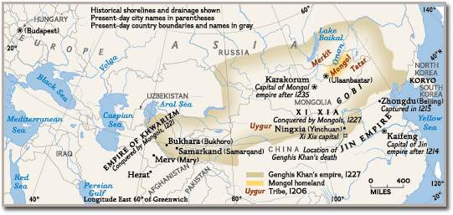

**Mongol Empires after Chinggis Khan’s death**

* Khubilai Khan rules Yuan Dynasty in China
  + Chinggis Khan's grandson, consolidated Mongol rule in China
  + Conquest of southern China
    - Song Dynasty fell in 1276, Yuan Dynasty founded in 1279
    - Unsuccessful conquests of Vietnam, Burma, Java, and Japan
  + Mongol rule in China
    - New hierarchy: Mongol and allies; northern Chinese; Southern Chinese
    - Central administration reserved for Mongols, allies
    - Brought foreign administrators into China and put them in charge
    - Dismissed Confucian scholars; dismantled civil service examination
    - Favored merchants, cities, peasants over Chinese elites
  + Mongol Social Policies
    - Would not allow Mongols to settle in China nor Chinese in Mongolia
    - Outlawed intermarriage between Mongols and Chinese
    - Promoted Buddhism, supported Daoists, Muslims, and Christians
    - Forbade Chinese from learning the Mongol language
    - Mongol ruling elite adopted Lamaist Buddhism of Tibet
    - Mongol women refused to adopt Chinese customs, retained influential status
* Mongols in S.W. and Central Asia
  + Destroyed many cities, captured Baghdad in 1258
  + Destroyed agricultural lands, irrigations systems of Iraq, Iran
  + Lands fell to the Ilkhanate of Persia; Khanate Of Chaghadai
    - Persians served as ministers, governors, local officials
    - Mongols only cared about taxes and order
    - Ilkhan converted to Islam, 1295; massacres of Christians and Jews
  + Baiburs, the Mameluk Sultan of Egypt defeated Mongol invasion of Africa
* The Mongol Impact on Europe and the Islamic World
  + Europeans altered military organization
  + Adopt use of gunpowder
  + Mongol conquests facilitated trade across the steppes
  + Mongol armies may also have transmitted the plague infection

**Mongols in Europe**

* Russia in Bondage
  + Russia fell under rule of the Khanate of the Golden Horde
  + Mongol conquest of Russia reduced the Russian princes to tribute-payers.
    - Payments fell heavily on the peasants
    - Peasants reduced to serfdom.
    - Some Russian cities (Moscow), recovered fortunes by increased trade
  + Rise of Moscow
    - Moscow profited as tribute collector for Mongol overlords.
    - Head of the Orthodox Church in Russia selected Moscow as his capital.
    - In 1380, the princes of Moscow turned against the Mongols
    - Led an alliance that defeated the Mongols at the battle of Kulikova.
    - Victory broke the hold of the Mongols on Russia
    - Nomads continued to make raids into the 15th century.
  + Mongol conquest of Russia ensured changes
    - Central position of Moscow and the Orthodox Church
    - Changes in Russian military organization
    - Revised the political concepts of Russian rulers
    - Mongol dominance cut Russia off from western Europe both politically and culturally.
* Mongol Incursions and the Retreat from Europe
  + First Christian reaction to Mongol invasions was positive.
    - They were convinced Mongols were potential allies against the Muslims
    - Assault on Russia proved that optimism was a miscalculation
    - Successful conquest of Hungary alerted Europe to danger of Mongols
    - Mongol hordes withdrew to Asia to resolve the succession crisis
  + Lithuanians defeated Mongol return

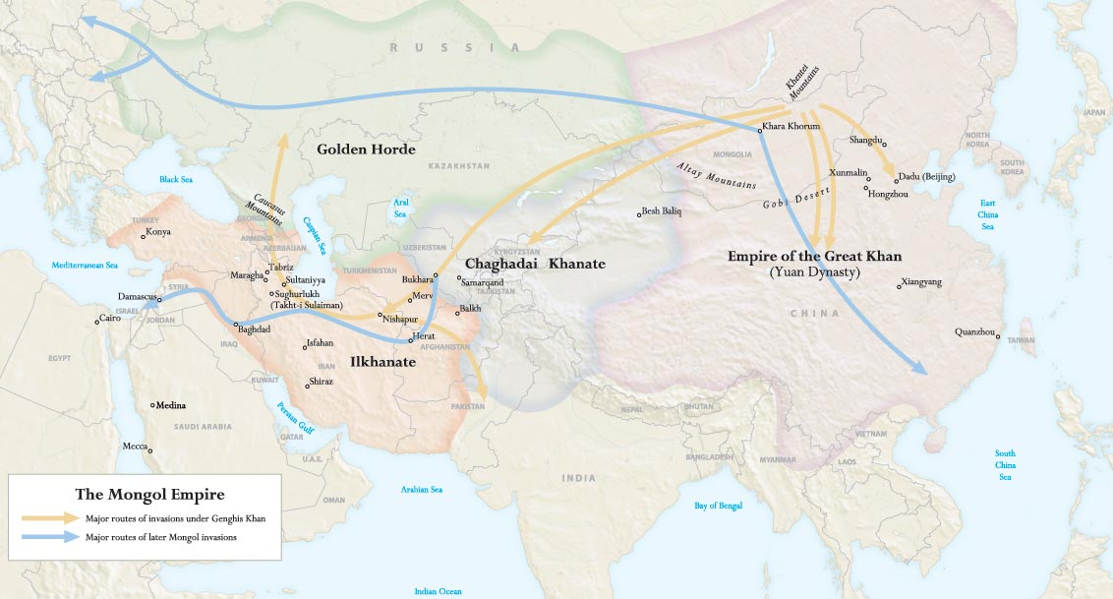

The Mongols and Eurasia

* Results of Mongols Conquests
  + Conquest destroyed all existing political structures in conquered region
  + Empire created the largest zone of continuous rule in history
  + Empire created a period of peace, prosperity in controlled regions
  + Disrupted those states it did not conquer
  + Facilitated rise of new states in vacuum
  + Forced innovation amongst existing peoples to resist Mongols
* Mongols were a tribute empire: trade was often a byproduct
* The Mongols and trade
  + Worked to secure trade routes, ensure safety of merchants
    - Organized protected trade caravans
    - Formed merchant/trade associations with insurance
    - Elaborate courier network with relay stations (postal stations)
    - Universal passes, protection given to merchants
    - Ordas acted as police, protection for travelers
    - Maintained order for merchants, ambassadors, missionaries
  + United Eastern Europe, SW Asia, S. Asia, E. Asian trade
* Diplomatic missions
  + Mongol empires maintained diplomatic communications
    - Used foreigners especially Christians, Muslims as diplomats
    - Threats were backed with force
  + Established relations with Korea, Vietnam, India, Europe
* Resettlement
  + Mongols needed skilled artisans, educated individuals
  + Resettled them in different locations to provide services
  + Uighur Turks served as clerks, secretaries, administrators
  + Arab, Persian Muslims served Mongols far from homelands
  + Chinese served as military specialists
  + Koreans served as naval specialists
  + Christian Nestorians served as emissaries, merchants
  + Skilled artisans often sent to Karakorum

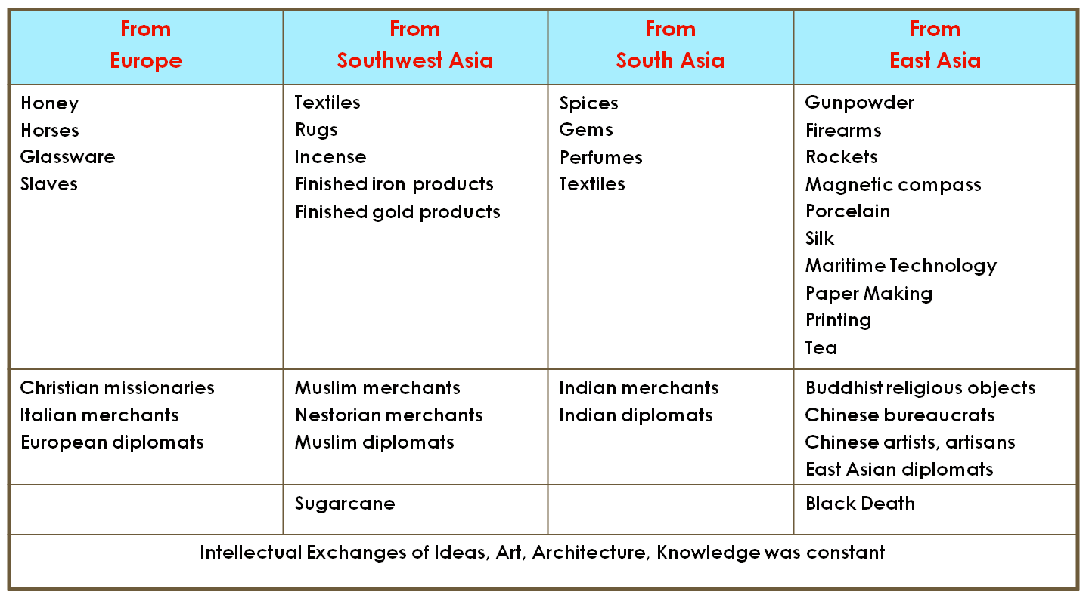

Exchanges during the Mongol Era

**Decline of the Mongols in Persia and Asia**

* Major Reason for Decline
  + Mongols too few in number, settled populations massive
  + Any interaction resulted in acculturation
  + Any intermarriage resulted in loss of identity
  + Mongol rule resented
  + Settled populations began to use firearms
* Collapse of the Persian Ikhanate
  + Excessive spending, overexploitation reduced revenues
  + Destruction of qanats reduced agriculture productivity
  + Failure of the Ilkhan's paper money
  + Intermarriage of Mongols with local populations
  + Factional struggle plagued the Mongol leadership
  + Last ruler died without an heir; the Ilkhanate collapsed
* Decline of the Yuan dynasty
  + Paper money issued by the Mongol rulers lost value
  + Power struggles, assassinations, civil war after 1320s
  + Bubonic plague in southwest China in 1330s
    - Spread through Asia and Europe
    - Depopulation, labor shortage undermined Mongols
  + By 1368, Chinese drove the Mongols back to the steppes
* Surviving Mongol khanates
  + The khanate of Chaghatai continued in central Asia
  + Golden Horde survived until the mid-sixteenth century

Tamerlane (1336 – 1404)

* Timur the Lame conqueror
  + Self-made; rose from poverty, to power in 1360
  + Established capital in Samarkand
* Tamerlane's conquests
  + United tribes in Central Asia
  + Conquered Persia, Afghanistan
  + Next attacked the Golden Horde
  + End of 14th c., invaded northern India
    - Destroyed vast regions
    - Laid waste much agricultural land
  + Raids into S.W. Asia, Ottomans, Russia
* Governance of Empire
  + Ruled through tribal leaders
  + Relied on existing bureaucrats to collect taxes
  + Used terror as weapon
  + Not interested in rule, would rather plunder
* Collapse of Nomads following his death
  + Heirs struggled, divided empire
    - Later descendants invaded India
    - Grandson established Mughal Empire
  + China was last civilization threatened
    - Chinese converted Mongols to Buddhism as prevention
    - Manchus overthrew Ming in 17th century for last nomadic invasion
  + Russia conquers Steppe and Central Asia
    - Employed steppe nomads (Cossacks) to conquer steppe
    - In 19th century, Russia conquered Central Asia

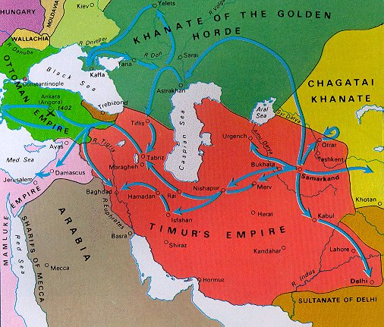

**Foundations of the Ottoman Empire**

* Turks
  + Nomadic Turks migrated to Persia and Anatolia
  + Ottoman Turks settled on Byzantine border
  + Established warrior society raiding Byzantines
* Osman
  + Charismatic leader of clan
  + Carved out a state in northwest Anatolia
  + Claimed independence from Seljuks, 1299
* Ottomans Conquer the Balkans in 1350s
  + Raided into Europe at Gallipoli (Dardanelles)
    - Conquered Bulgaria, Serbia
    - Pushed into Greece, Defeats Hungarian crusade
    - Temporarily stopped by Timur’s invasion
  + Mehmed II
    - Sacked Constantinople in 1453
    - Made Constantinople capital as Istanbul
    - Absorbed remainder of Byzantine empire
* During 16th century
  + Extended empire to southwest Asia
  + In southeast Europe
  + Into north Africa

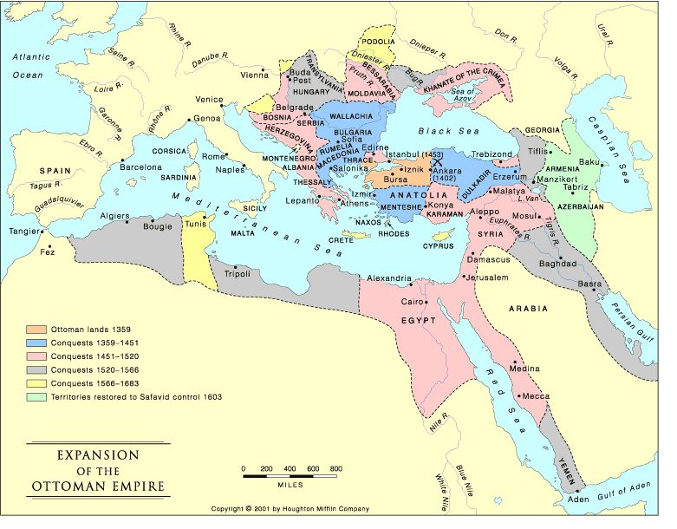

**Orthodox Christianity**

Orthodox Christianity arose as part of the general Christianity observed throughout the Roman Empire. From the beginning, it co-existed with the Roman Catholic tradition, the main difference being its use of Greek instead of Latin for worship. Gradually, the Church of Rome began to assume preeminence over the rest of Christianity, but not necessarily with the acknowledgment or cooperation of the eastern churches.

Eventually, doctrine differences coupled with questions of papal authority led to the "Great Schism" of 1054, when Rome excommunicated the Patriarch of Constantinople, Michael Cerularios. Thus, the question of when Orthodox Christianity was founded depends on who one asks. An Orthodox Christian will tell you 33 AD, but a Roman Catholic will say 1054 AD.

Many of the Orthodox churches consider themselves "Catholic" and some will have the word in their official titles. In Greek, the word “catholic” means universal. The Eastern Orthodox Church was the "One Holy Catholic and Apostolic Church" of the Byzantine Empire. The Christians that follow the Eastern Orthodox religion follow the doctrine defined by the first seven ecumenical councils. They recognize Christ as the head of the Church, and their doctrines are founded on the Holy Scriptures, holy tradition, and the decisions of the ecumenical councils. Others prefer the term orthodox because Eastern Rite Christians feel they more closely represent Christ’s intended church on earth.

The Church is also known as "Eastern Orthodoxy" because the most Orthodox are from the eastern regions of Europe and Asia, as in Russia, Greece, the Balkans, and the Coptics of Egypt.

Orthodox doctrine agrees with that of most of the other high liturgy churches as Roman Catholicism and the Anglican Church. In fact it is often hard to see how they differ. The major cause of the Great Schism was the addition of the “filoque” to the Nicene Creed by the Roman Church. The Nicene Creed stated that the Holy Spirit proceeds from the Father alone, whereas the filoque teaches that the Holy Spirit proceeds from both the Father and the Son. To Western Christians, this has resulted in a stronger notion of the Trinity of God the Father, the Son and the Holy Spirit as co-equal and co-eternal, whereas the Orthodox fell God the Father and the Son existed before the Spirit and created it.

Another issue of contention with the Roman Church is the authority of the Pope over

all of Christendom, with which the Orthodox could not agree. Orthodox have always felt that while the Pope was the single most important leader of the Church, first among equals so as to speak, he alone could not speak for the Church. God spoke through the general Church councils and synods and his Holy Spirit guided the Church councils, not the Pope. Consequently, whereas the Roman Catholics feel the Pope is infallible, the Orthodox feel the Councils will not err religiously. Another distinct trait of Orthodoxy is the veneration of icons, with which many western Christians cannot agree. While Roman Catholics also venerate icons, at the time of the Great Schism in 1054, many Orthodox Christians opposed the use of icons in worship. Today they accept them. Other differences between Orthodox and Catholics include the Orthodox tradition of married priests, which Roman Catholics discontinued around 1000, and the use of the local or vernacular language in worship, which until 1964, Roman Catholics did not allow.

Orthodox Christians recognize the New Testament and the Old Testament. In addition to these scriptures, the Church recognizes several other books as canon, not recognized by Protestants and Catholics. These books are known by Protestants as the Apocrypha, and to the Church as the Deuterocanonicals. The Orthodox also use four more books of the Bible than do Roman Catholics. Furthermore, Church tradition as revealed to the people through the councils is regarded as additional sources of divine truth.

Because Orthodox Christianity arose in areas with strong political leaders, it did not develop the independence of the Roman Catholic Church. In fact, the church was often considered a department or a bureau under the political influence of the emperors or tsars. Consequently, the Orthodox did not develop the exclusive monopolies over social welfare or educational institutions, which occurred in medieval Western Europe. Moreover, the clergy did not possess a monopoly on intellectual resources because the state and private enterprises maintained schools for the wealthy and talented. Only in areas where political authority collapsed through invasion or conquest, such as in Russia following the Mongol invasion or in Ethiopia, which was cut off from the Christian world by Muslim control of Egypt, did the Orthodox churches ever develop the level of power Roman Catholic clergy possessed. And unlike the Roman Catholics and after their wars with the Monophysites, the Orthodox rarely launched crusades against non-Christians (Jews are a major exception). In fact, the spread of Orthodoxy around the world was more often as not accomplished by missionaries, merchants, and movement of the already Orthodox to new lands to settle.

**Judaism**

Traditionally, historic Judaism was founded by Moses approximately 3,300 years ago. The patriarch Abraham is also considered the founder of the Jewish people. But most modern scholars believe Judaism coalesced from various associated tribes in Palestine more than 3,000 years ago.

Historically, the Judaism based on the Books of Moses, historical books, and prophetic books, which Christians call the Old Testament, and which Jews call the Tanakh, did not come into printed existence until around 600 BCE when the Jews were in exile in Babylon.

The earliest teachings of Judaism revolved around eretz yisrael, or the land of Israel, and geography is central to Judaism. In the Hebrew language of the "Old Testament", whenever the scriptures speak of a Jew entering the land, he "ascends". Whenever a Jew departs, he "descends". The Torah threatens exile from the land as the punishment for disobedience (Deuteronomy 28). Until the last 2,000 years of exile, the land was essential to the religion. Many of the laws of the Torah are only applicable when Israel is in the land. To emphasize the importance of the land to the fathers, each Pesach, or Passover is ended with the exclamation, "Next year in Jerusalem!" And have you ever wondered why hell is hot – deserts surround Israel and the Twelve Tribes were punished for sins by God and made to wonder in the desert for forty years under Moses. Besides, who would not want a land flowing with milk and honey as opposed to one of heat, scorpions, and rocks?

Judaism is usually considered an ethnic religion because of its association with a specific land. The Hebrew calendar is based on the agricultural cycle of Palestine. In that autumn is when the grains were harvested, the two holiest of Jewish holidays, Rosh Hashanah (New Year) and Yom Kippur (Day of Atonement) are both autumnal holidays associated with plenty and the end. Other holidays such as Sukkot (Feast of Booths) celebrate the Final Gathering of the Fruits, and prayers, especially for rain are offered. And because of the association of the human body with dirt and dust, the dead must be interred within one day of death.

The Torah mandated many practices, which were dictated by the environment. For example, the prohibitions against animals classed as unclean, such as pigs, affects what animals are raised. The very strict separation of meat from dairy products affects the handling and distribution of food products. Both milk and pork spoil quickly in hot climates. Historically, the Torah mandated a total rest of all farmland throughout Israel every seven years. In fact, the failure to observe this commandment is cited by the rabbis as being one of the contributing reasons for the first exile.

Although Judaism is primarily an ethnic religion, it does have universalizing elements. In the Second Temple era (approximately 2,000 years ago) there was active proselytization. However, the political atmosphere of the times eventually led Jewish leaders to discourage further proselytization. However, converts have made significant contributions to the faith. Judaism was the first major monotheistic religion. This monotheism eventually gave birth to two other world religions; namely, Christianity and Islam. The Jewish people were given the mission by God in the Hebrew Bible (referred to as the "Old Testament" by Christians) to be a blessing to the world. The three major tenets of Judaism are God, Torah, and Israel.

The books of the Tanakh, or the “Old Testament” are recognized as canon. *Tanakh* is an acronym for the three Jewish divisions of the Bible: Torah, the five books of Moses containing the Jewish Law; Nevi'im, the books of the prophets; and Ketuvim, the books more commonly known as "the Writings" such as the Psalms and the Proverbs. The Torah takes central stage in Jewish doctrine and way of life: it contains the 613 commandments that God gave to Israel (not the Christian ten). The Talmud Bavli, or Babylonian Talmud, is also authoritative. Various works on Halakhah, or Jewish Law, such as the Shulkhan Arukh are held in high regard.

**Islam**

Islam is one of the three great monotheistic faiths, which has had an impact upon the world and history that is immeasurable. It was Islam, which preserved many of the great texts of Greek knowledge from which the West would later learn. Islam produced great scientists and philosophers. Islamic mathematicians developed the numbering system we use today including algebra. Muslim explorers and traders traveled the world, bringing their faith with them, as their exchanged the goods and ideas.

Islam is an Arabic verb meaning to submit and a Muslim is one who submits. Islam is the religion of submission to God. Islam does not agree with concept of a chosen people found in Judaism nor with the Christian abandonment of strict monotheism in the doctrine of the trinity. For Islam, God is one and He alone is worthy of worship. The basics of Islam may be summed up in the Five Pillars:

1. The daily confession that there is one God and Mohammed is His prophet
2. The conduct of prayer five times daily, facing Mecca
3. The month-long fast of Ramadan
4. Zakat or giving alms to the poor (ideally ¼ of the Muslim's income)
5. Making the hajj or the pilgrimage to Mecca at least once in a Muslim’s life

The *Koran* is the major scripture holy to all Muslims. It is the collection of revelations given by the angel Gabriel to the prophet Mohammed, which is the final authoritative revelation given by God to the world. The "Old" and "New" Testaments of the Jews and Christians are considered to have been corrupted at some time in the past. For instance, in that Christians believe Jesus to be the Son of God and worship him (whom Muslims believe is a man and prophet), Muslims feel Christians have perverted the word of God. Owing to the beauty of the Arabic prose in which it is written, Muslims believe that it is impossible to translate the Koran to another language. The only thing that can be done is the translation of the meaning of the Koran. Thus, Muslims are encouraged to learn to read Arabic. Also important is a collection of traditions about the Prophet known as the *Hadith*. Sufi mystics use other collections of traditions. While there are other collections of books and teaching about Islam, which are respected, only the Koran is considered the inspired word of God. Additionally, because the Muslims have the first Korans, there is little conflict over original meaning, unlike the Christians and Jews, who do not have their original holy books.