Encounters and Exchanges in the Indian Ocean

Some Generalizations about Interaction & Trade in the Indian Ocean to the end of 15th century

1. Monsoons dictated patterns of trade. Three circuits: Arabia to India; India to Southeast Asia; Southeast Asia to China
2. Coasts of India served as relay stations. Gujarat/Malabar and Coromandel Coast
3. Islands of Southeast Asia serve as ports and relay stations. Control of trade is key to their power. Many small ports compete for hegemony, so their importance shifts over time.
4. Diaspora communities established. Lay-over, waiting for monsoon, encouraged establishment of distinct trading communities. Resident foreigners interpret local customs, provide traders with housing, protection, storage for goods, & a home away from home.
5. Motive of interaction in Indian Ocean was trade not conquest
6. Multiple groups were trading. You can't use up the wind. "God has made the earth and the seas, has divided the earth among mankind, and given the sea in common. It is a thing unheard of that anyone should be forbidden to sail the seas." (Macassas Indonesian ruler, 1615)
7. Indian Ocean is a single ocean - "a vast zone of neutral water." Trade would not stop, even if trade at one spot was halted. Seas remained open until the 17th century. No single power tried to establish control over the whole Indian Ocean trade. (Portuguese, in an attempt to control the trade, tried to establish a chain of fortresses.)
8. Desire for information (especially from India), as well as goods, motivates contact. Muslims seeking out scholars, saints and job opportunities across Dar al-Islam.
9. Ports are hospitable to foreign traders. Provide them with suitable facilities, fair trading practices, protection from piracy. Rulers want to lure or force traders to their ports.
10. Southeast Asia's access to outside world, particularly Indian influences, coming continuously, made people intellectually curious and outward-looking "with a propensity for modernity ."
11. Islam, with common language, common rituals, & common beliefs means traders in diaspora communities feel particularly "at home."

Muslims create zones of communication rather than an empire or nation.

1. Brotherhood of all believers, Umma = community of believers; Equality. Common rules.
2. Islam is supportive of travel - "Seek ye knowledge, even to China."
3. 5th Pillar was Hajj: Encouraged travel; gave those who had made the Hajj great status.
4. Islam sympathetic to trade: traders enjoyed high status; Common law went with them.
5. Spread of Islam: Trade was not initial motive, but soon became important.
6. Muslim communities were in coastal towns that relied on long-distance trade.
7. Middle East is funnel for trade, and Muslims dominate this area.
8. Carrier of civilization. Dunn: "Islam communicated unity and universality of civilized standards and unity of Islam."
9. " Community of discourse" - shared definition of proper human relationships, not a political empire or an economic system.
Quotes about Activities in the Indian Ocean from Secondary Sources
1. In 618 the T'ang dynasty was founded in China and in 622 Mohammed and a small band of
followers fled from Mecca to Medina, an event so important that Muslims start their calendar from that dale. "For commerce and civilization in the Indian Ocean, these separate and unconnected events mark a fresh beginning, a new order. The two great geographical divisions of the great sea, the western and the eastern,... were now gradually brought closer in a long chain of trans-oceanic trade. (K.N. Chaudhuri. 1985, p 34)
2. After the rise of Islam and its expansion along the west coast of India, Cliina's carrying trade
shifted from Hindu and Buddliists Indians to Arab, Persian, and Indian Muslims" (Risso. 1995,p 24)
3. Al-Mansur, the caliph who founded Baghdad in 762, slated: "This is the Tigris; there is no
obstacle between us and China; everything on the sea can come to us." (Shaffer. 1996. 40)
4. In the broadest perspective of Afro-Eurasian history, in the period from around 750 AD to at
least 1500, Islam was the central civilization for the whole of the Old World. Not only was it the most dynamic and creative of Rome's and Persia's successors; it was also the principal agency for contact between the discrete cultures of this period, serving as the carrier that transmitted innovations from one society to another. (Curtin, 1984, p 107)
5. In 1007 the [South Indian] Chola ruler Rajendra equipped a powerful navy and challenged
Srivijaya because it was interfering with Indian trade through the Strait of Malacca. Rajendra's forces succeeded in capturing Kedah and establishing Chola power on the Malay peninsula, but he was unsuccessful against Srivijaya. However, his campaign greatly weakened Srivijaya.
6. After the downfall of the Cholas "the supremacy of the oceanic routes had passed definitely to
the Arabs. They were the great carrier of Indian trade in the fourteenth and fifteenth centuries and their activities extended from the Red Sea ports to Canton and the marts of China. With the Indian potentates on the coast and with the Indian traders in the ports they maintained the happiest relations. There was no attempt at any time of exercising a naval control, perhaps as a result of the fact that Arab navigation was not the outcome of any State policy, but was developed through centuries thanks to activities of merchant adventurers..." (Panikkar, 1945. 36)
7. Abdur Razzak wrote in 1442 that at Calicut every sliip whatever place it might have come from
or wherever it might be bound for, when it put into this port was treated like other vessels
and had no trouble of any kind to put up with. The Arabs freely navigated the seas, traded
at Indian ports and even carried their cargoes as far East as China, as their own records /
prove. (Panikkar. 1945. p 35)
8. In the fourteenth century Srivijaya began definitely to decline. The maritime power in the Malay
archipelago then passed to a new Javanese kingdom, formed in 1293, called Madjpahit which held its own until 1389. The second half of the fourteenth century witnessed also the final collapse of the Angkor civilization. (Toussaint, 1967. p 66. )
9. In the early years of the fifteenth century Chinese ports were closed to foreign traders, and in
1435 the Ming dynasty withdrew their powerful fleet from the Indian Ocean. This created an enormous power vacuum in the Indian Ocean. (Abu-Lughod. 1989 p 259)
10. " Portuguese ships had guns that could sink enemy vessels at a distance of 100 yards or
more.... [The Portuguese then seized] strategic points on land for the control of trade. The port of Goa on the western coast of India (captured in 1510) became their headquarters. Forts and naval stations at the mouth of the Persian Gulf (captured in 1515) and at Malacca (captured in 1511), made naval control of the whole Indian Ocean possible." (William McNeill 1973 p. 389)
Decoding and Evaluating Secondary Sources

1. Using the information from the "Quotes about Activities in the Indian Ocean from Secondary Sources," summarize in two or three sentences what was happening in the Indian Ocean in the period 600 to 1500.
2. Based on these readings, and your study of activity in the Indian Ocean in the period 600 to 1500, evaluate (in the space below) this statement from a world history textbook:

The desire for new trade routes led to a great age of exploration in the 1400s. Information
from such early explorers as Marco Polo was very helpful. Portuguese explorers were
among the first to travel beyond the Mediterranean Sea.

Using Primary Documents: Statements from Travelers and Traders in the Indian Ocean

(Place written responses on the back of the blank map)

1. Using the attached labeled maps, your textbook and other resources, mark the places mentioned in these quotes/statements on the attached blank map of the Indian Ocean region.
2. Based on this evidence, draw on the attached map the possible routes these travelers and traders might have used. Make a key (legend) showing the meaning of your lines. You might use bolder lines to indicate what appears to have been the most well-traveled routes. Which city or port seems to have traded with what other cities or ports?
3. Create symbols for the various products being traded and place them in your key (legend). Then, based on the evidence from these quotes/statements, indicate on the map the various items that were exchanged.
4. Using these quotes/statements and your map, write a summary explaining what was happening in the Indian Ocean in the general period 600 to 1500 CE.
5. Briefly identify one major event that occurred in Afro-Eurasia that might have effected what was described in one or more of these quotes and then explain the possible connection between these two events or areas.

Primary Documents: Statements from Travelers and Traders

1. A Chinese document written about Funan [mainland Southeast Asia] during the third century CE noted:
"Merchants come there is great numbers to transact business ... The market is the meeting
ground of the East and the West. ... More than a thousand Brahmins from India reside there
The people follow their doctrines and give them their daughters in marriage."
(Panikkar. 1963. P80-81)

2. In 484 CE, Jayavarman, the ruler of Funan, sent an embassy to China to ask for aid against the growing power of Champa. The imperial edict issued by the Son of Heaven [the Chinese Emperor] stated:
"The king of Funan, Kaundinya Jayavaram, lives in the extreme limits of the ocean. From
generation to generation, he and his ancestors have governed the distant countries of the
South and their sincerity is manifest even from a distance. It is fit to show in return some
great favor and to confer on him a glorious title. This can be done by the title of the General
of the Pacific South, King of Funan."
(Panikkar. 1963. p 82)

3. Fa Xian (Fa Hsien) was a Buddhist monk who went from China to India to seek Buddhist scriptures. On his return trip in 415 CE he sailed from Orissa [in India] to Ceylon a trip that took him 14 days. From Ceylon he set out for Sumatra, but the ship encountering a terrible storm on the way. Speaking of himself in the third person, he recorded:
“Having obtained Sanskrit books [in Ceylon], Fa-Hsien set sail on a large merchant ship
which carried about two hundred passengers. A small boat trailed behind in case the large
vessel should be wrecked, as sailing on the sea was most hazardous. [When the boat got
caught in a typhoon and sprang a leak, the terrified merchants threw their goods overboard.]
Fa-hsien also cast overboard his pitcher, wash basin and some other possessions. Dreading
lest the merchants should throw his sacred books and drawings of images into the sea, he
invoked Avalokitesvara [the bodhisattva of compassion] in all sincerity, as well as the monks
in China who had embraced the faith. ‘I have come so far to search for the Law,’ he prayed.
‘Carry me back with your spiritual power to my destination!’ The hurricane lasted for thirteen
days and nights, but finally they reached the shore of an island. When the tide ebbed, they
found the leak and repaired it, then sailed on again."
(Quoted in Benda & Larkin. 1967 p 3-4)
4. Fa Xian stopped at Sumatra in 415 where he reported that there were two hundred merchants all of whom were Hindus. He wrote:
"In this country heretical Brahmanism flourishes/and there are very few Buddhists."
(Quoted in Benda & Larkin. 1967 p 3-4)

5. Yi Ting, a Buddhist scholar (635-713), went to India via Southeast Asia. He spent six months in Palembang in 671 on his way to India and on his return, stayed there from 685 to 695. He reported that the king possessed numerous ships which sailed regularly between India Srivijaya and also between Sumatra and China. He wrote:
"Many kings and chieftains in islands of Southern Ocean admire and believe [in Buddhism],
and their hearts are set on accumulating good actions. In the fortified city [of Palembang]
Buddhist [monks] number more than 1000 whose minds are bent on learning and good
practices. They investigate and study all the subjects that exist in [the heartland of Buddhist
India]. ... If a Chinese [monk] wishes to go to the West [India] in order to hear [discourses]
and read [texts], he had better stay here one or two years and practice the proper rules and
then proceed to ... India."
(Quoted in Shaffer. 1996. p. 37)

6. In 762, the newly established Islamic Abbasid caliphate built a new capital at Baghdad on the Tigris River which flows into the Persian Gulf. Al-Mansur, the caliph who founded Baghdad, stated:
"This is the Tigris; there is no obstacle between us and China; everything on the sea can
come to us."
(Shaffer. 1996.40)

7. Writing in 985/986, soon after the Fatimid conquest of Egypt (969), al-Maqdisi declares:
“Know further that Baghdad was once a magnificent city, but is now fast falling to ruin and
decay and has lost all its splendor.... Al-Fustat of Misr [Cairo] in the present day is like
Baghdad of old, I know of no city in Islam superior to it."'
(Hourani. p 79)

8. A Chinese inspector of foreign trade stated in 1225 that Srivijaya was not only a great emporium of trade, but controlled the Straits of Malacca and thus was able to dominate the sea trade of China with the West. (Panikkar. 1945. p 34)

9. An early 14th century traveler described Cambay, the major port of Gujarat as:
"one of the most beautiful city as regards the artistic architecture of its houses and...
mosques;" and claimed "the majority of its inhabitants are foreign merchants."
(Quoted in Abu-Lughod, 1989, p 272)

10. Ibn Battuta traveled from Morocco to China between 1325-1354. On his way through India, Sultan Muhammad Ibn Tughluq named him ambassador to China and he set out for the Celestial Kingdom with one hundred thoroughbreds, concubines & dancing girls, brocades, swords, embroidered gloves and gold candelabras. Stopping in Calicut he reported that the city had merchants from China, Sumatra, Ceylon, the Maldives, Yemen, and Persia. He stated:
"Cambay is one of the most beautiful cities as regards artistic architecture of its houses
and the construction of its mosques. The reason is that the majority of its inhabitants are
foreign merchants, who continually build there beautiful houses and wonderful mosques
- and achievement in which they endeavor to surpass each other."
(Quoted in Dunn. 1989, P218)

11.The oldest account of Malacca was written by a junior officer who accompanied the "Three- Jeweled eunuch" Zheng-He on his famous 15th century voyages. His 1436 report on Malacca stated: "The place did not formerly rank as a kingdom. It can be reached from Palembang on the
monsoon in eight days. The coast is rocky, the population sparse. The country used to pay
an annual tax ... [to the Thais].... [In 1409] the imperial envoy, the eunuch Zheng-He, and
his lieutenants conferred on the ruler, by Imperial command, a pair of silver seals, and a
headdress, girdle and robe. They also set up a tablet [stating that] Malacca had been
raised to the rank of a kingdom, but at first the Thais refused to recognize it. [In 1415] the
ruler [of Malacca desirous of] showing his gratitude for the Imperial bounty, crossed the
ocean and, accompanied by his consort and son, came to court with tribute. The Emperor
rewarded him appropriately”.
(Quoted in Benda & Larkin. 1967 p 14-5)

12. A Muslim interpreter who went on several of Cheng-He's voyages wrote in 1451:
"Formerly Malacca was not a kingdom... It had no king but only a chieftain. [After the king
visited the Chinese court, the Emperor] raised the place to the status of a city. ... Henceforce
the Thais dared not venture to attack it, {Since then] the king has built a bridge [over the
stream that flows by the royal palace and] constructed some twenty booths for the sale of
all kinds of commodities. Both the king and his subjects revere the laws of Islam, and observe
the fasts and penances.”
(Benda & Larkin. 1967 p 14-5)

13. Reporting on the Muslims at Malacca, the Muslim pilot Ibn Majid reported in 1480:
"They have no culture at all.... You do not know whether they are Muslim or not. ...They
are thieves for theft is rife among them and they do not mind. ... They appear liars and
deceivers in trade and labor."
(Quoted in Risso. 1995, p 49)

14. By 1520, Tome Piers, a European traveler who visited major port cities including Malacca in the early 16th century, claimed:
"Whoever is lord of Malacca has his hands on the throat of Venice..... If Cambay were
cut off from trading with Malacca, it could not live."
(Quoted in Abu-Lughod. 1989 p 291)

15. The late fifteenth century Portuguese traveler Duarte Barbosa seemed to believe that commercial success motivated conversion to Islam in Melaka:
"Many foreign Muslims having established their trade became so rich thereby that they
turned the people of the land into Moors [Muslims] also."
(Quoted in Risso, 1995, p 54)

16. In describing Malacca in the early 16th century, Tome Piers wrote:
"There were four Harbor Masters, each handled incoming and outgoing boats, collected
duties, provided warehouses and landing docks for storage of goods and lodging for their owners.... One was concerned exclusively with ships coming from the Middle East, Persia,
Indian and Ceylon, the second with ships from Sumatra and other points along the straits
- the "local" trade. The third dealt with ships coming from the closer islands, such as Java,
Borneo, and Makasser, and lf*»the final harbor master with traders from Siam, Cambodia,
Brunei and China."
(Quoted in Abu-Lughod. 1989 p. 309)

17. Portuguese ships had guns that could sink enemy vessels at a distance of 100 yards or more.... [The Portuguese then seized] strategic points on land for the control of trade. The port of Goa on the western coast of India (captured in 1510) became their headquarters. Forts and naval stations at the mouth of the Persian Gulf (captured in 1515) and at Malacca (captured in 1511), made naval control of the whole Indian Ocean possible.
(William\McNeill. 1973 p. 389)
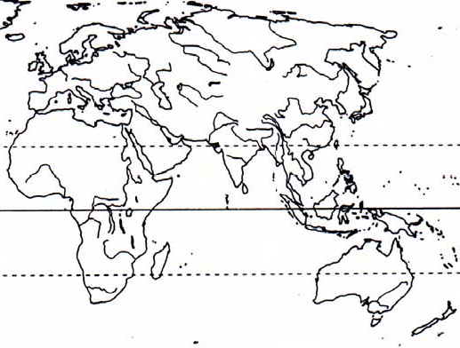
Encounters and Exchanges
in the Indian Ocean

Key (Legend)
Using Primary Documents: Statements from Travelers and Traders in the Indian Ocean
Written responses

2. Which city or port seems to have traded with what other cities or ports?

4. Using these quotes/statements and your map, write a summary explaining what was happening in the Indian Ocean in the general period 600 to 1500 CE.

5. Briefly identify one major event that occurred in Afro-Eurasia that might have effected what was described in one or more of these quotes and then explain the possible connection between these two events or areas.
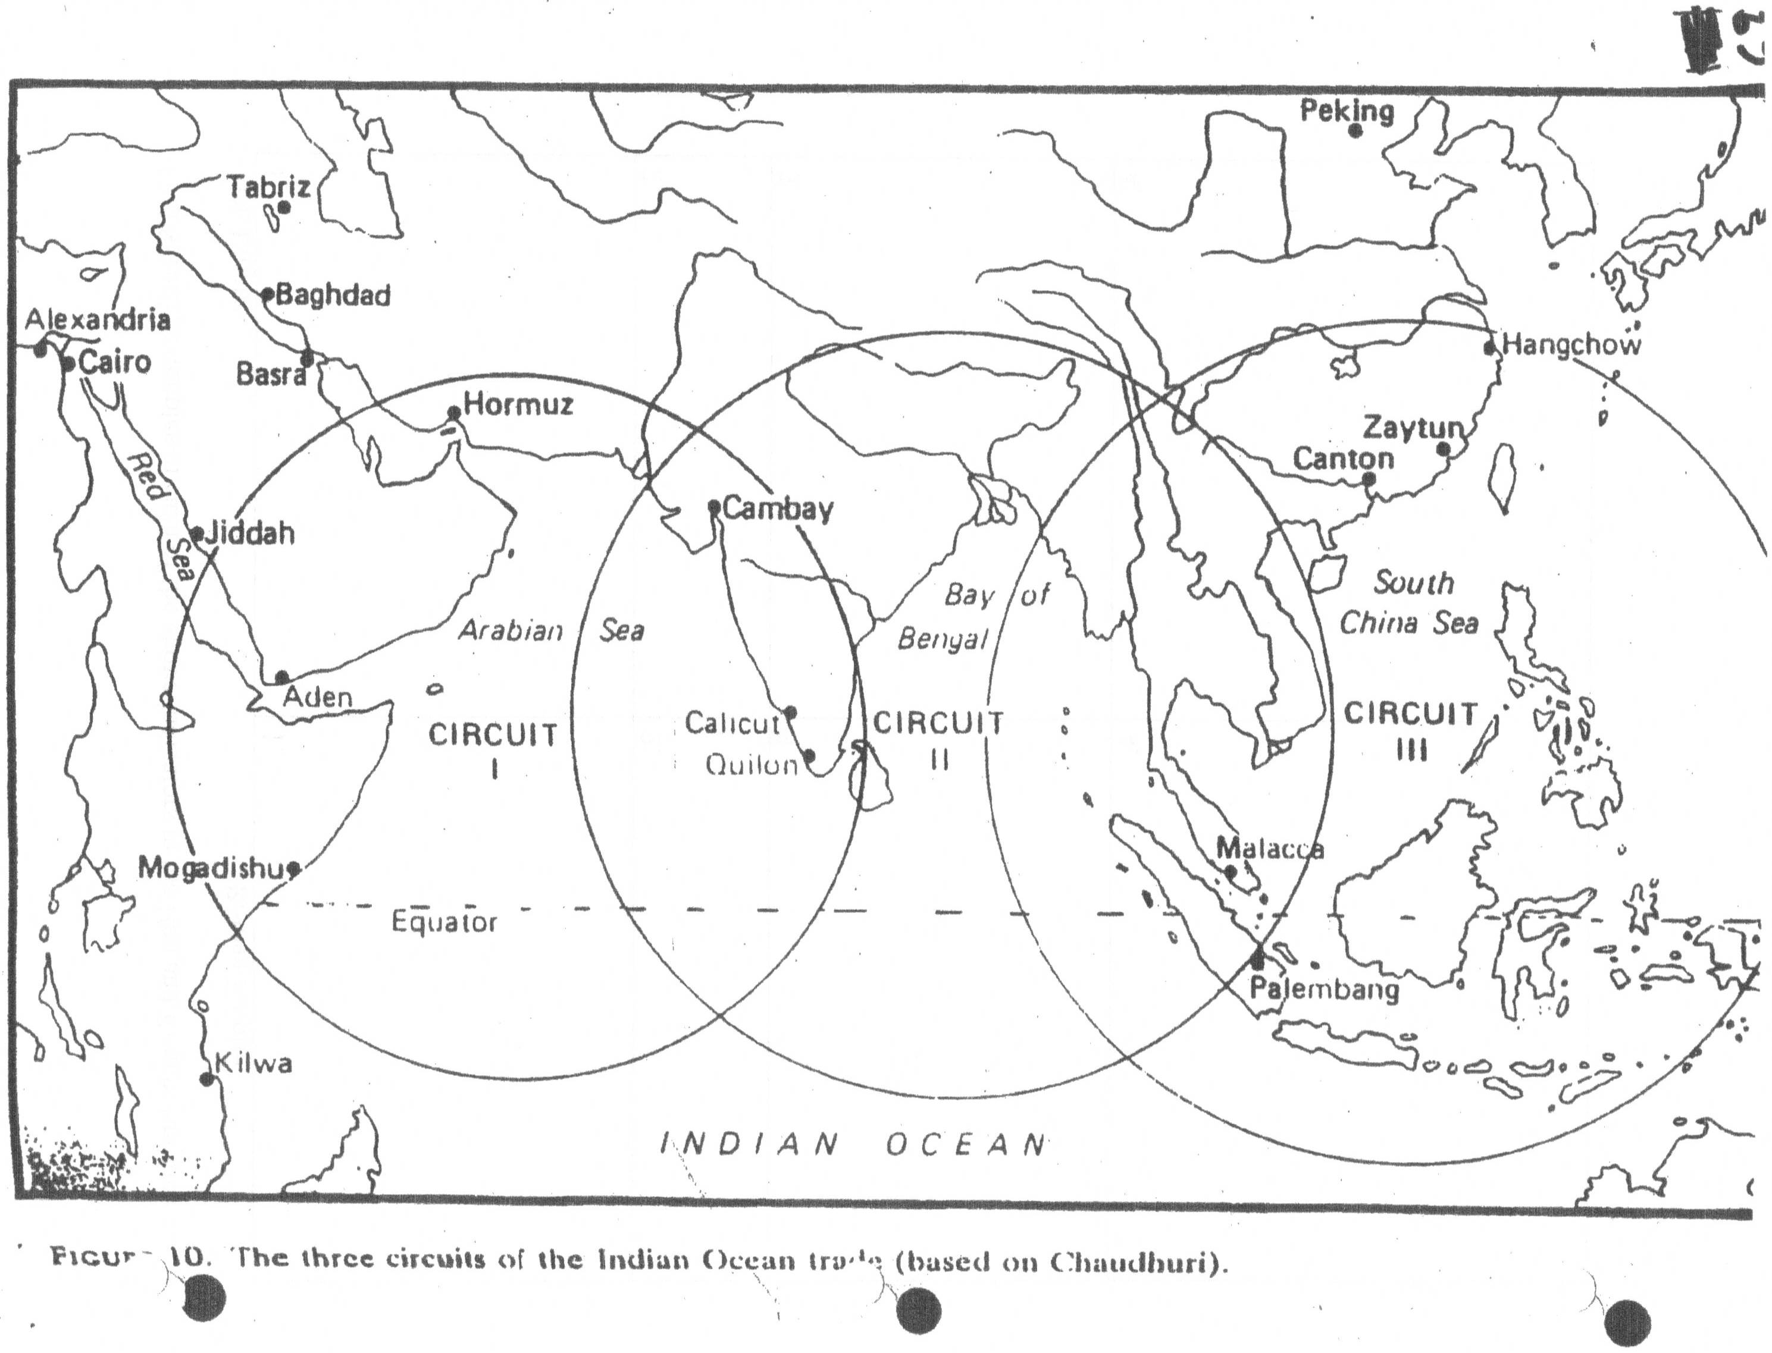

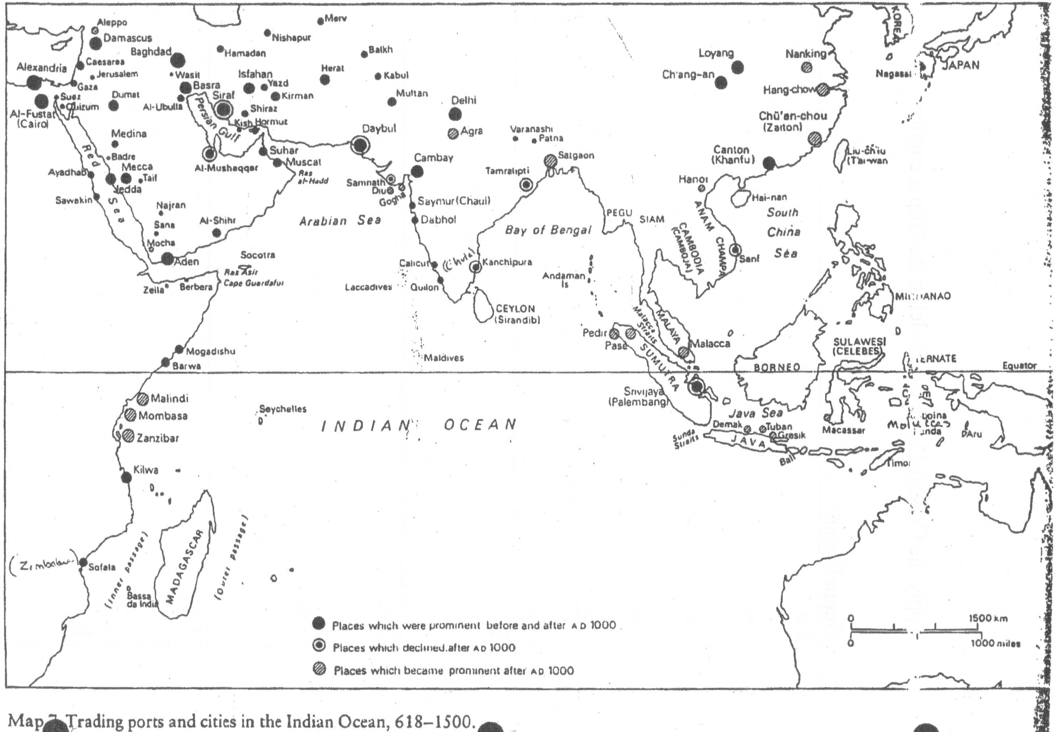

A LETTER FROM THE CAIRO GENIZA

Indian Ocean commerce was not confined to a single ethnic group. One group that played an active role was the Arabic-speaking Jewish community of Egypt, which served as an important intermediary in moving goods that originated in East and South Asia into the Mediterranean market. Those Jewish-Egyptian merchants who chose to deal directly with India sailed down the Red Sea, using Aden on the southern tip of Arabia as their midway point. From there they followed the trade winds to their Indian ports of call — usually the cities of the western coast. With luck, they returned home the next year, driven by the opposite trade winds. At a minimum, the merchant was away from home for two years. Often circumstances could extend that absence many more years.
A fairly large body of documents from the pens of these India traders from Egypt exists thanks to the discovery of the Cairo Geniza. A geniza is the place attached to a synagogue -where discarded scraps of paper on which the name of God was or might have been written are deposited. In order to preserve them from profanation, these writings are subsequently buried. When unearthed, geniza collections are a rich treasure trove for the historian. What makes the Cairo Geniza especially valuable is the fact that a large percentage of its documents are primarily secular in nature: business letters, contracts, accounts, shipping bills, court records, and the like.
The document appearing here is a letter that dates from around 1204 in which an India trader writes to his wife back home in Cairo. Portions of the letter are missing, as the brackets in the present translation show. The modern editor and translator of this letter concludes that the letter's lack of an address and some other major missing parts indicate that the author of the letter probably never sent it to his wife, perhaps having second thoughts about its revealing frankness. Rather, he returned to Egypt safely, was reunited with his wife, and personally deposited the draft letter in the geniza. Whatever the truth, the fact is this letter is an important document because it clearly shows us the hazards and strains of long-distance commerce.

1. Escape of the Family from the Plague
Would I cry to describe the extent of my feelings of longing and yearning for
you all the time, my letter would become too long and the words too many. But He
who knows the secrets of the heart has the might to bring about relief for each of us
by uniting us in joy.
Your precious letters have arrived; I have read and scrutinized them, and was
happy to learn from them that you are well and healthy and that you have escaped
from those great terrors, the like of which have not been experienced for many
generations.¹ Praise be to God for your deliverance and for granting you respite
until you might be recompensed in a measure commensurate with your sufferings.

2. The Dedicated Husband
In your letters you alternately rebuke and offend me or put me to shame and
use harsh words all the time. I have not deserved any of this. I swear by God, I do
not believe that the heart of anyone traveling away from his wife has remained like
mine, all the time during all the years — from the moment of our separation to the
very hour of writing this letter — so constantly thinking of you and yearning after you
and regretting to be unable to provide you with what I so much desire: your legal rights
on every Sabbath² and holiday, and to fulfill all your wishes, great and small, with
regard to dresses or food or anything else. And you write about me as if I had forgotten
you and would not remember you had it not been for your rebukes, and as if, had you
not -warned . me that the public would reprove me, I would not have thought of you.
Put this out of your mind and do not impute such things to me. And if what you think
or say about my dedication to you is the product of your mind, believing that words of
rebuke will increase my yearning — no, in such a way God will not let me reach the
fulfillment of my hope, although in my heart there is twice as much as I am able to
write. Bur he is able to have us both reach compensation for our sufferings and then,
when we shall be saved, we shall remember in what situation we are now.
3. Travel beyond the Coroniandel Coast³
You rebuke me with regard to the ambergris.⁴ You poor ones! Had you known
how much trouble and expenses I have incurred to get this ambergris for you, you
would have said: there is nothing like it in the world. This is the story: After I was
resurrected from the dead and had lost all that I carried with me I took a loan of [. . .]
dinars⁵ and traveled to countries beyond al-Ma'bar.⁶ I checked my accounts and
found [ ] with "the decimals." ⁷ I took them and paid to one of our coreligionists who
traveled back from al-Ma'bar to Aden . . . and for it he bought for you [. . .].

4. Drunk but Pious
This was my way of life from the moment I left you until I arrived in Aden (and
from there to India) and from India back to Aden:⁸ Day and night I was constantly
drinking, not of my free will,⁹ but I conducted myself in an exemplary way¹⁰ and if
anyone poked fun in foul speech in my presence, I became furious with him, until he
became silent, he and others. I constantly fulfilled what God knows, and cursed my
soul by fasting during the days and praying during the nights. The congregations in
Aden and in India often asked me to lead them in prayer, and I am regarded by them
and regard myself as a pious man.

5. As to Divorce —- The Choice Is Left to the Wife
Now in one of your letters you adjure me to set you free, then letters arrived
from the old man¹¹ saying the same.
Now, if this¹² is your wish, I cannot blame you. For the waiting has been long.
And I do nor know whether the Creator will grant relief immediately so that I can
come home, or whether matters will take time, for I cannot come home with nothing.
Therefore I resolved to issue a writ which sets you free. ¹³ Now the matter is in your
hand. If you wish separation from me, accept the bill of repudiation and you are free.
But if this is not your decision and not your desire, do not lose these long years of
waiting: perhaps relief is at hand and you will regret at a time when regret will be of
no avail.

¹ A reference to the famine and plague that devastated Egypt between 1201 and 1203

² Talmudic law (Chapter 6, source 49) dictated that a scholar was to visit his wife once a week on the night of the Sabbath — namely, Friday night. This merchant considered himself a member of the class learned in the Law.

³ The southeast coast of India. Few Jewish merchants from Egypt went to India's eastern coast. To sail to the Southeast Asian lands beyond it was extraordinary

⁴ A waxy substance that sperm whales expel and that is added to perfumes

⁵ Arabic gold coins

⁶ The Coromandel Coast (see note 6)

⁷ His abacus

⁸ Apparently he is now back in Aden

⁹ But out of the sorrow that came from his separation from his wife

¹⁰ Apparently he drank himself silly but avoided prostitutes

¹¹ Her late father

¹² The divorce (setting her free) mentioned above

¹³A conditional bill of repudiation, which becomes a valid divorce once she accepts it

