Japan, Vietnam, and Korea in the Post-Classical Age: The Spread of Civilization in East Asia

I. Geography Influences History

A. Relative Location
1. Korea, Vietnam border China
2. Japan located off coast of East Asia

B. Physical Characteristics
1. Korea, Vietnam
a. Mountainous, cut by river valleys
b. Population located on plains
2. Japan
a. Volcanic islands, very mountainous
b. Deep valleys with plains

C. Demography
1. Populace generally heavy on plains
2. Rice was principal crop
3. Cities exist but more rare than China
a. Cities: centers of Chinese culture
4. Countryside: resistant to Sinification
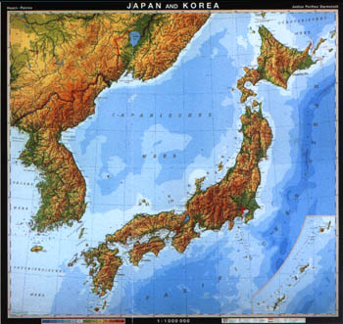
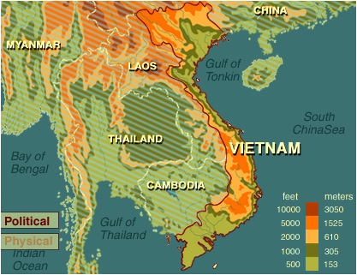

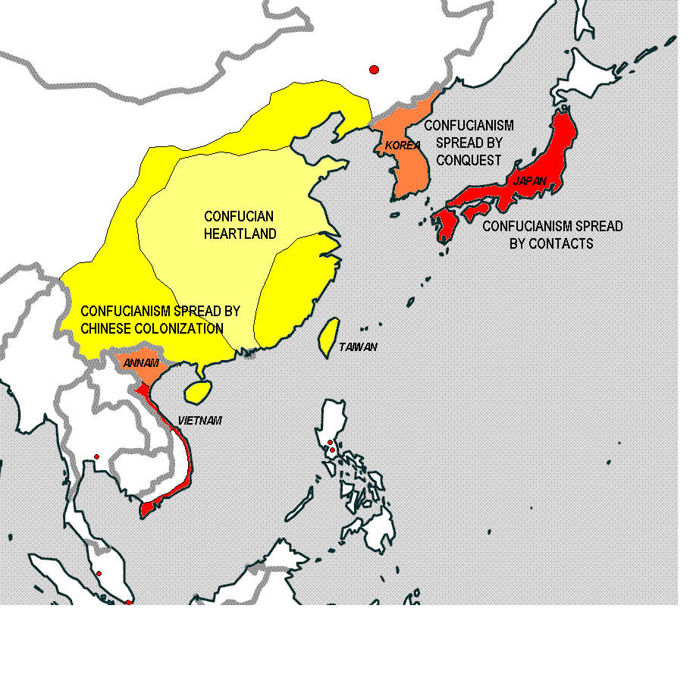The Confucian World

II. Korea: The Bridge

A. Korea in the Ancient and Classical Periods
1. Influenced by developments in China
a. Chinese armies invaded periodically
b. Chinese established control of parts of Korea
2. Nomadic invasions frequent
3. Fall of Han left regional Korean aristocrats in control

B. Korean History 669 – 1392 A.C.E.
1. Tang armies conquered much of Korea
a. Silla dynasty allied with Tang, ruled peninsula
b. Entered into a tributary relationship with China
2. Song replaced Tang
a. Koguryo conquered Silla in 935, ruled to 1392

C. China's influence in Korea
1. Sinification = becoming Chinese
a. Koreans borrowed what was useful, unavoidable; avoided what was not
2. Tributary embassies included Korean royal officials and scholars
3. Silla kings built new capital at Kumsong modeled on the Tang capital

D. Older Traditions
1. Ancestor worship strong in Korean society
2. Korean officials trained in Confucian ideas during Han, Tang but not as strong

E. Newer Traditions
1. Korean elite turned to Neo-Confucianism
2. Peasants turned to Chan Buddhism

F. Difference from China
1. Aristocracy and royal houses dominated Korea

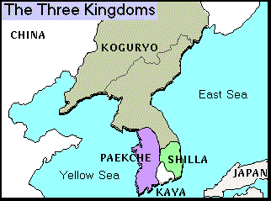

III. Vietnam: A Border State

A. Nam Viet people originated in Southern China
1. Rise of Han and southern settlement of Chinese pushed Viet out
2. Viet migrated into Red River Valley, down coast fighting local inhabitants

B. Vietnam under Chinese rule 111 B.C.E. to c. 983 A.C.E
1. Han first conquered Northern Vietnam in 111 B.C.E
a. Viet elites adopted Chinese agriculture, schools, thought; intermarried
b. Massive migration of Chinese official, scholars, bureaucrats to Vietnam
2. Trung sisters led revolt against Chinese rule (40 – 43 A.C.E.)
a. Peasants resented Chinese influence, role of towns, cities
b. 1,000 year struggle for independence
c. Relationship often tributary to China

C. Independent Vietnam (c. 983 A.C.E.)
1. Ruled by Dynasties, capital moved between Hanoi, Hue
2. Constant pressure against hill peoples, pushing south

D. Difference from China
1. Role of village equal to role of family in China
2. Few cities; village dominate countryside, elders ran villages
3. Many Vietnamese retained their religious traditions
4. Women played more prominent roles in Vietnam
a. Could be head of households, own land, engage openly in business
b. Were often leaders of villages and even at national level
5. Chinese influence in Vietnam limited to the elite
a. Elites adopted bureaucracy, form of state, emperorship, Confucianism
b. Adopted Chinese script, literary and artistic models
6. Mahayana Buddhism (although region is Theravada) also arrived
7. Irrigation and water control techniques

IV. Early Japan

A. Ancient Japan
1. Earliest inhabitants were nomadic Caucasians (Ainu) from Northeast Asia
2. Japanese related to Koreans, migrated into islands, pushed Ainu north
a. Ruled by several dozen states dominate by clans, 1st millennium BCE

B. Shinto: Ancestor veneration with deification of nature, spirits (kami)

C. Nara Japan (710-794 A.C.E.)
1. Inspired by Tang, Yamato clan claimed imperial authority
a. The imperial court modeled on that of the Tang
b. Built a new capital (Nara) in 710 C.E., modeled on Chang'an
c. Prince Shotoku wrote first Japanese constitution
d. Adopted Confucianism and Buddhism, but maintained Shinto

D. Heian Japan (794-1185 A.C.E.)
1. Moved to new capital Heian (modern Kyoto) in 794 A.C.E.
2. Japanese emperors as ceremonial figureheads and symbols of authority
a. Effective power in the hands of the Fujiwara family
b. Emperor did not rule
c. Lived in splendid isolation along with court elite
d. Effected by bureaucrats, complex etiquette
3. Chinese learning dominated Japanese education, culture
4. The Tale of Genji
•Women contributed most to Japanese literature and writing

E. Decline of Heian Japan
1. Equal-field system began to fail
a. Aristocratic clans accumulated lands
b. Rivalry between court nobility and landed aristocracy
2. Taira and Minamoto, the two most powerful clans, engaged in wars
a. The clan leader of the victorious Minamoto claimed the title of shogun

V. Medieval Japan

A. Japanese feudalism
1. Called the Shogunate Period
a. Military dictators ruled, Emperors reigned in splendid isolation
2. Government was centralized feudalism
a. Countryside divided up into fiefs
b. Daimyo appointed by the shoguns
c. Adopted Neo-Confucianism as state philosophy

B. Provincial lords controlled Japan
1. Called Daimyo, vied for power against each other
2. Constant war to increase personal power, wealth, fiefs
a. Kamakura Period (1185-1333 A.C.E.)
b. Muromachi Period (1336-1573 A.C.E.)
C. The Samurai
1. The lowest class of aristocratic nobility
a. Professional warriors of provincial lords
b. Observed samurai code called bushido
. Valued loyalty, military talent, and discipline; traded military skills for food
c. To preserve their honor, engaged in ritual suicide called seppuku

D. Japanese Women
1. Legendary founder of Japan, Yamato clan was sun goddess, Amaterasu
–Under Heian
2. They were the cultural elite with elaborate rituals including dress
a. Had great influence, including several empresses
3. Under Shogunate
a. Lost considerable influence as Neo-Confucianism introduced, warfare spread
b. Could still be samurai and fight but patriarchal society
c. Shinto was also male dominated and included ancestor worship

Fiefs of Feudal Japan

