Nomadic Empires and Eurasian Integration
- Nomad Society and Economy

A. Nomadic peoples
1. Pastoral nomads
- Organized into clans with related languages

B. Central Asia's steppes
1. Good for grazing, little rain, few rivers
2. Nomads and their animals; few settlements
a. Drove their herds in migratory cycles
b. Lived mostly on animal products
3. Also produced millet, pottery, leather goods, iron

C. Nomads and settled peoples
1. A love, hate relationship of war and trade
2. Sought trade, exchange
3. Nomads maintained caravan routes

D. Fluidity of classes in nomadic society
1. Two social classes: nobles and commoners
2. Autonomous clans and tribes

E. Religions:
1. Originally: mostly shamanistic
2. Later: Buddhism, Nestorian Christianity
3. By tenth century, Turks became Muslim

F. Military organization
1. Khan organized confederation of individual tribes for expansion
2. Outstanding cavalry forces, formidable military power

- Turkish Empires in Persia, Anatolia, and India

A. Turks in Central Asia
1. Interactions
a. Long history of interaction with Chinese
b. Khitans, Oighurs and others were Turks
c. Much intermixing with Mongols
2. Oguz migrated from Mongolia to Central Asia
3. Turks created a state, society long before Islam arrived
a. Co-existed with Muslims, later converted
b. Some tribes Migrated into S. W. Asia

B. Saljuq (or Seljuk) Turks and the Abbasid Empire
1. Lived in Central Asia, borders of Abbasid, 8-10th century
2. Converted to Islam in 10th century CE
3. Invaded S.W. Asia, defeat Byzantines, Abbasids
a. Served in Abbasid armies as Mameluks
b. Overshadowed Abbasid caliphs by the mid-11th century
4. Extended Turkish rule to Syria, Palestine, other parts

C. Saljuq Turks and the Byzantine Empire
1. Migrated to Anatolia, early 11th century
2. Defeated Byzantine army at Manzikert in 1071
3. Transformed Anatolia into an Islamic society
4. Crusades launched to stop Seljuk advance

D. Ghaznavid Turks
1. Dominated northern India
2. Created Turkish Sultanate of Delhi

III. Chinggis Khan and the Mongol Empire

A. Chinggis Khan ("universal ruler")
1. Unified Mongol tribes by alliance, conquests
2. Merged into empire

B. Mongol political organization
1. Organized new military units
2. Broke up tribal affiliations
3. Chose officials based on talent, loyalty
4. Capital at Karakorum

C. Mongol conquest of northern China
1. Overran Xi-Xia
2. Jurchen (Qin, Khaitan) in north China in 1211
3. Controlled North China to Yangtze by 1220
a. South China was still ruled by the Song dynasty
4. Towns, which resisted were used as examples
a. Later towns simply surrendered

D. Mongol conquest of Persia
1. Wanted trade and diplomatic relations with Persia
a. Khwarazim ruler murdered envoys
2. Mongol force invaded Khwarazim Empire
3. Mongol forces destroyed Persian cities and qanat

E. Chinggis died in 1227, laid foundation for a mighty empire
1. Mongol rule was generally tolerant.
2. Capital of his empire at Karakorum
3. Summoned intellectuals from his conquered kingdoms
4. Offered religious toleration to Confucians, Buddhists, Taoists, and Muslims
5. Administrators drawn from examples in Islamic and Chinese worlds
6. Formulated a legal code intended to end tribal and clan divisions
7. Trade and cultural exchange flourished.

8. Mongol heirs divide into four regional empires

F. Mongol warriors
1. Excellent horsemen
2. Accomplished archers
3. Raised in the saddle and able to hunt as children

G. Mongol armies
1. Entirely cavalry
a. Depended on speed and mobility in assaults
2. Chinggis Khan reorganized the tribal armies
a. Units called tumens containing 10,000 men
b. Each unit command by separate leaders
c. Sun-units called ordas; word “horde” in English
3. Communication by flag, drum
4. Able to cover vast distances in one day
a. Based on the hunting formations of the Mongols
5. Each army divided
a. Into heavy cavalry, light cavalry
b. Lightly armored scouts preceding the main forces
6. Severe discipline
7. Spies and informers produced information, maps
8. Later Mongol forces used gunpowder, artillery

Empire at the Time of Chinggis Khans' Death
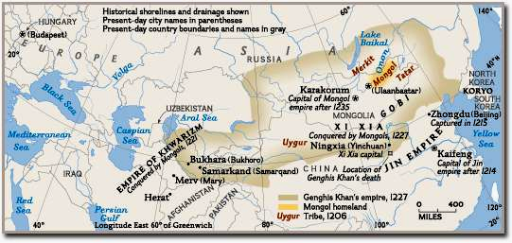

IV. Mongol Empires after Chinggis Khan

A. Khubilai Khan rules Yuan Dynasty in China
1. Chinggis Khan's grandson, consolidated Mongol rule in China
2. Conquest of southern China
a. Song Dynasty fell in 1276, Yuan Dynasty founded in 1279
3. Unsuccessful conquests of Vietnam, Burma, Java, and Japan

B. Mongol rule in China
1. New hierarchy: Mongol and allies; northern Chinese; Southern Chinese
2. Central administration reserved for Mongols, allies
a. Brought foreign administrators into China and put them in charge
b. Dismissed Confucian scholars; dismantled civil service examination
c. Favored merchants, cities, peasants over Chinese elites

C. Mongol Social Policies
1. Would not allow Mongols to settle in China nor Chinese in Mongolia
a. Outlawed intermarriage between Mongols and Chinese
2. Promoted Buddhism, supported Taoists, Muslims, and Christians
a. Forbade Chinese from learning the Mongol language
b. Mongol ruling elite adopted Lamaist Buddhism of Tibet
3. Mongol women refused to adopt Chinese customs, retained influential status

D. Mongols in S.W. and Central Asia
1. Destroyed many cities, captured Baghdad in 1258
a. Destroyed agricultural lands, irrigations systems of Iraq, Iran
b. Lands fell to the Ilkhanate of Persia; Khanate Of Chaghadai
2. Persians served as ministers, governors, and local officials
3. Mongols only cared about taxes and order
4. Ilkhan converted to Islam, 1295; massacres of Christians and Jews

E. Mongol Invasion of Africa
1. Baiburs, the Mameluk Sultan of Egypt defeated Mongol invasion of Africa

F. The Mongol Impact on Europe and the Islamic World
1. Europeans altered military organization
2. Adopt use of gunpowder
3. Mongol conquests facilitated trade across the steppes
4. Mongol armies may also have transmitted the plague infection

V. Mongols and Europe

A. Russia in Bondage
1. Russia fell under rule of the Khanate of the Golden Horde
2. Mongol conquest of Russia reduced the Russian princes to tribute-payers.
a. Payments fell heavily on the peasants
b. Peasants reduced to serfdom.
3. Some Russian cities (Moscow), recovered fortunes by increased trade

B. Rise of Moscow
1. Moscow profited as tribute collector for Mongol overlords.
2. Head of the Orthodox Church in Russia selected Moscow as his capital.
3. In 1380, the princes of Moscow turned against the Mongols
a. Led an alliance that defeated the Mongols at the battle of Kulikova.
b. Victory broke the hold of the Mongols on Russia
4. Nomads continued to make raids into the 15th century.

C. Change
1. Mongol conquest of Russia ensured changes
a. Central position of Moscow and the Orthodox Church
b. Changes in Russian military organization
c. Revised the political concepts of Russian rulers
2. Mongol dominance cut Russia off from Western Europe both politically and culturally.

D. Mongol Incursions and the Retreat from Europe
1. First Christian reaction to Mongol invasions was positive.
a. They were convinced Mongols were potential allies against the Muslims
b. Assault on Russia proved that optimism was a miscalculation
2. Successful conquest of Hungary alerted Europe to danger of Mongols
3. Mongol hordes withdrew to Asia to resolve the succession crisis
4. Lithuanians defeated Mongol return

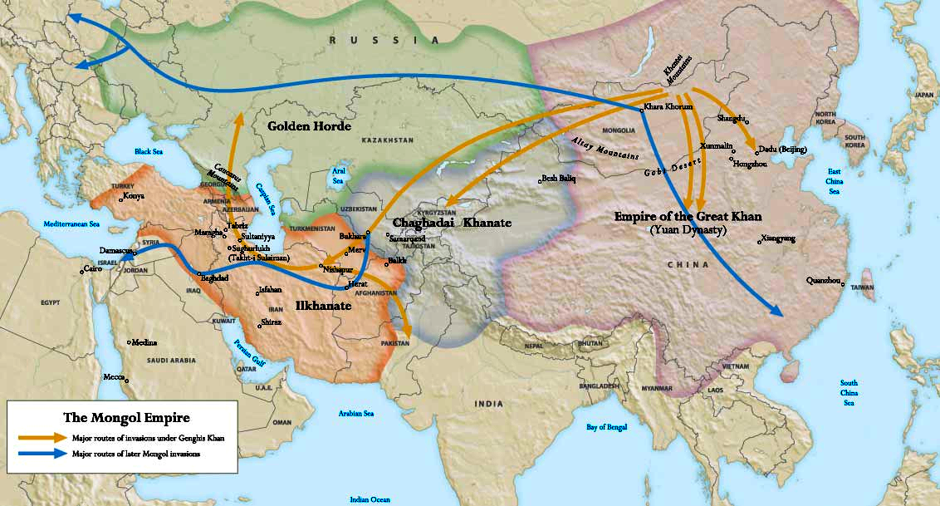

VI. The Mongols and Eurasia

A. Results of Mongols Conquests
1. Conquest destroyed all existing political structures in conquered region
a. Empire created the largest zone of continuous rule in history
b. Empire created a period of peace, prosperity in controlled regions
c. Disrupted those states it did not conquer
d. Facilitated rise of new states in vacuum
2. Forced innovation amongst existing peoples to resist Mongols
3. Mongols were a tribute empire: trade was often a byproduct

B. The Mongols and trade
1. Worked to secure trade routes, ensure safety of merchants
a. Organized protected trade caravans
b. Formed merchant/trade associations with insurance
2. Elaborate courier network with relay stations (postal stations)
3. Universal passes, protection given to merchants
a. Ordas acted as police, protection for travelers
b. Maintained order for merchants, ambassadors, missionaries
4. United Eastern Europe, SW Asia, S. Asia, E. Asian trade

C. Diplomatic missions
1. Mongol empires maintained diplomatic communications
a. Used foreigners especially Christians, Muslims as diplomats
b. Threats were backed with force
2. Established relations with Korea, Vietnam, India, Europe

D. Resettlement
1. Mongols needed skilled artisans, educated individuals
a. Resettled them in different locations to provide services
b. Uighur Turks served as clerks, secretaries, and administrators
c. Arab, Persian Muslims served Mongols far from homelands
d. Chinese served as military specialists
e. Koreans served as naval specialists
f. Christian Nestorians served as emissaries, merchants
2. Skilled artisans often sent to Karakorum

Exchanges During the Mongol Era
Black Death
Sugarcane
Buddhist religious objects
Chinese bureaucrats
Chinese artists, artisans
East Asian diplomats
Indian merchants
Indian diplomats
Muslim merchants
Nestorian merchants
Muslim diplomats
Christian missionaries
Italian merchants
European diplomats
Intellectual Exchanges of Ideas, Art, Architecture, Knowledge was constant
Spices
Gems
Perfumes
Textiles
From
South Asia
Honey
Horses
Glassware
Slaves
From
Europe
Gunpowder
Firearms
Rockets
Magnetic compass
Porcelain
Silk
Maritime Technology
Paper Making
Printing
Tea
Textiles
Rugs
Incense
Finished iron products
Finished gold products
From
East Asia
From
Southwest Asia

VII. Decline of the Mongols in Persia and China

A. Major Reason for Decline
1. Mongols too few in number, settled populations massive
a. Any interaction resulted in acculturation
b. Any intermarriage resulted in loss of identity
2. Mongol rule resented
a. Settled populations began to use firearms

B. Collapse of the Persian Ikhanate
1. Excessive spending, overexploitation reduced revenues
2. Destruction of qanats reduced agriculture productivity
3. Failure of the Ilkhan's paper money
4. Intermarriage of Mongols with local populations

5. Factional struggle plagued the Mongol leadership
a. Last ruler died without an heir; the Ilkhanate collapsed

C. Decline of the Yuan dynasty
1. Paper money issued by the Mongol rulers lost value
2. Power struggles, assassinations, civil war after 1320s
3. Bubonic plague in southwest China in 1330s
a. Spread through Asia and Europe
b. Depopulation, labor shortage undermined Mongols
4. By 1368, Chinese drove the Mongols back to the steppes

D. Surviving Mongol khanates
1. The khanate of Chaghatai continued in central Asia
2. Golden Horde survived until the mid-sixteenth century

VIII. Tamerlane (1336 A.C.E. - 1404 A.C.E.)

A. Timur the Lame: conqueror
1. Self-made; rose from poverty, to power in 1360
2. Established capital in Samarkand

B. Tamerlane's conquests
1. United tribes in Central Asia
2. Conquered Persia, Afghanistan
3. Next attacked the Golden Horde
4. End of 14th c., invaded northern India
5. Destroyed vast regions
a. Laid waste much agricultural land
6. Raids into S.W. Asia, Ottomans, Russia

C. Governance of Empire
1. Ruled through tribal leaders
a. Relied on existing bureaucrats to collect taxes
2. Used terror as weapon
a. Not interested in rule, would rather plunder
3. Collapse of Nomads following his death
a. Heirs struggled, divided empire

D. Later descendants invaded India
1. Grandson established Mughal Empire

E. China was last civilization threatened
1. Chinese converted Mongols to Buddhism as prevention
2. Manchu's overthrew Ming in 17th century for last nomadic invasion

F. Russia conquers Steppe and Central Asia
1. Employed steppe nomads (Cossacks) to conquer steppe
2. In 19th century, Russia conquered Central Asia

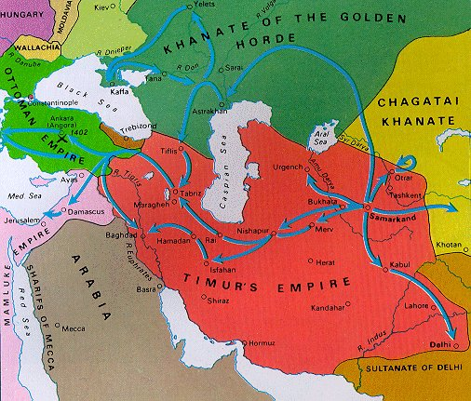

IX. The Foundation of the Ottoman Empire

A. Turks
1. Nomadic Turks migrated to Persia and Anatolia
2. Ottoman Turks settled on Byzantine border
a. Established warrior society raiding Byzantines

B. Osman
1. Charismatic leader of clan
2. Carved out a state in northwest Anatolia
a. Claimed independence from Seljuks, 1299

C. Ottomans Conquest
1. Conquer the Balkans in 1350s
2. Raided into Europe at Gallipolis (Dardanelle's)
3. Conquered Bulgaria, Serbia
4. Pushed into Greece, Defeats Hungarian crusade
5. Temporarily stopped by Timur’s invasion

D. Mehmed II
1. Sacked Constantinople in 1453
a. Made Constantinople capital as Istanbul
2. Absorbed remainder of Byzantine empire
3. Expansion
a. During 16th century: Extended empire to southwest Asia.
In southeast Europe. Into North Africa

Expansion of the Ottoman Empire
