The Chinese Silver Trade
The story of silver in China is really interesting and has been misunderstood for a long time. From 1500 to 1800, Mexico and Peru produced something like 85 percent of the world's silver. During that same period at least a third and some people would say over 40 percent of all that silver eventually wound up in China. Now what was going on there and what does it mean? The Europeans of course were not shipping the silver to China as an act of donation or charity. They were getting goods in return, such as silk, porcelain, and later especially tea.
The large volume of silver that was going there and the volume of other goods that must therefore have been coming back illustrate the dynamism of the Chinese economy. Silver supported the staggeringly large export sector. This is interesting for many reasons because it invalidates one of our stereotypes of China: that China turned its back on the sea and was not interested in the outside world.
Instead, we see massive foreign trade, which was attested to by all the silver coming in. So then the next question becomes, What did they want all this silver for? What were they doing with it? The main thing they were doing with it is monetizing it. They were making it their money supply.
For more or less coincidental geological reasons, China simply has very little in the way of precious metals: not much gold, virtually no silver, reasonable amounts of copper but not massive amounts. However, the huge Chinese population, something on the order of a quarter of humanity for most of the time since we've had decent records, developed an unusually dynamic, commercially sophisticated economy, which needed a medium of exchange: money. And that posed an enormous problem, which the Chinese solved in the Song dynasty by inventing the world's first paper money.
This again is one of the signs of early modernity: that they managed to find a medium of exchange that was extraordinarily cheap to produce. Paper money cost very little, but it required a certain technological sophistication, such as good printing. And again, it required social institutions: paper money is only as good as people's willingness to trust it.
For a couple hundred years, China had a paper currency that worked quite well, centuries before anybody else had it. This didn't last, however, because when later dynasties, the Yuan and then especially the early Ming, got into fiscal crises, they did what many governments in many moments have done: they tried to solve the problem by printing money, and they undermined confidence in it.
And once burned, people are shy for a long time. It will be centuries before they trust paper money again. It meant that this huge commercial economy had to be supplied with something else, with coinage. And what China turns to, for a whole series of reasons that are imperfectly understood, is silver.
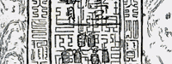
Chinese paper money, Ming dynasty.
Silver Turns to Opium
Eventually the Europeans, for reasons of their own, became reluctant to continue shipping so much silver to East Asia. This is largely because they preferred to hoard the silver so that they could use it to pay mercenaries in their ongoing wars. They started looking for something else to export to China and found that they were in a real bind because there were very few things that they produce more efficiently than the Chinese could. The thing that eventually filled the gap left when the Europeans tried to cut back on their silver shipments was opium.
Opium served a whole series of functions for the British in particular. It helped make their new colony in India profitable by providing a very ready revenue source. It saved on the silver that they no longer wanted to ship and, of course, the story of the opium trade to China then gets us into a whole different period of world history and different kinds of links between China and the outside world.
During this period when silver was flowing to China, the Mexican peso became the standard coin throughout much of the world. In some ways, it was the first global product with a brand name—"Mexican pesos," not "silver," was the preferred term for currency among many peoples.
Pesos were so familiar in China that they had cute little names for them. One of the kings of Spain, whose image was on the peso during his reign, looked to the Chinese like Buddha, so they referred to this as the "Fat Buddha" coin or the "Buddha Head" coin. And they were so used to this that, in fact, they drove world demand for this particular coin. Long after this particular Spanish king was dead, other people discovered that the Chinese wanted coins with this particular image on them, so the price of the coins rose.
As a result, people such as the Dutch were making coins with the face of a particular long-dead Spanish king on them because the Chinese wanted them. (Much as people today make fake Prada handbags to satisfy consumer demand.) The Chinese market for coins, essentially, set the global standard. These coins were also so common in China that land contracts normally had a price in copper or some local medium, and then in a little handwritten note on the side next to the standard price, they told you how much that was in Spanish or Mexican pesos. It was just a part of life there.
The Columbian Exchange and Asia
The silver trade really, in certain fundamental ways, brought the world together in a way it never had been before.
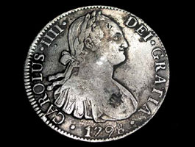
Silver coin from Mexico
with bust of Carlos IV, minted 1798
asiannumismatic.com
In preindustrial conditions, there aren't very many goods that are so valuable per pound that they're worth shipping huge distances. So it takes luxury goods—things like silver and silk—to make the long distance voyage profitable. You never would have made the voyage if what you had to sell was just grain or lead or whatever because it wouldn't have been worth it. It's not worth enough per pound to bear the shipping costs.
But once you're going anyway, all sorts of other things go with you. Goods go because you need ballast in the boat. Crop varieties go, too. Part of the story of the early modern world is also what has been called the Columbian exchange, in which all these New World plants that had not been known in Africa and Eurasia came to the Old World as a result of the European conquest of Latin America. We tend to emphasize the story of Europe; it's the story we know best, but those things came to Asia as well. Crops like the potato, the sweet potato, the peanut, corn, the chili pepper, the tomato, et cetera were tremendously important. Just try to imagine Italian cuisine without the tomato or Sichuan food without the chili pepper.
  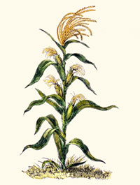
  Corn from the New World was introduced into China.
  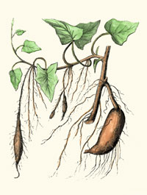
  Sweet potatoes, one of the New World crops introduced to China.
All these things came to Asia as well as to Europe and, in fact, in some cases, they were actually adopted faster in East Asia than they were in most of Europe. And they fit very particular ecological niches that were quite important. The potato, the sweet potato, corn, the peanut, all made it to China by 1600, on a very small scale, but they really took off in the eighteenth century.

