Parts of a Window | General Shortcuts  Open Menu ‘alt’ + Letter  Help ‘F1’  Undo ‘ctrl’ + Z  Close a Window ‘ctrl’ + ‘F4’  Editing Shortcuts  Cut ‘ctrl’ + X  Copy ‘ctrl’ + C  Paste ‘ctrl’ + V  *Insert two functions  Short Cut Desktop Menu | K  E  Y  B  O  A  R  D   | S  H  O  R  T  C  U  T  S
Title bar  Menu bar  Tool bar | 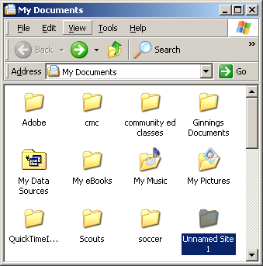 | Close  Maximize button  Minimize button  Scroll Up  Scroll Bar  Scroll Down

File Management
File Management | Terms:
File Management | Parent Directory:
To open a folder: Double-click the file or folder.  To create a folder: Right-click/New/Folder/type a name  To Rename a file or Folder: Select the folder/’F2’/type name of folder *keep in mind the extention  To Delete a File or Folder: Select the file or folder/delete on the keyboard  To Restore a deleted File: Open Recycle Bin/Right-click the item you want to restore. Select restore.  To Empty the Recycle Bin: Right-click the Recycle Bin/empty  Move/Copy a Folder: Right-click the folder/copy *Navigate to the desired location Right-click/paste  To Copy a folder to a different drive: Right-click the folder/send to/drive letter  To Change the View: Select View from the toolbar  To Select Multiple folders: ‘ctrl’ + click on the file or folder  To Select a Group of folders: Mouse an imaginary box around the folders  To Find a File: Start/Search/Enter the search conditions/Search  To Display the Folders Pane: Right-click Start/Explore/*navigate to your desired location  To View a File Properties: Right-click the file/properties  Save vs. Save as: Save-new item Save As: resaving  File/Save As/looking:=location/name: file name | Files/Folders:
 | Right-click:
 | Recycle Bin:
 | Drive:
 | View:
 | Menu:
 | Tree:
 | Associations:
 | Task Bar Composition
Start
Minimized Open Applications
Quick Launch
System Tray/Notification Area
Toolbars
Task Manager
Windows Layouts

 | My Computer Management
My Computer/Tools/Folder Options
General: browse folders options
View: hidden

