Advanced Technology Complex
DENTON ISD
2011-2012

Student Handbook
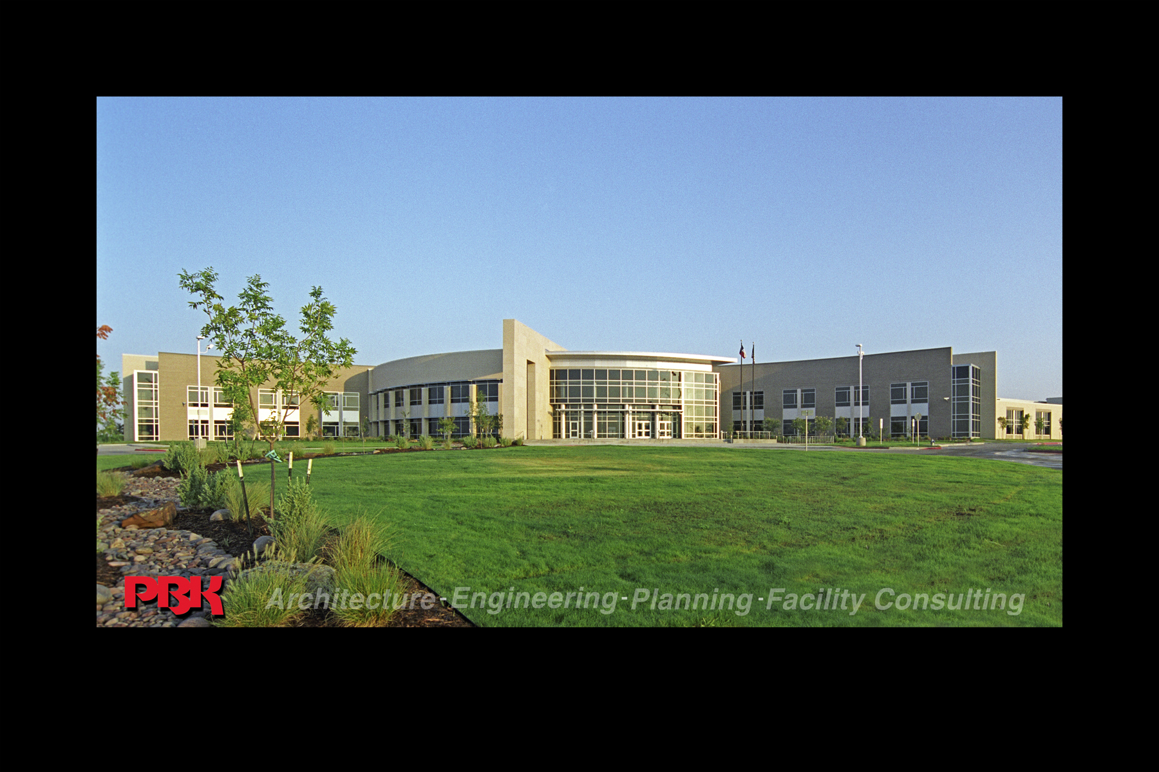

Sarah and Troy LaGrone
Advanced Technology Complex
1504 Long Rd
Denton TX, 76207
(940) 369-4850

Mission Statement
The mission of Career & Technology Education is to prepare students to succeed in high demand occupations within the 21st century’s competitive global economy.
- Rigor & Relevant Instruction
- Seamless Education Transition
- High Demand Occupations
- Community College Credits
- Aligned Educational Models
- Preparation for the Future
What do we do?
Technology is vital for the 21st century. To keep pace in the rapidly changing world, the Advanced Technology Complex was opened in August of 2006.
It is a professional training facility to prepare high school students and adults for today’s and tomorrow’s high demand careers.

Its main purpose is to provide an innovative advanced learning environment that partner with business/industry and aligns with university/community college programs to maximize student potential for success. Each academy specializes in students earning university or community college credit and/or professional certifications and licenses.
Advanced Technology Complex Programs

Architecture and Construction
Arts, Audiovisual Technology, and Communication
Business Management and Administration
Career Planning
Education and Training
Finance
Government and Public Administration
Health Science
Hospitality and Tourism
Human Services
Information Technology
Law, Public Safety, and Security
Manufacturing
Marketing, Sales, and Services
Science, Technology, Engineering, and Math
Transportation, Distribution, and Logistics

Introduction

The Advanced Technology Complex is where your academic skills meet the “real world” and it is my honor to welcome you to the next level in prepare for your future. You have the opportunity to graduate with advanced credits and/or certifications that will enhance your lifetime earning potential and open many doors.

Just remember it is you’re personal commitment and effort that will take an elective and make it an investment. So, sign up for the community college credit and meet the requirements and/or save your money for the professional exam fees to earn a professional certification.

The ATC is all about you and your future, so join the other 1,200 students from Denton, Argyle, Aubrey, Krum, Lake Dallas, Little Elm, Pilot Point and Sanger School District and make it your own “Cutting Edge” experience.

Advanced Technology Complex

Campus Phone Numbers
Main Office 940-369-4850
Attendance…………………………………………………………………..940-369-4856

Administration

Carla Ruge, Dean cruge@dentonisd.org

Career Counselors

DHS – Kim Keith kkeith@dentonisd.org
RHS – Patsy Chilcote pchilcote@dentonisd.org
GHS – Jeanie Bragg jbragg@dentonisd.org

The Denton Independent School District does not discriminate on the basis of sex, handicap, race, color, and/ or national origins in its educational programs. Admission to career programs is based on age, grade, interest, aptitude and ability. Lack of English language skills will not be a barrier to admission and participation in any educational programs. For information about your rights or grievance procedures, contact the Title IX Coordinator, Dennis Stephens, at 1307 N. Locust, Denton TX, 76201, (940) 369-0000.

Student Expectations
Students should remember that many ATC courses are college level in all respects. The curriculum is the same as used on the community college level. Students are expected to conduct themselves as college students.

It is important to understand that many of the ATC programs provide students with “hands on” and “real world” experiences by providing personal services or internships in the Denton area. Our clients give of themselves and their property for the education of our students. We must protect and promote the professional relationships the Denton County community has given the students and staff of the ATC.

ATC students shall maintain at all times the professional behavior, attitude, dress, and work ethic appropriate for the program in which they are enrolled. Students working with the community are expected to be punctual and accept personal responsibility for their actions. The ATC staff expects all students to take advantage of this facility and challenge themselves beyond their comfort zones to learn, grow, and explore future possibilities.

Community Placement Expectations
Students in internship positions are expected to follow the student code of conduct rules, student handbook and community member’s rules while at internship placement. At any time a student could be removed for violation of these policies and will not be allowed to return to community placement position without permission from the Dean.

Student Fees
Each program at the ATC has a required course fee that needs to be paid by August 26, 2011. This fee provides the basic uniforms, entrance requirements for program and any student material needed to complete course. The student could be removed from requested program before the start of school, if fees are not paid by deadline.

Professional Portfolio
Each student is expected to develop their personal professional portfolio. Personal skills and knowledge, as well as, successful completion of advanced credit via universities, community college and professional exams will be maintained. This professional documentation will prove to be useful throughout your lifetime.

College Week-NorTexas
The students at the ATC are provided the opportunity to attend a college fair at the University of North Texas on September 20, 2011 from 6:30-8:30 pm. This event provides the students with a chance to hear about scholarships, financial aid, application processes and student events on campus.

Bell Schedule
Morning class
9:00 1A/B Bell Rings
9:10 Late Bell
12:00 Bell Rings All Denton High School Students dismissed
12:10 Bell Rings Guyer/Ryan/OOD students are dismissed.

Afternoon Class
12:45 3B Bell Rings
12:50 Late Bell
3:50 Dismissal Bell for All Students

Dress Code Policy
ATC students shall wear appropriate uniforms as designated by Program Instructor.District Dress Code will be strictly enforced which is available in the Denton ISD Student Code of Conduct.
- Students will be provided an ID to wear. The ATC ID is to be worn in the building at all times. If student does not have an ATC ID, they are expected to serve a 1 hr detention or pay $3 for a replacement.
- It is not acceptable to wear clothing with holes or clothing that is torn, severely worn, or frayed to the ATC. Students will be asked to change clothes provided by the ATC or brought by a parent.
- Short Shorts and skirts are not allowed to be worn at the ATC.
- Facial piercings are not to be worn anytime during school hours or at any ATC event held before or after school hours.
- Hats will not be worn in the building unless it is part of your program and maybe worn inside your program area only. EX: Auto tech student may wear their hat in the automotive lab area. If a student caught with a hat on in the building, that hat will be confiscated and maybe returned to student upon serving a 1 hour detention. After the first infraction, hats will be confiscated until the end of the semester and can be picked up on the last day of school. If student fails to pick confiscated property within 10 days of the semester, the hats will be disposed off at that point.

Electronic Devices

Students are not permitted to possess such items as pagers, radios, CD players, tape recorders, camcorders, DVD players, cameras, electronic devices or games at school, unless prior permission has been obtained from the principal. Without such permission, teachers will collect the items and turn them in to the principal’s office. The principal will determine whether to return items to students at the end of the day or to contact parents to pick up the items.

Please refer to the Acceptable Use Policy for appropriate use guidelines for cell phones, laptops and approved web enabled devices. The school reserves the right to collect any web-enabled device that is not being used appropriately or that is not being used for an approved academic purpose as determined by the principal. Confiscated paging devices, cell phones, telecommunications devices, laptops or web enabled devices may be returned to the parent after a payment of a $15.00 administrative fee is received. In the event of repeat offenses, the device will be returned at the end of the semester after payment of a $15.00 administrative fee. This handbook serves as notification that the school will dispose of any confiscated paging devices, cell phones, telecommunications devices, laptops or web enabled devices, 10 business days after the end of each semester if no claim is made and no fee is paid. The school assumes no responsibility for lost, stolen or broken electronic or telecommunications devices confiscated in accordance with school policy.

Note: Students here at the ATC are allowed to use cell phones during their break times and in the hallways during non-instructional times.

Web Enabled Devices from Home
DISD will grant students in grades 6-12 permission to bring a personal web-enabled device from home to campus for their academic use. Student use of personally-owned devices in the classroom setting will be at the discretion of campus administration and/or classroom teachers.
Students who use web-enabled devices from home will have access to wireless Internet but will not have access to any district drives such as network folders. Network drives can only be accessed via district machines.

Students must check in their device with the Campus Tech as well as give them the administrator login to the device. A service tag will be placed on the device to let staff know the device has been checked in. DISD is not liable for any loss or damage incurred, nor can it load any software onto a student web-enabled device (software & hardware). Students should secure their devices in a locked locker. All students’ laptops and digital devices should be clearly labeled with the student’s name.

Identity theft is a growing problem. We recommend that any personally sensitive files (such as tax documents, social security information, bank records, etc.) are removed from any device before it is used on campus.

Users will not loan their device to someone else. The user is responsible for any content on the device regardless of how it originated. All technological devices brought onto a DISD campus are subject to search and seizure. Improper or non-educational use could result in loss of privileges for the on-campus use of such devices.

DISD is not responsible for lost, damaged, or stolen devices. Any dispute involving Acceptable Use of district or personal resources will be settled at the discretion of District personnel.

Student Parking:
Students who drive themselves to the ATC shall provide a valid driver’s license and proof of liability insurance. Drivers are required to purchase a parking pass, either a $25.00 for reserved assigned parking or $10.00 for unassigned parking at C.H. Collins. Students will receive a parking pass that shall be affixed to the vehicle in the designated location. Students shall not drive to or from the ATC with any passengers. Students are not allowed to go to the parking lot during class unless they get permission from the front office. Any car parked on the ATC campus may be searched at any time.

Consequences for vehicle violations could include:
- Saturday detention
- Parent conference with signed behavior contract
- Loss of driving privileges
- Towing of the vehicle at owners expense
- ATC Administration may recommend removal from all ATC programs

Transportation
Students that drive to the ATC are expected to follow the following rules:
- A student cannot carry passengers or be a passenger in another student’s car due to liability concerns.
- Students are expected to proceed directly from one campus to another.
- Student is expected to provide required driving information to the ATC, which includes a copy of driver’s license and insurance for the car.
- Students are expected to drive safely and follow all local and state regulations (laws)
- Students are expected to follow all driving and parking regulations at both campuses.

A student’s failure to follow these rules will result in disciplinary action.

Parent Expectations:
Student success is enhanced through parent involvement. The more parents participate in their child’s education the higher achievement they can expect. The ATC staff and administration ask that parents assist our students in learning the importance of professionalism and putting forth their best effort. The ATC programs give students an exploratory view into the professions in which they are interested. The experiences can only be maximized by our students setting goals and taking advantage of every opportunity to excel academically and behaviorally.

Entrance to the building
All students are required to come through the front or back door in the middle of the school. Students caught letting other students in through any side doors will receive appropriate discipline.

Leaving School Early
Students must do the following in order to leave school early:
- Take note to front receptionist counter before your class.
- The office will phone a parent to verify note and give you an early release pass.
- Student must show pass to teacher and sign out using the automated system at the receptionist counter.
- Failure to sign out will result in disciplinary action

Absences
In order to receive credit in class, students must attend 90% of each of their classes per semester. When students miss classes at the ATC, they are missing two class periods. A student with 4 or more unexcused absences at the ATC, during a semester, will lose credit for that semester. ATC may offer credit recovery classes for an additional fee.

When returning to school after an absence, a student must submit an absence note to the front office at the ATC attendance office. In order for the absence to be considered excused, a note must be provided within 48 hours of the students return to school.

Students Absences are taken each class period during the day.

Morning Class
- 1st Period Students who arrive after 9:15 should be marked absent
- 2nd Period Students who arrive after 10:15 should be marked absent
- 3A Period Students who arrive after 11:15 should be marked absent
Afternoon Class
- 3B Period Students who arrive after 1:00 should be marked absent
- 4th Period Students who arrive after 2:00 should be marked absent
- 5th Period Students who arrive after 3:00 should be marked absent

All students are required to sign in at the front desk after 9:10 and 1:00 pm. They will receive a slip to take to their teachers to admit them to class. Students that have early morning classes and scheduling issues from their home campus have a permanent pass issued on their ID and will not have to stop at the front desk. If you forgot your ID, then you will have to stop at the front desk.

Advanced Technology Complex
Faculty

Instructor | Phone | Dept
Brenda Buster | 369-4898 | Cosmetology
Carrie Sisco | 369-4877/76 | Health Science
Chris Langford | 369-4873 | Cisco/Computer Technology
Chris Vochoska | 369-4861 | Animation/Media Tech
Chuck Brazile | 369-4870 | Architecture/Welding
Cindy Greenleaf | 369-4862 | Court Systems and Practices
Deana Wilson | 369-4895 | Ad Design
Dial Swofford | 369-4863 | Health Science/Pre-LVN
Jeff Arrington | 369-4864 | Forensic/National Security
Joe Faddis | 369-4867 | Electronics
Katrina Chancellor | 369-4897 | Cosmetology
Larry Schenck | 369-4896 | Animation
Laura White | 369-4879 | Health Science/Pharmacy Tech
Loretta McDonald | 369-4874 | Education and Training
Mary Martin | 369-4867 | Law Enforcement
Matt Howard | 369-4886 | Auto Tech
Paul Niles | 369-4884 | Culinary
Robert Sayne | 369-4883 | Culinary/Hospitality
Russ Keith | 369-4887 | Auto Tech/Aircraft Technology
Sheila Temple | 369-4878/4881 | Health Science/CNA
Stacie Fischer | 369-4875 | Health Science
Thomas Babb | 369-4869 | Engineering
Will Milne | 369-4841 | Photography/Prof. Communications

