**Comparative Anatomy – Guided Practice**

Shown below are images of the skeletal structure of the front limbs of 6 animals: human, crocodile, whale, cat, bird, and bat. Each animal has a similar set of bones. Color code each of the bones according to this key:

|  |  |
| --- | --- |
| **Humerus [ Red ]**  **Ulna [ Blue ]**  **Radius [ Green ]** | **Carpals [ Orange ]**  **Metacarpals [ Yellow ]**  **Phalanges [ Purple ]** |

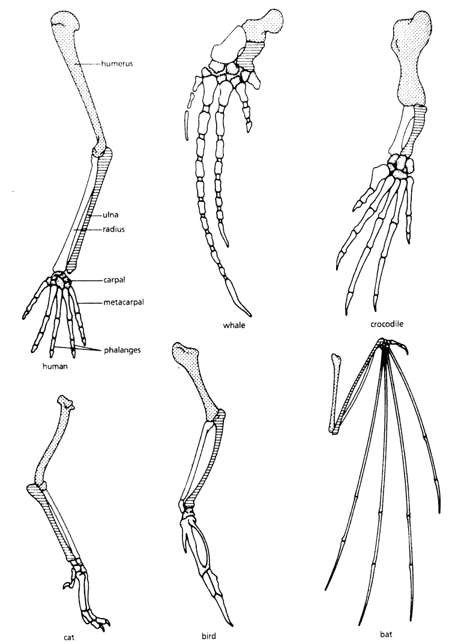

**For each animal, indicate what type of movement each limb is responsible for.**

|  |  |
| --- | --- |
| **Animal** | **Primary Functions** |
| Human | Using tools, picking up and holding objects |
| Whale |  |
| Cat |  |
| Bat |  |
| Bird |  |
| Crocodile |  |

**Compare the skeletal structure of each limb to the human arm. Relate the differences you see in *form* to the differences in *function*.**

|  |  |  |
| --- | --- | --- |
| **Animal** | **Comparison to Human Arm in Form** | **Comparison to Human Arm in Function** |
| Whale | Whale has a much shorter and thicker humerus, radius, and ulna. Much longer metacarpals. Thumb has been shortened to a stub. | The whale fin needs to be longer to help in movement through water. Thumbs are not necessary as the fins are not used for grasping. |
| Cat |  |  |
| Bat |  |  |
| Bird |  |  |
| Crocodile |  |  |

**Comparative Anatomy – Extra Practice**

**Compare the anatomy of the butterfly and bird wing below.**

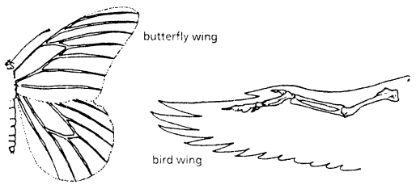

1. What is the function of each of these structures?

2. How are they different in form? Give specific differences.

**Compare the overall body structure of the cave fish and the minnow below.**

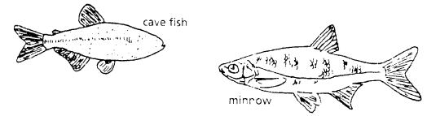

1. What is the biggest, most obvious difference between the body structures of these two fish?

2. Assume the two fish came from the same original ancestor. Why might the cave fish have evolved without eyesight?

3. What kind of sensory adaptation would you hypothesize the cave fish has to allow it to navigate in a cave, including catching and eating food?

**Comparative Anatomy – Independent Practice**

*You have now studied three different types of anatomical structures:*

* **Homologous structures** show individual variations on a common anatomical theme. These are seen in organisms that are closely related.

1. Give an example of a homologous structure from this activity: ________________________________

* **Analogous structures** have very different anatomies but similar functions. These are seen in organisms that are not necessarily closely related, but live in similar environments and have similar adaptations.

2. Give an example of an analogous structure from this activity: ________________________________

* **Vestigial structures** are anatomical remnants that were important in the organism’s ancestors, but are no longer used in the same way.

3. Give an example of a vestigial structure from this activity: ___________________________________

4. Below are some vestigial structures found in humans. For each, hypothesize what its function may have been.

|  |  |
| --- | --- |
| **Structure** | **Possible function?** |
| Wisdom teeth |  |
| Appendix |  |
| Muscles for moving the ear |  |
| Body hair |  |
| Little toe |  |
| Tailbone |  |

5. How are vestigial structures an example of evidence of evolution?

**Molecular Biology – Guided Practice**

Cytochrome c is a protein found in mitochondria. It is used in the study of evolutionary relationships because most animals have this protein. Your teacher will give you a list of the amino acids in part of a cytochrome protein molecule for 14 different animals. Any sequences exactly the same for all animals have been deleted.

1. Find the human, rhesus monkey, kangaroo, snapping turtle, bullfrog, and tuna on the "Amino Acid Sequences in Cytochrome-C Proteins from 14 Different Species" chart provided and underline their names.

2. For each non-human animal, take a **highlighter** and mark any amino acids that are different than the human sequence. When you finish, record how many differences you found in the table on the next page. For example, the number of differences between human and dog=10.

***Write that information below:***

|  |  |  |  |
| --- | --- | --- | --- |
| **Animal** | **Number of Amino Acid Differences Compared to Human Cytochrome C** | **Animal** | **Number of Amino Acid Differences Compared to Human Cytochrome C** |
| Dog | ***10*** | Tuna |  |
| Kangaroo |  | Bullfrog |  |
| Rhesus Monkey |  | Snapping Turtle |  |

3. The cladogram diagram below shows the relationship of selected animals based on their shared anatomical features. For example, out of seven key traits, all of these animals have a dorsal nerve cord, but only humans, monkeys and kangaroos have mammary glands.

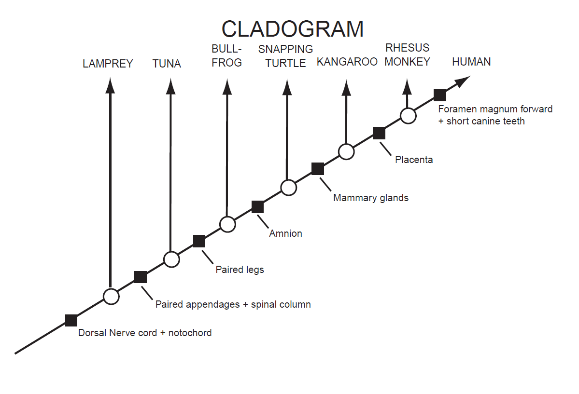

**Record** the total number of amino acid differences between humans and each animal shown below. Write your answer in the hexagon below the arrow pointing to the name of that animal.

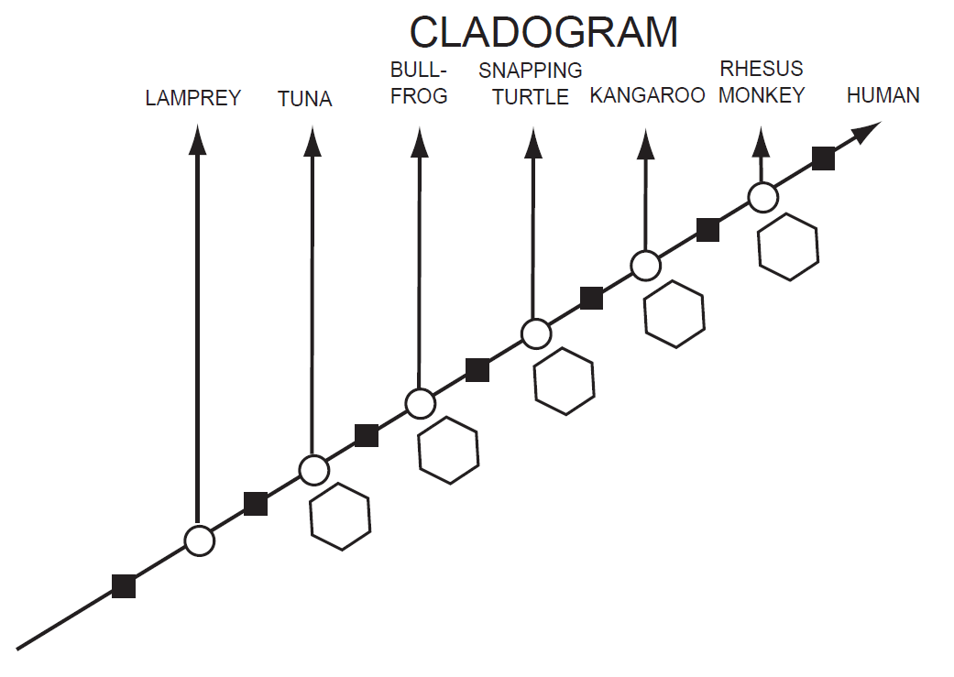

4. Based on the Cytochrome C data, which organism is most closely related to humans?

5. Does the data from the amino acid sequence generally agree with the anatomical data that was used to make the cladogram? **YES / NO**

6. Do organisms with *fewer* shared anatomical traits also have *more* amino acid differences?

**YES / NO**

7. Based on the molecular data, how does the "human-monkey" relationship compare to the "duck-chicken" relationship (which shows three amino acid differences)?

8. If the molecular data, the structural similarities, and the fossil record all support the same pattern of relationships, can we be fairly confident that the pattern is accurate? Why or why not?

**YES / NO , *because*:**

9. Write a short paragraph summarizing the important information that can be obtained from cladograms (not the information that was used to make them).

**Molecular Biology – Independent Practice**

*For each question below, explain whether the evidence is based on* ***homologous structures****,****analogous structures****,* ***molecular biology****, or from the* ***fossil record****. Then, using complete sentences, explain why it is evidence of evolution, or that life changes over time.*

Example:

**1. Humans, chimpanzees, whales, and bats all have the same bones in their arms, fins, or wings.**

**a. What type of evidence is this?** *Homologous structures*

**b. Why is this evidence of evolution?**

*This is evidence of evolution because if all these animals have the same bones, they probably all evolved from one creature that had those bones a very long time ago. Some of its children evolved (or changed) into humans, and other evolved into whales or bats or chimpanzees.*



**2. Scientists find fossilized bones of a huge animal that doesn’t exist today.**

a. What type of evidence is this? ___________________________________

b. Why is this evidence of evolution?

**3. The human gene for your muscle protein is different from monkey muscle protein in 4 places and different from a chicken’s gene in 25 places.**

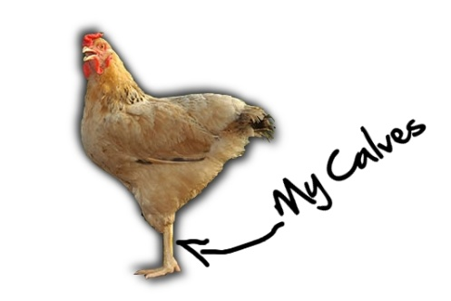

a. What type of evidence is this? ___________________________________

b. Why is this evidence of evolution?

**4. Honey possums lick nectar from flowers using a long tongue made of soft muscle. Butterflies lick nectar from flowers using a long tongue made of hard protein.**



a. What type of evidence is this? ___________________________________

b. Why is this evidence of evolution?

**5. Humans, rabbits, and zebras all have an *appendix*, an extra piece in their digestive system; although in humans it’s much smaller.**

a. What type of evidence is this? ___________________________________

b. Why is this evidence of evolution?

