CHAPTER **2**

**The Economizing Problem**

**Topic Question numbers**

**___________________________________________________________________________________________________**

1. Economizing problem 1-12

2. Economic rersources 13-19

3. Efficiency; full employment and full production 20-23

4. Production possibilities analysis 24-86

5. Opportunity costs 87-96

6. Allocative efficiency 97-108

7. Economic growth and decline 109-123

8. Applications 124-131

9. Economic systems 132-140

10. Circular flow model 141-156

Last Word 157-159

True-False 160-173

**___________________________________________________________________________________________________**

**Multiple Choice Questions**

**Economizing problem**

1. The economizing problem is one of deciding how to make the best use of:

A) virtually unlimited resources to satisfy virtually unlimited wants.

B) limited resources to satisfy virtually unlimited wants.

C) unlimited resources to satisfy limited wants.

D) limited resources to satisfy limited wants.

2. The concept of economic efficiency is primarily concerned with:

A) the limited wants-unlimited resources dilemma.

B) considerations of equity in the distribution of wealth.

C) obtaining the maximum output from available resources.

D) the conservation of irreplaceable natural resources.

3. When the economist says that economic wants are insatiable, this means that:

A) economic resources are valuable only because they can be used to produce consumer goods.

B) economic resources--land, labor, capital, and entrepreneurial ability--are scarce.

C) these wants are virtually unlimited and therefore incapable of complete satisfaction.

D) the structure of consumer demand varies from time to time and from country to country.

4. The fundamental problem of economics is:

A) to establish a democratic political framework for the provision of social goods and services.

B) the establishment of prices that accurately reflect the relative scarcities of products and resources.

C) the scarcity of productive resources relative to economic wants.

D) to achieve a more equitable distribution of money income in order to mitigate poverty.

5. The science of economics stems from the fact that:

A) the production possibilities curve is bowed inward to the origin.

B) resources are scarce relative to people's demand for goods and services.

C) individuals and institutions behave only in their self-interest.

D) historically the production possibilities curve has been shifting toward the origin.

6. The study of economics exists because:

A) government interferes with the efficient allocation of scarce resources.

B) resources are scarce in relation to economic wants.

C) the market system is an obstacle to the efficient use of plentiful resources to satisfy constrained wants.

D) resources are overly abundant as compared to wants; thus, an allocation problem exists.

7. The scarcity problem:

A) persists only because countries have failed to achieve continuous full employment.

B) persists because economic wants exceed available productive resources.

C) has been solved in all industrialized nations.

D) has been eliminated in affluent societies such as the United States and Canada.

8. Because of their scarcity, the efficient use of resources is:

A) an important issue in all economies.

B) an important issue only in centrally planned economies.

C) an important issue only in market economies.

D) not an important issue.

9. An "increase in efficiency" suggests that an economy:

A) has moved from a point outside of, to a point on, its production possibilities curve.

B) has decided to produce more consumer goods and fewer capital goods.

C) has moved from a point on, to a point inside, its production possibilities curve.

D) is able to get more output from a given amount of inputs.

10. Economics can best be described as the study of:

A) how to profitably invest one's income in stocks and bonds.

B) how to use scarce productive resources efficiently.

C) how government policies affect businesses and labor.

D) managing business enterprises for profit.

11. As used in economics, the idea of scarce resources means that:

A) mineral deposits are only available in finite amounts.

B) resources are not so plentiful that all economic wants can be fulfilled.

C) some resources are free while others have price tags on them.

D) the quantities available of some resources exceed the demand for them.

12. Economics is primarily the study of:

A) why resources are scarce.

B) how advertising and sales promotion shape consumer wants.

C) how to make profitable financial investments.

D) how to use scarce resources efficiently.

**Economic resources**

13. Which of the following is a land resource?

A) a farmer

B) an oil drilling rig

C) a machine for detecting earthquakes.

D) natural gas

14. Which of the following lists includes only capital resources (and therefore no labor or land resources)?

A) an ice arena; a professional hockey player; hockey uniforms.

B) the owner of a new startup firm; a chemistry lab; a researcher.

C) a hydroelectric dam; water behind the dam; power lines.

D) autos owned by a car rental firm; computers at the car rental agency; the vans that shuffle rental customers to and from the airport.

15. Money is not an economic resource because:

A) money, as such, is not productive.

B) idle money balances do not earn interest income.

C) the terms of trade can be determined in nonmonetary terms.

D) money is not a free gift of nature.

16. The money payments made to owners of land, labor, capital, and entrepreneurial ability are:

A) interest, wages, rent, and profits respectively.

B) rent, wages, dividends, and interest respectively.

C) rent, profits, wages, and interest respectively.

D) rent, wages, interest, and profits respectively.

17. Economic resources are also called:

A) free gifts of nature.

B) consumption goods.

C) units of money capital.

D) factors of production.

18. Which of the following is real capital?

A) a pair of stockings

B) a construction crane

C) a savings account

D) a share of IBM stock

19. The main function of the entrepreneur is to:

A) make routine pricing decisions.

B) innovate.

C) purchase capital.

D) create market demand.

**Efficiency; full employment and full production**

20. Assuming an economy has fixed quantities of resources, that economy:

A) is more efficient, the larger the amount of goods and services it produces.

B) is able to satisfy all consumer wants.

C) will produce the same output whether or not resources are used efficiently.

D) is able to produce the same amount of output regardless of the production technologies it chooses.

21. "Productive efficiency" refers to:

A) the use of the least-cost method of production.

B) the production of the product-mix most wanted by society.

C) the full employment of all available resources.

D) production at some point inside of the production possibilities curve.

22. If an economy produces its most wanted goods but uses outdated production methods, it is:

A) achieving productive efficiency, but not allocative efficiency.

B) not acheiving productive efficiency.

C) achieving both productive and allocative efficiency.

D) engaged in "roundabout" production.

23. To realize "full production" a society must achieve:

A) income inequality.

B) productive efficiency only.

C) both allocative and productive efficiency.

D) any output lying inside of its production possibilities curve.

**Production possibilities analysis**

24. The production possibilities curve illustrates the basic principle that:

A) the production of more of any one good will in time require smaller and smaller sacrifices of other goods.

B) an economy will automatically obtain full employment of its resources.

C) if all the resources of an economy are in use, more of one good can be produced only if less of another good is produced.

D) an economy's capacity to produce increases in proportion to its population size.

25. Which of the following will *not* produce an outward shift of the production possibilities curve?

A) an upgrading of the quality of a nation's human resources

B) the reduction of unemployment

C) an increase in the quantity of a society's labor force

D) the improvement of a society's technological knowledge

26. Unemployment and/or productive inefficiencies:

A) cause the production possibilities curve to shift outward.

B) can exist at any point on a production possibilities curve.

C) are both illustrated by a point outside the production possibilities curve.

D) are both illustrated by a point inside the production possibilities curve.

27. If the production possibilities curve is a straight line:

A) the two products will sell at the same market prices.

B) economic resources are perfectly shiftable between the production of the two products.

C) the two products are equally important to consumers.

D) equal quantities of the two products will be produced at each possible point on the curve.

28. A production possibilities curve illustrates:

A) scarcity.

B) market prices.

C) consumer preferences.

D) the distribution of income.

29. A production possibilities curve shows:

A) that resources are unlimited.

B) that people prefer one of the goods more than the other.

C) the maximum amounts of two goods that can be produced assuming the full and efficient use of available resources.

D) combinations of capital and labor necessary to produce specific levels of output.

30. A nation's production possibilities curve is "bowed out" from the origin because:

A) resources are not equally efficient in producing every good.

B) the originator of the idea drew it this way and modern economists follow this convention.

C) resources are scarce.

D) wants are virtually unlimited.

Use the following to answer questions 31-35:

Answer the next question(s) on the basis of the data given in the following production possibilities table:



31. Refer to the above table. If the economy is producing at production alternative C, the opportunity cost of the tenth unit of consumer goods will be:

A) 4 units of capital goods.

B) 2 units of capital goods.

C) 3 units of capital goods.

D) 1/3 of a unit of capital goods.

32. Refer to the above table. As compared to production alternative D, the choice of alternative C would:

A) tend to generate a more rapid growth rate.

B) be unattainable.

C) entail unemployment.

D) tend to generate a slower growth rate.

33. Refer to the above table. A total output of 3 units of capital goods and 4 units of consumer goods:

A) is irrelevant because the economy is capable of producing a larger total output.

B) will result in the maximum rate of growth available to this economy.

C) would involve an inefficient use of the economy's scarce resources.

D) is unobtainable in this economy.

34. Refer to the above table. For this economy to produce a total output of 3 units of capital goods and 13 units of consumer goods it must:

A) achieve economic growth.

B) use its resources more efficiently than the data in the table now indicate.

C) allocate its available resources most efficiently among alternative uses.

D) achieve the full employment of available resources.

35. Refer to the above table. For these data the law of increasing opportunity costs is reflected in the fact that:

A) the amount of consumer goods that must be sacrificed to get more capital goods diminishes beyond a point.

B) larger and larger amounts of capital goods must be sacrificed to get additional units of consumer goods.

C) the production possibilities data would graph as a straight downsloping line.

D) the economy's resources are presumed to be scarce.

36. When an economy is operating with maximum efficiency, the production of more of commodity A will mean the production of less of commodity B because:

A) of the law of increasing opportunity costs.

B) economic wants are insatiable.

C) resources are limited.

D) resources are specialized and only imperfectly shiftable.

37. Assume that a change in government policy results in greater production of both consumer goods and investment goods. We can conclude that:

A) the economy was suffering from unemployment and/or the inefficient use of resources before the policy change.

B) the economy's production possibilities curve has been shifted to the left as a result of the policy decision.

C) this economy's production possibilities curve is convex (bowed inward) to the origin.

D) the law of increasing opportunity costs does not apply in this society.

38. The production possibilities curve:

A) shows all of those levels of production that are consistent with a stable price level.

B) indicates that any combination of goods lying outside the curve is economically inefficient.

C) is a frontier between all combinations of two goods that can be produced and those combinations that cannot be produced.

D) shows all of those combinations of two goods that are most preferred by society.

39. Assume an economy is operating at some point on its production possibilities curve, which shows civilian and military goods. If the output of military goods is increased, the output of civilian goods:

A) will remain unchanged.

B) may be either increased or decreased.

C) must be decreased.

D) must also be increased.

40. Any point inside the production possibilities curve indicates:

A) the realization of allocative efficiency.

B) that resources are imperfectly shiftable among alternative uses.

C) the presence of inflationary pressures.

D) that more output could be produced with available resources.

Use the following to answer questions 41-42:

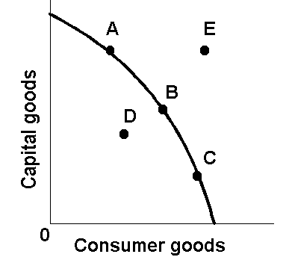

41. Refer to the above diagram. Other things equal, this economy will achieve the most rapid rate of growth if:

A) the ratio of capital to consumer goods is minimized.

B) it chooses point *C*.

C) it chooses point *B*.

D) it chooses point *A*.

42. Refer to the above diagram. This economy will experience unemployment if it produces at point:

A) *A.*

B) *B.*

C) *C.*

D) *D.*

43. In drawing the production possibilities curve we assume that:

A) technology is fixed.

B) unemployment exists.

C) economic resources are unlimited.

D) wants are limited.

44. Which of the following is assumed in constructing a typical production possibilities curve?

A) the economy is using its resources inefficiently.

B) resources are perfectly shiftable among alternative uses.

C) production technology is fixed.

D) the economy is engaging in international trade.

45. If the production possibilities curve were a straight downsloping line, this would suggest that:

A) resources are perfectly shiftable between the production of these two goods.

B) it is possible to produce more of both products.

C) both products are equally capable of satisfying consumer wants.

D) the two products have identical prices.

46. The typical production possibilities curve is:

A) an upsloping line that is concave to the origin.

B) a downsloping line that is convex to the origin.

C) a downsloping line that is concave to the origin.

D) a straight upsloping line.

47. Deltonia produces both consumer and capital goods. Other things equal, if Deltonia reduces the percentage of its output devoted to capital goods, then:

A) its rate of growth will decline.

B) its production possibilities curve will shift to the left.

C) it must also reduce the percentage of its output devoted to consumer goods.

D) its rate of growth will increase.

48. The slope of the typical production possibilities curve:

A) is positive.

B) increases as one moves southeast along the curve.

C) is constant as one moves down the curve.

D) decreases as one moves southeast along the curve.

49. Assume an economy is incurring unemployment and failing to realize least-cost production. The effect of resolving these problems will be to:

A) move the level of actual output to the economy's production possibilities curve.

B) create a less equal distribution of income.

C) shift its production possibilities curve to the left.

D) shift its production possibilities curve to the right.

50.

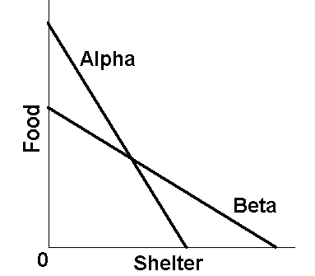

In the figure above are two linear production possibilities curves for countries Alpha and Beta. We can conclude that:

A) different value systems make it impossible to compare opportunity costs in the two countries.

B) the opportunity cost of shelter is greater in Beta than it is in Alpha.

C) the opportunity cost of food is greater in Alpha than it is in Beta.

D) the opportunity cost of shelter is greater in Alpha than it is in Beta.

51. The process of producing and accumulating capital goods is called:

A) money capital.

B) depreciation.

C) investment.

D) consumption.

52. Which of the following is *not* correct? A typical production possibilities curve:

A) indicates how much of two products a society can produce.

B) reveals how much each additional unit of one product will cost in terms of the other product.

C) specifies how much of each product society should produce.

D) indicates that to produce more of one product society must forgo larger and larger amounts of the other product.

53. A country can achieve some combination of goods outside its production possibilities curve by:

A) idling some of its resources.

B) specializing and engaging in international trade.

C) buying the debt (bonds and stocks) of foreign nations.

D) producing more capital goods and fewer consumer goods.

54. A point inside a production possibilities curve best illustrates:

A) unemployment.

B) the efficient use of resources.

C) the use of best-available technology.

D) unlimited wants.

Use the following to answer questions 55-59:

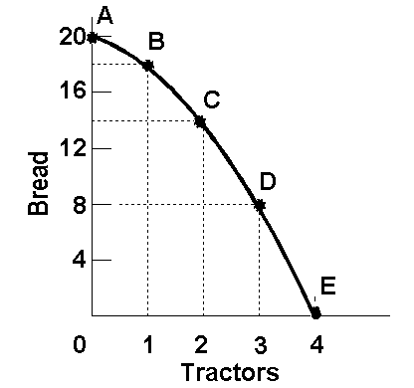

55. Refer to the above diagram. This production possibilities curve is constructed so that:

A) resources are presumed to be perfectly shiftable between bread and tractors.

B) the opportunity cost of bread diminishes as more bread is produced.

C) the opportunity cost of tractors diminishes as more bread is produced.

D) the opportunity cost of both bread and tractors increases as more of each is produced.

56. Refer to the above diagram. Which of the following is a normative statement?

A) Point *C* is superior to point *B* because it is important to enhance the future of society.

B) If society is initially at point *C*, it must sacrifice 6 units of bread to obtain one more unit of tractors.

C) If society produces 2 units of tractors and 12 units of bread, it is not using its available resources with maximum efficiency.

D) Other things equal, the combination of outputs represented by point *D* will result in more rapid economic growth than will the combination represented by point *C*.

57. Refer to the above diagram. Which of the following is a positive statement?

A) A point inside the production possibilities curve is superior to a point on the curve because the former requires less work effort.

B) Because any society should stress economic growth as its major goal, point *D* is superior to point *C*.

C) Point *B* is preferable to point *C* because the ultimate goal of economic activity is to maximize consumption.

D) Given its resources and technology, this society is incapable of simultaneously producing 3 units of tractors and 15 units of bread.

58. Refer to the above diagram. Starting at point *A*, the opportunity cost of producing each successive unit of tractors is:

A) a constant 2 units of bread.

B) 2, 4, 6, and 8 units of bread.

C) 8, 6, 4, and 2 units of bread.

D) the reciprocal of the output of tractors.

59. Refer to the above diagram. Starting at point *E*, the production of successive units of bread will cost:

A) a constant 8 units of tractors.

B) a constant 6 units of tractors.

C) 1/8, 1/6, 1/4, and 1/2 units of tractors.

D) 1/2, 1/4, 1/6, and 1/8 units of tractors.

Use the following to answer questions 60-61:



60. Refer to the above production possibilities curve. At the onset of the Second World War the United States had large amounts of idle human and property resources. Its economic adjustment from peacetime to wartime can best be described by the movement from point:

A) *c* to point *b*.

B) *b* to point *c*.

C) *a* to point *b*.

D) *c* to point *d*.

61. Refer to the above production possibilities curve. At the onset of the Second World War the Soviet Union was already at full employment. Its economic adjustment from peacetime to wartime can best be described by the movement from point:

A) *c* to point *b*.

B) *b* to point *c*.

C) *a* to point *b*.

D) *c* to point *d*.

62. The production possibilities curve shows:

A) the various combinations of two goods that can be produced when society uses its scarce resources efficiently.

B) the minimum outputs of two goods that will sustain a society.

C) the various combinations of two goods that can be produced when some resources are unemployed.

D) the ideal, but unattainable, combinations of two goods that would maximize consumer satisfactions.

63. The negative slope of the production possibilities curve is a graphical way of indicating that:

A) any economy "can have its cake and eat it too."

B) to produce more of one product we must do with less of another.

C) the principle of increasing opportunity costs applies to only parts of the economy.

D) consumers buy more when prices are low than when prices are high.

64. If an economy is operating *on* its production possibilities curve for consumer goods and capital goods, this means that:

A) it is impossible to produce more consumer goods.

B) resources cannot be reallocated between the two goods.

C) it is impossible to produce more capital goods.

D) more consumer goods can only be produced at the cost of fewer capital goods.

65. In drawing a production possibilities curve we hold constant:

A) the money supply.

B) the consumer price index.

C) both technology and resource supplies.

D) resource supplies only.

66. The construction of a production possibilities curve assumes:

A) the quantities of all resources are unlimited.

B) technology is fixed.

C) full employment, but not full production, is being realized.

D) there is no inflation in the economy.

67. A typical concave (to the origin) production possibilities curve implies:

A) that economic resources are unlimited.

B) that society must choose among various attainable combinations of goods.

C) decreasing opportunity costs.

D) that society is using a market system to allocate resources.

68. The production possibilities curve tells us:

A) the specific combination of two products that is most desired by society.

B) that costs do not change as society varies its output.

C) costs are irrelevant in a society that has fixed resources.

D) the combinations of two goods that can be produced with society's available resources.

69. The production possibilities curve has:

A) a positive slope that increases as we move along it from left to right.

B) a negative slope that increases as we move along it from left to right.

C) a negative slope that decreases as we move along it from left to right.

D) a negative slope that is constant as we move along it from left to right.

70. Which one of the following statements is *correct*?

A) Relative scarcity is no longer a central idea in economics because we are in an age of abundance.

B) Most production possibilities curves are convex to the origin.

C) The production possibilities curve shows society's preferences for consumer goods relative to capital goods.

D) The central concept underlying the production possibilities curve is that of limited resources.

Use the following to answer questions 71-75:

Answer the next question(s) on the basis of the following production possibilities tables for two countries, North Cantina and South Cantina:





71. Refer to the above tables. If South Cantina is producing at production alternative D, the opportunity cost of the third unit of capital goods will be:

A) 3 units of consumer goods.

B) 4 units of consumer goods.

C) 5 units of consumer goods.

D) 6 units of consumer goods.

72. Refer to the above tables. If North Cantina is producing at production alternative B, the opportunity cost of the eleventh unit of consumer goods will be:

A) 10 units of capital goods.

B) 1/4 of a unit of capital goods.

C) 8 units of capital goods.

D) 1/8 of a unit of capital goods.

73. Refer to the above tables. Suppose that North Cantina is producing 2 units of capital goods and 17 units of consumer goods while South Cantina is producing 2 units of capital goods and 21 units of consumer goods. We can conclude that:

A) North Cantina is fully and efficiently using its resources, but South Cantina is not.

B) South Cantina is fully and efficiently using its resources, but North Cantina is not.

C) neither South Cantina nor North Cantina are fully and efficiently using their resources.

D) both South Cantina and North Cantina are fully and efficiently using their resources.

74. Refer to the above tables. Suppose that resources in North Cantina and South Cantina are identical in quantity and quality. We can conclude that:

A) South Cantina has better technology than North Cantina in producing both capital and consumer goods.

B) North Cantina has better technology than South Cantina in producing both capital and consumer goods.

C) North Cantina is growing more rapidly than South Cantina.

D) North Cantina has better technology than South Cantina in producing consumer goods, but not capital goods.

75. Refer to the above tables. The opportunity cost of the fifth unit of capital goods:

A) is higher in North Cantina than in South Cantina.

B) is the same in North Cantina and South Cantina.

C) is lower in North Cantina than in South Cantina.

D) cannot be determined from the information provided.

76. If an economy is operating inside its production possibilities curve for consumer goods and capital goods, it:

A) can only produce more consumer goods by producing fewer capital goods.

B) can only produce more capital goods by producing fewer consumer goods.

C) can produce more of both consumer goods and capital goods by using its resources more efficiently.

D) must improve its technology to produce more output.

Use the following to answer questions 77-83:

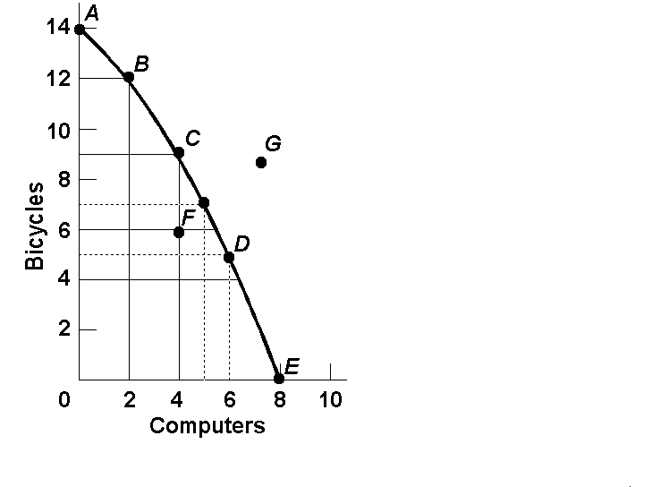

77. Refer to the above diagram. Points *A*, *B*, *C*, *D*, and *E*  show:

A) that the opportunity cost of bicycles increases, while that of computers is constant.

B) combinations of bicycles and computers that society can produce by using its resources efficiently.

C) that the opportunity cost of computers increases, while that of bicycles is constant.

D) that society's demand for computers is greater than its demand for bicycles.

78. Refer to the above diagram. This production possibilities curve is:

A) convex to the origin because opportunity costs are constant.

B) linear because opportunity costs are constant.

C) concave to the origin because of increasing opportunity costs.

D) convex to the origin because of increasing opportunity costs.

79. Refer to the above diagram. If society is currently producing 9 units of bicycles and 4 units of computers and it now decides to increase computer output to 6, the cost:

A) will be 4 units of bicycles.

B) will be 2 units of bicycles.

C) will be zero because unemployed resources are available.

D) of doing so cannot be determined from the information given.

80. Refer to the above diagram. The combination of computers and bicycles shown by point *G* is:

A) attainable, but too costly.

B) unattainable, given currently available resources and technology.

C) attainable, but involves unemployment.

D) irrelevant because it is inconsistent with consumer preferences.

81. Refer to the above diagram. If society is currently producing the combination of bicycles and computers shown by point *D*, the production of 2 more units of bicycles:

A) cannot be achieved because resources are fully employed.

B) will cost 1 unit of computers.

C) will cost 2 units of computers.

D) will cause some resources to become unemployed.

82. Refer to the above diagram. The combination of computers and bicycles shown by point *F*:

A) is unattainable, given currently available resources and technology.

B) is attainable, but entails economic inefficiency.

C) is irrelevant because it is inconsistent with consumer preferences.

D) suggests that opportunity costs are constant.

83. Refer to the above diagram. The movement down the production possibilities curve from point *A* to point *E* suggests that the production of:

A) computers, but not bicycles, is subject to increasing opportunity costs.

B) bicycles, but not computers, is subject to increasing opportunity costs.

C) both bicycles and computers is subject to constant opportunity costs.

D) both bicycles and computers is subject to increasing opportunity costs.

Use the following to answer questions 84-86:

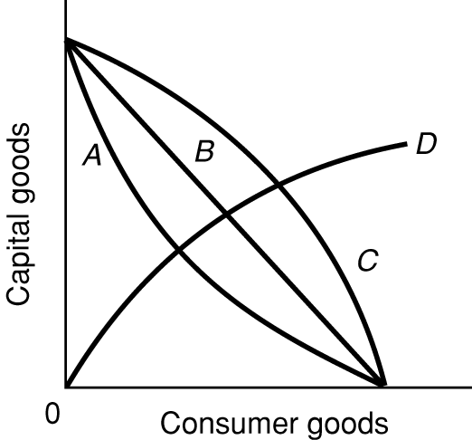

84. Refer to the above diagram. As it relates to production possibilities analysis, the law of increasing opportunity cost is reflected in curve:

A) A

B) B

C) C

D) D

85. Refer to the above diagram. Curve B is a:

A) production possibilities curve indicating constant opportunity costs.

B) production possibilities curve indicating increasing opportunity costs.

C) demand curve indicating that the quantity of consumer goods demanded increases as the price of capital falls.

D) technology frontier curve.

86. Refer to the above diagram. Curve C

A) reflects increasing opportunity costs because the slope of the curve becomes less steep as one moves down along the curve.

B) is a less desirable production possibilities curve for an economy than curve B.

C) is a more desirable production possibilities curve for an economy than curve A.

D) has a steeper slope throughout than curve B.

**Opportunity costs**

87. In deciding whether to study for an economics quiz or go to a movie, one is confronted by the idea(s) of:

A) scarcity and opportunity costs.

B) money and real capital.

C) complementary economic goals.

D) full production.

88. Which one of the following expressions best states the idea of opportunity cost?

A) "A penny saved is a penny earned."

B) "He who hesitates is lost."

C) "There is no such thing as a free lunch."

D) "All that glitters is not gold."

89. The fact that the slope of the production possibilities curve becomes steeper as we move down along the curve indicates that:

A) the principle of increasing opportunity costs is relevant.

B) society's resources are limited.

C) the opportunity cost of producing each product is constant.

D) resources are perfectly shiftable between alternative uses.

90. The idea of opportunity cost:

A) applies to consumers, but not to businesses.

B) applies to businesses, but not to consumers.

C) is relevant to economies of all ideological persuasions.

D) would disappear if we were able to eliminate poverty.

91. Which of the following is an economic explanation for why most college-aged movie stars do not attend college.

A) they are too dumb to get into college

B) they would find college life boring

C) the opportunity cost in terms of reduced income is too great

D) they cannot afford the room, board, and tuition fees most colleges charge.

92. The law of increasing opportunity costs states that:

A) if society wants to produce more of a particular good, it must sacrifice larger and larger amounts of other goods to do so.

B) the sum of the costs of producing a particular good cannot rise above the current market price of that good.

C) if the sum of the costs of producing a particular good rises by a specified percent, the price of that good must rise by a greater relative amount.

D) if the prices of all the resources used to produce goods increase, the cost of producing any particular good will increase at the same rate.

93. The concept of opportunity cost:

A) is irrelevant in socialistic economies because of central planning.

B) suggests that the use of resources in any particular line of production means that alternative outputs must be forgone.

C) is irrelevant if the production possibilities curve is shifting to the right.

D) suggests that insatiable wants can be fulfilled.

94. The law of increasing opportunity costs exists because:

A) resources are not equally efficient in producing various goods.

B) the value of the dollar has diminished historically because of persistent inflation.

C) wage rates invariably rise as the economy approaches full employment.

D) consumers tend to value any good more highly when they have little of it.

95. The law of increasing opportunity costs is reflected in a production possibilities curve that is:

A) an upsloping straight line.

B) a downsloping straight line.

C) concave to the origin.

D) convex to the origin.

96. Opportunity cost is best defined as:

A) the monetary price of any productive resource.

B) the amount of labor that must be used to produce one unit of any product.

C) the ratio of the prices of imported goods to the prices of exported goods.

D) the amount of one product that must be given up to produce one more unit of another product.

**Allocative efficiency**

97. Allocative efficiency is concerned with:

A) producing the combination of goods most desired by society.

B) achieving the full employment of all available resources.

C) producing every good with the least-cost combination of inputs.

D) reducing the concavity of the production possibilities curve.

98. Allocative efficiency involves determining:

A) which output-mix will result in the most rapid rate of economic growth.

B) which production possibilities curve reflects the lowest opportunity costs.

C) the point on the production possibilities curve that will maximize society's satisfaction.

D) the optimal rate of technological progress.

99. The point on the production possibilities curve that produces allocative efficiency can be found by:

A) estimating the marginal costs of both products in real or physical terms.

B) comparing marginal benefits and marginal costs in monetary terms.

C) determining where least-cost production occurs.

D) calculating where economic growth will be greatest.

100. "Allocative efficiency" refers to:

A) the use of the least-cost method of production.

B) the production of the product-mix most wanted by society.

C) the full employment of all available resources.

D) production at some point inside of the production possibilities curve.

101. The optimal or allocatively efficient point on a production possibilities curve is achieved where:

A) the smallest physical amounts of inputs are used to produce each good.

B) each good is produced at a level where marginal benefits equal marginal costs.

C) large amounts of capital goods are produced relative to consumer goods.

D) large amounts of consumer goods are produced relative to capital goods.

102. The marginal benefit curve is:

A) upsloping because of increasing marginal opportunity costs.

B) upsloping because successive units of a specific product yield less and less extra utility.

C) downsloping because of increasing marginal opportunity costs.

D) downsloping because successive units of a specific product yield less and less extra utility.

103. The marginal cost curve is:

A) upsloping because of increasing marginal opportunity costs.

B) upsloping because successive units of a specific product yield less and less extra utility.

C) downsloping because of increasing marginal opportunity costs.

D) downsloping because successive units of a specific product yield less and less extra utility.

104. The output of compact disc players should be:

A) reduced if marginal benefits exceed marginal costs.

B) reduced if marginal costs exceed marginal benefits.

C) increased if marginal costs exceed marginal benefits.

D) reduced to zero if their unit costs exceed the unit costs of alternative products.

105. If the output of product X is such that marginal benefit equals marginal cost:

A) the correct amount of resources is being allocated to X's production.

B) the value of producing X exceeds the value of producing alternative products with the available resources.

C) there can be a net gain to society by allocating either more or less resources to producing X.

D) resources are overallocated to the production of X.

Use the following to answer questions 106-108:



106. Refer to the above diagram for athletic shoes. The optimal output of shoes is:

A) *Q1*.

B) *Q2*.

C) *Q3*.

D) greater than *Q3*.

107. Refer to the above diagram for athletic shoes. If the current output of shoes is *Q*1, then:

A) society would consider additional units of shoes to be more valuable than alternative products.

B) society would consider additional units of shoes to be less valuable than alternative products.

C) society would experience a net loss by producing more shoes.

D) resources are being allocated efficiently to the production of shoes.

108. Refer to the above diagram for athletic shoes. If the current output of shoes is *Q*3, then:

A) resources are being allocated efficiently to the production of shoes.

B) society would consider additional units of shoes to be more valuable than alternative products.

C) society would consider additional units of shoes to be less valuable than alternative products.

D) society would experience a net gain by producing more shoes.

**Economic growth and decline**

Use the following to answer questions 109-111:



109. Technological advance in producing both capital goods and consumer goods is shown by the shift of the production possibilities curve from AB to:

A) CD.

B) EB.

C) AF.

D) GH.

110. Technological advance that is useful in producing capital goods but not in producing consumer goods is shown by the shift of the production possibilities curve from AB to:

A) CD.

B) BE.

C) AF.

D) GH.

111. Technological advance that is useful in producing consumer goods but not in producing capital goods is shown by the shift of the production possibilities curve from AB to:

A) CD.

B) EB.

C) AF.

D) GH.

112. The basic difference between consumer goods and capital goods is that

A) consumer goods are produced in the private sector and capital goods are produced in the public sector.

B) an economy that commits a relatively large proportion of its resources to capital goods must accept a lower growth rate.

C) the production of capital goods is not subject to the law of increasing opportunity costs.

D) consumer goods satisfy wants directly while capital goods satisfy wants indirectly.

113. Which of the following would be most likely to shift the production possibilities curve to the right?

A) a sudden and substantial expansion of consumer wants

B) an improvement in the literacy level and general level of education

C) a decline in the size of the population and labor force

D) shifting resources from the production of capital goods to the production of consumer goods.

114. Which of the following will shift the production possibilities curve to the right?

A) an increase in the unemployment rate from 6 to 8 percent

B) a decline in the efficiency with which the present labor force is allocated

C) a decrease in the unemployment rate from 8 to 6 percent

D) a technological advance that allows farmers to produce more output from given inputs

115. Other things equal, which of the following would shift an economy's production possibilities curve to the left?

A) the discovery of a low-cost means of generating and storing solar energy

B) the entrance of more women into the labor force

C) a law requiring mandatory retirement from the labor force at age 55

D) an increase in the proportion of total output that consists of capital or investment goods

Use the following to answer questions 116-120:

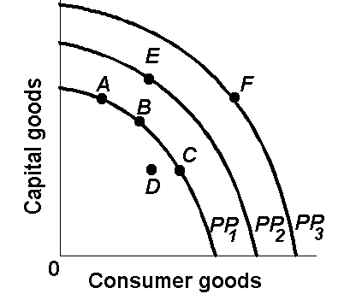

116. Refer to the above diagram. The concave shape of each production possibilities curve indicates that:

A) resources are perfectly substitutable.

B) wants are virtually unlimited.

C) prices are constant.

D) resources are not equally suited for alternative uses.

117. Refer to the above diagram. The concept of opportunity cost is best represented by the:

A) shift of the production possibilities curve from *PP*1 to *PP*2.

B) move from *B* on *PP*1 to *E* on *PP*2.

C) move from *B* on *PP*1 to *C* on *PP*1.

D) move from *D* inside *PP*1 to *B* on *PP*1.

118. Refer to the above diagram. Which of the following positions relative to *PP*1 would be the most likely to result in a future production possibilities curve of *PP*3, rather than *PP*2 ?

A) *A*.

B) *B.*

C) *C.*

D) *D.*

119. Refer to the above diagram. An improvement in technology will:

A) shift the production possibilities curve from *PP*1 to *PP*2.

B) shift the production possibilities curve from *PP*2 to *PP*1.

C) move the economy from *A* to *C* along *PP*1.

D) move the economy from *A*, *B*, or *C* on *PP*1 to *D*.

120. Refer to the above diagram. Which one of the following would shift the production possibilities curve from *PP*1 to *PP*2?

A) immigration of skilled workers into the economy

B) worsening of the AIDS epidemic

C) an increase in consumer prices

D) a reduction in hourly wages

121. Which of the following statements, if any, is correct for a nation that is producing only consumption and capital goods?

A) Other things equal, the more consumer goods a nation produces, the greater will be its future growth rate.

B) Other things equal, the more capital goods a nation produces, the greater will be its future growth rate.

C) There is no general relationship between the current division of output between consumer and capital goods and the future growth rate.

D) None of the above statements is correct.

122. All of the following could immediately or eventually lead to an inward shift of a nation's production possibilities curve, *except*:

A) emigration of skilled workers from the nation.

B) a decline in the birth rate.

C) an increase in the average skill level of all occupational groups.

D) depletion and reduced availability of major energy resources.

123. A nation's production possibilities curve might shift to the left (inward) as a result of:

A) technological advance.

B) increases in the size of the labor force.

C) the depletion of its soil fertility due to overplanting and overgrazing.

D) investing in more capital goods.

**Applications**

124. Which of the following might shift a nation's production possibilities curve inward?

A) improved technology.

B) devastation by war.

C) improved health care.

D) a business downturn in which unemployment temporarily rises.

125. Suppose that a university decides to spend $1 million to upgrade personal computers and scientific equipment for faculty rather than spend $1 million to expand parking for students. This example illustrates:

A) distorted priorities.

B) opportunity costs.

C) increasing opportunity costs.

D) productive efficiency.

126. Which of the following most closely relates to the idea of opportunity costs?

A) tradeoffs

B) economic growth

C) technological change

D) capitalism

127. Which of the following will enable a nation to obtain a combination of consumer goods and capital goods outside its production possibilities curve?

A) full employment

B) international specialization and trade

C) full production

D) productive efficiency.

128. Suppose that Zualia, which has full employment and full production, can obtain 1 unit of capital goods by sacrificing 2 units of consumer goods domestically, but can obtain 1 unit of capital goods from another country by trading 1 unit of consumer goods for it. This reality illustrates:

A) a rightward (outward) shift of the production possibilities curve.

B) increasing opportunity costs.

C) achieving points beyond the production possibilities curve through international specialization and trade.

D) productive efficiency.

129. Through specialization and international trade a nation:

A) can attain some combination of goods lying outside its production possibilities curve.

B) can move from a high consumption-low investment to a high investment-low consumption point on its production possibilities curve.

C) will attain some combination of goods lying within its production possibilities curve.

D) will cause its production possibilities curve to shift leftward.

130. Some agricultural sub-Saharan nations of Africa have overfarmed and overgrazed their land to the extent that significant portions of it have turned into desert. This suggests that:

A) the concavity of the production possibilities curves of such nations has increased.

B) the production possibilities curves of such nations have shifted inward.

C) the production possibilities curves of such nations have shifted outward.

D) these nations are operating at some point outside of their production possibilities curves.

131. If all discrimination in the United States were eliminated, the economy would:

A) have a less concave production possibilities curve.

B) produce at some point closer to its production possibilities curve.

C) be able to produce at some point outside of its production possibilities curve.

D) produce more consumer goods and fewer investment goods.

**Economic systems**

132. The two general types of economic systems that exist today are:

A) market systems and capitalism.

B) socialism and central planning.

C) market systems and command systems.

D) laissez faire systems and pure command systems.

133. Which of the following is a distinguishing feature of a command system?

A) private ownership of all capital.

B) central planning.

C) heavy reliance on markets.

D) wide-spread dispersion of economic power.

134. Which of the following is a distinguishing feature of a market system?

A) public ownership of all capital.

B) central planning.

C) wide-spread private ownership of capital.

D) a circular flow of goods, resources, and money.

135. Examples of command economies are:

A) the United States and Japan.

B) Sweden and Norway.

C) Mexico and Brazil.

D) Cuba and North Korea.

136. Of the following countries, the one that best exhibits the characteristics of a market economy is:

A) Canada.

B) Cuba.

C) North Korea.

D) China.

137. The French term "laissez-faire" means:

A) "there is no free lunch."

B) "let it be."

C) "circular flow."

D) "public ownership."

138. An "economic system":

A) requires a grouping of private markets linked to one another.

B) is a particular set of instituitional arrangements and a coordinating mechanism used to respond to the economizing problem.

C) requires some sort of centralized authority (such as government) to coordinate economic activity.

D) is a plan or scheme that allows a firm to make money at some other firm's expense

139. The term "laissez faire" suggests that:

A) land and other natural resources should be privately owned, but capital should be publicly owned.

B) land and other natural resources should be publicly owned, but capital equipment should be privately owned.

C) government should not interfere with the operation of the economy.

D) government action is necessary if the economy is to achieve full employment and full production.

140. Economic scarcity:

A) is peculiar to the United States economy.

B) applies to all economies.

C) is peculiar to command systems.

D) is peculiar to market systems.

**Circular flow model**

141. The simple circular flow model shows that:

A) households are on the buying side of both product and resource markets.

B) businesses are on the selling side of both product and resource markets.

C) households are on the selling side of the resource market and on the buying side of the product market.

D) businesses are on the buying side of the product market and on the selling side of the resource market.

142. The two basic markets shown by the simple circular flow model are:

A) capital goods and consumer goods.

B) free and controlled.

C) product and resource.

D) household and business.

143. In the resource market:

A) businesses borrow financial capital from households.

B) businesses sell services to households.

C) households sell resources to businesses.

D) firms sell raw materials to households.

144. Which of the following is a limitation of the simple circular flow model?

A) product markets are ignored.

B) resource markets are ignored.

C) The determination of product and resource prices is not explained.

D) households are included, but not businesses.

145. In the simple circular flow model:

A) households are buyers of resources.

B) businesses are sellers of final products.

C) households are sellers of final products.

D) there are real flows of goods, services, and resources, but not money flows.

Use the following to answer questions 146-149:

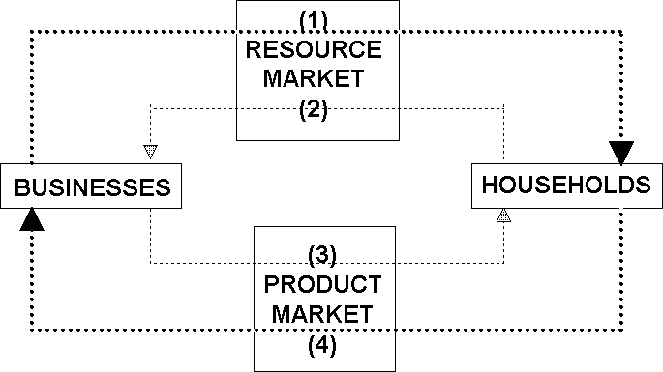

146. Refer to the above circular flow model of the economy. In the diagram flow (1) represents:

A) wage, rent, interest, and profit income.

B) land, labor, capital, and entrepreneurial ability.

C) goods and services.

D) consumer expenditures.

147. Refer to the above circular flow model of the economy. In the diagram flow (2) represents:

A) wage, rent, interest, and profit income.

B) land, labor, capital, and entrepreneurial ability.

C) goods and services.

D) consumer expenditures.

148. Refer to the above circular flow model of the economy. In the diagram flow (3) represents:

A) wage, rent, interest, and profit income.

B) land, labor, capital, and entrepreneurial ability.

C) goods and services.

D) consumer expenditures.

149. Refer to the above circular flow model of the economy. In the diagram flow (4) represents:

A) wage, rent, interest, and profit income.

B) land, labor, capital, and entrepreneurial ability.

C) goods and services.

D) consumer expenditures.

150. In terms of the circular flow diagram households make expenditures in the _____ market and receive income through the _____ market.

A) product; financial

B) resource; product

C) product; resource

D) capital; product

151. In terms of the circular flow diagram businesses obtain revenue through the _____ market and make expenditures in the _____ market.

A) product; financial

B) resource; product

C) product; resource

D) capital; product

152. Households and businesses are:

A) both buyers in the resource market.

B) both sellers in the product market.

C) sellers in the resource and product markets respectively.

D) sellers in the product and resource markets respectively.

153. In the circular flow model:

A) households sell resources to firms.

B) households receive income through the product market.

C) households spend income in the resource market.

D) businesses neither buy nor sell resources.

Use the following to answer questions 154-156:

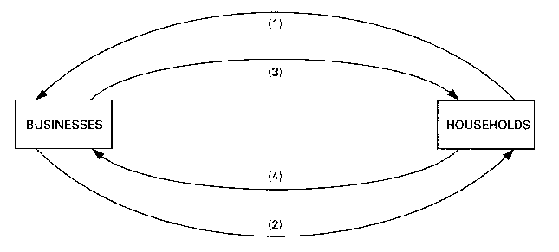

154. Refer to the above diagram. Arrows (1) and (2) represent:

A) goods and resources respectively.

B) money incomes and output respectively.

C) output and money incomes respectively.

D) resources and goods respectively.

155. Refer to the above diagram. Arrows (3) and (4) represent:

A) goods and services respectively.

B) incomes and consumer expenditures respectively.

C) resources and goods respectively.

D) consumer expenditures and income respectively.

156. Refer to the above diagram. Arrows (1) and (3) are associated with:

A) the money market.

B) the resource market.

C) the product market.

D) international trade.

**Last Word Questions**

157. (Last Word) The rapid rise in the number of women in the paid U.S. workforce over the past several decades has:

A) shifted the U.S. production possibilities curve inward (to the left).

B) moved the U.S. economy from a point inside its production possibilities curve to a point on the curve.

C) reduced income inequality in the United States.

D) shifted the U.S. production possibilities curve outward (to the right) and expanded total output.

158. (Last Word) Over the past several decades, the percentage of women in the paid U.S. workforce has:

A) increased in spite of declining wages for women.

B) decreased because relatively more women are staying home to raise their children.

C) increased due to higher wages, expanded job accessibility, changing preferences and attitudes, and other factors.

D) increased for unmarried women, but decreased for married women.

159. (Last Word) Rising wages for women in the United States have:

A) increased the proportion of women working part time compared to working full time.

B) increased labor costs and thus shifted the nation's production possibilities curve inward.

C) increased average family size in the United States.

D) increased the percentage of married women in the workforce.

**True/False Questions**

160. Full production means that all available workers have jobs.

161. The production possibilities curve shows various combinations of two products that an economy can produce when achieving full employment and productive efficiency.

162. The entrepreneur's sole function is to combine other resources (land, labor, and capital) in the production of some good or service.

163. Products and services are scarce because resources are scarce.

164. An economy cannot produce at a point outside of its production possibilities curve because human economic wants are insatiable.

165. The process by which capital goods are accumulated is known as investment.

166. The present choice of position on the production possibilities curve will not influence the future location of the curve.

167. Although sleeping in on a work day or school day has an opportunity cost, sleeping late on the weekend does not.

Use the following to answer questions 168-171:

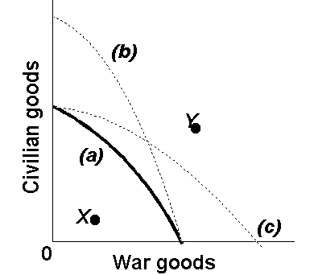

168. Refer to the above production possibilities curves. Given production possibilities curve (a), the combination of civilian and war goods indicated by point *X* is unattainable to this economy.

169. Refer to the above production possibilities curves. Given production possibilities curve (a), point *Y* indicates that society is failing to use available resources efficiently.

170. Refer to the above production possibilities curves. The movement from curve (a) to curve (b) implies an increase in the quantity and/or quality of society's productive resources.

171. Refer to the above production possibilities curves. The movement from curve (a) to curve (c) indicates an improvement in civilian goods technology but not in war goods technology.

172. An economy will always operate at some point on its production possibilities curve.

173. The increasing wealth of the United States has reduced the relevance of economics.