DBQ: PRE-COLUMBIAN MESOAMERICAN TECHNOLOGY

Directions

The following question is based on the accompanying documents. (The documents have been edited for the purpose of this exercise). The question is designed to test your ability to work with and understand historical documents. Write an essay that:

- Has relevant thesis and supports that thesis with evidence from the documents.

- Uses all or all but one of the documents.

- Analyzes the documents by grouping them in as many appropriate ways as possible and does not simply summarize the documents individually.

- Takes into account both the sources of the documents and the authors’ points of view.

Essay Prompt

Identify the roles played by technology and intellectual accomplishments in the development of Mesoamerican society from the Ancient through the Post-Classical Periods.

Based on the following documents, discuss the significance of technology in the Mesoamerican world. What types of additional documentation would help access the importance and impact of technology on Mesoamerican lifestyles and civilizations?

Historical Background

When humans first reached the Americas, they brought with them their tools. This technology spread across the Americas and is often found buried in graves with their previous owners. As Mesoamericans became sedentary, technology changed to meet their needs. When the Europeans arrived in 1521, they found flourishing civilizations and cities as large as any in the Old World.

DOCUMENT 1

Friar Bernadino de Sahagun, from his Florentine Codex, which used Aztec sources and witnesses who had lived during the Aztec region, describing clay making, 1575 – 1577

“The clay griddle maker is one who moistens clay, kneads it, tempers it with soft pieces of reed, makes it into a soft paste. He beats the clay, flattens it, polishes it, smoothes it; he applies a slop. He places the unfired pieces in the oven; he feeds the fire, makes the oven smoke, cools the oven. He sells hard-fired griddles which ring, which are well tempered.”

DOCUMENT 2

Francisco Hernandez, Spanish naturalist, from his notes, describing the use of the Maguey plant in the Valley of Mexico, early 16th century

“This plant has innumerable uses. The plant itself serves as firewood and for fencing fields. Its leaves serve to cover roofs, as roof tiles, as plates or as dishes, to make paper, and to make thread for footwear, cloth, and all kinds of garments. They make nails and tacks from the thorns. From the juice that drips out into the plants central cavity when the interior leaves are cut out with stone knives, they make wine, honey, vinegar and sugar.”
Note: cotton was only raised in warmer, wetter climates such as the lands of the Olmecs and Maya

DOCUMENT 3

Mayan Battle Song, 15th century titled “Awaken the Flint”

“Awaken the flint! Kukican sweats, he is sweating blood, ordering the Maya, to go now to war, and to launch from the steadfast bow, the swift, sharp flint arrow. Prepare from the cauipil, the breastplate (body armor), the cape, and the collar. Awaken the flint! The cutting edge shines equally on lance and ax. And the great piercing sound of the shell (horn) is heard everywhere and all the warrior peoples await the chance to show their courage.”

DOCUMENT 4
Hueheutlahtolli or the Discourses of the Elders, author unknown, early 16th century, a dialog where an Aztec noblewoman describes the education of noble boys and girls in Texcoco

“And when the boys had eaten, the adults began teaching them to do battle, how to hunt, how to shoot a blowgun, how to hurl stones; they were taught all about the shield and handsword, how to hurl spears and darts with a spear thrower; also about netting and snaring. Others were taught the different crafts: feather work, how feathers and plumes were arrayed; also mosaic work, goldsmithery, jewel cutting, and metal polishing; and also codex (book) painting, woodworking, and the various other crafts. Others were taught song composition and oratory and the science known as the drum and rattle (music), and also the science of the heavens, how the sun and moon and stars move; and then what are called the divine codices. And some they took to the fields or the flower gardens to teach them how to sow the seeds, to plant trees and flowers, and to cultivate and to work the land. They were taught all that was needed for them to know by way of service, knowledge, wisdom and prudent living. Likewise in the house, the girls are taught all the different things that women do: sweeping, sprinkling, preparing food, making beverages, also the art of the spindle, and the weavers reed and various kinds of embroidery; also dyeing, how rabbit down or rabbit fur was dyed different colors.”

DOCUMENT 5

Spanish Friar Juan de Torquemada describing King Nezahualpilli of Texcoco, a city-state allied with the Aztec Empire, events based on 1487 CE Texcocan source as recorded in Torquemada’s translation, mid-16th century

“It is said he was a great astronomer; that he was much concerned with understanding the movement of the celestial bodies. Inclined to the study of these things, he would seek in his kingdom for those who knew of such things and he would bring them to his court (to work at his temple observatory and generate the celestial calendar).”

DOCUMENT 6
Imperial tribute from all provinces, one year in the early 16th century, recorded in the Codex Mendoza, a copy of an Aztec imperial scroll

Textiles and Clothing | Quachtli and capes | 12,800 items
 | Garments | 19,200 items
 | Raw Cotton | 4,400 loads
 | Cochineal dye | 65 bags
Military Supplies | Warrior costumes, shields | 665 sets
 | Canes for arrows | 32,000 items
Jewelry and Luxuries | Colorful feathers | 29,680 items
 | Feather products | 7 items
 | Feather down | 20 bags
 | Lip plugs | 82 items
 | Amber | 2 large pieces
 | Turquoise masks | 10 items
 | Turquoise items | 5 items
 | Jade beads and stones | 22 strings
 | Gold objects | 60 items
 | Gold dust | 65 bowls
 | Gold bars | 10 items
 | Copper, bronze bells | 80 items
 | Copper, bronze axes | 560 items
Animal Products | Deer skins | 3,200 skins
 | Jaguar skins | 40 skins
 | Bird skins | 160 skins
 | Seashells | 1,600 items
Foodstuffs | Maize (corn) | 88 large bins
 | Chiles | 1,600 loads
 | Honey | 3,800 loaves
 | Ground grain | 320 baskets
 | Cacao beans | 680 loads
Building Materials | Lime for construction | 4,400 loads
 | Wood beams, planks | 14,400 pieces
Other | Balls of rubber | 16,000 items
 | Paper | 32,000 sheets
 | Reed mats, seats | 16,000 items
 | Canes | 48,000 items
 | Gourd bowls | 17,600 items
 | Pottery bowls | 2,400 items
 | Carrying Frames | 800 items

DOCUMENT 7

Hernan Cortes, Spanish conqueror of the Aztec Empire, describing the Aztec capital of Tenochitlan, 1521 from his letters and memoirs

“We saw the fresh water which came from Chapultepec (a floating garden part of the city composed of chinampas or artificial floating agricultural islands), and the bridges on the three causeways (dikes built across the water to link the city to the shore), built at certain intervals so the water could go from one part of the lake to another and a multitude of canoes. We saw that every house in the great city and in the others built on the water could be reached only by wooden drawbridges or by canoes. We saw temples built like towers and fortresses in these cities. We could look down on the flat roofed houses and other little towers and temples like fortresses along the causeway.”

DOCUMENT 8

Ixtiuxochiti, brother of the last native ruler of Texcoco, a later convert to Christianity, from his account in the prologue to his Historia Chichimeca, early 16th century

“They had scribes for each branch of knowledge. Some dealt with the annals, putting down in order the things, which happened each year, giving the day, the month and the hour. Others had charge of the genealogies, recording the lineages of rulers, lords, and noblemen, registering the newborn and deleting those who had died. Some painted the frontiers, limits, and boundary markers of the cities, provinces and villages, and also the distribution of fields, whose they were and to whom they belonged. Other scribes kept the law books and those dealing with the rites and ceremonies, which they practiced when they were infidels. The priests recorded all matters to do with the temples and images, with their idolatrous doctrines, the festivals of the false gods, and their calendars. And finally, the philosophers and learned men which there were among them were charged with painting all the sciences (writing the codices or books) which they had discovered, and with teaching by memory all the songs in which were embodied their scientific knowledge and historical traditions.”

DOCUMENT 9
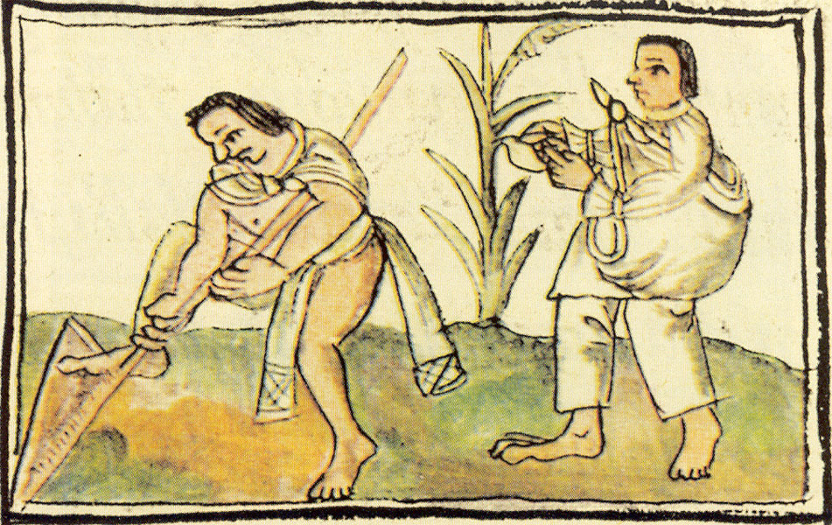

Mesoamerican Indians planting and harvesting corn, first planted at Tehuacan in the Valley of Mexico, c. 8000 BCE; original image from the Codex Florentine, 1575 - 1577

FOOTNOTES

- Michael Smith, The Aztecs (Malden, Massachusetts: Blackwell Publishers, Inc., 1996), 90.

- Smith, Aztec, 94- 95.

- Miguel Leon-Portilla and Earl Shorris, The Language of Kings: An Anthology of Mesoamerican Literature: Pre-Columbian to Present (New York, London: W. W. Norton and Company, 2001), 567.

- Miguel Leon-Portilla and Earl Shorris, The Language of Kings, 148.

- Smith, Aztec, 258 – 259.

- Smith, Aztec, 181.

- Nigel Davies, The Aztecs: A History (Norman, Oklahoma: University of Oklahoma Press, 1973), 257.

- “Aztec Books, Writing, and Documents” from SPAN 3300: Spanish American Civilization, History and Literature (Turlock, California: California State University, Stanislaw, 1999) (Accessed January 5, 2007); [Information Service on Line]: available http://www.azteca.net/aztec/nahuatl/writing.html

- Smith, Aztec, 71.

